**+**



**NORTH AINSLIE PRIMARY SCHOOL**

**OVERVIEW FOR PARENTS**

**2021**

# Welcome to the North Ainslie Primary School Community. We wish you a happy and productive association with our community.

*North Ainslie Primary School was opened in 1958 and it continues to be a community school with a high level of parent participation.  We pride ourselves on being an inclusive school which provides learning to a diverse range of children. This includes mainstream students, children with disabilities, and children with English as a Second Language. The school is home to the Northside Primary Introductory English Centre (IEC) which supports migrant, refugee and temporary international private students. As an International Baccalaureate School, we encourage all our students to be creative and connected citizens of the world.*

**Our Contact Details**

**Principal:** Tania Collis

**Deputy Principals:** Rikkie Klootwijk (3-6) and Sharon Moloney (P-2)

**Executive Teachers:** Haeley Simms

**Business Manager:** Nadia Murad

**Front Office:** Meenakshi Mahajan, Kathleen Hancock and Joanne Munoz

**Address:** 122 Majura Avenue, Ainslie ACT 2602

**Phone:** 02 6142 0760

**Fax:** 02 6142 0775

**Email:** [admin@nthainslieps.act.edu.au](mailto:admin@nthainslieps.act.edu.au) (for general emails)

[absence@nthainslieps.act.edu.au](mailto:absence@nthainslieps.act.edu.au) (to communicate a student absence ONLY)

**After School Care:** 02 6242 4040 (YMCA)

cscanberra@ymca.org.au

**School Hours** 9.00am to 3.00pm

**School Times**

Bell for morning assembly 8.55am

Assembly in Senior Courtyard 9.00am - 9.05am

First Session 9.05am - 11.00am  
Recess 11.00am - 11.30am  
Second Session 11.30am - 12.50pm  
Lunch Time Eating 12.50pm - 1.00pm  
Lunch Time Play 1.00pm - 1.40pm  
Third Session 1.40pm - 3.00pm  
School Finish 3.00pm

North Ainslie Primary School (NAPS) is an authorised International Baccalaureate World School offering the Primary Years Program (IB PYP). We provide a program where ‘hearts meet minds’ and we produce global learners that make a difference in the world.

**Our Mission Statement**

*North Ainslie Primary School, as a member of the International Baccalaureate Organisation, aims to develop inquiring, knowledgeable and caring young people who take positive action in the world.*

*Our school is a centre of learning where effort and achievement are celebrated and diversity is embraced within a restorative, respectful environment.*

*The heart of the local community, NAPS instils a passion for lifelong learning, enabling all students to be the best they can be as they confidently look to the future.*

**Philosophy Statement**

As an IB school operating within a restorative, respectful environment, North Ainslie continually strives to be an internationally minded community of learners who exemplify the attributes expressed in the IB Learner Profile. Our curriculum aims to develop students with these attributes:

|  |  |  |
| --- | --- | --- |
| Inquirers  Knowledgeable  Thinkers | Communicators  Principled  Open-minded  Caring | Risk-takers  Balanced  Reflective |

In order to develop these Learner Profile attributes, at North Ainslie we explicitly teach the following Approaches to Learning (ATL) Skills, which underpin all learning, both in the classroom and wider school community.

• **Thinking Skills:** The ability to creatively and critically analyse, apply, evaluate, synthesize, conceptualize, contextualize, reason, and solve problems.

• **Communication Skills:** The ability to produce and interpret messages effectively.

• **Social Skills:** The ability to participate and collaborate with others whilst showing awareness and respect for other cultures, varying points of view, and individual differences.

• **Research Skills:** The ability to determine the extent of information needed, locate and access information, organize and evaluate information, and use and share information effectively, efficiently, and ethically.

• **Self-management Skills:** The ability to set goals, manage 'me and tasks effectively, and manage your state of mind, self-motivation, resilience, and mindfulness.

**Communication**

**Communication with our school community is important to us and occurs through a variety of means.**

* **Morning Assembly** is held each morning in the senior courtyard. This is a time where we remind students of special events, lunchtime clubs, and general happenings in the school so it is an excellent way to keep up with school events if you are able to attend.

# The Gang Gang Gazette (newsletter), goes home every Friday via email so it is important we have the most up to date email address for your family. A hard copy can be given to the youngest or only student in the family if you do not have access to email. The newsletter contains important information for families so please make sure you read it each week.

# Important dates are sent home via the term calendar which is sent home with the newsletter in week 2 of each term. Upcoming events are also listed on the front page of the newsletter each week. A draft calendar for the following year is emailed home at the end of term 4.

# Information, notes and payment for excursions are sent home as either a hard copy, email or both. Notes and the payment should be returned to the school via the silver letterboxes in each corridor. Please ensure that money and/or notes are sent to school in a securely sealed envelope. Please do not hand in money/notes directly to the front office or to your teacher unless specified.

* **Assemblies:** School assemblies are an important part of our school program and help to communicate the learning program to our families. They are conducted every second Friday in the Hall at 12.00pm. They bring our community together and provide opportunities for children to perform before an audience. Assemblies also feature general announcements and award presentations. Assemblies are shown on the calendar, and feature in the upcoming events section of The Gang Gang Gazette. Special assemblies are advised in the school newsletter. Parents are very welcome to attend any assembly.

# Parent and Community Involvement

**Volunteering for the school**

We pride our school on being a “community school”. Parents are welcomed in many roles: helping with art, literacy and numeracy tasks; library work; fund raising; sporting activities etc. You can initiate this by talking to your child’s class teacher or class parent representative.

Please note: regular volunteer work, by law, now requires “Working with Vulnerable People” registration.

**P&C**  
NAPS P & C provides a chance to meet new people, exchange ideas and become involved in your child's schooling. It is a friendly forum where parents and carers interact and have the opportunity to express their thoughts about school issues in a supportive environment. The executive positions on the P & C are filled by volunteers, and, over the years, many people have appreciated the opportunity to learn new skills while performing these roles and have established close friendships with other committee members.

Our P &C have their own website <https://napspc.com.au/> which has all the information you need including our uniform shop, fundraisers and canteen.  
Our P & C meets twice a term, on Tuesday evenings at 7:30pm, and everyone is welcome to attend. The dates are announced in the school Newsletter.

# NAPS School Board

# The School Board plays a strong leadership role in the development of the school's philosophy and character. The Board is comprised of three members of the Parent and Carer community, three members of the teaching staff (one of whom is the Principal), one member representing the A.C.T. Education Directorate and co-opted members as determined by the Board. The Board's purpose is governance. Within that role it determines broad curriculum policy, assesses the building and equipment needs of the school, communicates with the A.C.T. Education Directorate, monitors the expenditure of school funds and develops community relationships. A regular report is presented at monthly P & C meetings and the Annual Report is published in the Newsletter. Minutes from previous meetings are available at the front office. Elected parent members of the Board are happy to be contacted on any school matter. Their contact details can be found on the front page of the Gang Gang Gazette .Board elections take place at the commencement of the school year. The Board chooses its Chair from the three parent members of the Board.

**Parent Class Representatives:**   
Each class has a parent class representative who acts as a conduit between teachers and the parent body. Class representative coordinate class events and are a sounding board for any parent who has concerns. The class representatives are coordinated by the P & C at the beginning of the school year.

# Facilities

# Uniform Store – Phone 61420760 for details

The North Ainslie school uniform colours are black and red. The uniform consists of black shorts, skirts, track pants, or trousers worn with a red t-shirt, either polo or crew neck. Jackets and sloppy joes are available for winter. Shoes should be runners or black school shoes. Sandals, plastic shoes and thongs are not suitable. Students are also expected to wear a 'sun-smart' hat at all times when outside e.g. broad-brimmed (min. 6cm brim), bucket (min. 5cm brim with a deep crown) or legionnaire hats with adequate side flaps that cover the face, ears and neck.

The P & C Association supports the wearing of school uniform through its uniform store, which is staffed voluntarily by parents and provides good quality uniform items at cost price. The uniform store mainly sells items that have been specially printed with 'North Ainslie' on them. Pre-owned items are also on sale. Parents and carers are encouraged to purchase generic black items from department stores (who buy in bulk and so can sell items for a much more reasonable cost).  
   
Uniform Can be ordered online via P & C website <https://napspc.com.au/home/uniform-shop/>.

# NAPS Canteen

The school canteen has been recognised as a model provider of healthy food. It is open for business each Wednesday to Friday for both recess and lunch. Lunch can be ordered online using Flexischools App or [www.flexischools.com.au](http://www.flexischools.com.au).

# YMCA - Before and After School Care at NAPS – phone 6242 4040 (YMCA)

The YMCA of Canberra offers Before and After School Care at North Ainslie Primary for primary school aged children. This service is fully licensed and operated in accordance with the ACT Office of Childcare. This service is provided from 7.30am to 9.00am in the mornings and 3.00pm to 6pm Monday to Friday during the school term. Bookings can be made on a permanent or casual basis. Activities include craft, games, movies, sport, cooking and much more. The children are provided with a healthy snack each day.

**School Holiday Program**

The YMCA of Canberra also offers vacation care every school holidays in several locations throughout Canberra for primary school age children. Vacation care with the YMCA offers supervised care by qualified staff, fun and interesting activities, and a special excursion or activity every day of the program. This service is fully licensed and operated in accordance with the ACT Office of Childcare. Bookings can either be short day care (8.00am-3.30pm) or long day care (8.00am-6.00pm). Activities include, but are not limited to craft, games, movies, sport, cooking and much more.

For more information about these programs, please visit the YMCA of Canberra's web site. Afters can be contacted on 6242 4040 and are located in the Hall near the canteen.

**After school activities**

The school works with a range of community organisations that come into the school to provide after school learning opportunities. In the past this has included, dance, guitar lessons, piano lessons, languages other than English, art, martial arts and drama. A complete list of activities and times will be published at the beginning of the school year to assist you to enroll your child if they are interested.

**Breakfast Club**

Breakfast Club is run in the school hall two mornings a week, Thursday and Friday. All students are welcome to attend Breakfast Club and they are always looking for volunteers to help in the morning before school.

**Volunteers Program**

The school also works with a variety of organisations who volunteer within the school in a range of ways such as Meccano, reading with students and assisting with homework.

# Curriculum Overview

***“The curriculum is all learning, academic and non-academic, that is written, taught and assessed.”***

(*Making the PYP Happen, 2007*)

**Our curriculum goals are supported by the following practices.**

Learning is made visible to students through:

* explicit learning intentions
* clear success criteria
* ongoing formative assessment and
* constructive feedback.

Teachers working in teams:

* ensures consistent practice across our school
* collaborate and communicate frequently
* increases skill development amongst staff
* fosters professional dialogue and reflection and
* improves programs by formal reflection processes.

Partnerships between parents/carers and school promote:

* help with at-home learning
* volunteer work in the school
* fund-raising
* strong school committees and
* provision of expertise and resources.

Personalised Learning Plans for students who require additional support are developed to:

* create a clear learning pathway
* enable each student to work with their teacher to set personal goals
* promote high standards of educational achievement and wellbeing for every child and
* raise standards by focusing teaching and learning on the aptitudes and interests of students, recognising individual difference.

### Our practice and the curriculum

**Primary Years Programme and Australian Curriculum**

Staff at North Ainslie Primary School work in collaborative teams to plan the teaching and learning for our students. Our Primary Years Program is a transdisciplinary P-6 curriculum that is designed to be engaging, relevant, challenging and significant. The program seeks to achieve a balance between five essential elements: the acquisition of **essential knowledge** and **skills**, the development of **conceptual understanding**, the demonstration of **positive attitudes and values**, and the taking of responsible **action**. Content choices are guided by the Australian Curriculum in all key learning areas with teachers using the achievement standards to guide our planning, teaching and assessment.

Whenever we plan the curriculum, we ask three key questions as a community of learners:

**What do we want to learn?** (the written curriculum)

**How best will we learn?** (the taught curriculum)

**How will we know what we have learned?** (the assessed curriculum)

**English**

At North Ainslie the explicit teaching of literacy occurs each day and also being taught within our transdisciplinary program of inquiry and all key learning areas. We use the Gradual Release of Responsibility to ensure all students receive explicit teaching, modeled and shared experiences and chances to demonstrate their learning independently.

We use a range of strategies to teach literacy including:

* guided reading
* buddy and shared reading
* cooperative reading
* explicit teaching and practice of spelling and word study
* guided and independent writing
* speaking and viewing experiences.

We promote early identification of children's specific literacy needs and appropriate intervention strategies. At North Ainslie, every child's development is monitored regularly to ensure students are progressing appropriately. Teachers work together to differentiate for all learners based on their next step. These interventions include differentiation within the classroom, small group work and individual assistance if required.

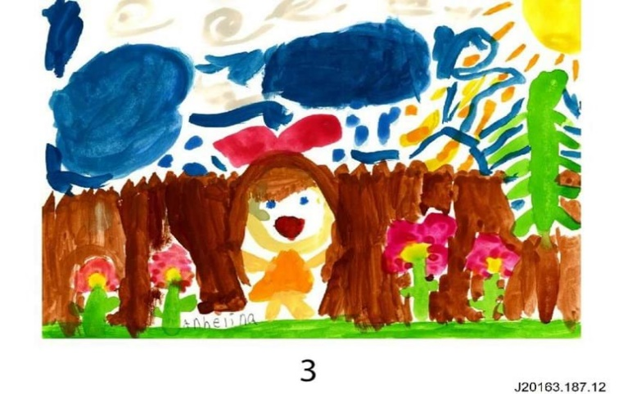

**Mathematics**

Learning experiences in mathematics at North Ainslie give students the opportunities to actively construct meaning about mathematics, transfer that meaning into symbolic form (mathematical notation and diagrams) and then apply their knowledge, skills and understandings. Students’ understanding of numeracy is facilitated by the inclusion of hands-on learning experiences, real world problem solving and inquiry. Emphasis is placed on the development of confidence and the enjoyment of mathematics. We believe that, wherever possible, mathematics should be taught through the relevant, realistic context of the units of inquiry so that students gain an understanding of the application of mathematics in their world. Students also need opportunities to identify and reflect on the “big ideas” within and between the different strands of mathematics.

Our mathematics programs build upon prior knowledge and are responsive to the demonstrated needs of individual students. Opportunities for remediation and extension are provided to best suit the needs of the students. Several additional programs may be offered to students: Tournament of Minds, UNSW Mathematics Competition, and Australian Mathematics Trust Maths Challenge.

**Health and Physical Education**

As a health promoting school, North Ainslie values the development of children's' physical, emotional and spiritual selves, and seeks to build social and emotional capacity within every member of our school community. Our program is underpinned by the restorative and relational framework and incorporates instruction in healthy living practices and social skills.

Students participate in regular physical activity, including human movement to music. They:

* learn to care for and maintain their bodies and minds
* learn to understand basic human anatomy
* develop fine and gross motor skills and
* develop the ability to participate in a team environment.

**The Arts**

At North Ainslie we believe that an arts program provides a variety of media through which students can develop sound emotional literacy and respond creatively to their environment and sense of humanity. We offer a comprehensive program that incorporates the strands of drama, music, visual arts, media and dance.

The school has specialist visual arts and performing arts teachers who work with students across the school from kindergarten to year 6. Students are exposed to the techniques of various artists and periods, and are taught skills relating to colour, line, form and shape. Our performing arts program teaches students about music through the use of instruments and recorded music and also incorporates opportunities for drama and dance. Lunchtime dance clubs operate during the year along with a lunchtime choir. Singing is used in the classroom, and by teams for shared time, and is quite often performed at school assemblies and the annual concert. The school participates in the ACT Instrumental Music Program and has a year 5 and year 6 band which students may be selected to join. The school participates in the Northside Spectacular, Limelight and holds regular art exhibitions.

**Personal and Community Health (PaCH)**

Students from kindergarten to year 6 will have an opportunity each year to learn and work in the school’s Healthy Eating Hub (HeHub) as part of our Personal and Community Health program. These both compliment the work done in our Units of Inquiry. Personal and Community Health forms part of the school’s release program and is delivered by specialist teachers. It includes opportunities to be involved in science and hands on experiences in the gardens.

**French**

Language education enriches learners intellectually, linguistically and culturally, enabling them to communicate in multiple ways and to view the world from multiple perspectives. Teachers at North Ainslie believe that learning an additional language is important to the education of young people. We believe that additional language education:

* develops the learner’s capacity to communicate and interact across languages and cultures
* develops cognitive skills
* extends literacy skills in both one’s own and additional languages
* allows the learner to more easily decode language, make comparisons between languages and draw conclusions about how language works
* strengthens our understanding of culture and identity through an understanding of global commonality and difference
* develops social cohesion by creating linguistically and culturally aware citizens
* affirms the knowledge and experiences of all students from culturally and linguistically different backgrounds
* promotes empathy for our students in the Introductory English Centre
* promotes tolerance, understanding and global capital
* prepares learners for greater immersion in languages at high school
* skills students in lingua franca
* builds bridges to communities in near/neighbouring countries
* supports trade and intercultural understanding

At North Ainslie Kindergarten students receive a basic introduction to the French language. Junior school students start to learn French from year 2 whilst students in years 3 to 6 receive a weekly minimum of 60 minutes delivered by a specialist teacher. At times specialist teachers also team with classroom teachers to provide the French program.

**Units of Inquiry (UOI)**

***“Tell me and I forget, show me and I remember, involve me and I understand."***

***“It is in the answers to the questions we ask that our knowledge exists.”***

*(Aristotle)*

As an International Baccalaureate School delivering the Primary Years’ Programme (IBO PYP), we advocate a structured and purposeful inquiry approach to delivering curriculum. It is child centred, both in terms of learning and assessment. It encourages children to formulate and investigate their own questions, based on existing knowledge, and to evaluate their own learning. It is a global, holistic curriculum approach which develops conceptual understandings, knowledge, skills, attitudes and values, and insists upon reflection.

North Ainslie has adopted a transdisciplinary, inquiry-based approach to learning in the areas of **social sciences, health,** **technology and science**. The program of inquiry is carefully planned by teachers and is designed to give students the skills to take the lead in their own learning. Together with our students, we establish what each child knows, what knowledge they have access to, and what knowledge they can build. We explore the world in which we live, ask questions, make discoveries and develop new understandings. Our adoption of this approach empowers us to meet national and system curriculum requirements alongside the needs of our students. We seek to promote, reflect and utilise the diversity of cultures and backgrounds within our existing school community, given that our students come from over forty different cultures and speak more than eighty different languages.

**What is Inquiry Learning?**

Inquiry learning involves the process of asking questions, investigating, creating, discussing and reflecting. Initially the teachers model the inquiry process and then guide the students through it. Later the students participate in more independent units of inquiry where classmates investigate topic-related questions that are student formulated. This is why “teacher questions” and “student questions” are found in the checklists in our students’ Unit of Inquiry Books. This approach to learning helps children to develop the understandings, concepts, skills and attitudes of an international, lifelong learner.

In Preschool and Kindergarten, inquiry is largely done through play where children engage in problem solving, posing questions, trialling solutions and refining learning. This type of inquiry occurs naturally through planned, scaffolded, and well-structured play sessions where teachers have explicit teaching goals. Research shows that a play-based inquiry program enhances literacy and numeracy outcomes, engages children in writing, improves social skills and enhances well-being. It also provides a seamless link between preschool and formal schooling.

In years 1-6 students participate in six units of inquiry per year. Each unit starts with guided inquiry before moving on to independent, student directed inquiry. Units have specific concepts that teachers want students to understand and these are taught through the use of fiction, non-fiction, research and discussions. Content from the Australian Curriculum is used as a way of investigating and understanding these key concepts and lines of inquiry.

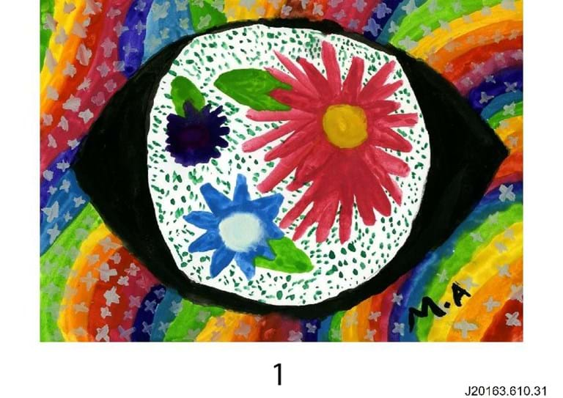

**Assessment and Reporting**

Assessment is a continuous process of gathering evidence to determine what each student knows, understands, values, and can do. Our beliefs about assessment and reporting are outlined in the relevant policy document. North Ainslie School has developed a range of authentic and targeted assessment strategies. We gather relevant objective data from across the school, as well as anecdotal information. Both formal and informal methods of assessment and reporting are used, including A-E, NAPLAN, portfolios, unit of inquiry books, midyear conferences and written end of year reports.

In the preschool and kindergarten years, students are exempt from A-E reporting. However, in kindergarten the children are tested for literacy and numeracy competency at the beginning and end of the year and parents are given the Performance Indicators in Primary Schools (PIPS) test reports.

**Assessment and Reporting Overview**

Term 1

* Information Night
* ‘Getting to know you’ interviews
* BASE testing for Kindergarten students
* Unit of inquiry assessment checklist which describes the child’s achievements and identifies any areas of concern

Term 2

* Parent/teacher interviews. All parents will be invited to attend an interview in term 2
* Mid-year written progress report (P-6) which includes A -E for year 1 -6
* National Assessment Program for Literacy and Numeracy (NAPLAN) testing for Years 3 and Year 5
* EALD Moderation Assessment Tasks for all EALD students K-6

Term 3

* Student led conference – Parents are invited to join their child/ren for a session to celebrate their child’s learning across all learning areas. This is usually held at the culmination of a unit of inquiry

Term 4

* Individual NAPLAN reports are sent home to parents/carers
* End of year BASE testing for Kindergarten students
* End of Year written progress report (P-6) which includes A -E for year 1 -6
* Optional parent/teacher interviews

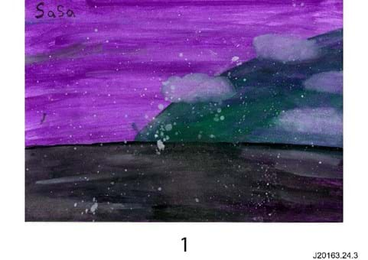Year 6 Exhibition is usually held in Term 3 or 4, depending on the Unit of Inquiry Cycle and celebrates 7 years of learning through the Primary Years Program. Families are invited to join their child/ren for a presentation and demonstration of the learning based around a Unit of Inquiry and question that particularly interested them and their group.

