***North Ainslie Information Session***

***and Enrolment Timeline for 2022***

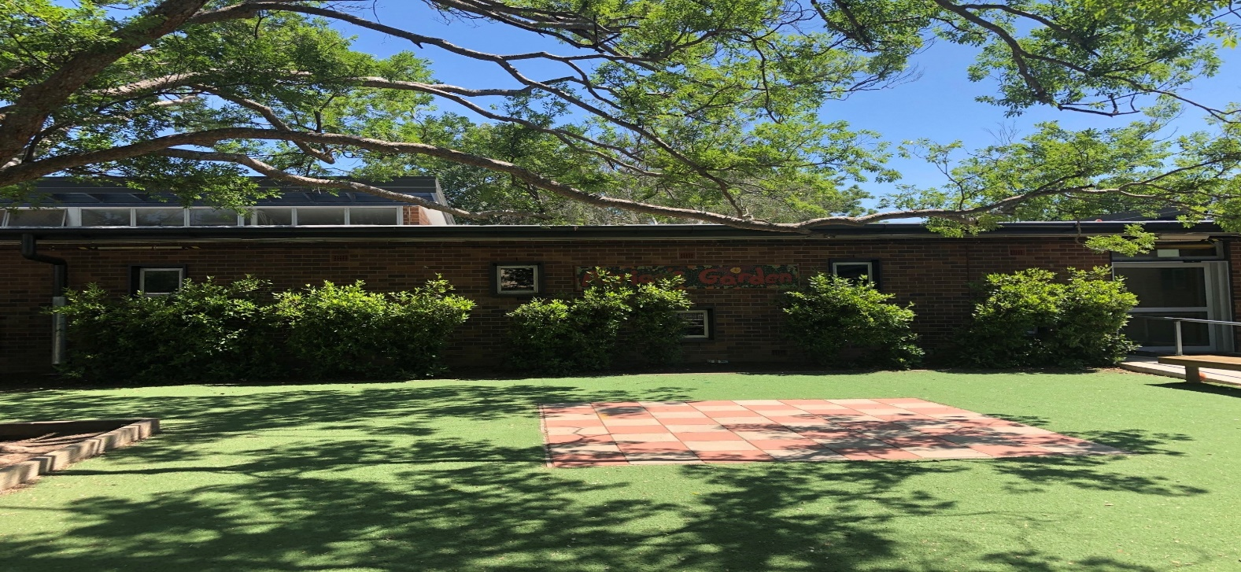

**2022 Enrolments now open,**

**come and visit us at NAPS**

*Discover what makes your local school a great school – attend the North Ainslie Primary School Information Session.*

***Date:*** *Wednesday 12th May*

***Time:*** *9:15am-10.30am*

***Location:*** *North Ainslie Primary, Majura Ave, Ainslie (with parking on Sherbrooke St)*

***Place:*** *School Hall*

*You’ll have the opportunity to see our school facilities, meet current students and hear about their experiences. After a quick presentation about our programs and practices, you can ask questions and get a sense of what it means to be a part of our school community.*

Please note: COVID-19 procedures still apply. To assist with planning, please RSVP by Monday, 10th May to [admin@nthainslieps.act.edu.au](mailto:admin@nthainslieps.act.edu.au)

If you are unwell, please do not attend.

**Enrolling/Transferring in**

**ACT Public Schools**

Visit the Education Directorate’s website at [www.education.act.gov.au](http://www.education.act.gov.au) for more information and to apply to enrol using the online enrolment form. Enrolments for the 2022 school year, open at 6am, 27 April 2021.

Parents/carers are welcome to apply to enrol or transfer their child at any time during the school year using an online application form. Full details are also available from the Education Directorate’s website.

***Important Dates for***

***2022 Enrolment***

**Tuesday 27 April**

2022 preschool to year 6 applications for enrolment open at 6am

**Friday 4 June**

2022 bulk round closes at 5pm for preschool applications ONLY

**Monday 26th July**

Preschool to year 6 applications submitted by 5pm, 4 June, will receive an offer of place at a school.

**CONTACT DETAILS**

**Principal:** Tania Collis

**Deputy Principals**: Rikkie Klootwijk (3-6)

Sharon Moloney (P-2)

**Phone**: 6142 0760

**Website:** www.nthainslieps.act.edu.au

**Email:**

admin@nthainslieps.act.edu.au

