***The Gang Gang Gazette***

*Week 6, Term 3 (21st August, 2020)*

Principal: Tania Collis Deputy Principals: Rikkie Klootwijk and Sharon Moloney

School Leaders: Haeley Simms, Kate Bush, Melissa Datson and Jarryd Heywood

Board Parent Representatives: Sue Webeck, Stephen Van Gerwen and Lucy Hopkins

Board Email:  [napsboardreps@gmail.com](mailto:napsboardreps@gmail.com)

P & C President: Maree Wright [napscommunity@gmail.com](mailto:napscommunity@gmail.com)

**Upcoming Events**

|  |  |
| --- | --- |
| Preschool Photos: Group 1  Group 2 | Tuesday 1st September  Thursday 3rd September |
| K – 6 School Photos | Wednesday 2nd September & Thursday 3rd September |
| 3/4 National Gallery Excursion: Group 1  Group 2 | Thursday 10th September  Friday 11th September |
| Year 6 Combined Band at Anslie Primary School | Monday 7th September |
| Year 5 Combined band at North Ainslie | Monday 14th September |

|  |
| --- |
| **Notes Home**   * Kindergarten BASE reports * 3/4 National Museum Excursion |
|  |
| **Board**  Next Meeting:  Tuesday, 8th September, 6.00 pm  **P & C**  Next Meeting:  Tuesday, 8th September, 6.00 pm |

Dear families and friends,

This week was another busy one as our students return to accessing incursions and excursions to enrich their learning. For our staff it was also a big week of learning as we participated in workshops associated with the upgrades to the oval. Many of us attended the sessions for staff and parents and carers with Uncle Tyronne and Adam Shipp. They shared their presentation on the importance of plants and animals in Indigenous Culture and how integral they are in the practice of Caring for Country. They shared amazing artefacts as they told us about how connected all parts of their lives are to the land and helped us understand more about how Indigenous people use artefacts in their daily lives. We also learnt so much about native plants and their uses for maintaining health and well-being and had lots of fun tasting some teas they brewed for us. Uncle Tyronne and Adam engaged us with their knowledge and answered so many questions for us. Everyone spoke about how lucky they felt to have had the time with them. On Wednesday, our teachers participated in an informative and inspiring session with Paul Barnett on how the master plan for the oval will come together and all we want to achieve whilst re-inventing the space. Thank you again to the P & C for all their work organising the presentations and working with the 3/4 students on ideas for what they would like to include in the oval upgrade. Next week more learning will be provided to our whole staff and parents and carers by Paul, Uncle Tyronne and Adam Shipp. I would once again like to thank the P &C team who have worked with such enthusiasm and commitment to organise these workshops and bring such important learning into our school community.

We continued to have students participate in the ICAS competitions through the University of New South Wales and look forward to seeing their results in the coming weeks. Thank you to Daniel Madden for organising and running these assessments over the last few weeks and well done to all of our students who have participated.

Our 3/4 students had a wonderful time this week out at Birrigai on either Tuesday or Thursday as part of their latest unit of inquiry. They all came home speaking of what they learnt and the fun they had making damper and learning out in the beautiful surrounds of Birrigai. A highlight for many of them was the campfire and I know they brought the smells of that home with them as they excitedly told us about building and sitting around their fires. Some of their recounts and photos from the days can be found later in the newsletter.

**Online Conference**

Thank you to Sarah Buckley who has organised a fabulous opportunity for our Indigenous students. Today they engaged with First Nations perspectives on Caring for Country and sustainability by exploring the designs of leading Aboriginal and Torres Strait Islander artists, in a free one hour video conference that brought the Powerhouse Museum into the classroom. In the guided tour of the Museum’s Linear exhibition, they were encouraged to consider and create responses to the themes of Caring for Country and Reconciliation, as a part of the Schools Reconciliation Challenge 2020. We look forward to seeing their artworks when they are completed.

**Satellite Selfie**

****This week Kindergarten participated in the Satellite Selfie an event presented by ACT National Science Week and the Where You Are Festival with the support of the ACT Government and The Australian National University. A satellite flew over the ACT and surrounding area and captured an image of as much of Canberra and the people in it as possible to create a time-capsule image of Australia's Capital from above. Kindy wanted to spread some happiness and colour, so decided to create a gigantic human rainbow. The satellite selfies will be sent out in early September. We will put our satellite selfie in the newsletter when it is released. Thank you to Kate Bush, Cassie Blewitt, Rashmi Paneswar, Rameeya Cheng and Gen Murphy for giving this opportunity to our kinder students.

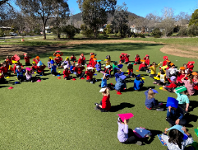

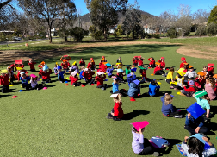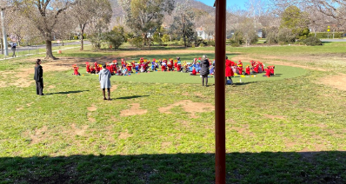

**2020 School Satisfaction & Climate Survey**

It is getting close to the closing of the 2020 School Satisfaction and Climate Survey and we would love your input by completing the surveys. Parents: please take 10 minutes to complete the *2020 School Satisfaction & Climate Survey* and help improve our school. Enter this link [**https://tinyurl.com/y6y8owmj**](https://tinyurl.com/y6y8owmj) into your device to complete the online survey for parents before 4 September. You will need to have your child’s Student ID handy. This link may be re-used if you want to complete the survey for a second child. Please ring the front office if there are any issues with completing the survey.

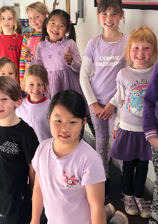**Wear It Purple Day**

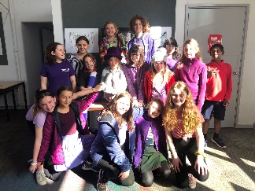Today was Wear It Purple Day and lots of members of our community showed their support for the day by wearing purple or rainbows. This is the day’s 10th year and the theme for 2020 is ‘We Are The Change’. In seeing so many of us today showing our support, I could clearly see this theme in action as we encourage and empower our community to create spaces for all minority groups to feel safe.

Finally, today we had our first online assembly with our junior school with an amazing performance by kindergarten. Thank you to the teachers and Kate Bush for sharing it. We were also able to give out awards based on our IB Attributes and it was such fun to see all the smiling faces and waving hands on my computer screen. Well done to everyone and thank you to Haeley Simms for organising.

Have a wonderful weekend.

Tania Collis

Principal

## School Photos

Next week we will be having our school photos for the year. Please see the information below regarding timing and ordering:

* On Tuesday 1st September, photos will be taken for both beginning of the week preschool classes.
* Photos of kindergarten, year 3/4, year 5/6, IEC and the LSUA will take place on Wednesday 2nd September.
* Photos for the end of the week preschool classes, Year 1/2 , band students, student leaders , sports leaders and year 6 photos will take place on Thursday 3rd September.
* Sibling photos will be taken at recess and lunch over the three days. If you would like a sibling photo taken, please ask your eldest child to come to the front office to collect the envelope. These will need to be returned to the photographer on the siblings Photo day, to ensure the photos are taken.
* Please be aware that **School Photos are Online Ordering Only.** Each student has received their own order form with their name printed on the top and an online shoot key.
* Duplicate families will be given a separate envelope. If you lose your envelope, please call 6142 0760 or email our office at admin@nthainslieps.act.edu.au to get your shoot key.

## 3-4 Camp

Dear Diary,

I got to school at 8.30 and played octopus till the bus came. The bus driver played music all the way to Birrigai. We then learnt about explorers and we got to be explorers at Birrigai! After this we had lunch and the lunch was amazing! We had a bun with chicken, cheese, lettuce, cucumber, tomato, beetroot and tomato sauce. We then made a campfire. I had trouble lighting my fire though. We made damper and put maple syrup through the middle. It was so yummy!

We then built some awesome shelters. At the end of the day we climbed Monkey Rock and then went back on the bus and the bus driver played music all the way to school.

Lewis B

Dear Diary,

Today I went to camp! I arrived at 8:30 – the deadline time! After 30 minutes we got on the bus to head to Birrigai. My bus buddy was Lewis. Lewis and I listened to music with headphones but after the bus driver put on music Lewis decided to listen to the music from the bus and I got both headphones so I had music twice as good!

After 30 minutes or so we got off the bus and went towards the Birrigai teachers. We got into our class groups and started our activities. My class started with the exploring activity. Everyone had one of four roles – navigator, botanist, artist or geologist. I was a navigator and was given a compass, clip board and a map to draw the landscape, I had to get everyone back to the colony. When we got back to the colony we had lunch. At lunch time we had cheese and ham rolls. After lunch we walked to the campfire area. First we had to gather dry sticks for the campfires. We had to gather a few different types of sticks (kindling, small sticks, medium sticks and larger sized sticks). Once we had enough sticks we were given newspaper and matches. Everyone in my group got a turn at lighting matches. Once everyone’s fires were lit we got to make damper.

How to make damper:

1. Mix flour and water
2. Find a stick and stick the dough on
3. Once golden take the damper off the stick

Mine was amazing! We then built shelters – and I sat at a really nice creek till we left to go to Monkey Rock or free play if you liked. Then we went back on the bus and drove to school.

Will B

Dear diary,

Today I went to Birrigai school camp and we were lucky we got to go because Covid has stopped other bookings. The bus played music!

When we got to Birrigai we were greeted with Birrigai biscuits and warm smiles. The first thing we did was the adventure walk where we pretended to be settlers and had to find land and a water source. We had navigators and botanists alongside artists and geologists.

After that we had lunch of rolls or if you had allergies you could choose from other suitable foods.

In the afternoon we made damper which was cooked over a fire we made. Collecting fire wood was fun but the fires gave out a lot of smoke so my eyes got a little but watery. After that we made rain proof shelter and had fun at Monkey Rock.

Then it was time to go home so we hoped on the bus and set off on our hour long journey home.

Isabel M

Dear reader,

I am explorer Daphne and I am an artist in my explorer group. We have just finished exploring New Holland and are discussing where to plant our crops and build our houses. Some of the options of where to live were a nice clear spot with bad, rocky soil; a place with lots of tiny plants and quite good soil; or a place covered in medium-sized plants with really good soil and right next to water.

There are some strange animals here, like giant hopping rats. That is really fun but hard to draw!

At one point, a couple of days ago, we ran out of water, so asked the navigators to find some. When they did, we ran into another group of explorers that also needed a drink.

Before that, the botanists found a type of plant that, if you rub your hand along it, and sniff your hand, it will smell funny!

We built some camp fires and started cooking the damper that we brought along with us. After that, we built some shelters using some of the fallen branches. Now you are up to date, so good-bye.

Daphne L, 3/ 4 KT

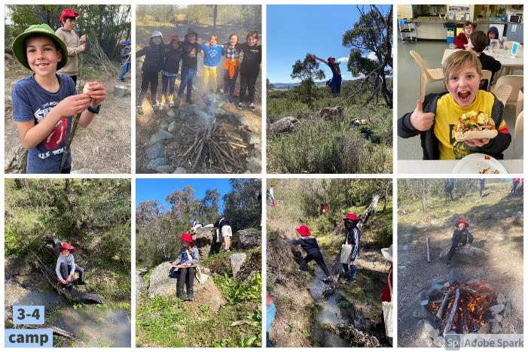

## NAPS P & CP&C News

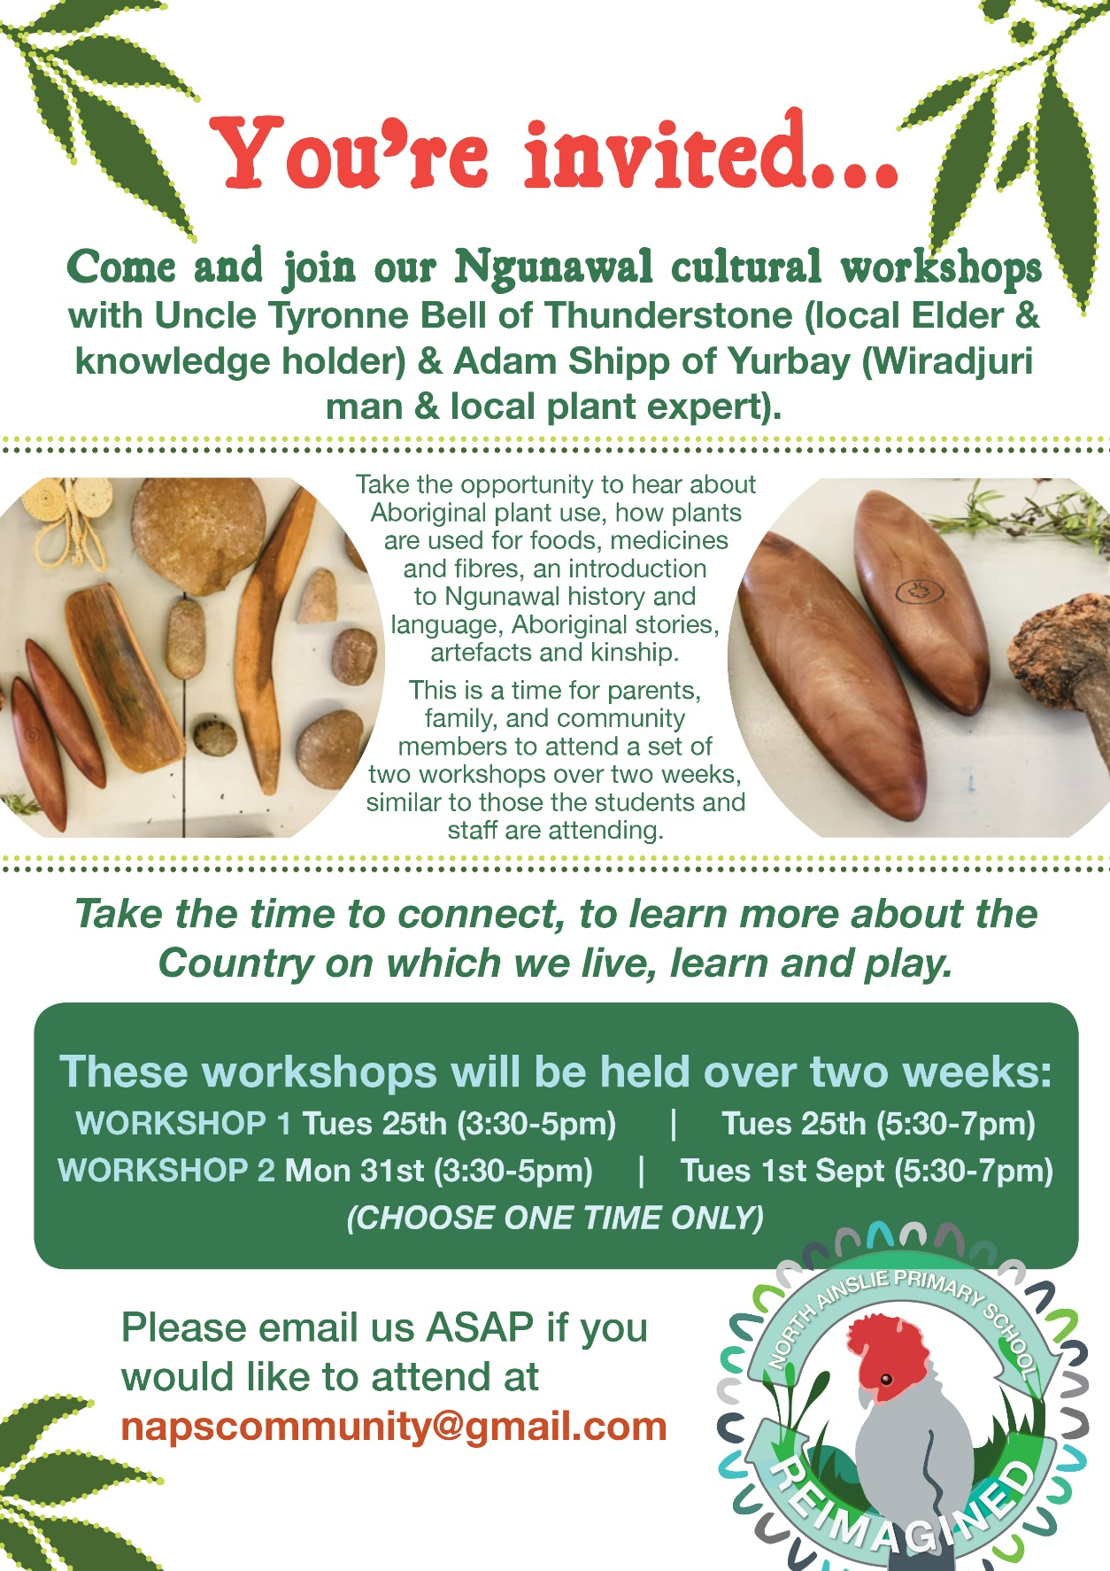

**Healthy Eating Hub LogoTERM 3 HEHUB CANTEEN MENU (Open Wednesday and Friday)**

**Healthy Eating Canteen Menu:** **Term 3**

**We are open for recess and lunch on Wednesdays, Thursdays and Fridays**

|  |  |
| --- | --- |
| **ALL WEEK RECESS**  **NOTE: not for lunch orders, counter orders only** | |
| Yoghurt | $2.50 |
| Frozen Peas 'n' Corn cup | $1.00 |
| Fruit of the day | $1.00 |
| Frozen fruit cup | $1.00 |
| Cheesey corn fritters | $1.00 |
| Pikelets, popcorn | $0.50 |
| Toasties | $1.00 |
| Muffins | $0.50 |
| **ALL WEEK LUNCH** | |
| Vegie sticks – from the counter | Free |
| Fruit of the day | $1.00 |
| Sausage Roll (homemade) | $4.00 |
| Sandwiches (Ham, chicken, tuna or cheese) | $4.00 |
| -Add salad (lettuce, tomato, carrot and cucumber) | $0.50 |
| -Make it a wrap | $0.50 |
| -Toast it | $0.50 |
| Vegemite sandwich | $3.00 |
| Honey sandwich | $3.00 |
| Salad bowl with either chicken or tuna | $4.00 |
| Yoghurt | $2.00 |
| **DRINKS** |  |
| Milk bottle (200ml) | $2.50 |
| Soy milk | $2.50 |
| Smoothie (collect from canteen) | $3.00 |
| Juice Box | $2.50 |
| **LUNCH PACKS** |  |
| Toasted chicken/cheese + milk + fruit | $7.00 |
| Toasted tuna/cheese + milk + fruit | $7.00 |
| Toasted chicken/cheese + juice + yoghurt | $7.00 |
| Toasted tuna/cheese + juice + yoghurt | $7.00 |

|  |  |  |  |  |
| --- | --- | --- | --- | --- |
| **DAILY LUNCH SPECIALS – ALL $4.00 EACH** | | | | |
| **Monday** | **Tuesday** | **Wednesday** | **Thursday** | **Friday** |
| Closed | Closed | Mini Quiche | Spaghetti Bolognese | Pizza  Margherita or Ham/Cheese |

**How do I make a lunch order?**

Lunch orders are available to all children and are for lunch, lunch pack and drink items only.  
**They need to be received by the canteen by 9.30am.**

**Cash orders:** Should be written on a brown paper bag with your name and class**,** what you'd like to order and the correct money. Lunch or drinks items only please.

**Online orders**: Flexischools App or www.flexischools.com.au. Online orders close 9.30am on the same day as you are ordering for.

*If you have a problem with your order, please call/text the manager, not the school front office.*

Canteen manager: Karen 0406 937 139

naps.canteen@gmail.com

## After School activities

