***The Gang Gang Gazette***

*Week 8, Term 2 (19th June, 2020)*

Principal: Tania Collis Deputy Principals: Rikkie Klootwijk and Sharon Moloney

School Leaders: Haeley Simms, Kate Bush (Acting), Melissa Datson (Acting) and Jarryd Heywood (Acting)

Board Parent Representatives: Sue Webeck, Stephen Van Gerwen and Lucy Hopkins

Board Email:  [napsboardreps@gmail.com](mailto:napsboardreps@gmail.com)

P & C President: Maree Wright [napscommunity@gmail.com](mailto:napscommunity@gmail.com)

|  |
| --- |
| **Notes Home**   * 5/6 Movie note * Headlice notification(1/2) |
|  |
| **Board**  Next Meeting:  Tuesday, 11th August, 6 pm  **P & C**  Next Meeting:  Tuesday, 11th August, 7.30pm |

Dear families and friends,

This week was a busy and interesting week for us as we head towards the end of the term. On Tuesday we had both our School Board and P & C Meetings and were able to hold them face to face for the first time since last term. The P & C Meeting also provided the opportunity for parents and carers to attend via Zoom and there was a large group of families who joined us through the online forum. We had our full board in attendance and it was fantastic to be able to share what has been going on in the school during the online learning period and now that we are back on site. One of the things to have come out of this time has been the trial of the Kiss and Drop area for drive through drop off and pick up each day. This initiative has proven to be highly successful and, based on the feedback, we have decided to make it a permanent fixture at the school. We have worked with Transport Canberra and City Services (TCCS) who visited to see the area in operation and agreed that it was working well. With their advice and assistance, we will be creating permanent signage and a more permanent way of both blocking off and providing access to the carpark when the Kiss and Drop is not in operation.

On Tuesday, the leadership team had the privilege of working with Helen Timperley via an online meeting with Helen in New Zealand. Helen Timperley is Professor Emeritus of Education at The University of Auckland and schools in the ACT were asked to put in an expression of interest to work with her to reflect on the changes brought to our practice through the online learning and professional experiences we had due to the Coronavirus. We were lucky enough to be one of the ten schools selected to share our practice and having her expertise guide us on next steps. Helen’s research has focused on school and system change through professional learning, professional conversations with impact and evaluative thinking in educational innovation and her insights were impactful and have helped us to plan for our professional learning for the rest of the year.

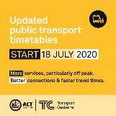**Updated public transport timetables**

From Saturday 18 July 2020, Transport Canberra will be updating timetables for bus services. These changes will help make public transport in Canberra easier to use by providing more services and increased frequency, to ensure that people have greater opportunity to spread out their travel across the day as we recover from COVID-19. As a new timetable is being introduced, there will be minor changes for all students travelling to and from school on public transport across Canberra from the first day of Term 3, 2020 (Monday 20 July 2020). In most cases, this will mean that students will catch the same service from the same stop, but the times that services arrive and leave may change.

All schools, parents and students can find out more about the specific changes by:

* + checking the information packs for each school, which are online at [www.transport.act.gov.au](http://www.transport.act.gov.au)
  + checking timetables for each route (including school specials), which are online at [www.transport.act.gov.au](http://www.transport.act.gov.au)
  + calling 13 17 10.

We have also attached to the newsletter the timetable that will be in place from the beginning of the term for your reference.

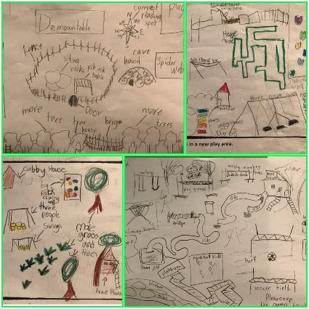Our P & C continues to work tirelessly on our joint project to upgrade the oval and we are thrilled at how far we have come. Students and teachers are working together to have input into the design, and the consultation process will continue with our older students in the coming weeks. In the pictures we have included today, you can see some of the amazing design ideas the juniors have already started putting together and how we are living the IB Learner Profile and Approaches to Learning through this process. Despite knowing how amazing our students are, I am still surprised at how well they are able to articulate their clear thinking and explain their choices. This has been very evident in the learning the juniors have already completed. Being able to design this space with input from the whole community, and have our students tell us what it is they want and need from their play space, is very exciting and makes me very grateful to be the principal of North Ainslie.

On Wednesday, Sharon Moloney lost an earring that is very precious to her as it was handmade for her by a friend. If you find the earring she would be most grateful if you could return it to the Front Office.

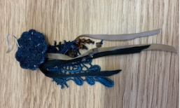

Have a great weekend.

*Tania Collis*

Principal

Public Transport

## P & C logoP & C NEWS

This week we held our regular meeting, which was our first on-site, in-person meeting since COVID-19 took over our lives 3 months ago. Zoom was still a popular choice, and will stay on as a valuable communication tool at all our meetings, allowing more parents to contribute to our community. P&C meetings are held in week 4 and week 8 of each term and are open to everyone.

The P&C were delighted to welcome Allie Patrick to the committee as Assistant Treasurer at the meeting. Allie is also Treasurer for the North Ainslie Primary Preschool subcommittee and will be a great help in the role. Thanks Allie!

Thanks to everyone who contributed to our Uniform Drive, we've gathered nearly 200 items! This is a fantastic achievement, and we hope to run this twice a year. You are always welcome to donate clean uniform items to us, once the uniform shop reopens. Thanks to Tiina and Harry for your hard work organising this worthwhile event.

We are working hard to plan a few fundraisers for the second half of the year, as conditions allow. If you can spare a few hours, we would love to hear from you. We will be seeking donations from local businesses for our annual raffle and could use a little help. Volunteering is a fun way to meet people, as well as supporting our community. We are also going to run our usual Art Fundraiser, so never fear, the 'Rona hasn't stolen your best source of Christmas gifts for grandma!

**Senior Oval Update:**

In exciting news, the Education Directorate were very happy with our Proposal, and have agreed to fund our design work! They were "very impressed at the sophisticated approach the school and NAPS P&C have undertaken to date". This is an excellent outcome, and I'd like to say a massive thank you to the subcommittee for all your hard work so far.

As the project really kicks off next term, we will need some extra support next with organising workshops, as well as sharing regular communications. If you have skills you think would help, and would like to be involved, we’d love to have a chat with you. This project will be so valuable to our whole school community, as well as heaps of fun! Keep an eye out for more information soon. We are continuing to develop relationships with various experts and advisors and look forward to finalising the designer selection process next week.

This week I want to share the final section of our Project Outline:

**"Collaborative Approach**

To achieve an outstanding result, the project will be developed through ongoing, meaningful consultation and dialogue with our whole school community. This will be incorporated in the students’ learning, in line with our inquiry-based pedagogy. Our students, particularly year 3-6 students, will have input into the design, in consultation with the design company and local aboriginal consulting organisations, to maximise learning opportunities. Our school grounds should reflect our community, and we hope to incorporate a ‘legacy’ contribution from our year 6 classes, to signify the ongoing connection even after graduation.

Our grounds are integral to our local community, and parents and local residents will be invited to participate in creating, learning from and caring for our gardens, as well as simply enjoying their use. This will help to build the sense of community ownership of public land, increasing its value and ensuring the long-term success of this project.

In order for this project to reach its full potential, we will partner with experts and work closely with government departments from many areas including TCCS (Urban Waterways), EPSDD, and Education (Strategic Procurement, Infrastructure & Capital Works, Environment & Sustainability, etc). We value and actively seek collaboration in order to deliver the best possible outcome for all stakeholders."

Maree

**Healthy Eating Hub LogoERM 2 HEHUB CANTEEN MENU (Open Wednesday and Friday)**

The canteen has reopened with a limited menu on WEDNESDAY and FRIDAY only, for online lunch orders. At this stage, we are **only** offering **online lunch orders through Flexischools**. There will be no recess service, and no over-the-counter lunch service.

The menu is limited to two $7 lunch pack options only:

**Chicken and Cheese toasted sandwich OR Tuna and Cheese toasted sandwich**

**With**

**Fruit OR Yogurt**

**And**

**Milk OR Juice**

## After School Activities

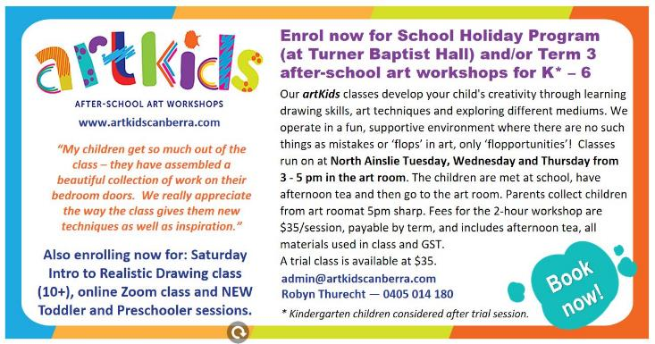

Saver Plus 