***The Gang Gang Gazette***

*Week 2, Term 2 (8th May, 2020)*

Principal: Tania Collis Deputy Principals: Rikkie Klootwijk and Sharon Moloney

School Leaders: Haeley Simms, Kate Bush (Acting), Melissa Datson (Acting) and Jarryd Heywood (Acting)

Board Parent Representatives: Sue Webeck, Stephen Van Gerwen and Lucy Hopkins

Board Email:  [napsboardreps@gmail.com](mailto:napsboardreps@gmail.com)

P & C President: Maree Wright [napscommunity@gmail.com](mailto:napscommunity@gmail.com)

Dear families and friends,

**Board**

Next Meeting:

Tuesday, 19th May: 6.00pm

**P & C**

Next Meeting:

Tuesday, 19th May: 7.30pm

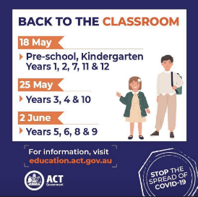Happy week 2. We hope you are all doing well and staying safe in these challenging times. This week we continued to receive good news regarding COVID-19 in the ACT. This has resulted in the easing of some restrictions and some changes in how we can now live and interact. By now you should have received an email from me outlining the return to face to face teaching over the coming weeks. It was sent yesterday, Thursday, and included two attachments – a letter from our Director General, Katy Haire, and one from the Chief Health Officer. You can also see from the picture I have included here that the return is phased and begins in week 4 on the 18th May with preschool to year 2. Students who are registered to attend the hub can also return to the North Ainslie site on that day. If they are in preschool to year 2 they will join their class and teacher for face to face teaching. Students in years 3 to 6 will continue with online learning, supervised at school. All students will return to face to face teaching by Tuesday, 2nd June. Students and teachers with chronic health conditions or compromised immune systems will be allowed to remain studying/working from home. If this applies to your child, please contact the school next week and we will work with you to put plans in place.

As the plans for the return continue, we will ensure we remain in contact with you about what is happening and how you can help us to make the return as seamless as possible. There will be changes to how you drop off and pick up students. This will be communicated as soon as possible to help everyone to know what to do on that first day and in the weeks following.

Yesterday, our P & C President, Maree Wright, sent me some questions from their survey and I will answer as many as I can here. Some of your questions require me to source additional information and I will answer those as we continue the process of transition back to our school site.

***If there is a case at NAPS, will school be closed for ages? Will there be alternate arrangements for kids whose parents have to work, or will we all need to take time off?***

* The Education Directorate has established procedures in place to respond to a confirmed or suspected case in an ACT public school. This includes working with the Chief Health Officer to determine risks and may include full or partial closure of an individual school in the case of localised infection. If this were to happen at North Ainslie, we would work with ACT Health to implement the above procedures and work with our community for all students, including those children of essential workers etc.
* Procedures and systems are also in place if there were a need to return to system wide remote learning if community restrictions are reinstated. The ACT’s significant investment and planning for remote learning will enable flexibility to respond to any return to community restrictions if required. Our teachers have planned the learning for the whole term, as we usually do, and will be able to respond by teaching face to face or through the use of the platforms we have been using this term.
* The Education Directorate will work closely with schools to review these arrangements in the months ahead to ensure effective implementation and management of COVID-19 related risks.

***What measures have been put in place to reduce risk? Will there always be enough soap in the toilets and sanitiser in the classrooms?***

* The ACT Education Directorate has worked with the ACT Chief Health Officer and taken their advice on how schools will return to face to face learning. This has included advice on physical distancing measures for adults, managing risks to vulnerable populations in schools, hygiene measures, environmental cleaning, management of suspected and confirmed cases and the provision of routine and emergency first-aid care.
* We will continue to use the recommended hand and respiratory hygiene measures. This will include having good supplies of sanitiser and soap for classrooms and the school.
* We have already sourced increased supplies of hand sanitiser through the assistance of a community member and our regular suppliers. The ACT Education Directorate has also sourced additional supplies of sanitiser and soap for every school. Cleaning in ACT Government Schools will have a greater focus on cleaning areas of higher risk.

***Will there be school assemblies and morning lines?***

* When we return to school this term there will be no morning lines or assemblies. We will continue to follow guidelines from the Chief Medical Officer around these gatherings and other events usually held in schools.

***What happens at drop-off and pick-up time?***

* There will be new protocols around drop-off and pick-up. We have started working on these and will communicate them to you next week before preschool to year 2 returns.

***Will kids have to socially distance at recess and lunch?***

* In the letter sent home to families yesterday, the advice from ACT Health stated that research shows there is very limited transmission from child to child, or from child to adult. It also states that students aged 3-19 years are not at increased risk in returning to face to face learning. There are further details in that letter for families on your questions about social distancing etc.

***I feel like my child has fallen behind - how will they be helped to catch up?***

* When we return to school our focus will be on making sure we continue to do the best for each student as an individual. This will include their well-being and their learning. We are well equipped to assess where students are at and adapt our class teaching to differentiate for the various needs of our students. If a student needs an additional boost, we will also put processes in place and ensure we continue to meet their needs whilst working with families.

***How are the kids in the IEC and LSU being supported through this change?***

* We have worked together with their class teachers and the Directorate, and our students in the LSUA and the Senior IEC (years 3-6) are all able to return to face to face teaching at the same time as students in preschool to year 2, i.e. on the 18th May. Extra transition support and working with families will happen to ensure this is successful for our students.

***Are teachers prepared to support our children’s mental health and wellbeing during all this disruption?***

* Social and Emotional Learning is an integral part of what we do and value at NAPS. Our focus for everyone when we return will be wellbeing, connecting and engaging as a community again. If we feel a student needs extra assistance, we will work together with the family and our school psychologist on the way forward.
* A new online and telehealth service is also available to provide ongoing ongoing wellbeing support to students during this period of remote learning and the return to school. This is the Student Wellbeing Telehealth Support Service (SWTSS) and is being delivered by a team of psychologists from the ACT Education Directorate. This service will offer students and their families psychological support for issues related to both wellbeing and learning. The support occurs through a phone call or online meeting and appointments can be made through an [online booking form](https://tinyurl.com/actedutelehealthservice) external link iconor by calling [6205 1559](tel:0262051559) and speaking to the booking officer. Appointments will be available between 9:00am and 4:30pm.

I hope this answers many of your questions but do also read the information sent home and make use of the Directorate’s website which has frequently asked questions addressed for families. The link can be found below.

<https://www.education.act.gov.au/public-school-life/remote-learning-in-term-2-2020/frequently-asked-questions-for-school-communities>

**Enrolling for 2021 and North Ainslie Information Session**

Applications for enrolment at Canberra Public Schools opened on Tuesday 28 April. For applications received by 5 June, offers will begin from 27 July. Further details on enrolling can be found on the Directorate’s website at <https://www.education.act.gov.au/>

**Kindergarten Health Check**

Due to the redeployment of Registered Nurses during the COVID-19 pandemic response and the closure of schools, the 2020 physical component of the Kindergarten Health Check has been cancelled.  The Academic Unit of General Practice questionnaire data, completed by parents at the beginning of the 2020 school year, has been collected as usual. The results of the questionnaire will be sent to your GP if consent has been given to do so. If parents have concerns regarding the physical check we recommend they see their GP for assessment. For more information please contact the School Health Team on 5124 1585.

**Visual Arts Opportunity**

The Art Gallery of NSW is presenting **Together in Art Kids,** an invitation to primary school aged children to*‘Take part in the power of art and join this new online project. Let’s come together in artmaking and share what we think, feel and see.’* If you are interested in finding out more, visit<https://www.togetherinart.org/kids>

**A Message for Our Keen Gardeners at NAPS**

Ainslie Urban Farm, a local environmentally friendly business, is growing seedlings for sale. They propagate the seedlings in Ainslie and only sell what they are growing in their own backyard in Ainslie. Great varieties and high-quality seedlings are grown in seed raising mix from Yass in cell trays made in Australia using recycled plastic. The trays can be returned clean for re use or recycling. Seedlings will be available from mid-April onwards. They will be for sale at the contactless garden stall in Stephen Street, Ainslie. They will post on Instagram using the hashtag #ainslieurbanfarm and on other social media when seedlings or produce are ready. You can also pre-order by emailing Fiona at [info@ainslieurbanfarm.com.au](mailto:info@ainslieurbanfarm.com.au) or on 6257 1582. More info can be found by visiting

[www.ainslieurbanfarm.com.au](http://www.ainslieurbanfarm.com.au) and Instagram #ainslieurbanfarm

**Moments in Time**

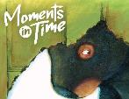The ACT Education Directorate has started a new initiative called Moments in Time. It is a 10-week journaling project developed by Learning and Wellbeing Policy and Design. It encourages students to record their experiences to provide insight for future students. The Director General launched it with a writing prompt and new prompts are released each week. She also has a video explaining how it works. Your contribution will form an archival journal and a selection of key ideas, sentences and themes will also be used to create a public artwork. If you are interested in taking part, you can find out more at:

<https://sites.google.com/ed.act.edu.au/momentsintime/information>

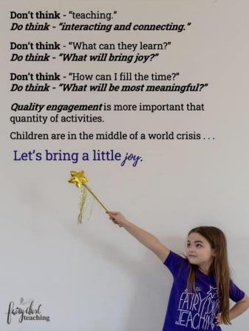The last few weeks have been challenging and have asked us to be adaptive, resilient, flexible and to find new ways of living, learning and being together. As we transition back to face to face teaching, we are realising that it may still require some adaptations and may not look the same as it did before COVID-19. As adults we can find this difficult and we are then asking the same of our children who may already be missing friends and family and the ways in which they could play and get together. Like many of you, I do look at social media and the news and find inspiration from people across the world. This morning we talked as a staff about what is happening over the coming weeks and what is important for all of us. Once again it came back to community and well-being. I shared this photo with them as the thoughts expressed in it really resonated with me. For all our students, whether they are soon returning to NAPS or continuing to learn online, I thought I would also share it with you.

Have a great weekend everyone and we look forward to seeing you all soon.

*Tania Collis* (Principal)

Lyneham High school enrolment

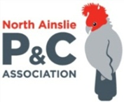**P &C NEWS**



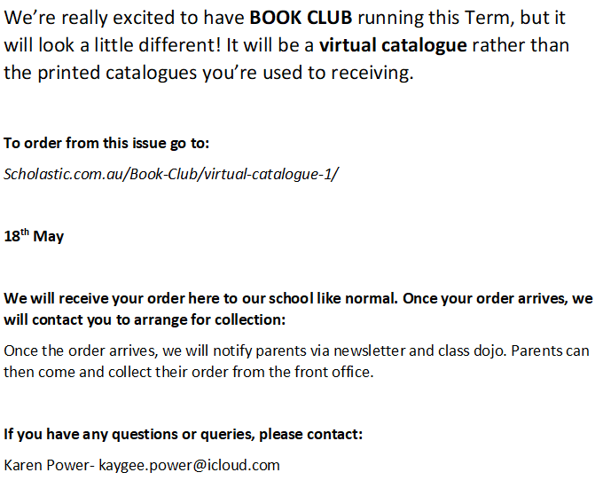

## After School Activities

Mojo Guitar