***The Gang Gang Gazette***

*Week 1, Term 1 (1st May, 2020)*

Principal: Tania Collis Deputy Principals: Rikkie Klootwijk and Sharon Moloney

School Leaders: Haeley Simms, Kate Bush (Acting), Melissa Datson (Acting) and Jarryd Heywood (Acting)

Board Parent Representatives: Sue Webeck, Stephen Van Gerwen and Lucy Hopkins

Board Email:  [napsboardreps@gmail.com](mailto:napsboardreps@gmail.com)

P & C President: Maree Wright [napscommunity@gmail.com](mailto:napscommunity@gmail.com)

Dear families and friends,

**Board**

Next Meeting:

Tuesday, 19th May: 6.00pm

**P & C**

Next Meeting:

Tuesday, 19th May: 7.30pm

Welcome to the first newsletter for term 2 as we all find ourselves on an exciting but steep learning curve. I first want to thank all the staff for the hard work they have put in at the end of last term, over the break and this week to help us to transition to online/remote learning. A special thanks to our teachers for the innovation you have shown in developing engaging and impactful lessons on these new platforms. I have the privilege of being able to see everything being sent home and am blown away at how quickly teachers have adapted to filming the reading of books and stimulus ideas, using Screen Castify to explicitly teach concepts and develop sequenced learning for all year levels. I know the Google Meets are important to both staff and our community and I have been lucky enough to attend a few this week. It was so much fun to see the faces of our students and I look forward to being in more next week.

I would also like to thank the community for being so supportive of us during these challenging times. It is always nice to receive positive feedback from our families and, especially at this time, is much appreciated. I have been passing on the lovely messages and thanks to our staff when we have our regular check ins via Google Meets and I know the messages have brightened their days.

Our P & C have been very busy over the break and still found ways to bring community together and to raise funds for our school with their Hot Cross Bun fundraiser. They have also been doing lots of work on the master plan for improving our outdoor spaces. In their section below, they are sharing some of the ideas that have been put forward for these spaces, including a different way of developing and using the oval based on what we know about how children play. We are very supportive of looking at this creative way of using the space so more children can use the areas in a range of ways. I encourage you to read what Maree has shared and become part of the consultation process.

**Enrolling for 2021 and North Ainslie Information Session**

Applications for enrolment at Canberra Public Schools opened on Tuesday 28 April. For applications received by 5 June, offers will begin from 27 July. Further details on enrolling can be found on the Directorate’s website at <https://www.education.act.gov.au/>

As a school, we are exploring ways of sharing what we do in a new way as we are unable to have our traditional Information Session for prospective families. More on this soon.

**Reading Eggs and Mathletics Trial**

A big thank you to Haeley Simms who has worked with 3P Learning to obtain a 30-day trial of Reading Eggs and Mathletics. Both Reading Eggs and Mathletics are great online resources that can be set at the right level for each student. Reading Eggs helps children to develop and continue to improve their reading and comprehension skills through engaging games and songs. Teachers can access big books and other resources to support student learning. Mathletics can be targeted at a student’s level and can be set up in a variety of ways by the teacher. This includes setting lessons before students play the games to practice the skills they have been learning about. We will be seeking feedback from teachers and families in a couple of weeks after everyone has had a chance to try the programs.

Students in kindergarten to year 6 will receive passwords from their teachers by the end of next week. As we have over 600 to work through, they will come at different times during the week and we will do our absolute best to get them out as quickly as we can. The password will come to you from your class teacher and we apologise if siblings do not receive them on the same day. If you have not received a password for all your children in kindergarten to year 6 by the end of the week, please contact Haeley and she will follow up for you. Her email address is [haeley.simms@ed.act.edu.au](mailto:haeley.simms@ed.act.edu.au)

**Borrowing from our library**

We have been receiving requests to borrow, return or renew books through our library. I am pleased to let you know that we have come up with a process whereby this can happen in a contact-free way. A big thank you to Rebecca Cameron for her work on this. I know it will be appreciated by lots of our families. You will be able to reserve the books you want through Oliver which can be found on the Digital Backpack. The link to the Digital Backpack is on our school’s website and is one of the orange tabs at the top.

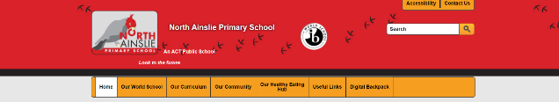

Please read below for the instructions from Rebecca on what to do once you are in Oliver. She will also be posting a ‘how to’ video on Class Dojo to assist you to use the facility.

*Would your child like to borrow some new books? On Tuesday, Wednesday and Thursday next week we will be trialling ‘a drive through’, contactless, book collection service. It's easy to take part, just follow these steps:*

1. *Search Oliver for books you are interested in. Make sure you select 'available items only.'*
2. *When you find the book you are interested in ‘Reserve it.’*
3. *When you have Reserved up to 5 books, email Rebecca at*[*rebecca.cameron@ed.act.edu.au*](mailto:rebecca.cameron@ed.act.edu.au)*to tell her you have reserved books.*
4. *Wait for Rebecca to reply. She will tell you when your books are ready to be collected from the front office.*
5. *Come to school and return the books you have finished into the designated trolley in the front foyer. Now, collect your books from the foyer/ hall in front of the office.Your pile of books will have your name on it.*
6. *Take the books home and enjoy!*

*Please note, it may take a couple of days for Rebecca to get back to you. Please do not come to school to collect books until you have been contacted.*

I may see you on a Google Meet soon. Have a great weekend.

*Tania Collis* (Principal)

Lyneham High school enrolment

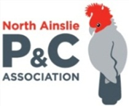**P &C NEWS**

Welcome back to Term 2. I hope you are all coping with the extreme juggling act we are trying to master at the moment - between little ones, and work, and school, I know I'm having a hard time feeling that I'm doing anything well! Fingers crossed we can keep on top of this virus and find a new, calmer path forward.

While we are all trying our very best to make life work for each of us right now, I'd like to keep you up to date on what the P&C are doing as well. Our focus is on our two major projects, the Master Plan and Senior Oval, and we had an outstanding presentation from Paul Barnett of Paul Barnett Design Group at last week's meeting. Paul and his team are very passionate about designing regenerative landscapes and have been working with schools in Canberra for the last 15 years. His grasp of the most current evidence base is excellent, and we explored some best-practice design approaches with him for around 45 minutes. If you missed the meeting and would like to catch up, please email us at [napscommunity@gmail.com](mailto:napscommunity@gmail.com) and I can share the presentation with you. We have not yet committed to any design company for either project, but a team has been working hard to develop the project plan to ensure we get the very best outcomes.

If you've missed our other communications, I'd like to let you know that the recommendation from the Education Directorate's landscape architect is to develop a more creatively designed set of play spaces, rather than a single large sports field in the traditional sense. The P&C are very supportive of this approach, as it would allow for more students to be more engaged in variety of activities, at the same time, and within the limited space. I’ve included a provocation graphic for you to get a feel for the style of design we are considering. It is not a design for NAPS, and all students, staff, and parents will have an opportunity to have meaningful input and provide feedback during the design process. We are planning to work closely with the school, and a design company, to make sure the final design meets the needs of all the students, teachers, as well as the broader school and local community.

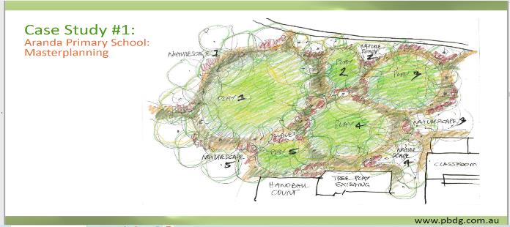

*This is an EXAMPLE concept sketch to illustrate the kind of creative thinking we are working towards for the senior oval. This is NOT a design for North Ainslie Primary. Credit to Paul Barnett Design Group.*

Thanks to everyone who supported our Hot Cross Bun fundraiser, and special thanks to Jo Fisher for organising, and the Polo Restaurant for supporting NAPS P&C (again!). We will be watching the health situation carefully over the next few weeks, and if it’s safe, and allowed, we will look into other events which we may be able to start organising.

Finally, thanks to the teachers and school staff for their dedication and hard work over the last few weeks, and their incredible efforts to adapt quickly and deliver quality education for our children. It’s a really tough and stressful time for everyone, and we are all doing our best.

Our next meeting will be Tuesday, Week 4 at 7:30pm on Zoom. The meeting link will be distributed via Class Dojo on the day. We also send the agenda and previous minutes, as well as the meeting link, to our mailing list. If you haven’t been getting emails from us directly, you can sign up via our website [www.napspc.com.au](http://www.napspc.com.au) or email us at [napscommunity@gmail.com](mailto:napscommunity@gmail.com)

Be safe, be kind, and I hope to see you all again in person soon.

Maree

P&C President



