***The Gang Gang Gazette***

*Week 1, Term 4 (16th October 2020)*

Principal: Tania Collis Deputy Principals: Rikkie Klootwijk and Sharon Moloney

School Leaders: Haeley Simms, Kate Bush, Melissa Datson and Jarryd Heywood

Board Parent Representatives: Sue Webeck, Stephen Van Gerwen and Lucy Hopkins

Board Email:  [napsboardreps@gmail.com](mailto:napsboardreps@gmail.com)

P & C President: Maree Wright [napscommunity@gmail.com](mailto:napscommunity@gmail.com)

**Upcoming Events**

|  |  |
| --- | --- |
| Book Week  Book Week Dress Up Day | Week 2  Friday 23rd October |
| Preschool Arboretum Excursion Group 1:  Group 2: | Monday 19th October  Thursday 22nd October |
| Adam Shipps Bush Tucker Workshop | Monday 19th October & Thursday 22nd October |

|  |
| --- |
| **Notes Home**   * Whole School Sociograms * 1/2 UOI Timeline Letter * Whole School Chicken Pox (email) * K-2 Dance Workshops * Preschool Reptile Zoo Incursion |
|  |
| **Board**  Next Meeting:  Tuesday, 3rd November, 6.00pm  **P & C**  Next Meeting:  Tuesday, 20th October, 7.30pm |

Dear families and friends,

Welcome back for our final term for the year. It is lovely to be coming to work in sunshine and I always feel the return of the warmer weather helps us all to be more energised and ready for learning and fun. I hope you all had a chance to relax and refresh this break and to spend time with family and friends. I took the opportunity to catch up with friends I had not seen in a very long time, enjoy the lovely surrounding towns in NSW and refresh my garden.

Some restrictions across the ACT have been lifted and these have also been incorporated into a new ‘Roadmap’ for schools. This ‘Roadmap’ can be found at <https://www.education.act.gov.au/public-school-life/covid-school-arrangements> along with other information on frequently asked questions and end of year events. You will notice that this has resulted in some additional excursions and incursions beginning to happen again. It is wonderful to be able to provide these enriching learning experiences for our students. We will be using these guidelines to plan the rest of the year and this will include some exciting activities for our year 5/6 students and the year 6 graduation. They will also guide us in how we work with our preschool and kindergarten families on transitions for next year. Information on these will come out shortly.

You will notice that later in the newsletter there is a section on Book Week. We are excited to be able to announce we will be having our annual parade for our students. Due to the restrictions, it will only be for students but we will be sharing the highlights with you.

**Sociograms**

Whole school sociograms went home this week. They are important in helping us to set up our classes for next year. It is most helpful for us if the children identified are from the same year group as this supports age group friendships and connections which can be maintained across your child’s schooling. Names can include someone from another class whom they have enjoyed being in class with in previous years or someone they would like to have next year based on this year’s friendships. If you have any questions in relation to filling the sociogram out with your child, please contact your child’s class teacher for assistance.

Putting together classes each year is an important job for us. We put a lot of thought into our class placements and use the sociograms, along with information from class teachers, to help us make the best class groupings to maximise outcomes for students both socially and academically. You can assist us by talking it through with your child and asking them some questions focusing on what you and they think will work best for them in their classroom.

Questions you might like to ask your child when completing the sociogram include:

• Who do you get along well with both in class and on the playground?

• Which of your friends helps you to learn best in the classroom?

• Who do you think will help you to have a successful year of learning next year?

• Think about a time you have done some group work in class; who did you work well with?

Please note, if we do not receive your child’s hand by the date below, your child’s current class teacher will complete this with them to ensure they are included.

**P&C Election BBQ**

Tomorrow is election day and our P&C have received permission by the Chief Health Officer to run a sausage sizzle. The stall will include cakes and drinks. The event’s COVID-19 Safe Plan has been seen by the Chief Health Officer and was developed in conjunction with the ACT Council of Parents and Citizens Associations.

The P&C are looking for volunteers for the day and would love your help. You can volunteer by going to:

<https://www.volunteersignup.org/HKY43>

If you have any questions about the event or their COVID-19 plan, please contact them on [napscommunity@gmail.com](mailto:napscommunity@gmail.com)

I may see you tomorrow at the BBQ. Have a great weekend.

Tania Collis (Principal)

**Book Week**

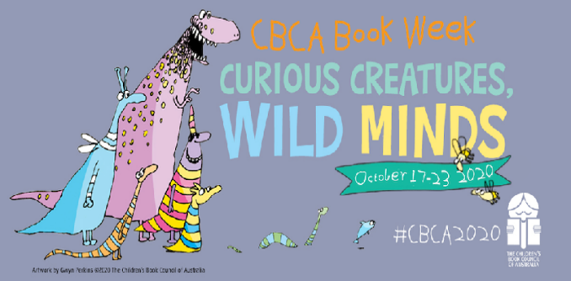Next week is Book Week. This year’s theme is Curious Creatures, Wild Minds. This week in our library, we have been reading and sharing the Children’s Book Council Award nominee books.

To celebrate Book Week, on Friday 23 October we will be having our Book Week Character dress up day. This day will look a little different this year, due to COVID restrictions. Unfortunately, parents will not be able to attend. We will be sure to share with families our wonderful costumes and dress ups. All children are welcome to come to school dressed as their favourite book character. Please be rest assured if your child is not able to come dressed up, our teachers will have some options for everyone, so they are a part of the day. We are still finalising the plans for the day to ensure we meet the current COVID restrictions and once this is all worked out, we will share our celebration of books with you.

**Baby Chickens and Ducks**

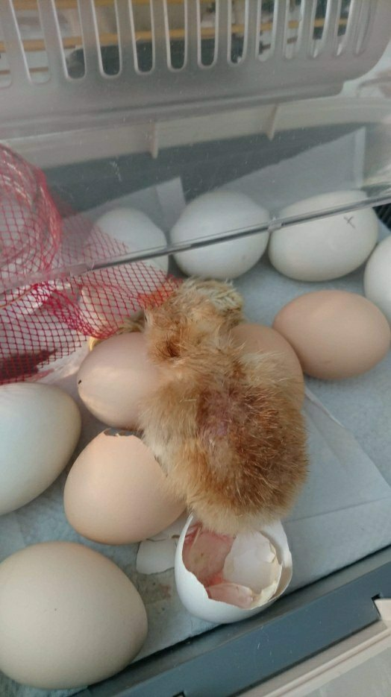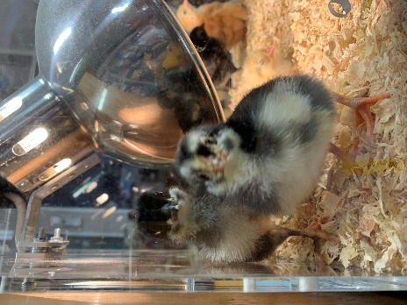This term, our preschools are inquiring into living things and what they need and the importance of caring for them. We have welcomed some new baby chicks to both NAPS and Hackett preschool classes this week.

The eggs arrived on Monday and one even hatched just as they arrived! The chicks are very cute, and the children have been making observations about how they grow so quickly, sleep a lot on their bellies, and make a lot of noise!

## P&C News

**P & C General Meeting**

**Tuesday 20 October at 7.30pm**

The next P&C general meeting will be held next Tuesday 20 October at 7.30pm.

The meeting will be run **online only**, using the video conferencing platform "Zoom". You can download the free app on your phone.

**Topic:** Term 4 Week 2 P&C Meeting

**Time:** 20 October 2020 07:30 PM

**Join Zoom Meeting** https://us02web.zoom.us/j/85788749466

**Meeting ID**: 857 8874 9466

**One tap mobile**

+61871501149,,85788749466# Australia

+61280156011,,85788749466# Australia

**Meeting ID**: 857 8874 9466

**Find your local number**: https://us02web.zoom.us/u/kd3gcNKYIt

Our agenda will include:

* Election day BBQ feedback
* Engagement Grant
* COVID-19 updates
* Oval – redevelopment
* Uniform Store
* Canteen
* Fundraising
* Future Events and alternative options

If you would like us to add any other items, please email napscommunity@gmail.com

### P&C Fundraising

As with many things in our lives, COVID-19 has impacted many of the P&C's traditional fundraising activities. But we're ending Term 4 on a high with some of our most popular fundraising activities, that are fortunately COVID safe!

#### Mangoes and Cherries

NAPS Primary and NAPS Preschool P&Cs have joined together to bring you a tasty, fruity fundraiser.  More details are in the attached note.

**Mangoes are $27 tray, order by 5pm Friday 30 October via the online shop on the P&C website**: [**napspc.com.au**](http://napspc.com.au)

Watch this space for details on prices and ordering for cherries.





**CANTEEN**

Our canteen is open Wednesday to Friday, go to the Flexischools website / app to order.

**We are also welcoming volunteers back to the canteen**, with enhanced hygiene and sign-in requirements for COVID.

If you would like to volunteer, please email [naps.canteen@gmail.com](mailto:naps.canteen@gmail.com) to arrange with Karen. She is particularly busy just prior to lunch, so if you can help pack lunch orders just for an hour 12-1pm, that would be great.

**Healthy Eating Hub LogoTERM 4 HEHUB CANTEEN MENU (Open Wednesday and Friday)**

**Healthy Eating Canteen Menu:** **Term 4**

**We are open for recess and lunch on Wednesdays, Thursdays and Fridays**

|  |  |
| --- | --- |
| **ALL WEEK RECESS**  **NOTE: not for lunch orders, counter orders only** | |
| Yoghurt | $2.50 |
| Frozen Peas 'n' Corn cup | $1.00 |
| Fruit of the day | $1.00 |
| Frozen fruit cup | $1.00 |
| Cheesey corn fritters | $1.00 |
| Pikelets, popcorn | $0.50 |
| Toasties | $1.00 |
| Muffins | $0.50 |
| **ALL WEEK LUNCH** | |
| Vegie sticks – from the counter | Free |
| Fruit of the day | $1.00 |
| Sausage Roll (homemade) | $4.00 |
| Sandwiches (Ham, chicken, tuna or cheese) | $4.00 |
| -Add salad (lettuce, tomato, carrot and cucumber) | $0.50 |
| -Make it a wrap | $0.50 |
| -Toast it | $0.50 |
| Vegemite sandwich | $3.00 |
| Honey sandwich | $3.00 |
| Salad bowl with either chicken or tuna | $4.00 |
| Yoghurt | $2.00 |
| **DRINKS** |  |
| Milk bottle (200ml) | $2.50 |
| Soy milk | $2.50 |
| Smoothie (collect from canteen) | $3.00 |
| Juice Box | $2.50 |
| **LUNCH PACKS** |  |
| Toasted chicken/cheese + milk + fruit | $7.00 |
| Toasted tuna/cheese + milk + fruit | $7.00 |
| Toasted chicken/cheese + juice + yoghurt | $7.00 |
| Toasted tuna/cheese + juice + yoghurt | $7.00 |

|  |  |  |  |  |
| --- | --- | --- | --- | --- |
| **DAILY LUNCH SPECIALS – ALL $4.00 EACH** | | | | |
| **Monday** | **Tuesday** | **Wednesday** | **Thursday** | **Friday** |
| Closed | Closed |  |  | Quiche  Veg & ham |

**How do I make a lunch order?**

Lunch orders are available to all children and are for lunch, lunch pack and drink items only.  
**They need to be received by the canteen by 9.30am.**

**Cash orders:** Should be written on a brown paper bag with your name and class**,** what you'd like to order and the correct money. Lunch or drinks items only please.

**Online orders**: Flexischools App or www.flexischools.com.au. Online orders close 9.30am on the same day as you are ordering for.

*If you have a problem with your order, please call/text the manager, not the school front office.*

Canteen manager: Karen 0406 937 139

naps.canteen@gmail.com

## After School activities



ALL GIRLS are invited to visit their local guide unit and find out what guides get up to

Guides have **FUN** indoors and outdoors, learn new skills and make new friends.

Guides is for girls aged 5 –18 yrs.

Local guide units meet once a week at the Guide halls in Lister Cres, Ainslie and Clianthus St, O'Connor.

To find out more, go to:

<https://girlguides-nswactnt.org.au/>