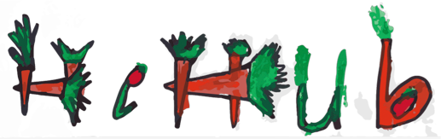
Healthy Eating
Canteen Menu: Term 3
We are open for recess and lunch on Wednesdays, Thursdays and Fridays

ALL WEEK RECESS
NOTE: not for lunch orders, counter orders only
Yoghurt | $2.50
Frozen Peas 'n' Corn cup | $1.00
Fruit of the day | $1.00
Frozen fruit cup | $1.00
Cheesey corn fritters | $1.00
Pikelets, popcorn | $0.50
Toasties | $1.00
Muffins | $0.50
ALL WEEK LUNCH
Vegie sticks – from the counter | Free
Fruit of the day | $1.00
Sausage Roll (homemade) | $4.00
Sandwiches (Ham, chicken, tuna or cheese) | $4.00
-Add salad (lettuce, tomato, carrot and cucumber) | $0.50
-Make it a wrap | $0.50
-Toast it | $0.50
Vegemite sandwich | $3.00
Honey sandwich | $3.00
Salad bowl with either chicken or tuna | $4.00
Yoghurt | $2.00
DRINKS

Milk bottle (150ml) | $1.50
Soy milk | $2.50
Smoothie (collect from canteen) | $3.00
Juice Box | $2.50
LUNCH PACKS
Toasted chicken/cheese + milk + fruit | $7.00
Toasted tuna/cheese + milk + fruit | $7.00
Toasted chicken/cheese + juice + yoghurt | $7.00
Toasted tuna/cheese + juice + yoghurt | $7.00

DAILY LUNCH SPECIALS – ALL $4.00 EACH
Monday | Tuesday | Wednesday | Thursday | Friday
Closed | Closed | Mini Quiche | Spaghetti Bolognese | Pizza  Margherita or Ham/Cheese

How do I make a lunch order?

Lunch orders are available to all children and are for lunch, lunch pack and drink items only.
They need to be received by the canteen by 9.30am.

Cash orders: should be written on a brown paper bag with your name and class, what you'd like to order and the correct money. Lunch or drinks items only please.

Online orders: Flexischools App or www.flexischools.com.au. Online orders close 9.30am on the same day as you are ordering for.

If you have a problem with your order, please call/text the manager, not the school front office.

Canteen manager: Karen 0406 937 139
naps.canteen@gmail.com

