The Gang Gang Gazette
Week 9, Term 3 (18thSeptember, 2020)
Principal: Tania Collis Deputy Principals: Rikkie Klootwijk and Sharon Moloney
School Leaders: Haeley Simms, Kate Bush, Melissa Datson and Jarryd Heywood
Board Parent Representatives: Sue Webeck, Stephen Van Gerwen and Lucy Hopkins
Board Email: napsboardreps@gmail.com
P & C President: Maree Wright napscommunity@gmail.com

Upcoming Events
5/6 Excursion To Parliament | Tuesday 22nd September
My Place Viewing and Mt Ainslie Excursion :  Group 1: 1/2 AC, 1/2YJ, 1/2LF and 1/2 KW  Group 2: CTS classes, 1/2SM and 1/2 CL | Thursday 24th September  Friday 25th September
End of Term 3 | Friday 25th Septermber
Term 4 Starts | Monday 12th October

Notes Home

- Chicken Pox (email)
Board
Next Meeting:
Tuesday, 3rd November, 6.00pm

P & C
Next Meeting:
Tuesday, 20th October
Dear families and friends,

We are almost at the end of the term and although things are still different at school, we are finding ways to come together to share our learning and be part of the NAPS Community. This week our year 6 band played for us in our courtyard on Tuesday and Thursday. It was an enjoyable experience, sitting out in the beautiful spring sunshine, listening to fantastic musicians. Thank you to Kath Bingham for putting this together so the students could have the pleasure of sharing their talents and showcasing their hard work. I was also able to attend two assemblies today, a junior and a senior one, and today I joined in with some of the classes in their rooms whilst we came together online through the Google Classroom.

I had a wonderful session on Tuesday and Thursday with our Student Leaders, Paul Barnett, Adam Shipp and Uncle Tyronne along with the representatives from the P & C and teachers to pull together all the ideas from the focus groups for our senior oval. I learnt so much more from Adam and Uncle Tyronne about this area and all its connections as well as the rich native flora and fauna and how this can be incorporated into our design. The further along we get, the more exciting the project becomes, and I cannot wait to see the final result.

Our teachers have had a wonderful term of learning as we have engaged in our own cycles of inquiry into teaching writing across the school. The rich discussions and analysis of our work has been inspiring to see as has the way in which teachers have embraced this challenge. They will continue with this cycle of inquiry and next week we are looking forward to them sharing their insights as to what has worked well for students and what they will continue to do in term 4. You may see them walking around Ainslie during recess and lunch as many of us participate in STEPtember to raise money for Cerebral Palsy by taking 10,000 steps each day over the month. It has been lots of fun, good for our physical and mental health and gratifying for us to be able to support this important cause as we head into spring. I might add, there is also some healthy competition amongst us to who has the most steps, but I believe those who are the runners are blitzing us all at the moment!!

How to turn off screen time
I often try to share interesting articles or research as I find them and one of the issues that regularly comes up is screens of all types and being online. One of these revolves around why some children are harder to get off a screen and what to do. The author of the article I came across, Anita Lehmann, had just this question and went to clinical psychologist Isabelle Filliozat for some answers. Here are some excerpts from the article.

Why is it hard for kids to stop screen time?
Have you ever had the electricity cut off just as the football game reached its most nerve-wracking stage? Or your toddler pressed the "off" switch just as the protagonists in the deeply engrossing romantic comedy were finally going to kiss?
When human beings (not only children!) are absorbed in a film or playing a computer game, we are, mentally, in another world. Screens are hypnotic to our brains. The light, the sounds, the rhythm of the images puts the brain into a state of flow. We feel good, and don't want to do anything else. We certainly don't want the situation to change. During these moments, our brains produce dopamine, a neurotransmitter which relieves stress and pain. All is well—that is, until the screen is turned off. The dopamine levels in the body drop fast and without warning, which can, literally, create a sensation of pain in the body. This drop in hormones, this physical shock, is where children's scream time begins.
It doesn't matter that we are clear when screen time ends. After all, we'd discussed and arranged it beforehand, and/or given them warning. Cutting them off forcefully is hurtful. So instead of simply switching the off button, the trick is not to cut them off, but to instead enter their zone. Here are three tips that Isabelle Filliozat recommends to turn off screen time without a fight:

1. Enter your child's world.
Whenever you decide that screen time should come to an end, take a moment to sit down next to your child and enter their world. Watch TV or sit with them while they play their game on the screen. This doesn't have to be long, half a minute is enough. Just share their experience.

2. Ask questions.
Asking, "What are you watching?" might work for some kids, others might need more specific questions. "So what level are you on now?" or "That's a funny figure there in the background. Who's he?" Generally, children love it when their parents take an interest in their world. If they are too absorbed still and don't engage, don't give up. Just sit with them a moment longer, then ask another question.

3. Build a bridge back to reality.
Once the child starts answering your questions or tells you something they have seen or done on screen, it means that they are coming out of the "cut-off" zone and back into the real world. They're coming out of the state of flow and back into a zone where they are aware of your existence—but slowly. The dopamine doesn't drop abruptly, because you've built a bridge—a bridge between where she is and where you are. You can start to communicate, and this is where the magic happens.
You can choose to start discussing with your child that it's time to eat, to go have their bath or simply that screen time is over now. Because of the minute of easing-in, your child will be in a space where they can listen and react to your request. They might even have been smoothed back into the real world gently enough, and are so happy about the parental attention that they want to turn off the TV/tablet/computer on their own.
Chickenpox
We have been sending home emails as we have had further cases of chickenpox over the last week and will continue to do so if there are any more cases. As you know, even children who have been immunised can still catch and share chickenpox, so we are constantly working with the ACT Education Directorate and ACT Health around the issue and following all of their advice and procedures. If you or your family has anyone who is immunocompromised or at greater risk to their health if they do develop chickenpox, please let us know at the front office so we can work with you and these organisations in order to provide advice and assistance.

Climate Change Action
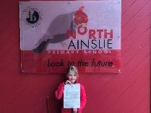
One of the tenets of the International Baccalaureate is to develop global citizens who take action and we try to do this by developing student voice. Over the last week our senior students have been working with Aidan Beiboer as to how they can be a continuing part of young voices speaking about climate change. Next Friday, they will participate in a global day of action with other students by sharing speeches and marching around the oval. Parents will not be able to attend in person due to Covid 19 restrictions. To prepare, they have met with Aidan and talked about what they can do and how they can show their support for this important issue. They are challenging you to show your support by having their post on Dojo’s School Story the most liked we have ever had. When we do the post, we would love you to ‘like’ it and, if you would like to leave them a message, we can share them next term.

One of our youngest students, Hermione from year 2, recently wrote to the Prime Minister, Scott Morrison, asking him about what Australia is doing on climate change. Today she brought in the letter she received back from him to share with us all. Well done Hermione we are very proud of you.

Have a wonderful weekend.

Tania Collis
Principal

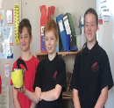
Introducing Iris the Ibis: The Green Team Mascot
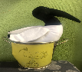
This week, the CTS (1/2SH, 1/2MR and 1/2CD) had the privilege of having Iris the Ibis the Green Team mascot in their classroom. The Green Team presented Iris the Ibis to the CTS because they had the least amount of rubbish going to landfill. Any class can have Iris in their classroom, as long as they have the least amount of rubbish going to landfill.

This is also a reminder to parents and students to reduce waste going to landfill at home and at school. Stay green and waste free!
Amelia E and Edward C (5/6JC)

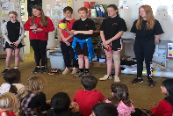

Wanted: Seedling Donations for Hehub Garden

Spring is here, and the soil is warming up! Green thumbs prepare for planting. We are seeking seedling donations for Springtime. Please drop off the seedlings to the front office or Hehub garden.

- Snow peas  - Cucumbers  - Beans  - Peas  - Radish | - Carrots  - Beetroot  - Strawberries  - Tomatoes  - Cherry tomatoes (we love!)

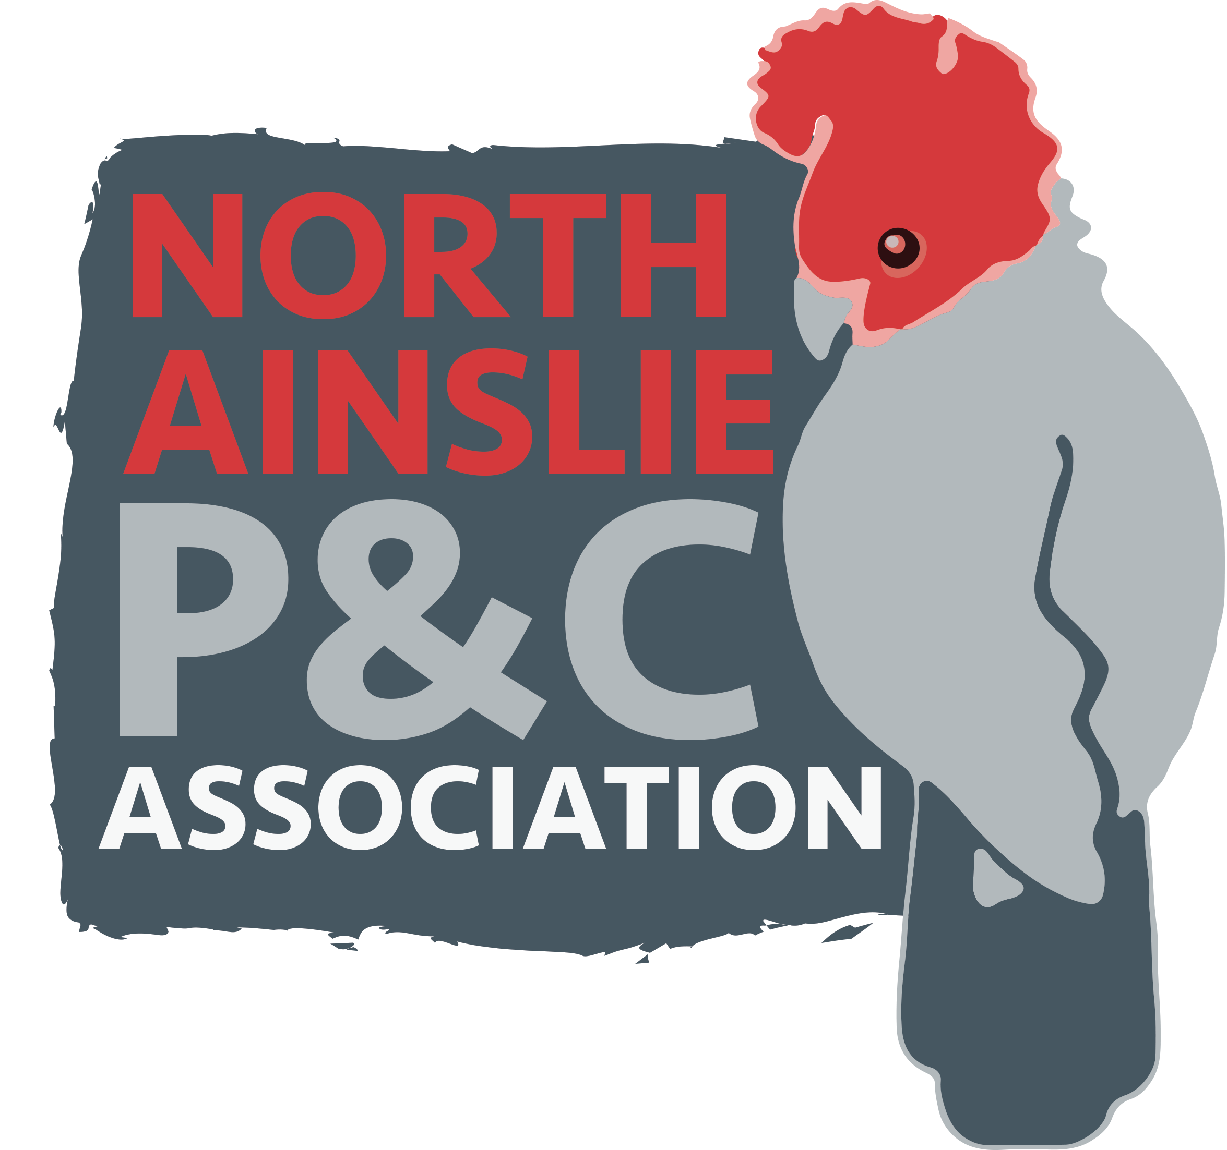
P&C News

Crazy Camel Art Fundraiser
We are full steam ahead for our end of year Crazy Camel art fundraiser. For those unfamiliar, Crazy Camel print high quality notebooks, calendars, pillowcases and other products showcasing each child's artwork. This year we are moving to online ordering so you will be able to preview your child's artwork on each product before choosing whether you wish to order.
Sarah our wonderful art teacher has been working with each child in the school to select a favourite piece to submit and we will be sending those to Crazy Camel shortly, with ordering to open at the start of term 4. All artwork will be returned and sent home at the end of year. Last year we raised over $3k for the school art program and P&C projects, and created some wonderful Christmas presents in the process! If you have any questions, please contact Fiona at napsfundraising@gmail.com

TERM 3 HEHUB CANTEEN MENU (Open Wednesday and Friday)

Healthy Eating Canteen Menu: Term 3
We are open for recess and lunch on Wednesdays, Thursdays and Fridays
ALL WEEK RECESS
NOTE: not for lunch orders, counter orders only
Yoghurt | $2.50
Frozen Peas 'n' Corn cup | $1.00
Fruit of the day | $1.00
Frozen fruit cup | $1.00
Cheesey corn fritters | $1.00
Pikelets, popcorn | $0.50
Toasties | $1.00
Muffins | $0.50
ALL WEEK LUNCH
Vegie sticks – from the counter | Free
Fruit of the day | $1.00
Sausage Roll (homemade) | $4.00
Sandwiches (Ham, chicken, tuna or cheese) | $4.00
-Add salad (lettuce, tomato, carrot and cucumber) | $0.50
-Make it a wrap | $0.50
-Toast it | $0.50
Vegemite sandwich | $3.00
Honey sandwich | $3.00
Salad bowl with either chicken or tuna | $4.00
Yoghurt | $2.00
DRINKS
Milk bottle (200ml) | $2.50
Soy milk | $2.50
Smoothie (collect from canteen) | $3.00
Juice Box | $2.50
LUNCH PACKS
Toasted chicken/cheese + milk + fruit | $7.00
Toasted tuna/cheese + milk + fruit | $7.00
Toasted chicken/cheese + juice + yoghurt | $7.00
Toasted tuna/cheese + juice + yoghurt | $7.00

DAILY LUNCH SPECIALS – ALL $4.00 EACH
Monday | Tuesday | Wednesday | Thursday | Friday
Closed | Closed | Mini Quiche | Spaghetti Bolognese | Pizza  Margherita or Ham/Cheese

How do I make a lunch order?
Lunch orders are available to all children and are for lunch, lunch pack and drink items only.
They need to be received by the canteen by 9.30am.
Cash orders: Should be written on a brown paper bag with your name and class, what you'd like to order and the correct money. Lunch or drinks items only please.
Online orders: Flexischools App or www.flexischools.com.au. Online orders close 9.30am on the same day as you are ordering for.
If you have a problem with your order, please call/text the manager, not the school front office.
Canteen manager: Karen 0406 937 139
naps.canteen@gmail.com

After School activities

