The Gang Gang Gazette
Week 6, Term 4 (22nd November, 2019)
Principal: Tania Collis Deputy Principals: Rikkie Klootwijk and Deborah Lowrey (A/g)
School Leaders: Haeley Simms, Alex Patterson (A/g) and Kate Bush (A/g)
Board Parent Representatives: Sue Webeck, Tara Pearce and Stephen Van Gerwen
Board Email: napsboardreps@gmail.com
P & C President: Jhay Mann napscommunity@gmail.com

Upcoming Events
P & C Movie Night @5.30pm | Friday 22nd November
Kindergarten Firefighter Visit | Monday 25th November
Swimming Lessons (3, 4, 5 ,6) | Week 7 and Week 8
Preschool Transition Day No 2 | Tuesday 3rd December & Thursday 5th December
Kindergarten Information Session @3:30pm | Thursday 5th December
2020 Prospective Pre-schoolers Visit @ 3:30pm | Tuesday 10th December
Year 6 Graduation Assembly @ 11:30am | Thursday 12th December
Year 6 Graduation Dinner @6pm | Thursday 12th December
Year 5/6 Disco @ 7pm | Thursday 12th December
IEC Class Graduation | Friday 13th December

Notes Home
- Year 6 yearbook order note
- Test email (email)
- End of year concert (email)
- Swimming protocol (email)
- Headlice notification (yr 3/4)
- Band notification

Board
Next Meeting:
Tuesday, 3rd December, 6.00pm

P & C
Next Meeting:
Tuesday, 3rd December, 7.30pm
Dear Families and Friends,
Tonight is a big night for our P &C with our movie night and pre-show entertainment. The night will start with Kath Bingham and her drummers showcasing their talents on the new djembes the P & C kindly donated to the school earlier this term. Our senior students will be running the side-show alley to raise funds for various charities and the school’s courtyard project. Then we will have Trolls, up on the big screen and it is all taking place on the junior oval and playground area.

Today, Sarah Buckley ran an art project where our Indigenous families came in to work with local artist Jakki Kennedy on an art project to be displayed in the school. We are lucky to have Jakki working with us and are looking forward to having parents, carers, aunties, uncles and other family members and friends come into the school to work with us. We are excited to have Aunty Jenny and Kuzi from Dickson College joining us for the day to meet our families and become part of our community here at NAPS.

This week we had our transition days. Students were able to visit classrooms and learn with teachers and students from the year above them or mentor students from the year below. I was fortunate to be part of the year 6 program and took students for some dance and had a wonderful time. Students who will be joining the school next year were able to visit us and join in classes for the morning. Thank you to our whole staff who worked hard to put these days together.

Bandstrav
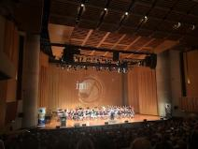
BandStaraTuesday night was Bandstrav and we were proudly represented by our year 6 band who combined with other primary school bands in our cluster to put on a wonderful performance. It is always amazing to hear all the bands come together bringing all the instruments into harmony and to see how much each and every child has grown since joining the band in year 5. The night also showcases senior bands so students can see what opportunities lay ahead if they are interested. Senior bands at high school have opportunities for all students, not only those in primary bands so if your child is not in band in primary school the music programs at high school may be the way forward for them. Well done to the band and Ms B for all your hard work over the last two years, it definitely shows. Well done to Zac O, Jade H, Alice M, Riley W and Katherine M who were part of IMP Junior Primary Concert Band. IMP Junior Primary Concert Band has students from all over the ACT who auditioned and received a place in this representative band. It was a fabulous night.

Test Email for School Reports
Earlier this week we sent home an email about reports for the second semester. Once again, we will be reporting through Sentral and the reports will be emailed home so it is important we have the correct email address for your family as they are only able to be sent to one address in this bulk email. For families who require a second report, we send a separate email to the chosen address.

The school will be sending a test email on Monday 25th November in preparation for the end of year reports which will be emailed home on Tuesday, 10th December. If you do not receive this test email, or you would like the report sent to a different email address, please contact the school by Friday 29th November by email at admin@nthainslieps.act.edu.au

Please send your email from the address you would prefer the report to be emailed to. In the subject line, please write ‘Address for Reports’. In the body of the email, please include your child’s name and current class.

If we don’t hear from you by Friday 29th November, we will presume that the test email address is correct. Thank you for your assistance.

I look forward to seeing many of you tonight. Have a great weekend.

Tania Collis

Principal

P &C NEWS
Cherries to NAPS……

Taste tested and approved! We’re bringing you some delicious cherries from Young.

2kg boxes for $27 - Go halves with a neighbour or munch the entire lot!

Martin Sullivan, a father of four, and small independant cherry farmer will be hand picking and delivering in week 9. So get your online orders in by Friday 5pm 29th November www.napspc.com.au

*Thankyou for supporting our local farmers and our school.

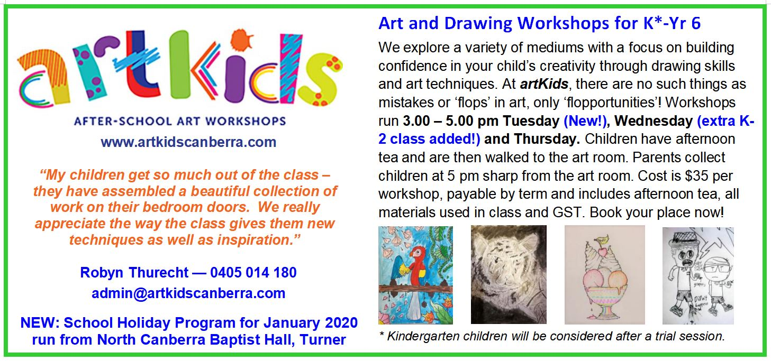

TERM 4 HEHUB CANT EEN MENU (Open Wednesday, Thursday Friday)

Recess
A selection from the following:
Frozen Peas ‘n’ corn cup $1.00 Fruit of the day / Apple slinky $0.50 / $1.00
Pikelets, Popcorn (VG) $0.50 Toasties $1.00 Frozen fruit cup $1.00 Vanilla Yogurt (V, GF) $2.00
Banana muffin (v, DF) $1.00 Cheesy Corn Fritters $0.50

Lunch
Vegie sticks Free Fruit of the day $0.50
Vegemite sandwich (VG) $2.00 Vanilla Yogurt (V, GF) $2.00
Tex Mex toasted wrap(V) $2.50 Milk bottle (150ml) $1.50
Soy milk (VG) $2.50 Tuna & cheese toasted sandwich $3.50
Smoothies $2.00 (collect from canteen) Baked Potato with Salsa+/- cheese (GF) $ 3.50
Daily Lunch Special- $3.50
Wednesday: Thursday: Friday:
Pizza(V) Chicken Burger (DF) Sushi Tuna or Veg (GF, DF

