***The Gang Gang Gazette***

*Week 4, Term 1 (1st March, 2019)*

**Principal: Tania Collis Deputy Principals: Rikkie Klootwijk and Deborah Lowrey (Acting)**

**School Leaders: Marni Payne, Kate Stear** **Alex Patterson, and Kate Bush**

**P & C President: Trudy Green**  [napscommunity@gmail.com](mailto:napscommunity@gmail.com)

**Board Parent Representatives: Amanda Galbraith, Tara Pearce** **and Sue Webeck**

**Board Email**:  [napsboardreps@gmail.com](mailto:napsboardreps@gmail.com)

## Upcoming Events

|  |  |
| --- | --- |
| 2019 | |
| Year 5/6 Oz Tag | Tuesday 5th March |
| NAPS Preschool Social Picnic | Wednesday 6th March (3.30pm - 5pm) |
| Senior Assembly hosted by 3/4TW & 3/4CW | Friday 8th March @12pm |
| Canberra Day | Monday 11th March |
| NAPS Swimming Carnival | Tuesday 12th March |
| Kindergarten water fun day | Tuesday 12th March |
| Year 5/6 Oz Tag | Wednesday 13th March |
| Junior assembly hosted by 1/2CL & 1/2KW | Friday 15th March |

|  |
| --- |
| **Notes Home**   * 5/6 Camp note * Board election (email) * Head lice notification (Preschool, 1/2 & Year 3/4 |
|  |
| **Board**  Next Meeting:  Tuesday 26th Mar 2019, 6.00pm  **P & C**  Next Meeting:  Tuesday 26th Mar 2019, 7:30pm |

**Dear Families and Friends,**

Last night we held our community welcome for 2019 with our Bush Dance in the courtyard. This is the first time we have had the Billy Tea Bush Band join the school and the feedback has been overwhelmingly positive. During the day our students were able to learn the dances. A highlight for us was all the year groups learning together. Having our older students help the junior students to learn the steps demonstrated the caring attribute which is such an important part of our culture. It also allowed the junior students a chance to get to know our older students in a fun and engaging environment.

The Bush Dance was well attended with the band commenting on the wonderful vibe and how fantastic it was to see so many families dancing and having fun together. I have been home unwell all week so was unable to attend last night but was lucky to have many pictures and videos sent through to me during the lessons in the day and the dance at night. I would like to thank the band for their wonderful leadership of the event and our P and C who provided the barbecue before the dance. Thanks also to all of you who joined us and huge thanks and appreciation to the staff of NAPS who set up and attended last night to ensure our celebration of the start of 2019 was so successful.

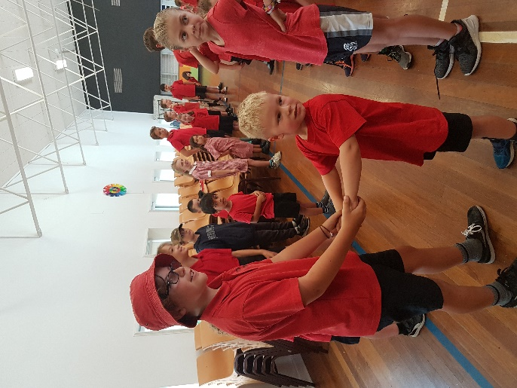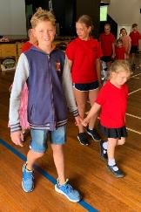

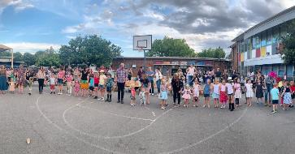

available on

Class Dojo.

More photos and videos

**Clean up Australia Day**

This year NAPS is playing its role in Clean Up Australia Day by helping to keep our school clean and tidy. Today we worked together holding an Emu Parade. Since 1992, schools across Australia have got involved and made a real difference to their environment and local communities through participating in Schools Clean Up Day. Schools Clean Up Day occurs annually on the first Friday of every March and are an important way to teach young Australians about the responsible disposal of rubbish, resource recovery and the repercussions of rubbish being dumped irresponsibly in the local environment. They assist schools by providing resources to help ensure the clean up is conducted safely and to help educate students how they and their families can help our precious environment. Thanks to Amy and Kylie our Personal and Community Health (PaCH) teachers for organising this and for sharing their learning at last night’s bush dance.

**Board Elections**

Earlier this week we sent out an email to ask you to assist the school by voting in our School Board Election for 2019. The Board meets at 6.00pm in weeks 4 and 8 of each term and is always happy for parent feedback. This year the School Board has openings for two new parent representatives and we have three nominations for those positions.  Thank you to our nominees for expressing your interest in taking on this important role. Each nominee has completed a bio which is included in our newsletter to introduce themselves to our school community. You can then also play your role by casting your vote.  Ballot papers will be available from the Front Office from 11.00am on Thursday, 28 February and voting closes on 11.00am on Thursday 7 March.  There is no electronic voting; it must be done on paper with a signed declaration.  This year’s nominees are:

* Frances Bevan
* Stephen van Gerwen
* Sue Webeck

**P and C**

The Board and P and C are our two parent bodies who make significant contributions to our school and ensure your voice is heard in our school community. Our P and C held its first meeting this week on Tuesday to set their goals for the year and have already started planning their events for 2019. They oversee the running of our canteen and uniform shop and work with the school on fundraising and purchasing of resources for students. If you would like to find out more about the P and C, please contact them directly or through our Front Office.

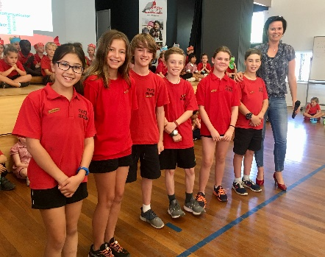**Student and Sports Leaders**

On Monday, we announced our Student Leaders for the year. Congratulations to Jade H, Amelie B, Georgia W, Hamish D, Gus W and Alex T who will represent the students for 2019. Today we held our first sporting house meetings in preparation for our upcoming Swimming Carnival and elections were held for Sports Leaders. We will announce our House Captains and Vice Captains in next week’s newsletter.

**Maintenance at school**

Over the weekend there will be some maintenance conducted on mechanical switchboards in several areas in the school. You may see workers and vans on site on Saturday and should remain clear of their worksites and follow any signage.

Have a wonderful weekend.

Tania Collis

Principal

**School travel and safety survey**

Transport Canberra and City Services has engaged First Person Consulting to conduct research into parents’ attitudes to their children's active travel to and from schools. Part of this is investigating the role that crossing supervisors have in improving safety around schools, and the extent to which parent’s attitudes to children travelling actively change as a result. You may have completed a similar survey last year. This is the final survey as part of the evaluation to gauge parent perceptions about safety around schools. To complete the survey please click [here](https://www.surveygizmo.com/s3/4828047/School-Crossing-Supervisor-Survey-Control-Feb19), or copy and paste the following link into your browser: <https://www.surveygizmo.com/s3/4828047/School-Crossing-Supervisor-Survey-Control-Feb19>

**The survey should take about five minutes. The survey will not collect any identifiable information, and all responses will be kept confidential.**  
Thank you in advance for your time in completing this survey. If you have any questions please contact the [TCCS Schools Program](mailto:TCCS.Activetravel@act.gov.au).

**Board Nominees**

***Frances Bevan***

I am asking for your vote to join the North Ainslie Primary school board because I want to keep building a school community which welcomes and supports all students and their families. As a step-parent to Fletcher (Year 2) and mum to Amelia (Preschool) and Lincoln (seven weeks) I have been impressed by the dedication and creativity of North Ainslie’s teachers, staff and P&C members and would work hard to match their efforts by representing the views of parents in important decisions. In Canberra I have worked as a public servant and ministerial adviser, currently with the Department of Prime Minister and Cabinet and previously with the Department of Foreign Affairs and Trade and the ACT Minister for Police and Emergency Services. As a manager and policy adviser I am committed to inclusive decision-making and communication and I would bring the same approach to this role. I love living in Canberra and I am glad to be raising my kids here. Joining the North Ainslie Primary School community has been a great experience for my family and I would value this opportunity to make a contribution in return.

***Sue Webeck***

My name is Sue and I am Mum to fantastic twins who are in year 3 this year. I have been on the school board for the last two years and serving as the chair of the board for the last year and have enjoyed it immensely. I hope to continue on the board to progress the strategic plan for the school alongside the first full year of implementation of the Education Directorate’s strategic plan and to support a governance response to the recently undertaken IB school review. I have 14 years experience of sitting on community sector boards and governance committees and am committed to ensuring our school executive are supported by strong and effective governance so that they have the resources and time to deliver an outstanding educative experience for our children in a great work environment. Please feel free to stop and have a chat should you have any questions, I am at drop off and pick up most days.

***Stephen van Gerwen***

I was previously a Student at North Ainslie Primary School during the 1980’s, completing Kindergarten to sixth grade. This has started a long relationship with the school with other generations if my family reaping the benefits of a North Ainslie education. My daughter, now in high school attended the school and I have a son in grade five and twins in grade one. This will see a van Gerwen at the school for another six years. I have been a Board Member of Lyneham High School and Board Chair for the past two years. I have been privileged to be part of the selection panel that chose the new Lyneham High School Principal, an experience that provided great insight into the functioning of schools and the Directorate. North Ainslie has a strong reputation within the community and is a desired school for many Students. The School Board is strategically placed to work with Tania Collis and her executive to continue the work already being undertaken and to help drive the school to new heights. As a nominating parent, I can bring my previous experience within school boards and as a parent of six children to provide input to the North Ainslie Primary School Board. An opportunity I would relish given my previous experience as a Student and now as a Parent.

**Healthy Eating Hub LogoTERM 1 HEHUB CANTEEN MENU (Open Wednesday, Thursday Friday)**

**Recess**

A selection from the following:

Frozen Peas ‘n’ corn cup $1.00 Fruit of the day / Apple slinky $0.50 / $1.00

Pikelets, Popcorn (VG) $0.50 Toasties $1.00 Frozen fruit cup $1.00 Vanilla Yogurt (V, GF) $2.00

Banana muffin (v, DF) $1.00 Cheesy Corn Fritters $0.50

**Lunch**

Vegie sticks Free Fruit of the day $0.50

Vegemite sandwich (VG) $2.00 Vanilla Yogurt (V, GF) $2.00

Tex Mex toasted wrap(V) $2.50 Milk bottle (150ml) $1.50

Soy milk (VG) $2.50 Tuna & cheese toasted sandwich $3.50

Smoothies $2.00 (collect from canteen)

**Daily Lunch Special- $3.50**

**Wednesday: Thursday: Friday:**

*Pizza(V) Italian chicken toasted sandwich (DF) Veg Sushi (VG),*

*Tuna Sushi (GF)*

## After school activities

***Dickson Pi memorising competition***

***Dickson Pi***

***Memorising***

***Competition***

**When?**

Thursday 14th of March starting at 3:09pm. (3rd month, 14th day, 15th hour, 9th minute, 26th second) Students from other schools can keep rolling in until 4:15.

**Who?**

Categories are Primary, High School, College and Open, so your Mum can enter.

**Entry Cost?**

Free

**Prizes?**

Yes –A novelty die for 10 digits. Pi bookmarks for 30 digits. Various prizes for 50 digits. Scarves and more for winners in each category who are above 100 digits.

**Food?**

Feel free to bring a plate of circular food to share for afternoon tea (optional).

**Permission notes?**

Available at the North Ainslie Front Office

**Questions?**

E-mail: caroline.evers@ed.act.edu.au