***The Gang Gang Gazette***

*Week 5, Term 1 (6th March 2020)*

Principal: Tania Collis Deputy Principals: Rikkie Klootwijk and Sharon Moloney

School Leaders: Haeley Simms, Kate Bush (Acting), Melissa Datson (Acting)and Jarryd H(Acting)

Board Parent Representatives: Sue Webeck, Tara Pearce and Stephen Van Gerwen

Board Email:  [napsboardreps@gmail.com](mailto:napsboardreps@gmail.com)

P & C President: Maree Wright [napscommunity@gmail.com](mailto:napscommunity@gmail.com)

## Upcoming Events

|  |  |
| --- | --- |
| Canberra Day | Monday 9th March |
| National Ride2School Day | Friday 13th March @ 8.15am |
| Senior assembly hosted by 5/6MD & 5/6AP | Friday 13th March @12.00pm |
| Fiesta | Saturday March 14th, 3pm-7pm, on the Junior Oval |
| Nutrition Magician Preschool visit | Tuesday 17th March & Friday 20Th March |
| Junior assembly hosted by 1/2KW & 1/2 LF | Friday 20th March |
| Harmony Day | Friday 20th March |
| Preschool Bus Wash Excursion | Tuesday 24th March & Thursday 26th March |

|  |
| --- |
| **Notes Home**   * Student Information Check Sheet * Year 6 Polo Shirt note |
|  |
| **Board**  Next Meeting:  Tuesday, 24th March: 6.00pm  **P & C**  Next Meeting:  Tuesday, 24th March: 7.30pm |

**Dear Families and Friends,**

This morning I couldn’t help but smile with delight looking at my green garden as I left for work and certainly hope our gardens here at NAPS also start to green up from the recent rain. Our HeHUB should also produce some wonderful autumn food for us in the next few months. The rain has done wonders for our territory and the surrounding regions after the months of dry weather and fires. I want to extend a thank you to all students and teachers and the principled way they coped with being “inside” on the consecutive wet weather days.

**Staffing News**

We are also excited to announce three new staff members. Aidan Beiboer will be taking over Michael Vitek’s class and they will be team teaching together next week to ensure a comprehensive hand over. We would like to thank Mr Vitek for stepping in at the very last minute to take this class. He has expressed to me this morning how much he will miss every single student and we are lucky he will be remaining at NAPS as inbuilt relief so he will be able to catch up with the students from his class regularly.

Sargam Malhotra will be starting as inbuilt relief and getting to know Alex Patterson’s class. When Alex goes on maternity leave in term 2, Sargam will take over the class. Until this time, she will also take Melissa Datson’s class one day a week for her School Leader C release. Danielle Sturgeon will be working two days a week and taking Mr Heywood and Mrs Datson’s class while they complete their School Leader C duties.

**Leadership Team**

I would like to take this opportunity to introduce the leadership team at North Ainslie and congratulate Melissa, Jarryd and Kate on winning the acting positions.

* Principal – Tania Collis
* Deputy Principal (Junior school) – Sharon Moloney
* Deputy Principal (Senior school) – Rikkie Klootwijk
* School leader C – Haeley Simms
* School Leader C- Jarryd Heywood
* School Leader C – Kate Bush
* School Leader C – Melissa Datson

**Individual Learning Plans**

If your child has an Individual Learning Plan (ILP), we will be running meetings for these in the coming weeks of this term. We feel it is important for the new class teacher to get to know your child, their interests and academic needs before developing new short-term goals. The current ILP has been given to their teacher and the Leadership Team has met with them to discuss individual needs. We will be sending out invitations to ILP meetings early next week.

**Kindergarten Learning**

After being at school for 5 weeks, some kindy students wanted to share some learning they have been doing with our school community. I’m sure the following will put a smile on your face!

***Dulcie*** – *I’ve been learning about letters. I know lots of letters now and I’m starting to do a little bit of writing. The best thing about kindy is that all my friends from preschool are in my class.*

***Summer*** *– I’ve been learning that we are all different and that it’s okay to be different. What makes me different is that I have 1 baby sister and she’s very cute and cheeky because she always hides from me. The best thing about being in kindy is learning. I’ve also made lots of “big” friends in the school because I go to before school care.*

***Eliza*** *– I’ve been learning about who we are. I’ve learnt we are all different and special. I’m special because I have a cat. His name is Obby and he is brown, white and orange. I love him. I also have a dog called Poncho. Poncho and Obby are very good friends.*

***Matilda*** *– I’ve been learning about letters. I’ve learnt how to write them and I’ve also been learning how to count backwards to 1. We have been learning about who we are. I’m special because one of my feet is bigger than the other!*

***Deacon*** *– I’ve been learning about letters and that letters all make different sounds. Our unit of inquiry is about who we are and I’m special because I can write my own name and I can do cool tricks on monkey bars. I’m also very good at counting to 50.*

***Oscar*** *– I’ve been learning about numbers. I can count all the way to 100. I’m very special because I can spin around on one foot on a hoola hoop without falling over. The best thing about being in kindy is we get to learn and play.*

***Maisie*** *– I’ve been learning about words. I have learnt what a sentence is. I can write ”I see a very hungry caterpillar.” In who we are we have been learning about how we are all different. I’m different because I have blonde and my baby brother is really cute. Another thing that makes me special is I have a dog called Billy. I love Billy.*

**Sports and Green Team Leaders**

Last week we made a mistake we announced the names of some our year 6 leader roles. Apologies to those students whose names we got wrong. Congratulations to all of our leaders.

* **Kingfishers: Joe L, Uli H, Violet B and Jasmine M**
* **Cockatoos: Jem P, Thomas V, Isla F and Lekky W**
* **Rosellas: Louis W, Jay M, Sienna l and Radha T F**
* **Parrots: Asher C, Mathias L, Eloise H and Matilda V B**
* Green Team: **Lulu S, Amara H, Ed C and Peter H**

## ****PYP Explained!****

Each fortnight I will be explaining some of the beliefs, values, vocabulary and terms which underpin the Primary Years Program. If there are certain things you would like explained or clarified about the PYP please email me and I will be sure to cover it in the PYP Explained section of our newsletter.

**What is the Primary Years Program (PYP)?**

Designed for students age 3-12, the IB Primary Years Programme (PYP) provides the knowledge, concepts, skills personal attributes and the capacity to take action, all of which younger students need to equip them for successful lives, both now and in the future. Learning through inquiry, a child’s investigations across and beyond subject areas will strengthen knowledge and understanding as they explore global, topical and relevant ‘big picture’ questions, or transdisciplinary themes.

##### **Student-centred learning**

The PYP provides an ideal foundation for children to become successful, lifelong learners by developing their:

* social and emotional well-being
* independence, as they take responsibility for their own learning
* international mindedness
* understanding of the world and their ability to function effectively within it
* attitudes and dispositions for learning
* ability to take mindful, appropriate and sustainable student-initiated action
* language skills; all students study an additional language from at least 7 years of age.

Learning in the PYP is underpinned by six transdisciplinary themes, each selected for their relevance to the real world. Young learners explore the commonalities of human experience by investigating these themes through a programme of inquiry.

###### **Who we are**

Inquiry into the nature of the self; beliefs and values; person, physical, mental, social and spiritual health; and human relationships.

###### **Where we are in place and time**

Inquiry into our orientation in place and time; personal histories; the discoveries and explorations of humankind; and the interconnectedness of individuals and civilizations.

###### **How we express ourselves**

Inquiry into the ways in which we discover and express ideas, feelings, nature, culture, beliefs and values.

###### **How the world works**

Inquiry into the natural world and its laws, the interaction between the natural world and human societies; the impact of scientific and technological advances on society and on the environment.

###### **How we organise ourselves**

Inquiry into the interconnectedness of human-made systems and communities; the structure and function of organisations; and their impact on humankind and the environment.

###### **Sharing the planet**

Inquiry into rights and responsibilities in the struggle to share finite resources with other people and other living things; access to equal opportunities; and peace and conflict resolution.

**IB Mission Statement**

The International Baccalaureate aims to develop inquiring, knowledgeable and caring young people who help to create a better and more peaceful world through intercultural understanding and respect.

To this end the organisation works with schools, governments and international organisations to develop challenging programmes of international education and rigorous assessment.

These programmes encourage students across the world to become active, compassionate and lifelong learners who understand that other people, with their differences, can also be right.

**North Ainslie Primary School Mission Statement**

North Ainslie Primary School, as a member of the International Baccalaureate Organisation, aims to develop inquiring, knowledgeable and caring young people who take positive action in the world.

Our school is a centre of learning where effort and achievement are celebrated and diversity is embraced within a restorative, respectful and friendly environment.

The heart of the local community, NAPS instils a passion for lifelong learning, enabling all students to be the best they can be as they confidently look to the future.

Next Fortnight’s PYP Explained section of the newsletter will focus on transdisciplinary learning and the learner profile

**Rikkie Klootwijk (Deputy Principal)**

**SAFETY OF STUDENTS**

Please keep the safety of our students in mind when driving around our school. This week there was a close call at a pedestrian crossing near our school involving a North Ainslie student. Please remind your children to look before crossing at a green pedestrian light as motorists don’t always do the right thing. This leads on to safety in our car park area.

**Think before you park…and keep our kids safe!**

With school now back for the year we are encouraging all parents to make parking safety a priority!

This means:

• keep clear of ‘no stopping’ and ‘no parking’ zones

• don’t park in bus zones, on school crossings, across footpaths or driveways; and

• don’t double (or triple) park!

Remember - it’s okay to park a little further away from the school and walk the rest of the way!

**Consider** - having a pre-determined meeting spot agreed with your kids. That way if you are a little late, they know where to wait.

**Think** - visibility around schools and if your car may be blocking the view of crossings for other motorists. Also be mindful when entering or leaving parking spots – look twice!

**Be kind** - to other road users and pedestrians and also if you see any parking officers in the area – they are doing their job and working to keep our kids safe!

**Note** - Licence Plate Recognition (or electronic chalking) vans are now actively monitoring schools. Penalties range from $114 upwards to $600. Details at www.act.gov.au/accessCBR

**[Image result for ride and walk to school logo](http://www.google.com/url?sa=i&rct=j&q=&esrc=s&source=images&cd=&ved=0ahUKEwjNvf2VusPSAhXFl5QKHehCBoAQjRwIBw&url=http://www.ipecs.act.edu.au/our_community/ride_or_walk_to_school&psig=AFQjCNHjOoIekMfTi_SBSbCr0dYyYCRZzg&ust=1488943836079757)**

**National Ride To school Day- Friday 13th March**  
It’s National Ride to School Day. Walk or ride to school on bikes, scooters, skateboards, rollerblades, roller shoes, anything with wheels that gets you moving. We are holding this national event to encourage students to become more active as part of a healthy lifestyle.

**The P&C will be running a BBQ with bacon and egg rolls for $5 between 8:00-9:00am on the Senior Oval**

Come have breakfast with your family, pick up a piece of fruit and check in at the safety station where volunteers will be checking gear. Please remember you must wear your helmet, obey road rules and ride safely.

*As it is National Ride2School Day, the Adventure Track will be open in the morning from 8.15am during which time teachers will be on duty. Get your bacon and egg roll and then take a spin around the track.*

***Students in all year levels will be participating in bike activities throughout the day. Decorate your bikes, scooters or if you are a walker, yourself. It’s Friday the 13th – Freaky Friday!***

**Kindy and 1/2 Students please leave bikes and scooters at the junior bike racks behind the library**

**3/4 and 5/6 Students please leave bikes and scooters in the senior bike cage**

Kindergarten - 12:00- 12:45pm bike, scooter, walker parade - Library courtyard

1/2 Students - 9:30-10:30 am bike, scooter, walker parade - Senior Courtyard

3/4 Students - 11:45 – 12:45pm bike games -Senior oval

5/6 Students – 1:45 – 2:45pm bike games - Senior oval

Several bike shops have kindly donated items to be given out as prizes.

**Parent volunteers are needed to help with cutting fruit and the safety check of bikes on the day –** Please see the front office or Rachel Levinson

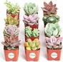**Succulents in Teacups**        
At Fiesta, our fabulous PACH team will be running a Succulent in Teacups stall. We are seeking donations of succulent cuttings and any tiny figurines that your children no longer play with.

Please drop off all donations to the Front Office. For more information email Amy or Kylie. [amy.pepper@ed.act.edu.au](mailto:amy.pepper@ed.act.edu.au)  [kylie.giltrap@ed.act.edu.au](mailto:kylie.giltrap@ed.act.edu.au)

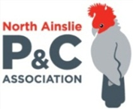**P &C NEWS**

**FIESTA 2020 - Volunteers Still Needed**

Fiesta 2020 is coming up very very soon and we still need your help to make it amazing.

Please spare us a couple of hours of your time on Saturday 14th March - there are still plenty of jobs to choose from.

Sign up here: <https://www.volunteersignup.org/RWCHH>

We also need rice cookers and slow cookers - if you can lend us yours for the night please leave at the front office on Friday 13th March (with your name and number for return)

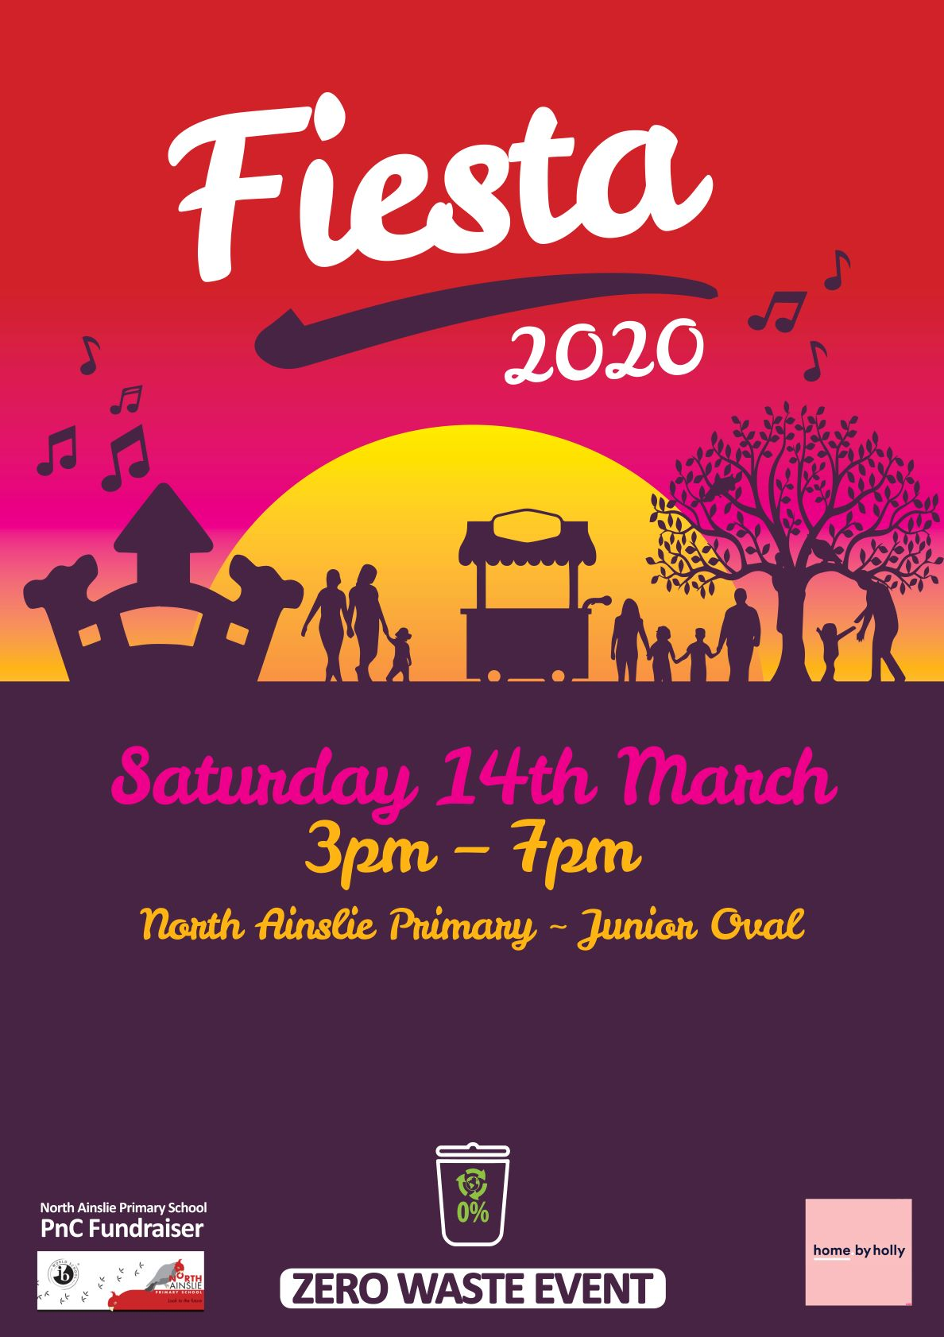

Uniform store

**Healthy Eating Hub LogoTERM 1 HEHUB CANTEEN MENU (Open Wednesday, Thursday Friday)**

**Recess**

A selection from the following:

Frozen Peas ‘n’ corn cup $1.00 Fruit of the day / Apple slinky $0.50 / $1.00

Pikelets, Popcorn (VG) $0.50 Toasties $1.00 Frozen fruit cup $1.00 Vanilla Yogurt (V,GF) $2.00

Banana muffin (v, DF) $1.00 Cheesy Corn Fritters $0.50

**Lunch**

Vegie sticks Free Fruit of the day $0.50

Vegemite sandwich (VG) $2.00 Vanilla Yogurt (V,GF) $2.00

Tex Mex toasted wrap(V) $2.50 Milk bottle (150ml) $1.50

Soy milk (VG) $2.50 Tuna & cheese toasted sandwich $3.50

Smoothies $2.00 (collect from canteen)

**Daily Lunch Special- $3.50**

**Wednesday: Thursday: Friday:**

*Pizza(V)* Italian chicken toasted sandwich (DF) *Veg Sushi(VG),*

*Tuna Sushi (GF*

**After School Activities**

