***The Gang Gang Gazette***

*Week 6, Term 3 (30th August, 2019)*

Principal: Tania Collis Deputy Principals: Rikkie Klootwijk and Deborah Lowrey (A/g)

School Leaders: Marni Payne, Kate Stear, Alex Patterson (A/g) and Kate Bush (A/g)

Board Parent Representatives: Sue Webeck, Tara Pearce and Stephen Van Gerwen

Board Email:  [napsboardreps@gmail.com](mailto:napsboardreps@gmail.com)

P & C President: Jhay Mann [napscommunity@gmail.com](mailto:napscommunity@gmail.com)

## Upcoming Events

|  |  |
| --- | --- |
| School Photos | Wednesday 4th September & Thursday 5th September |
| Preschool Photos | Tuesday 3rd September & Thursday 5th September |
| Preschool Arboretum Excursion | Monday 2nd September & Friday 6th September |
| Junior assembly hosted by 1/2CL & 1/2KW | Friday 6th September@ 12 pm |
| Junior assembly hosted by KSM & KGM | Friday 13th September @ 12pm |
| Year 5 & 6 Bandfest ANU school of Music | Friday 13th September |

|  |
| --- |
| **Notes Home**   * 5/6 Bandfest (note) * 3/4 Equipment for UOI (email) * Influenza Information (email) * Satisfaction Survey Reminder (email) |
|  |
| **Board**  Next Meeting:  Tuesday 10th September, 6.00 pm  **P & C**  Next Meeting:  Tuesday, 10th September, 7.30pm |

**Dear Families and Friends,**

We had a wonderful start to the week with our Book Week Parade on Monday morning. We all had so much fun watching our students and staff share their passion for books and their characters as they paraded on the courtyard. Thanks to all our families for putting so much effort into preparing the costumes for the day. Thanks also to Rebecca Cameron for organising and hosting the event. Her love of, and knowledge about books was certainly contagious. Yesterday we were awarded our five-star accreditation from ACTsmart to acknowledge the work of many people over many years in promoting sustainability and looking after our environment here at NAPS. To learn more, you can read the full story from our Green Team below. Thanks to Amy, Kylie and Rachel for the work over the last three years as our PACH teachers leading the way for all of us.

Today we had over 30 students representing North Ainslie at the North Gungahlin Athletics Carnival. Thank you to Jarryd Heywood who organised our students and supported them at the carnival. We also had our chess team representing us at the Open Primary Championship final at Wanniassa. Well done to the boys who made it to this second level of competition and thanks to Yara Jerious who runs our lunchtime chess club and Rainer Reuss for training our team. It’s also been a busy week for our P and C who ran our Father’s Day Stall on Tuesday and who are hosting our 80’s Trivia Night tonight. Their continued support of our school through fundraising and holding community building events is much appreciated and valued.

Today was Wear It Purple Day and it was lovely to see so many students wearing purple to support rainbow children at our school and all over the world. I would also like to wish the best of luck to our students competing in the ACT TOMS Competition at Campbell High School on Sunday. Thanks to Amanda Collins who has spent many lunchtimes preparing them for the competition.

As someone who spends at least an hour a day in the car travelling to and from school, I enjoy listening to a range of podcasts. They are becoming more and more popular and this has led to a greater range of podcasts being made for children. After doing some research, here are some you might be interested in trying for your family. Happy listening!

[***KiDNuZ***](https://kidnuz.com/)

*Created by 4 Emmy winning journalists, KidNuz is a daily 5-minute news podcast made for kids. The podcast provides briefings on the day’s top stories that are appropriate for kids (8-14) with unbiased and nonpartisan reporting.*

[***Story Pirates***](https://itunes.apple.com/us/podcast/story-pirates-podcast/id719585944?mt=2)

Story Pirates*is a captivating audio show by real actors, comedians, and entertainers who tell stories that have been written by kids. With episodes like "Eat a Spider Day" and "Princess Lifeguard Camp," the silliness and imaginative tales will keep kids entranced.*

[***Little Stories for Tiny People***](http://www.littlestoriestinypeople.com/)

*This series is a great way to test out your kids' interest in podcasts, since most of the stories hover around the 10-minute mark. Some are shorter, some are longer, but all are original stories that primarily feature whimsical tales about animals.*

[***Peace Out***](https://bedtime.fm/peaceout)

*Speaking of bedtime the series of podcasts from*Peace Out*comes close. These calming stories teach mindfulness and meditation, and are a perfect introduction to cultivating this life-long skill.*

[***What If World***](http://www.whatifworldpodcast.com/episodes/)

*This clever podcast is designed to ease the burden for parents who get asked hard-hitting questions like, "What if cars could talk?" and “What if it rained candy?" For a moment in time,*What If World*makes these questions a reality, and describes what these worlds would be like in vivid, imaginative detail.*

[***But Why: A Podcast for Curious Kids***](http://www.vpr.net/apps/podcasts/but-why-a-podcast-for-curious-kids)

*For the ever-curious kids who ponder our existence, this podcast answers questions that are based in reality. Topics like how butterflies fly, why the sea is salty, and the universal question on why the sky is blue are all featured.*

[***Spare the Rock Spoil the Child***](http://sparetherock.com/wordpress/)

*For a fresh and upbeat compilation of songs that will appeal to young and old(er), this podcast/audio stream is a great way to introduce music from your generation. There are familiar kids' tunes, mixed in with favourites from groups like*They Might Be Giants*, for a continuous playlist that everyone will bee bop to.*

[***Sesame Street***](https://itunes.apple.com/us/podcast/sesame-street-podcast/id264537349?mt=2)

*The* Sesame Street *podcast features the adorable characters your kids know and love, including Elmo, Abby, Cookie Monster, and the newest character, Julia. Fun stories, songs, and ABC activities with their familiar friends will keep the love for the Sesame crew going when the TV is off.*

[***Brains On!***](http://www.brainson.org/)

*Families can explore scientific concepts together like the recent slime craze, how elevators work, and life on other planets. What's cool is that each episode is co-hosted by a different kid, who gives a unique perspective on these topics and makes it fun for fellow kids to listen to.*

[***Five Minutes with Dad***](http://fiveminuteswithdad.com/podcast-episodes/)

*This sweet podcast series stars a dad and his two young kids and features genuine conversations between the three of them about everyday things like courage, kindness, how to show love, and being a good sport. This authentic podcast lets its audience listen in to teachable moments and how a caring dad interacts with his kids.*

[***Wow in the World***](http://www.npr.org/podcasts/510321/wow-in-the-world)

*This series will help kids discover worldly things, how things work, why things are the way they are, and so much more. One of the first questions explored in the series, "How do astronauts poop in space?" is sure to be a hit with your kids. Anything poop-related, right?*

[***Short and Curly***](https://itunes.apple.com/us/podcast/short-and-curly/id1093699006?mt=2)

*A podcast idea that masks entertaining content with underlying ethical questions is a brilliant way to engage in discussions with your kids. From serious questions like "Is it ever OK to lie?" to sillier ones like "Should you move to Mars?", Short and Curly makes kids think about decisions based on what they know (and are learning) to be wrong and right.*

**School Photos**

This week we had our whole school photo for 2019 taken in front of our Adventure Track and next week will see three days for the rest of our photos for the year. On Tuesday, photos will be taken for both beginning of the week preschool classes, kindergarten to year 3/4, our IEC and the LSUA. On Wednesday, it will be our 5/6 classes and our bands, student and sports leaders and our year 6 photos. Thursday will be our end of the week preschool classes. Sibling photos will be taken at recess and lunch over the three days. If you have any other questions, please contact our front office.

**2019 School Satisfaction Surveys**

Thank you to everyone who has completed this year’s School Satisfaction Surveys. If you have not yet had the opportunity to do so, we would appreciate you providing us with this important feedback. The survey closes on Monday night.

I may see you tonight at the Trivia Night and have a great weekend.

Tania Collis (Principal)

Drop off your containers and help us raise funds

**NAPS 5 Star Sustainability Accreditation and the Container Deposit Scheme**

This week NAPS received a five-star accreditation from ACTsmart in recognition of our work to promote sustainability knowledge and practises. To celebrate this fantastic achievement, Ros Malouf, the Senior Director of Sustainability Programs, and Olivia Merrick, the Manager of Actsmart Schools, presented us with 5 fruit trees. These trees will be planted in the Hehub garden for students to enjoy for many years to come!

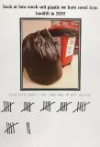Some examples of the action we take at NAPS to promote sustainability include:

·      composting food scraps in the Hehub garden;

·      recycling paper and plastics;

·      our soft plastic recycling system has saved 32 giant garbage bags of soft plastic going to landfill this year so far;

·      Units of Inquiry that focus on sustainability and how we share the planet;

·       Personal and Community Health (PACH) program where students participate in gardening, cooking fresh food and sustainability classes, and;

·      our Sustainability Fair won the Biggest Recycler, Small Event Award at the ACTsmart Business Sustainability Awards this year!

But we don’t want to stop there!

**We are launching the Container Deposit Scheme (CDS) at NAPS.**

From next week you will be able to drop off your poppas, cans, glass bottles and water bottles. Containers need to have the 10c logo to be eligible. 4 yellow bins will be located in the small courtyard near the new bike rack and there will be a bin for each type of container. Simply place your clean containers in the correct bin to help our school raise money and recycle.

To continue with our efforts promoting student agency, we are seeking families to help us return the containers for cash. A roster of people will help us deliver the containers to the drop off points and money raised will all go back into the HeHub garden!

Olivia Merrick, the manager of Actsmart Schools and Tracey Bool, Horticultural Consulutant and Garden Writer presented our school with five new fruit trees this week. Olive, lime, mulberry, kaffir lime and fig are the new additions to our Hehub. Thank you to Sophea C, Amelia B, Mirrin G-M, Lulu S, Skye M and Amara H for accepting the gift on behalf of the school and being fantastic communicators! Well done to all!

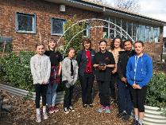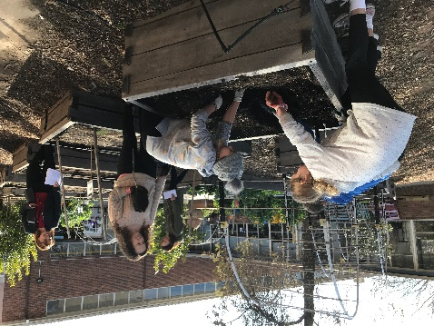

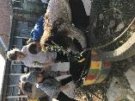

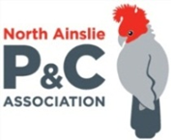**P &C NEWS**

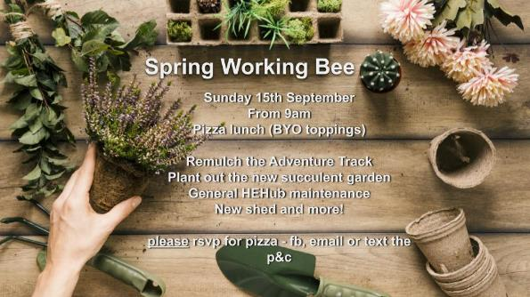

## Healthy Eating Hub LogoTERM 3 HEHUB CANTEEN MENU (Open Wednesday, Thursday Friday)

**Recess**

A selection from the following:

Frozen Peas ‘n’ corn cup $1.00 Fruit of the day / Apple slinky $0.50 / $1.00

Pikelets, Popcorn (VG) $0.50 Toasties $1.00 Frozen fruit cup $1.00 Vanilla Yogurt (V, GF) $2.00

Banana muffin (v, DF) $1.00 Cheesy Corn Fritters $0.50

**Lunch**

Vegie sticks Free Fruit of the day $0.50

Vegemite sandwich (VG) $2.00 Vanilla Yogurt (V, GF) $2.00

Tex Mex toasted wrap(V) $2.50 Milk bottle (150ml) $1.50

Soy milk (VG) $2.50 Tuna & cheese toasted sandwich $3.50

Smoothies $2.00 (collect from canteen) Baked Potato with Salsa+/- cheese (GF) $ 3.50

**Daily Lunch Special- $3.50**

**Wednesday: Thursday: Friday:**

*Pizza(V) Italian chicken toasted sandwich (DF) Pasta beef bolognaise (DF)*