***The Gang Gang Gazette***

*Week 9, Term 2 (28th June, 2019)*

**Principal: Tania Collis Deputy Principals: Rikkie Klootwijk and Deborah Lowrey (Acting)**

**School Leaders: Marni Payne, Kate Stear,** **Alex Patterson and Kate Bush**

**P & C President: Jhay Mann** [napscommunity@gmail.com](mailto:napscommunity@gmail.com)

**Board Parent Representatives: Sue Webeck, Tara Pearce and Stephen Van Gerwen**

**Board Email**:  [napsboardreps@gmail.com](mailto:napsboardreps@gmail.com)

## Upcoming Events

|  |  |
| --- | --- |
| Parent Interviews | Week 10 |
| Term 2 Ends | Friday 5th July |
| Term 3 Starts | Monday 22nd July |

|  |
| --- |
| **Notes Home**   * Semester 1 Reports * P & C Canteen email * Head Lice notification (Yr 3/4 & 5/6) |
|  |
| **Board**  Next Meeting:  Tuesday 13th August 2019, 6.00 pm  **P & C**  Next Meeting:  Wednesday 13th August 2019, 7.30 pm |

**Dear Families and Friends,**

This week our semester 1 reports(kindergarten to year 6) were emailed home to families yesterday. In preschool and our Introductory English Classes, they were given to families by teachers. Thank you to our staff for the amazing effort that has gone into producing them as our teachers and front office staff navigated the new template and system of sending home reports via email. If you have not received the report for your child, please contact the front office. Next week we will be holding our parent/teacher interviews so please ensure you have booked a time if you would like to speak to your child’s teacher.

Last year I began a journey with principals from the ACT Public School System on developing our understanding of Indigenous Culture and Perspectives. Over the last 18 months I have had three amazing days with Indigenous leaders who have shared their experiences and knowledge with great generosity. Many of our teachers have joined me on this journey and two have been rewarded with very special scholarships. I would like to congratulate Sarah Buckley who is part of the Bundian Way Arts Exchange (BWAE) Field Program and participated in her first two days this week. The program is a creative project which focuses on building positive reciprocal relationships between the Canberra community and local regional Indigenous and non-indigenous communities. The BWAE features learning events in Canberra and a field program visiting areas along the Bundian Way which is a shared historic pathway used by Aboriginal people for tens of thousands of years, linking Mount Kosciusko with Twofold Bay on the Far South Coast of NSW. The Bundian Way Arts Exchange is a 2-year cultural exchange project initiated by the ANU School of Art & Design and supported by ArtsACT. Meredith Regan has won the AEU Scholarship to attend the annual Garma Festival of Traditional Cultures in August. The Garma brings together business and political leaders, academics and journalists to discuss the issues that face Australia. It incorporates visual arts, dance and ancient storytelling to provide ways to strengthen the preservation of Indigenous culture. I know that Sarah and Meredith will bring back their new understandings to share with the school and consequently transferred into our students’ learning.

**PJ Day for Asthma**

Don’t forget our term 2 fundraiser raising money for the Asthma Foundation through a PJ Day on the last day of school, Friday, July 5. Students can wear their pyjamas and bring in a gold donation which will go towards asthma education and research. Student leaders will collect the money and share how much we raised for this important cause.

**Michael Grose**

In 2017, we were lucky enough to be part of three schools who were able to attend an evening with Michael Grose as he spoke to us about raising independent children. Michael shared insights and ideas that I know many of our parents found helpful and they enjoyed being able to ask him questions directly. He is visiting Canberra again with Dr Jodi Richardson as they are co-authors of a new book, *Anxious Kids: how children can turn their anxiety into resilience*. They will be holding a seminar in Canberra at the Hellenic Club on 30 July. The seminar is $39.95 and is from 7pm-9pm and is aimed at parents, teachers, and any other professional who work with children. For more information you can see the links at the parenting ideas website. <https://www.parentingideas.com.au/parent-resources/seminars/anxious-kids-seminar-tour>

**New books in the library**

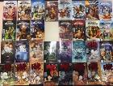We are very lucky to have our librarian, Rebecca, working hard as she aims to make our library better than ever. She is currently going through all our resources and thinking of ways to display and share them all to the best of their advantage. Watch the library space over the rest of the year to see what fabulous ideas we will be putting into practice.

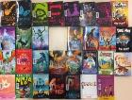Rebecca has also been looking at borrowing records to see what the most popular books and series are, and she has been listening to our students. She is excited to announce that a large selection of new books have been placed on the shelves in the library. The chapter books were chosen from Book Club by some of our 3/4 and 5/6 classes late last term with the graphic novels being requested by some of our individual, avid readers. Some of the great titles include Songbird, Sherlock Holmes and books by Jane Austen. Series include those from Wings of Fire and Avatar.

Happy reading and I look forward to seeing many of you next week during our interviews.

Have a great weekend.

Tania Collis

(Principal)

## PACH News

Students in Personal and Community Health (PACH) continued learning about healthy food choices this week. Students are learning about the environmental and health benefits of eating seasonally.

Why buy seasonal fruit and vegetables?

* Fresh produce from your region doesn’t need to travel weeks across the country getting to you, meaning it can be picked for taste, not transport.
* Fruits and vegetables start to lose nutrients immediately after they are harvested, so the freshest produce is the best produce.
* Local produce travels less and needs less refrigeration, meaning less fossil fuel and fewer greenhouse gases.
* Shopping at markets connects us with the people that live around us and supports the local farmers that grow our food.

And guess what? Oranges are in season! So we got juicing...Lots of sticky fun!!!

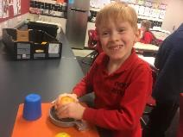 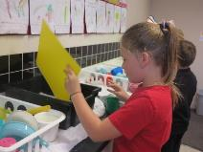 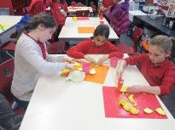

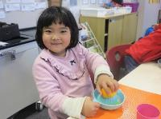 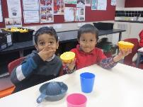 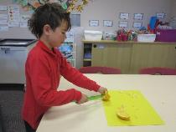

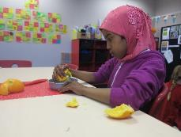

Seasonal Food guide

Seasonal Food Guide

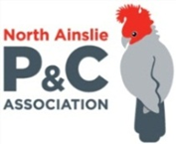

**P &C NEWS**

**Canteen volunteers needed**

The P&C Association supports the canteen at NAPS to provide a valuable service which offers healthy and delicious meals to our students. To provide this service, we employ a part-time canteen manager and rely on volunteers to help them prepare and serve food to the students. Without volunteers the job can be very difficult so we are looking for more help from our parents and carers.

If you have an hour or two to spare on a Wednesday, Thursday or Friday morning, we could really use your help in the canteen. Email [naps.canteen@gmail.com](mailto:naps.canteen@gmail.com) or drop by to see Karen or Heather on these days between 9am and 2pm. Volunteers get morning tea and a cuppa, and your child will also receive a free smoothie or lunch on the days you volunteer!

We particularly need extra Wednesday support. Spend an hour tallying orders or making pizza dough or stay as long as you are able.  Come once or weekly, it's up to you.

Thanks!

NAPS P&C



**Healthy Eating Hub LogoCanteen News**

**TERM 2 HEHUB CANTEEN MENU (Open Wednesday, Thursday Friday)**

**Recess**

A selection from the following:

Frozen Peas ‘n’ corn cup $1.00 Fruit of the day / Apple slinky $0.50 / $1.00

Pikelets, Popcorn (VG) $0.50 Toasties $1.00 Frozen fruit cup $1.00 Vanilla Yogurt (V, GF) $2.00

Banana muffin (v, DF) $1.00 Cheesy Corn Fritters $0.50

**Lunch**

Vegie sticks Free Fruit of the day $0.50

Vegemite sandwich (VG) $2.00 Vanilla Yogurt (V, GF) $2.00

Tex Mex toasted wrap(V) $2.50 Milk bottle (150ml) $1.50

Soy milk (VG) $2.50 Tuna & cheese toasted sandwich $3.50

Smoothies $2.00 (collect from canteen) Baked Potato with Salsa+/- cheese (GF) $ 3.50

**Daily Lunch Special- $3.50**

**Wednesday: Thursday: Friday:**

*Pizza(V) Italian chicken toasted sandwich (DF) Pasta beef bolognaise (DF)*

## Community Notices

## Lantern Making Workshop

