***The Gang Gang Gazette***

*Week 10, Term 1 (12th April, 2019)*

**Principal: Tania Collis Deputy Principals: Rikkie Klootwijk and Deborah Lowrey (Acting)**

**School Leaders: Marni Payne, Kate Stear,** **Alex Patterson, and Kate Bush**

**P & C President: Trudy Green**  [napscommunity@gmail.com](mailto:napscommunity@gmail.com)

**Board Parent Representatives: Sue Webeck and Stephen Van Gerwen**

**Board Email**:  [napsboardreps@gmail.com](mailto:napsboardreps@gmail.com)

## Upcoming Events

|  |  |
| --- | --- |
| Term 2 Starts | Monday 29th April |
| 2020 P-6 Enrolments Open | Monday 29th April |
| ANZAC Assembly (hosted during morning lines) | Tuesday 30th April |
| Peer Support Training | Wednesday 1st May |
| Year 6 to Lyneham High School Concert | Thursday 2nd May |
| Peer Support | Friday 3rd May |
| ACT Swimming Carnival | Monday 6th May |
| NAPS Cross Country | Wednesday 8th May |
| Senior assembly hosted by 3/4LOF & 3/4SD | Friday 10th May |
| National Gallery of Australia excursion  Group 1 (3/4 LOF, 3/4 SD, 3/4 CW and 3/4 TW)  Group 2 (3/4 JM, 3/4 AC and 3/4 LF) | Group 1: Monday 6th May 2019  Group 2: Friday 10th May |

|  |
| --- |
| **Notes Home**   * Rostrum Note (K, 1/2, 3/4 & 5/6) * Headlice Notification (Preschool) * Year 5 Band Jam Note * P & C email |
|  |
| **Board**  Next Meeting:  Tuesday 21st May 2019, 6.00pm  **P & C**  Next Meeting: Special AGM  Monday 6th May 7:30pm |

**Dear Families and Friends,**

As I write the last newsletter for the term, I would like to say thank you to everyone in our community. Thank you to our staff who continue to work above and beyond to provide a wonderful and caring environment for our students. Thank you to our community who continue to support us in so many ways enabling us to do our work. Thank you to our students who continue to be the reason we come to school each day, to see their smiling faces, to learn alongside them and to marvel at what they are able to achieve. Yesterday we saw all of this in action with our celebration for World Autism Awareness Day. We started with the whole school from preschool to year 6 assembling on the courtyard to hear more about the day and why it is celebrated. Our amazing students from our Learning Support Unit, Autism (LSUA) then shared their stories telling us about their strengths and some of their difficulties. They engaged everyone in the school and we are so proud of them and their risk-taking. For many of them, it was the first time they have ever done public speaking, particularly in front of such a large audience. We then blew bubbles, and what fun that was! To see our school community, dressed in blue, all together showing their support for this important day has been a highlight for all of us. Thanks to all of you we have raised $750 form our Student Leaders’ first fundraiser.

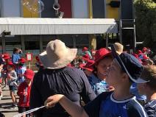

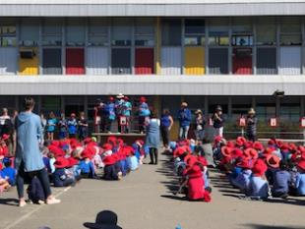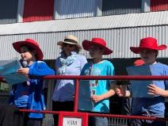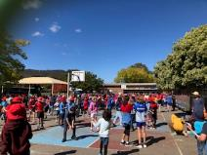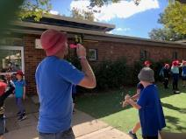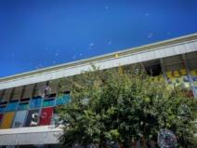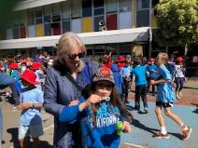

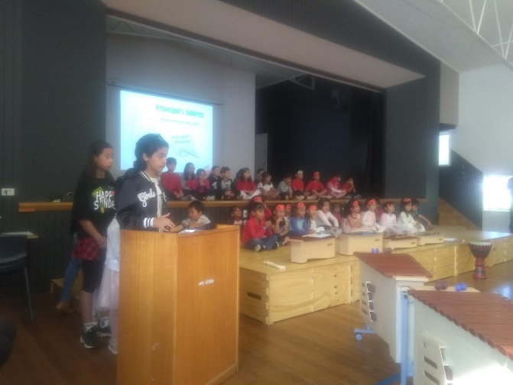**IEC Graduation**

Today we had our IEC Graduation Assembly. We celebrated all the students in our Introductory English Centre and their progress over the last term. They entertained us with a percussion performance and a wonderful dance that we all tried together at the end of the assembly. Seven students also graduated, receiving their certificates from their teachers. They will be joining their new school for term 2 and we wish them all the best for the future.

**Board Reps**

At our last Board Meeting in term 1, Amanda Galbraith finished her appointment as one of our parent representatives and Travis Thurston finished as our staff representative. On behalf of the School Board, the staff, students and community I would like to thank Amanda and Travis for their work on the Board. Both Amanda and Travis have represented the very best interests of the students and have made a significant contribution to our school. I am pleased to announce the reappointment of Sue Webeck and welcome Stephen Van Gerwen as our new parent representatives and Shamus Morton as our newest staff representative.

**Enrolling for school in 2020**

Enrolment applications for 2020 open on Monday 29 April 2019 and must be submitted online at <https://form.act.gov.au/smartforms/landing.htm?formCode=1087>. All ACT children are guaranteed a place in an ACT Public School. Information about the enrolment assessment criteria and priority enrolment areas can be found at <https://www.education.act.gov.au/school_education/enrolling_in_an_act_public_school>.

Have a great holiday and please stay safe if you are travelling. We look forward to seeing you all again for another great term.

Tania Collis

(Principal)

**NAPLAN Online**

NAPLAN Online will occur in our school between 14 and 24 May 2019.

NAPLAN Online is a more engaging assessment that adjusts questions to each student’s achievement level. It also delivers more precise results to schools and parents more quickly.

NAPLAN provides valuable information to schools and parents about literacy and numeracy achievement. It supports school improvement processes by enabling teachers to monitor student progress over time and to identify areas of strength and development.

All eligible students are encouraged and supported to participate in NAPLAN testing. Visit [www.nap.edu.au](http://www.nap.edu.au) to see interactive versions of the test and for more information.

If you have any questions in regard to NAPLAN or if you wish to discuss your child’s participation in NAPLAN 2019 please see Rikkie Klootwijk ASAP.

**Changes to Public Transport**

[](https://www.transport.act.gov.au/getting-around/journey-planner)Just a friendly reminder to all parents and students that Transport Canberra’s new public transport network starts on the first day of **Term 2, Monday 29 April 2019**. For the first time in Canberra, we will see a new integrated network incorporating buses and light rail. Students can use the [TC Journey Planner](https://www.transport.act.gov.au/getting-around/journey-planner) to plan their trip to and from school. As part of the new network some bus stops will be closed, so please check your options via the journey planner. The journey planner and on-line school maps are the easiest and most effective way for students to check the best options for school trips. To celebrate the launch of the new network, Transport Canberra will provide a month of free travel when using your MyWay card. The free travel period is between Monday 29 April 2019 to Sunday 26 May 2019 on every bus and light rail journey.

In order to travel for free, students will need to make sure they:

* Have a MyWay card
* Tap on when they get on a bus or get to a light rail stop
* Tap off when they get off the bus or at a light rail stop
* Have a positive balance on their MyWay card.

For more information on MyWay visit the [Transport Canberra](https://apac01.safelinks.protection.outlook.com/?url=https%3A%2F%2Fdmtrk.net%2F2EO8-1DSS7-62TY7C-V9CAG-1%2Fc.aspx&data=02%7C01%7C%7C7380059df5d249a25f8008d6a36b5609%7Cb46c190803344236b978585ee88e4199%7C0%7C0%7C636876078738170442&sdata=iNPp5MAySEkoLbVdbarBGZoV7G4fYuSfHP4f5lyl%2F6A%3D&reserved=0) website.

## ANZAC DAY by Lex

ANZAC Day is a day of remembering the people who fought in all the wars.  It is not just about the people that died but also those people who came back alive because they still fought in the war for our freedom.

Now these are some of the things that they used to use to commemorate ANZAC Day.  First poppies are worn because where they fought there was a giant patch of poppies and that's why they remember it.  Rosemary is also worn because it is a memorable herb.

Two Up was a game played by the soldiers in the trenches and is only allowed to be played on ANZAC Day. Lots of people make ANZAC biscuits because the soldiers used to have them baked and sent to them.  They had sugar and oats for energy.

Now in these days there are old people from the wars that are in their wheelchairs with their medals and scouts marching.  People get up early at dawn to go to the dawn service but if children want to go there's a dawn service for them but it is a little later.

We still remember the wars so we do one minute of silence. ANZAC Day is a special day for Australian and New Zealand people to remember those soldiers who fought in the war.

## World’s Greatest Shave

 My name is Will. I am 7 years old, and I am taking part in the World’s Greatest Shave for the Leukaemia Foundation!

I’m on a mission to raise money. I want to help support the sick people with blood cancer, and their families during this time. The money I raise will fund research to help more people in the future, and improve their quality of life.

I will be shaving my head after the school holidays on Friday 3 May. Any donations would be greatly appreciated! Parents, students and teachers, please feel free to donate through the following options:

* A cash donation via the front office
* Online via the World’s Greatest Shave Website
* Contact my mum, Kobi-Lee on 0418 270 863

Thank you so much for your support.

**Easter Egg Wrapper Competition**

ACTSmart are running a competition this year to see which school can create the biggest ball of aluminium foil from Easter egg wrappers. Please see below for more details. Please bring your aluminium foil wrappers to school next term to help us win the prize. They need to come flat as we will put them into one large ball here at school.



**P &C NEWS**



…so the Federal Election has finally been called for Saturday 18th May.

We will running our inaugural **Election Day Fair** on Saturday 18th May from 9-2pm.

*We need your pre-loved books*, so if you can spend some time during the school holidays clearing out the bookshelves we welcome your donations. Please leave pre-loved books at the front office

*We need your help*….Please find the Volunteer signup link. If you can spare some time to help make the event fantastic, it would be appreciated. Please click on the following web link (or copy it into your web browser if clicking doesn't work) to go to the signup sheet:

[volunteersignup.org/3ACME](https://volunteersignup.org/3ACME)

|  |  |
| --- | --- |
| [https://volunteersignup.org/images/square_logo.png](https://volunteersignup.org/3ACME) | [2019 Election Day Fair](https://volunteersignup.org/3ACME)  Volunteer signup sheet  volunteersignup.org |

To sign up, just follow the instructions on the page. It only takes a few seconds to do.

Thank you for volunteering!

**Healthy Eating Hub LogoTERM 2 HEHUB CANTEEN MENU (Open Wednesday, Thursday Friday)**

**Recess**

A selection from the following:

Frozen Peas ‘n’ corn cup $1.00 Fruit of the day / Apple slinky $0.50 / $1.00

Pikelets, Popcorn (VG) $0.50 Toasties $1.00 Frozen fruit cup $1.00 Vanilla Yogurt (V, GF) $2.00

Banana muffin (v, DF) $1.00 Cheesy Corn Fritters $0.50

**Lunch**

Vegie sticks Free Fruit of the day $0.50

Vegemite sandwich (VG) $2.00 Vanilla Yogurt (V, GF) $2.00

Tex Mex toasted wrap(V) $2.50 Milk bottle (150ml) $1.50

Soy milk (VG) $2.50 Tuna & cheese toasted sandwich $3.50

Smoothies $2.00 (collect from canteen) Baked Potato with Salsa+/- cheese (GF) $ 3.50

**Daily Lunch Special- $3.50**

**Wednesday: Thursday: Friday:**

*Pizza(V) Italian chicken toasted sandwich (DF) Pasta beef bolognaise (DF)*

## After School Programs

## Creative Kids

Creative Kids

Uni _Norths Rugby

**ALL GIRLS are invited to visit their local guide unit and find out what guides get up to.**

Guides have **FUN** indoors and outdoors, learn new skills and make new friends.

Guides is for girls aged 5 –18 yrs.

Local guide units meet once a week at the Guide halls in Lister Cres, Ainslie and Clianthus St, O'Connor.

To find out more, go to: https://www.girlguides-nswact.org.au/