***The Gang Gang Gazette***

*Week 10, Term 2 (5th July, 2019)*

**Principal: Tania Collis Deputy Principals: Rikkie Klootwijk and Deborah Lowrey (Acting)**

**School Leaders: Marni Payne, Kate Stear,** **Alex Patterson and Kate Bush**

**P & C President: Jhay Mann** [napscommunity@gmail.com](mailto:napscommunity@gmail.com)

**Board Parent Representatives: Sue Webeck, Tara Pearce and Stephen Van Gerwen**

**Board Email**:  [napsboardreps@gmail.com](mailto:napsboardreps@gmail.com)

## Upcoming Events

|  |  |
| --- | --- |
| Term 3 Starts | Monday 22nd July |
| Limelight Art Show Opens | Tuesday 30th July |
| SEL Summit hosted by Student Leaders | Friday 1st August @ 12pm |
| Year 3/4 Touch Footy | Friday 1st August |

|  |
| --- |
| **Notes Home**   * 1/2 Fraction Party Note * Canteen menu * Headlice notification |
|  |
| **Board**  Next Meeting:  Tuesday 13th August 2019, 6.00 pm  **P & C**  Next Meeting:  Wednesday 13th August 2019, 7.30 pm |

**Dear Families and Friends,**

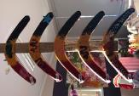Our final week of the term has been another busy one with our parent and teacher conferences taking place. It is always wonderful to have so many parents and carers coming into the school to be active participants in their child’s learning journey to celebrate successes and set goals for the future.

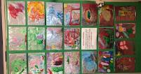The past week has also seen all our preschool classes holding their Art Shows as part of their unit of inquiry, How we express ourselves. We have been sharing some of the amazing artworks on Dojo and will continue to do so as we head into the holidays but we wanted to congratulate the staff and students on the outstanding learning and creativity on display.

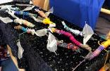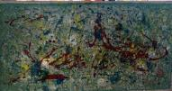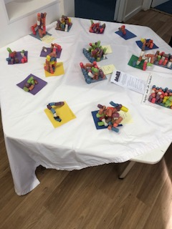

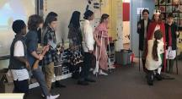The creative arts were on display with the French Footlights this week with our senior students presenting plays to other senior students in French. Well done to Madame Patricia and her stunning cast who entertained and engaged us in French History with their wonderful plays. They will be presenting their learning to the junior school next term.

This week our boys’ chess team competed in the annual North Gungahlin Chess Championship, taking out second place. Well done to Francis M, Leo L, Tyler H, Otis J -R, Max M, Joseph L, Boua T, Abel C and Angus M on representing NAPS. I know a lot of hard work went into practising and preparing for the comp. Thank you to Rainer Reuss for coaching and joining the boys at the comp, your support is much appreciated.

**PJ Day for Asthma**

Thank you to everyone who supported PJ Day for Asthma today. Your efforts have raised $ 517.35

**NAIDOC Week**

During the holidays Australia will be celebrating NAIDOC Week. NAIDOC Week is held across Australia each July to celebrate the history, culture and achievements of Aboriginal and Torres Strait Islander peoples. The week is a great opportunity to participate in a range of activities and to support your local Aboriginal and Torres Strait Islander community. NAIDOC is celebrated not only in Indigenous communities, but by Australians from all walks of life. This year’s theme is Voice, Treaty, Youth and we will be holding our celebrations and exploring the theme when we return to school next term. Don’t forget to look up the great range of activities running in Canberra to celebrate NAIDOC Week which you can attend during the holidays.

Have a great break and see you in term 3.

Tania Collis

(Principal)

## PACH News

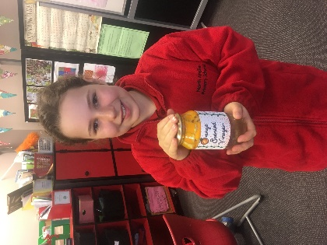Students in Personal and Community Health (PACH) recycled orange peels to make an environmentally friendly cleaning product: orange scented vinegar. Thank you to all who supported the sales of our excellent product. All donations go straight back into the Hehub garden. And a big thank you to Alice Harcourt whose label design added the final touch!

If you would like to get messy with orange peels these holidays, check out these great ideas:

<https://www.kidspot.com.au/lifestyle/home/home-solutions/24-ways-to-use-up-orange-peel/news-story/23f82d6451318199fb818b3b08e7e6aa>

<https://preparednessmama.com/24-uses-for-oranges/>

**Woden Interchange Service Updates**

**Platform numbers and departures are changing from 6 July 2019**

Transport Canberra is making improvements to the Woden Interchange, to make it easier for customers to use the new public transport network.

 You will notice platform changes as we work to improve customer information throughout the interchange, which includes new and improved signage and a simplified layout.

Our friendly Customer Service staff will be available in the interchange to provide assistance. Please refer to the below map for platform and departure changes, for your regular services.

School services will continue to leave from the same location in the interchange, however, the platform number will be updated to reflect the broader changes as seen in the map attached.

For further information, please visit: [transport.act.gov.au](http://www.transport.act.gov.au/).

Woden Interchange

**P &C NEWS**

## Trivia Night

If you have a bit of time over the next two months to help the organisers with TRIVIA NIGHT, we’d love to have you on board! Email napscommunity@gmail.com and we’ll get back to you!

## Community Gardens Grant Application

One of the key themes from last year’s parent survey, and this year’s Parents Forum, was a desire for the P&C to focus on developing and beautifying the school gardens and grounds.

In collaboration with the school, we are currently applying for a community garden grant from the ACT government to extend the HEHub gardens. If you have skills, experience, or a passion in the following areas we would love your advice and/or assistance in planning the project and preparing the grant application:

Grant writing

Plumbing & irrigation

Horticulture

Any other relevant field

If you are involved in a business which may be interested in supporting or sponsoring our project, please get in touch soon, the grant submission period closes July 28th.

## You can contact us:

Via email napscommunity@gmail.com

On FaceBook on the NAPS Parents & Carers page,

In person via the front office or any of the P&C committee

Or by phone on 0431062423 (Maree, P&C Treasurer)

## Canteen Volunteers

A big thanks to those who responded to our call for volunteers, much appreciated! More volunteers are always welcome, feel free to drop in and see Heather or Karen on Wednesdays, Thursdays or Fridays for an hour or all morning. You can also email naps.canteen@gmail.com

Thanks for your support, we can't do it without you!

**Healthy Eating Hub LogoCanteen News**

**TERM 3 HEHUB CANTEEN MENU (Open Wednesday, Thursday Friday)**

**Recess**

A selection from the following:

Frozen Peas ‘n’ corn cup $1.00 Fruit of the day / Apple slinky $0.50 / $1.00

Pikelets, Popcorn (VG) $0.50 Toasties $1.00 Frozen fruit cup $1.00 Vanilla Yogurt (V, GF) $2.00

Banana muffin (v, DF) $1.00 Cheesy Corn Fritters $0.50

**Lunch**

Vegie sticks Free Fruit of the day $0.50

Vegemite sandwich (VG) $2.00 Vanilla Yogurt (V, GF) $2.00

Tex Mex toasted wrap(V) $2.50 Milk bottle (150ml) $1.50

Soy milk (VG) $2.50 Tuna & cheese toasted sandwich $3.50

Smoothies $2.00 (collect from canteen) Baked Potato with Salsa+/- cheese (GF) $ 3.50

**Daily Lunch Special- $3.50**

**Wednesday: Thursday: Friday:**

*Pizza(V) Italian chicken toasted sandwich (DF) Pasta beef bolognaise (DF)*

## Community Notices

## Art CompetitionThreatened Species Art Competition

Need a holiday project? The Threatened Species Children’s art competition is running until the 2nd August. It is the perfect activity to keep the kids busy over the winter holidays!

**The Threatened Species Children’s art competition helps children unleash their artistic creativity while learning about our local native plants and animals facing extinction.**

The judges will be looking for works that display technical skills, interesting interpretations and compositions, and work that demonstrates an emotional connection with the species.

There will be eight categories of prize winners: 5-7 year olds, 8-10 year olds and 11-12 year olds. Prizes include art equipment, gift vouchers for Westfield and Smiggle, books, and passes to Taronga Zoo and Featherdale Wildlife Park. All prize winners will have their work displayed in the exhibition at the Australian National Botanical Gardens in Canberra.

For more information about the competition, and how to enter, explore the competition website at: <http://www.threatenedspeciesartcomp.net.au/how-to-enter.html>

**Instructions for the artist:**  
**1. Research**  
Do your own research on one threatened animal or plant in your state. A list of threatened species for NSW can be found or on<http://www.environment.nsw.gov.au/threatenedSpeciesApp/>    Some plants and animals are listed in [our Gallery](http://www.environment.nsw.gov.au/threatenedSpeciesApp/) and more information can be found in a list at the end of this section. You could look for a species that is threatened in your own area, or one that used to live in your area but is now extinct there. You could find out the reasons that species is threatened, such as logging, land-clearing or feral animals.  
**2. Create**  
Create your own work of art that interprets this theme. Make sure it falls within the categories of drawing, painting or mixed media (such as collage). Three dimensional, photography and video works can’t be accepted. Please make sure it is your OWN WORK. Copying the shape and form of a species is fine as long as you make it your own creation. Tracing, or having a parent or anyone else work on any part of your entry is not allowed.  
**3. Reflect**  
The reflection is a short piece of writing that describes anything you care to mention about the artwork, like what inspired you to depict that species. It should be 50-150 words long and can be included in the registration form. This will help the judges understand more about you and your work. Parents or teachers can help younger children to fill in this section.   
**4. Send**  
Please ask for an adult's assistance to create a clear digital copy of your artwork under 5MB in size.  The file should be sent to the competition organiser in digital format, along with a Registration Form that must be completed by a parent, teacher or legal guardian.   
**RESEARCH STARTS HERE FOR NSW**  
<http://www.environment.nsw.gov.au/threatenedSpeciesApp/>   
<http://plantnet.rbgsyd.nsw.gov.au/search/spatial.htm>  
<http://www.edonsw.org.au/native_plants_animals>  
[http://www.environwww.environment.nsw.gov.au/topics/animals-and-plants/threatened-species/about-threatened-speciesment.nsw.gov.au](http://www.environment.nsw.gov.au/topics/animals-and-plants/threatened-species/about-threatened-species)/t  
​[https://www.smh.com.au/environment/here-are-13-remarkable-animals-facing-extinction-in-nsw--and-there-are-hundreds-more-20150416-1mmmrv.htmlopics/animals-and-plants/threatened-species/about-threatened-species](https://www.smh.com.au/environment/here-are-13-remarkable-animals-facing-extinction-in-nsw--and-there-are-hundreds-more-20150416-1mmmrv.html)

## Lantern Making Workshop

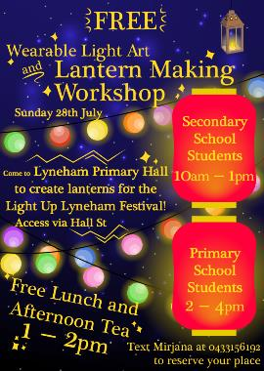

## Tiakoz Performance

To all North Ainslie Families, Tiakoz Música Viva in schools performed here at NAPS. They are coming to the Canberra Theatre for a big concert Called the Beauty of 8. I hope some of you are lucky enough to go. **Kath Bingham**

