***The Gang Gang Gazette***

*Week 6, Term 2 (5th June, 2020)*

Principal: Tania Collis Deputy Principals: Rikkie Klootwijk and Sharon Moloney

School Leaders: Haeley Simms, Kate Bush (Acting), Melissa Datson (Acting) and Jarryd Heywood (Acting)

Board Parent Representatives: Sue Webeck, Stephen Van Gerwen and Lucy Hopkins

Board Email:  [napsboardreps@gmail.com](mailto:napsboardreps@gmail.com)

P & C President: Maree Wright [napscommunity@gmail.com](mailto:napscommunity@gmail.com)

**Upcoming Events**

|  |  |
| --- | --- |
| Queen’s Birthday Long Weekend | Monday 8th June |

|  |
| --- |
| **Notes Home**   * Note to 3/4CK (email) * Note to 5/6AP (email) * Head lice notification (1/2 & 3/4) |
|  |
| **Board**  Next Meeting:  TBA  **P & C**  Next Meeting:  Tuesday, 16th June, 7.30pm |

Dear families and friends,

We are all back at school and it has been fantastic to have our 5/6 students join us this week. One of the lovely things for me over the last few weeks are the many students of all ages who have eagerly shared with me how excited they are to be back at school. For lots of us the chance to reconnect with friends and for our students to also have a chance to play with them, has been a highlight of coming back on to the school site. I have heard lots about how much they are enjoying learning together with both their peers and teachers. They are appericiate a chance to learn again with their peers in a more hands on way. Our PACH students have been back in the garden and students across all year groups have been keeping fit and warm through games and PE skills. Our hall has been full of music and I have been amazed watching our students drumming with vigour as they follow complicated drumming patterns, no matter what year level they are in. Visual art lessons have also been a highlight with some beautiful pieces already finished and ready for display. I think the chance to discuss learning and ideas face to face is much appreciated.

**Safety of our community**

With the number of families walking to school and the new procedures in place in the mornings and afternoons, we have had several of close calls and some minor accidents with people on bikes. This is particularly evident on the path outside the main gates and the gate to the junior bike rack. Please hop off your bike and walk it down the hill toward these paths to avoid any further accidents.

**P & C**

Our wonderful P & C has been hard at work, looking at ways in which we can improve the outside environments at school, particularly the senior oval. Teachers and students have been working together on thinking about what they would like around the oval and how they will use it to play and learn. It would be fabulous if you could share in this conversation and talk to your child/ren about what they might like to have there and help them to share that with us. Next week we will share some of the ideas and photos of other areas to inspire you.

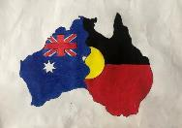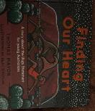**Reconciliation Week**

Over the last week, we have been sharing in Reconciliation Week through the learning and conversations across our school. All classes have been involved and it has been wonderful to hear about what they have learnt and reflected on, and to see what they have created. Although our Reconciliation Day was different this year, I am heartened to know how much it is still in the minds of our community as we share the importance of this special day.

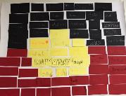In preschool they shared the book, *The Rabbits*, by John Marsden and Shaun Tan and created fabulous responses, including a beautiful mural. Our older students participated in a variety of activities designed to make them think about this year’s theme – In this together – and understanding what reconciliation truly means. Students in 1/2 created a beautiful response through their art on rocks which will be used permanently in one of our gardens once finished. Another book used this year was *Finding Our Heart,* by Thomas Mayor and Blax Douglas, which is a story about the Uluru Statement, specifically for young Australians. We also had free yarns and walked and explored this beautiful Ngunnawal land and talked about what we could do to personally help Reconciliation and how we can represent Australia

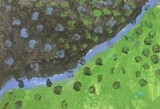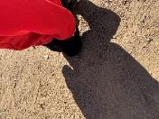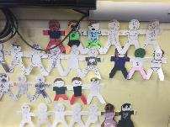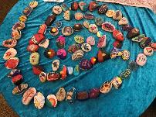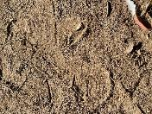

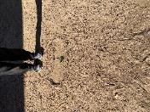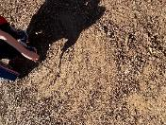

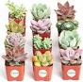**Succulents**   
Thank you to those people who have dropped off some succulents to help us revamp the front garden. We are always happy to have more, so if you have some succulents or cuttings you can share with us, we would very much appreciate you bringing them to the Front Office.

Have a great weekend.

*Tania Collis*

Principal

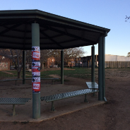

**P & C Fundraiser**

A reminder the P & C is doing a great fundraiser, that benefits our environment, by collecting and upselling old school uniforms. The drop off area is the senior rotunda on the oval.

**School uniform**

## P & C logoP &C NEWS

## A Team Effort:

The Senior Oval Redevelopment team have been busy this week working behind the scenes, and we aren't the only ones - the students have started to get their creative juices flowing! Our year 1/2's have been documenting initial ideas about the space within their UOI of 'Sharing the Planet', with the fun creation of their 'Lunchtime Ecosystem' as drawings or mind mapping. These kids are so creative, it will be wonderful to see the ideas they share.

As our senior students settle back into their classrooms, the teaching staff and student leaders are coming up with their own ways to incorporate this initial conversation into the learning for the 3/4s & 5/6's. These drawings and ideas will give the designers an idea of where we are starting from and mark the beginning of the consultation process.

We excited to see these ideas being generated, as an important first step to working out the best solution for the space, together. There will be many more opportunities for teachers, parents and others to share ideas, make suggestions, and hopefully also learn some new things too. While the kids (and some of us!) might have a "wish list" of great inclusions, this is only the beginning of the process, and it will take quite a while, and a team of professionals, to distil the most important elements and develop a great new design for the space. Our selection process has prioritised "community consultation" as baseline essential for this project, so the designer will bring loads of experience to the table. The most important feature won't be trees or turf, it will be the collaborative community vision of our shared space. This will take time to grow, so please be patient and enjoy the journey!

We expect to be able to lay out a more detailed road map for how the process will work in the next few weeks, once a contract has been signed. This will outline when you will get a chance to contribute (so save your photos and ideas for then) as well explaining how we will work through decisions and choices to come to a final design that works best for our whole school community.

**Healthy Eating Hub Logo**

**TERM 2 HEHUB CANTEEN MENU (Open Wednesday and Friday)**

The canteen has reopened with a limited menu on WEDNESDAY and FRIDAY only, for online lunch orders. At this stage, we are **only** offering **online lunch orders through Flexischools**. There will be no recess service, and no over-the-counter lunch service.

The menu is limited to two $7 lunch pack options only:

**Chicken and Cheese toasted sandwich OR Tuna and Cheese toasted sandwich**

**With**

**Fruit OR Yogurt**

**And**

**Milk OR Juice**