***The Gang Gang Gazette***

*Week 7, Term 2 (14th June, 2019)*

**Principal: Tania Collis Deputy Principals: Rikkie Klootwijk and Deborah Lowrey (Acting)**

**School Leaders: Marni Payne, Kate Stear,** **Alex Patterson and Kate Bush**

**P & C President: Jhay Mann** [napscommunity@gmail.com](mailto:napscommunity@gmail.com)

**Board Parent Representatives: Sue Webeck, Tara Pearce and Stephen Van Gerwen**

**Board Email**:  [napsboardreps@gmail.com](mailto:napsboardreps@gmail.com)

## Upcoming Events

|  |  |
| --- | --- |
| Musica Viva | Wednesday 19th June |
| Peer Support | Friday 21st June |
| NAPS Preschool Program 1 Art Gallery | Monday 24th June (8:30am – 9:30am) |
| CEIS | Tuesday 25th June |
| Senior assembly hosted by 5/6LK & 5/6JC | Friday 28th June |
| Peer Support | Friday 28th June |
| Parent Interviews | Week 10 |
| Term 2 Ends | Friday 5th July |

|  |
| --- |
| **Notes Home**   * Scholastic Book Order   (Due Friday 21st June)   * Holiday Happenings * Australian Girls’ Choir |
|  |
| **Board**  Next Meeting:  Tuesday 18th June 2019, 6.00pm  **P & C**  Next Meeting:  Wednesday 19th June, 6:00pm  *Function Room at the Dickson Quality Inn.* |

**Dear Families and Friends,**

This week, some of our students attended the ACT Cross Country event at Stromlo Forrest park. Congratulations to Nafanua H, Tilly V B, Zebulon V, Zoe S, Pepi W, Abigail S, Gus C, Evie S C, Eva K who put in outstanding efforts showing their commitment by doing their very best. They also represented the school by being principled and caring showing support for each other and representatives from other schools.

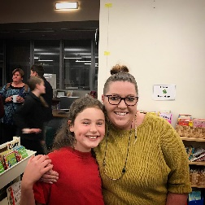Isla F did a fantastic job representing our school at the Rostrum Quarter Final last night. Her speech about her family was thoughtful and engaging and she was an amazing communicator using her voice and manner to bring the audience on her journey. Well done to everyone.

**Peer Support**

Peer Support continues to be a highlight of term 2 as I see students from across kindergarten to year 6 learning together and making new friends and connections. Our year 6 leaders are doing a fabulous job and can articulate what it means to them to have this opportunity to be leaders and role models in our school. They can to tell you about the challenges of leading a group of multi-aged students and how it is developing their attributes as the continue to grow into their role. It is lovely to see the year 5 students supporting the kindergarten students to participate, and our students in years 1-4 also helping to make each group learn and collaborate.

**Skoolbag app**

Last week I wrote to you about ceasing the use of the SkoolBag App. As we have had no feedback from the community to say this will be an issue, it will be finishing this week.

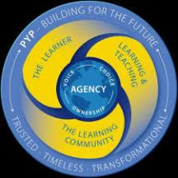**Enhanced PYP**

This year our school is one of the many IB, PYP Schools from across the world who are beginning to use the Enhance PYP which was launched late last year. The process of reviewing the PYP began in 2012 and the launch is timely with our school having our 5-year evaluation by the IB last year. We have been exploring the Enhanced PYP since the beginning of this year and teachers are engaging with other IB schools across the ACT to share our practice. The Enhanced PYP has the focuses of The Learner, Learning and Teaching and the Learning Community at the centre. There is a strong emphasis on Agency, and this has been an area where teachers and schools have been coming together to share what they are doing with students to develop their voice, choice and ownership of their learning.

The Transdisciplinary Themes and focus on Action remain the same as does the use of inquiry with central ideas and lines of inquiry developed by teachers and students. The eight key concepts; Form, Function, Causation, Change, Connection, Perspective, Responsibility and Reflection have now been reduced to seven. Reflection is now integrated through all the concepts. Our Learner Profile Attributes also remain unchanged. The Transdisciplinary Skills are now the Approaches to Learning and the Attitudes sit within the attributes and help us to understand how those attributes are developed. You may have seen our poster on this in one of your child’s classrooms, with the attitudes being the roots of the tree that develop into the attributes.

We now have Approaches to Teaching which include:

* The continued use of inquiry
* A focus on conceptual understanding
* Development of units within local and global contexts
* Development of effective teamwork and collaboration
* Differentiation to meet the needs of all learners
* Practice informed by formative and summative assessment.

This week our teachers walked through all of our classrooms to share our current inquiries and the learning of our students. The walkthrough was a valuable experience with teachers taking ideas from each other and celebrating our wonderful students. In every inquiry, students are encouraged to ask their own questions and to follow these ‘wonderings’. We were amazed by the depth of the questions and the ideas expressed by our students from preschool to year 6. Students were able to articulate why they thought the arts was important, to ask questions about changes in technology and how they impact on us and think about big ideas such as climate change, its past impact, its future impact and what needs to be done. This weekend you might like to take the opportunity to ask your child about some of the ‘wonderings’ they have based on what they have been learning about at school.

I’m looking forward to seeing you at the P and C’s forum next Wednesday.

Have a great weekend.

Tania Collis

(Principal)

**PACH News**

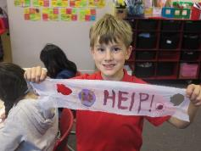Students in Personal and Community Health (PACH) recognised the theme #Beatairpollution for World Environment Day by making creative face masks. Lots of fun was had by all and students also learnt about the importance of the 4Rs: Reuse, Reduce, Recycle, Refuse to help take action in their community. NAPS is fantastic at recycling and composting our waste, so keep up the amazing effort everyone. We are very lucky to have so many great resources in Canberra: Green Shed, Buy Nothing, ACT Smart, Container Deposit Scheme. But here are some other handy hint websites. Happy recycling!

Handy hints:

<https://www.actsmart.act.gov.au/quick-tips/waste_management>

<https://www.facebook.com/costathegardengnome/>

<https://www.natgeokids.com/au/discover/geography/general-geography/what-is-climate-change/>

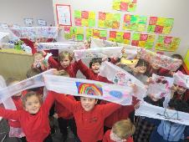 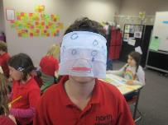 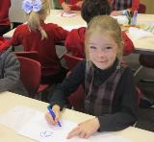

**4Rs**

**Refuse –** means to not do something in order to cut the waste you will produce. A simple example of this is to not accept a plastic shopping bag from the shop assistant when you have bought only one small item. Another example is to not use aluminium foil to roast potatoes in their jackets in the oven.

**Reduce –** means buying and using things more carefully so that you produce less waste overall. For example, if you buy one large box of cereal instead of two small ones, that means you will have less cardboard packaging overall. Packing the right amount of food for your school lunch means that you will have less uneaten food to throw away after lunch.

**Reuse –** means to use more than once for the same or a different purpose. For example, a girl might use a Ziploc bag for some biscuits for lunch and then wash the bag and use it over and over again to hold different sorts of snacks.

**Recycle –**means the process of making something new from something that has been thrown away. The new product can be the same as the old one or something quite different. For example, a sheet of photocopy paper could be made into another sheet of photocopy paper (same) or it could be made into a cardboard box (different). With some materials (e.g. glass, metals and plastic), heat is used in the recycling process, bringing about a change of state from solid to liquid and back to solid again.

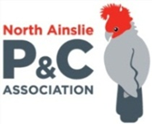**P &C NEWS**

NAPS P & C Forum

**Canteen News**

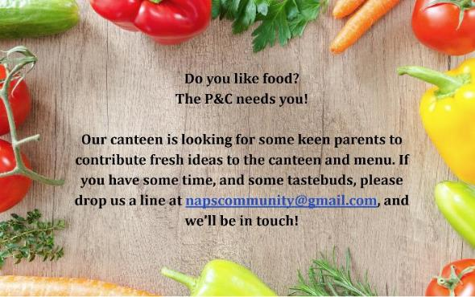

**Healthy Eating Hub LogoTERM 2 HEHUB CANTEEN MENU (Open Wednesday, Thursday Friday)**

**Recess**

A selection from the following:

Frozen Peas ‘n’ corn cup $1.00 Fruit of the day / Apple slinky $0.50 / $1.00

Pikelets, Popcorn (VG) $0.50 Toasties $1.00 Frozen fruit cup $1.00 Vanilla Yogurt (V, GF) $2.00

Banana muffin (v, DF) $1.00 Cheesy Corn Fritters $0.50

**Lunch**

Vegie sticks Free Fruit of the day $0.50

Vegemite sandwich (VG) $2.00 Vanilla Yogurt (V, GF) $2.00

Tex Mex toasted wrap(V) $2.50 Milk bottle (150ml) $1.50

Soy milk (VG) $2.50 Tuna & cheese toasted sandwich $3.50

Smoothies $2.00 (collect from canteen) Baked Potato with Salsa+/- cheese (GF) $ 3.50

**Daily Lunch Special- $3.50**

**Wednesday: Thursday: Friday:**

*Pizza(V) Italian chicken toasted sandwich (DF) Pasta beef bolognaise (DF)*

## Community Notices

Larissa Dann



**PARENT EFFECTIVENESS TRAINING (P.E.T)**

*Supported by Parentline ACT*

Tired of yelling? Looking to find a way to get out the door on time, while still liking each other? Learn respectful communication skills for a peaceful, gentle approach to parenting, without the use of punishment or reward. P.E.T helps children and parents develop resilience, emotional intelligence, confidence and consideration. The course is powerful, proven and practical, and will help you put peace back into your parenting.

For more information visit our [**Parent Skills website**](http://www.parentskills.com.au/blogs/larissa); join the [**Parent Skills Facebook**](https://www.facebook.com/parentskills/) community; and read [P.E.T. on a Page](http://www.parentskills.com.au/blog/pet-page-summary-skills-and-principles-parent-effectiveness-training-pet).

*The 24 hour course consists of three-hour sessions, once per week, for eight weeks.  Booking is essential.*

*Investment includes a workbook and textbook.*

***Course begins:*** *Monday, 29th July, 2019 (minimum number of participants required);* ***Time:*** 6.30 pm to 9.45 pm*;* ***Place:*** Weston, ACT.

Enjoy P.E.T. with **Larissa**, accredited P.E.T. instructor. [info@parentskills.com.au](mailto:info@parentskills.com.au)

