***The Gang Gang Gazette***

*Week 7, Term 3 (6th September, 2019)*

Principal: Tania Collis Deputy Principals: Rikkie Klootwijk and Deborah Lowrey (A/g)

School Leaders: Marni Payne, Kate Stear, Alex Patterson (A/g) and Kate Bush (A/g)

Board Parent Representatives: Sue Webeck, Tara Pearce and Stephen Van Gerwen

Board Email:  [napsboardreps@gmail.com](mailto:napsboardreps@gmail.com)

P & C President: Jhay Mann [napscommunity@gmail.com](mailto:napscommunity@gmail.com)

## Upcoming Events

|  |  |
| --- | --- |
| Junior assembly hosted by KSM & KGM | Friday 13th September @ 12pm |
| Year 5 & 6 Bandfest ANU School of Music | Friday 13th September |
| K-5 Student Led Conference Week | Week 9 |
| Preschool Wetland Excursion | Tuesday 17th September & Friday 20th September |
| CEIS | Tuesday 17th September |
| NAPS preschool P &C meeting @ 7:30pm | Wednesday 18th September @ 7:30pm |

|  |
| --- |
| **Notes Home**   * Student Led conference (Kindergarten) * P & C Art fundraiser note * Photographs (email) * 3/4 Camp Note |
|  |
| **Board**  Next Meeting:  Tuesday 10th September, 6.00 pm  **P & C**  Next Meeting:  Tuesday, 10th September,7.30pm |

**Dear Families and Friends,**

As we finish week 7 and head into the last three weeks of school, we would like to remind you that our Student Led Conference Week is not far away. In week 9 (16-20 September) our classrooms will be open for you to join your child to share in their learning journey. Each class will have two opening times where you can see what they have been doing in class and what has been happening in the specialist areas of the school. Please make sure you look out for the notes and times. We hope to see you there.

Last Friday night our P and C held their annual Trivia Night with an 80’s theme. A wonderful time was had by all and, once again, we were all impressed with the amazing costumes. Everyone put in a huge effort to celebrate the special decade that brought us classic music, big hair, fluro clothing and sky-high shoulder pads. We were also inspired by the generosity of our community during the auction and fundraising section of the night, so thank you to all. Well done to the P & C who ran a fun night which had us all thinking and laughing as we remembered the sounds of the dial up modem and put our heads together in a tightly contested competition. Unfortunately, the teachers were unable to defend their title from last year but came a respectable fourth, and we all had a fantastic time. We know how much time went into putting together the questions, food and gathering all the donations, so a huge thank you to our P & C and their Trivia Night organisers.

Thank you also to everyone who completed the Satisfaction Survey which closed on Monday.

**Tournament of Minds**

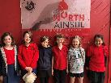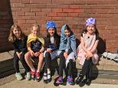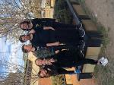On Sunday we had three teams competing in the annual Tournament of Minds Competition at Campbell High School. After six weeks of problem solving and practice, the teams competed in the Social Sciences or Arts events. I had the pleasure of joining them all at the event and was excited to see how well they performed on the day. The teams had made their costumes, props and written fabulous scripts for their plays which demonstrated their solution to their arts or social science problem. Remembering their scripts was a huge feat and it was wonderful to see them all enjoying themselves so much as they competed. Congratulations to Evie N, Megan F, Katriona B, Tamara G, Bronte G, Naomi K, Violet B, Melda A, Ava Rose W, Isabella P, Eloise K, Olivia T, Ciara G, Matteo T, Arijana M-S, Oliver N and Ru W. Thank you to all the families who came to support the teams and to Amanda Collins who has worked with them over the last term for many hours over many lunch times.

**Chess**

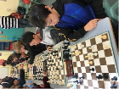During the year our students who enjoy playing chess meet each week to practise and play. They can attend either the lunchtime club (Wednesday) or the chess club after school on a Thursday. We have also had teams compete in local primary school comps with one of our teams competing last week in the ACT final. Well done to Otis J-R, Leo L, Abel C and Lucas G. Many of these events are run by the ACT Junior Chess League. This group runs competitions across Canberra, but also links people with coaching and opportunities to attend various events. This holiday (from Tuesday 1 to Friday 4 October) they have a Spring Boot Camp which offers, coaching, Allegro (quick play) and and a long time tournament. For further information on the Junior Chess League, visit <https://actjcl.org.au/actjcl/index.php>

**Affiliated School Program**

This term we have been lucky to have students from the University of Canberra join us at school each Thursday as part of the Affiliated School Program. Through this program, students attend a lecture each week at the school and then move into classrooms to practise what they are learning and to continue to develop their practice as teachers. In keeping with our school priorities, the UC students are focusing on maths as they work in 3/4 classrooms.

**North Gungahlin Athletics**

Well done to our team who represented us last week.

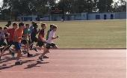

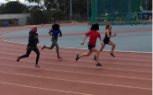

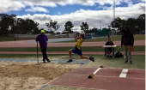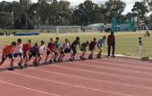

I look forward to seeing some of you on the 15th at our working bee. Remember, bring your own topping for a pizza from our pizza oven in the HEHub. Have a good weekend.

Tania Collis (Principal)

**1/2 Students are Taking Action**

During our *Where we are in place and time* inquiry the 1/2 students have been learning about explorations, discoveries and inventions. They have become explorers making their own discoveries and inventions. They learned about how significant discoveries and explorations have impacted on our lives and the lives of others. To further their learning, they decided to take action.

Have you ever wondered what to do with all those plastic lids from milk containers and plastic bottles that can’t be recycled?

The 1/2 students have figured it out!

Instead of sending them to landfill, the lids can be recycled to make prosthetic limbs for children.

The idea comes from Envision Hands in Victoria, a not-for-profit community initiative that uses 3D printing to turn plastic waste into mechanical hands and arms for kids, with the products being sent around the world.

Help us help others by bringing your clean plastic lids to school.

**What**: Plastic lids (look for number 2 or 4 on the inside of the lid)

Please take out any plastic or cardboard liner from your lids and clean them before bringing them to school.

**Where:** Deposit in the Lids 4 Kids tub at morning lines.

**Together we can all make a difference.**

To find out more about this amazing initiative click on the link below.

<https://7news.com.au/the-daily-edition/envision-hands-turns-bottle-caps-into-prosthetic-limbs-for-kids-in-need-c-200981>

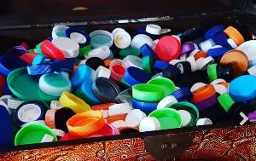

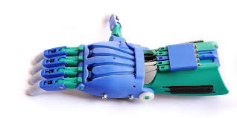

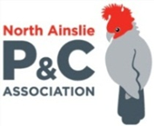**P &C NEWS**

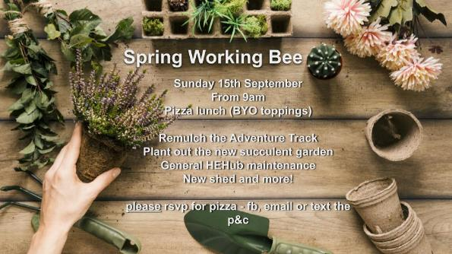

## Healthy Eating Hub LogoTERM 3 HEHUB CANTEEN MENU (Open Wednesday, Thursday Friday)

**Recess**

A selection from the following:

Frozen Peas ‘n’ corn cup $1.00 Fruit of the day / Apple slinky $0.50 / $1.00

Pikelets, Popcorn (VG) $0.50 Toasties $1.00 Frozen fruit cup $1.00 Vanilla Yogurt (V, GF) $2.00

Banana muffin (v, DF) $1.00 Cheesy Corn Fritters $0.50

**Lunch**

Vegie sticks Free Fruit of the day $0.50

Vegemite sandwich (VG) $2.00 Vanilla Yogurt (V, GF) $2.00

Tex Mex toasted wrap(V) $2.50 Milk bottle (150ml) $1.50

Soy milk (VG) $2.50 Tuna & cheese toasted sandwich $3.50

Smoothies $2.00 (collect from canteen) Baked Potato with Salsa+/- cheese (GF) $ 3.50

**Daily Lunch Special- $3.50**

**Wednesday: Thursday: Friday:**

*Pizza(V) Italian chicken toasted sandwich (DF) Pasta beef bolognaise (DF)*

## Upcoming Events

Library ACT upcoming events

* **For parents and staff**
* > Toni Hassan: *Families in the digital age* author talk  
      6 September | Dickson Library
* **For families**
* > The Ultimate Storytelling Battle: Mick Elliott vs Oliver Phommavanh  
      15 September | Floriade

