North Ainslie Preschool and Hackett Preschool Handbook

CONTENTS
WELCOME  Enrolment procedures  Early entry and early intervention | 2  2
PHILOSOPHY STATEMENT  Primary school philosophy and mission statement  Preschool philosophy | 3  4
CURRICULUM  Our preschool curriculum  Early Years Learning Framework  School transitions  Excursions and library | 5  6  7  7
COMMUNICATION AND COLLABORATION  Time to talk  Collaboration within the program  Parent involvement  Contributions to decision making  Participation of volunteers  VOLUNTARY CONTRIBUTIONS | 8  8  8  9  9  10
STUDENT WELFARE AND MANAGEMENT  Delivery and collection of children  Changes to details  Information on hygiene procedures  Food and food safety tips  Birthdays  Sun smart practices  Children’s clothing  Child protection practices  Immunisation  Medical and accidents  Diseases and outbreaks  Exclusion periods | 10  10  11  11  11  13  13  12  12  13  13  13  14-15
FEEDBACK OR CONCERNS | 15
PARENT SUPPORT | 15
Welcome
On behalf of every child, every parent and every staff member, I welcome you to North Ainslie Primary School.
North Ainslie Primary is a co-educational primary school, situated in inner northern Canberra and providing an education for six hundred and fifty students. We are proud to offer the International Baccalaureate Primary Years Program (IB PYP) from preschool to year 6.
North Ainslie Primary was established in 1958, with Terry O’Connell as founding principal. O’Connell was considered an innovative leader in education and was principal of North Ainslie until 1974. North Ainslie was very much a community school in 1958. Over fifty years later, the school continues to boast a wonderfully strong community base. We also proudly celebrate a uniquely diverse student clientele. North Ainslie students come from over forty different cultural and linguistic backgrounds, attending either our mainstream school or our Introductory English Centre (IEC). We also host a learning support unit for students with autism and provide an inclusive mainstream education for children with disabilities.
We offer four fifteen hour preschool sessions, all of which deliver our IB inquiry program and a play based developmental curriculum, underpinned by the Early Years Learning Framework. We highly value play based learning, which continues to be a strong element of our Primary Years Program in kindergarten to year 2.
The inquiry approach to teaching and learning continues into the later primary years. Through purposeful, guided inquiry we strive to develop students who are knowledgeable, curious, intelligent, open-minded and caring. We hope that, as truly internationally minded young people possessing these attributes, our students will take positive action in their world.
Sincerely
Tania Collis (Principal)

How to enrol at our school
Parents can enrol their children at North Ainslie if they reside in Ainslie, Dickson or Hackett . Children seeking to enter school at the preschool entry point should be four years of age on or before 30 April in that year. Preschool enrolments normally open from the end of April. The enrolment application is completed online through the Education and Training Directorate website www.education.act.gov.au/ . If you have difficulty accessing a computer to complete the online enrolment form please come to the school for assistance. A translator can be arranged should you require one. Please make an appointment on 6142 0760.
To complete the enrolment, you need to provide your child's birth certificate, immunisation details and proof of residence.
Early entry
Early enrolment for children under compulsory education age is available in some circumstances. Further information is available on the Directorate's website at www.education.act.gov.au/ .
PHILOSOPHY STATEMENT
North Ainslie North Ainslie Primary School (NAPS) is an authorised International Baccalaureate World School offering the Primary Years Program (IB PYP). We provide a program where ‘hearts meet minds’ and we produce global learners that make a difference in the world.
North Ainslie Primary School Mission Statement
North Ainslie Primary School, as a member of the International Baccalaureate Organisation, aims to develop inquiring, knowledgeable and caring young people who take positive action in the world.
Our school is a centre of learning where effort and achievement are celebrated and diversity is embraced within a restorative, respectful and friendly environment.
The heart of the local community, NAPS instils a passion for lifelong learning, enabling all students to be the best they can be as they confidently look to the future.
North Ainslie Philosophy Statement
As an IB school operating within a restorative, respectful environment, North Ainslie continually strives to be an internationally minded community of learners who exemplify the attributes expressed in the IB Learner Profile. Our curriculum aims to develop students with these attributes:
Inquirers | Risk-takers | Well balanced
Communicators | Caring | Open-minded
Thinkers | Reflective | Knowledgeable
Principled

In order to develop these Learner Profile attributes the curriculum at North Ainslie regards the following values and attitudes as being of great significance:
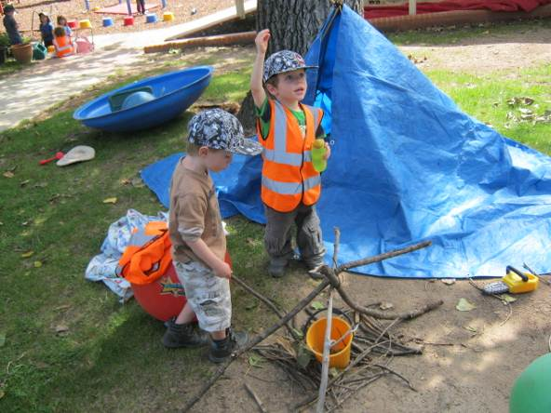
Appreciation | Cooperation | Empathy
Commitment | Creativity | Enthusiasm
Confidence | Curiosity | Independence
Integrity | Respect | Tolerance

North Ainslie and Hackett Preschool Philosophy Statement
The North Ainslie and Hackett Preschool unit’s philosophy builds upon our school’s vision statement, incorporating the principles and practice from both the Primary Years Program and the Early Years Learning Framework.
We build secure, respectful and reciprocal relationships with all members of the community.

At our preschool, the educators:
- respect the child as a partner in the teaching and learning process through warm, trusting and reciprocal relationships
- acknowledge the child’s prior knowledge, background, interests and differences
- provide safe, secure and stimulating learning environments in which children can express themselves and fell valued for their contributions to the classroom, and
- build on children’s prior learning and experiences to build continuity for their development.

We develop partnerships with families that support the learning and development of all children. At our preschool, the educators:
- recognise and cater for children’s learning and development at school and at home
- work with families towards shared decision making about each child’s learning and developmental needs
- create a welcoming and culturally inclusive environment where all families are encouraged to participate in and contribute to children’s learning and developmental experiences
- provide families with ongoing information about their children’s learning and development, and about what they can do to further support their children
- actively engage families and children in planning children’s learning and development, and
- acknowledge the significance of transitions within services. We ensure the children understand the process and have an active role in preparing for these transitions.

We strive for high expectations and equity for all.
At our preschool, the educators:
- strive to develop internationally minded children who live the learner profile
- establish high expectations for all children’s learning and development
- support children’s learning and development through a combination of child and adult-led play based learning, as well as active teacher-led learning
- create opportunities for every child to experience success in their learning and development
- recognise that every child can learn, and some children require different opportunities and supports to do this
- encourage children to explore, solve problems, communicate, think, create and construct, and
- encourage children as active participants for sustainability, influencing the quality of life now, and for future generations.

We have respect for diversity in our learning community.
At our preschool, the educators:
- recognise the value of bi and multilingualism and support these children to maintain their first language and learn English as a second language
- promote cultural awareness in all children, including greater understanding of and participation in Aboriginal and Torres Strait Islander ways of knowing and being
- support children to develop a sense of place, identify and a connection to the land
- build on children’s interests, abilities, cultures and previous learning experiences to extend their thinking, learning and development, and
- recognise the connections between aspects of children’s learning and development.

We enhance the learning and development of all children by engaging in ongoing learning and reflective practice. At our preschools, we continually develop our professional knowledge and skills to enable us to provide the best possible learning and opportunities for all children. Ongoing assessment of the children and reflections are used to refine and develop the educational program.
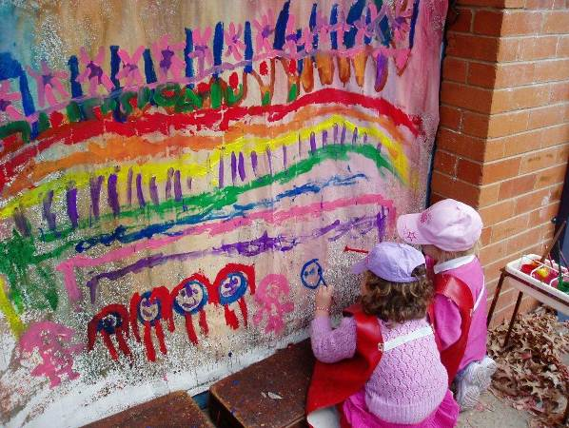

Children need to feel secure and happy as they learn and develop confidence within themselves and the preschool environment. We aim to excite and ignite a lifelong love of learning through a fun and engaging educational program.

OUR PRESCHOOL CURRICULUM
Primary Years Program
Our preschool curriculum is developed in the context of the Primary Years Program (PYP) of the International Baccalaureate Organisation (IBO).
The most significant and distinctive feature of the IB Primary Years Programme are the six transdisciplinary themes which guide our planning.
They include:
- Who we are
- Where we are in place and time
- How we express ourselves
- How the world works
- How we organize ourselves
- Sharing the planet
These six themes of global significance create a transdisciplinary framework that allows students to "step up" beyond the confines of learning within subject areas.
Within this framework the preschool teachers develop a programme of in-depth investigations into significant and enduring central ideas. Each central idea is the starting point of what we refer to as our ‘Unit of Inquiry’. After establishing what children already know, the children’s questions, thinking, research and learning drive the inquiry over many weeks.
More information on the IBO Primary Years Program is available at www.ibo.org

Early Years Learning Framework
A national early learning framework for children from birth to five years has been developed.
The Early Years Learning Framework has been developed to ensure child receive quality education programs in their early childhood settings. This is a vital time for them to learn and develop.
The Framework‘s vision is for all children to experience play-based learning that is engaging and builds success for life: https://www.education.gov.au/early-years-learning-framework-0
The Early Years Learning Framework describes childhood as a time of belonging, being and becoming.
- Belonging is the basis for living a fulfilling life. Children feel they belong because of the relationships they have with their family, community, culture and place.
- Being is about living here and now. Childhood is a special time in life and children need time to just ‘be’—time to play, try new things and have fun.
- Becoming is about the learning and development that young children experience. Children start to form their sense of identity from an early age, which shapes the type of adult they will become.
Together with the beliefs and values that drive the IBO Primary Years Program, the Early Years Learning Framework guides our pedagogy, principles and practice. Our intention is always, in partnership with families, to develop learning programs responsive to children’s ideas, interests, strengths and abilities, and to recognise that children learn through their play.
To view Education and Training Directorate policies visit www.education.act.gov.au/

Transitions
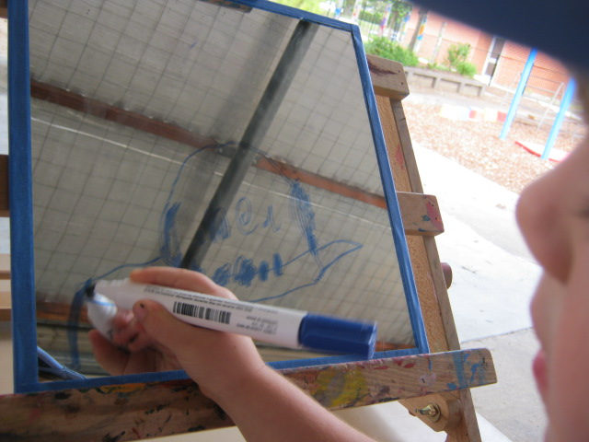
Your child is a member of the North Ainslie Primary school community. By enrolling your child into our preschools your child can automatically move on to kindergarten in our school. As with all transitions, the staff will facilitate a transition program with the goal of enabling a successful move onto primary school. To do this we have implemented a transition program for our preschool children.
This involves:
- a primary school 'buddy program' which involves developing individual relationships with year five North Ainslie Primary school children throughout the preschool year. The buddy program runs during our normal preschool session times
- engaging with the school band through special performances for the preschool group
- participating in any relevant primary school activities e.g. the school art programs.
- utilising the primary school building and outdoor facilities so that children develop familiarity with the setting, and
- participating in orientation visits to North Ainslie Primary school in Term 4 of their preschool year.
For more information about this topic please follow the link to this website for some handy hints: Starting school - a guide for parents :www.parentlink.act.gov.au
Excursions and Incursions
Excursions are part of the educational program at the North Ainslie and Hackett Preschools. On enrolment, parents are asked to give permission for their child to go on incidental excursions e.g. walk to the shops or around preschool. If children use any form of transport, parents will be advised in advance and asked to give permission, in writing, for their child to attend. The adult/child ratio is 1:4 on major excursions as required.
Library
Both North Ainslie and Hackett Pre-schools have an extensive library of books. Children are encouraged to borrow books weekly to foster their literacy skills at home. Children need to have a separate cloth bag to protect library books. These are available at a small cost from each pre-school or you can buy your own.

COMMUNICATION AND COLLABORATION
We recognise families as children’s first and most influential educators. We value the unique insights families have about their children. Open communication and collaboration between staff and families better enables us to ensure our program is responsive to individual children’s ideas, knowledge, culture, abilities and interests.
Time to talk
- At the beginning of the year time is set aside for families to meet with staff and share information about their child so that we can facilitate a positive transition to preschool that is responsive to their child’s needs.
- At the end of semester one, time is set aside again for parents to have an appointment with the teacher to share information about your child’s learning at preschool.
- We encourage parents to check in with staff before or after session by phone or in person with any questions, concerns or to make an appointment with the teaching staff.
- We also provide parents with statements of learning at the end of each semester highlighting aspects of your child’s journey throughout their preschool year.

Collaboration within the program
- Each current ‘program of inquiry’ is posted on the parent notice board alongside ongoing program plans outlining day to day events.
- Parents/carers are invited to read and contribute to our unit of inquiry board in the classroom at any time. This display gives information about the ‘central idea’ we are investigating, and tracks the children’s thinking, questions and discoveries throughout the unit. Looking at the inquiry board with your child is a valuable tool for finding out about your child’s current thinking.
- School newsletters and family questionnaires give insights to the current preschool program and future program plans.
- The teacher reports on the current program and collaborates with parents about future plans at each parent committee meeting. Parents are encouraged to attend these meetings.
- It should be noted that some units of inquiry explore the culture, heritage, backgrounds and traditions of children in our preschools and seek to promote tolerance and respect for others (Early Years Learning Framework, Education and Training Act). Due to the nature of these units there may be reference to different religions in the context of clothing and special occasions. We understand that this may be of concern to some families and will respect parents’ wishes in this regard. Please contact your child’s teacher if this is the case.

Parent involvement
- We welcome families to share their skills and expertise within our program. These may include job expertise or interests related to units of inquiries, music, storytelling, cooking or sharing significant cultural events.
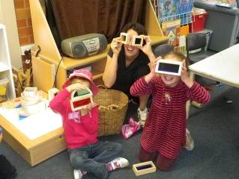
- Parents are encouraged to participate in the program. The type and amount of involvement is flexible to suit individual families. This may be in the form of assistance with food routines, working with small groups or individuals, supporting children’s investigations/play, bringing any interests to the program such as music, art, literature or sports. The opportunity to participate in the program gives parents valuable insight into their child’s experience at preschool as well as an opportunity for the building of relationships between families and their child’s preschool community.
- Families are encouraged to participate in school social activities to enable them to meet each other and form a sense of belonging to the school.
- Other ways parents can contribute include volunteering to wash laundry, helping out at working bees, assisting with supervision at excursions, and becoming an active member of our parent association. All of these roles help with the smooth running of the program and enhance the students’ learning outcomes.

Contribution to decision making
Families are welcome to contribute to decision making procedures of the school through the preschool parent committee, the North Ainslie Primary School Board and the North Ainslie Primary School P&C.
Board
Each government school in the ACT is administered by a school board whose membership comprises the school principal, two elected staff members, three elected members of the parent body and a nominee of the Department of Education. Elected members normally serve for a two-year period.
The Board is the policy-making body of the school. Its major functions are to:
- determine the educational policies to be implemented at the school
- assess, from time to time, the needs of the school in relation to the provision of buildings and facilities, equipment, funds and teachers and other staff, and make recommendations to the Chief Executive (of the Department of Education)
- determine the purposes for which funds made available for the School are to be expended
- make recommendations to the Chief Executive in respect of the use of the buildings, facilities and equipment of the School for purposes other than school purposes
- develop relationships between the school and the community and between the school and community organisations, and
- make recommendations to the Chief Executive on matters relating to the school.
Responsibility for the implementation of policies established by the Board rests with the Principal.

Preschool Parents and Citizens Association
The North Ainslie Preschool Parent Associations (PPA) are incorporated bodies made up of families who have children currently attending the preschools. An AGM is held at the beginning of each year to elect the office bearers of the incoming parent association bodies. All parents of enrolled children are automatic members and are welcome to attend meetings throughout the year.
Each PPA has a valuable role in supporting the preschool programs through fundraising, purchasing of resources to enrich the program and assisting with the costs of excursions and incursions. Parent association meetings are also a valuable opportunity for the parents to get more insight into, and have input in, their children’s preschool program, and to meet other families.

Participation of volunteers
Our school values the many ways parents participate in the preschool experience. All parents are asked to fill out a ’Nomination form for Volunteers’ (found in your enrolment pack) so that you are legally covered to be involved in the planned and spontaneous experiences that arise at preschool throughout the year.
When you volunteer at preschool more than 7 days in a 12 month period you need to register and apply for a ‘Working with vulnerable people’ (WWVP) card, which can be completed online at- www.accesscanberra.act.gov.au. Volunteers are asked to comply with the Code of Conduct for Volunteers. This code of conduct has been formulated to clarify the type of conduct that is expected of volunteers when participating in programs and activities in ACT Government schools
Volunteers have a special place in schools and assist in many ways. This may include:
- interacting with individuals and small groups of students in a range of different activities
- assisting the school in providing a safe environment and a positive educational climate
- observing similar standards of behaviour and ethical conduct to that required of staff. For example, you are expected to act within the law, be honest and fair, respect other people (including students), and work to the best standard of your ability
- observing confidentiality in respect of all information gained through your participation as a volunteer. Volunteers should not discuss nor disclose personal information about students, staff or students’ parents/carers to others
- accepting and following directions from the principal/supervisor and seek guidance through clarification where you may be uncertain of tasks or requirements
- observing safe work practices which avoid unnecessary risks, applying reasonable instructions given by supervisors and report to staff any hazard or hazardous practice in the workplace, and
- reporting any problems as they arise to your teacher including injury or property damage.

VOLUNTARY CONTRIBUTIONS
Public education is free. Our preschool may offer or facilitate some specific optional items, activities and services for which parents may be asked to pay if they want their child to access them. This may include events such as excursions, specialist music programs and class photos.
Schools do ask families to contribute a voluntary contribution to enable them to continue to resource a quality play based learning environment for our children.
Purchases rely upon the commitment and generosity of our parent community.

STUDENT WELFARE AND MANAGEMENT
At North Ainslie Primary School we value that everyone is an individual and that we all have the special qualities that make us who we are. It is important that students are treated with respect and by valuing their uniqueness and what they bring to the school. We provide a supportive, welcoming and culturally inclusive educational environment where students feel safe and happy. The school has a Student Management and Wellbeing policy that outlines the steps for addressing student welfare and management issues. North Ainslie operates within a restorative and relational practices framework.
Delivery and collection of children
Regular attendance is important as this allows the children to settle into routines and establish themselves as part of the group. In accordance with the National Quality Standard, collection of children must be by a parent or authorised nominee.
Please do not leave your child at pre-school before normal starting time as staff are preparing for the day or attending meetings and are unavailable to supervise children. It is really important that you hand your child to a staff member each morning so that we know your child has arrived at pre-school.
Pre-schools cannot operate without two qualified staff members and occasionally it may be necessary to close the pre-school for the day when relief staff are not available.
The attendance record at preschool is in the form of a class roll which is filled out at the start and end of each session. If your child is brought to preschool after morning roll time or is collected before the end of session parents or the authorised nominee are required to sign their child in/out.
Changes to details
Please keep preschool staff and the school informed on admin@nthainslieps.act.edu.au of any changes to address, email contact, home/work phone numbers, child care arrangements, medical information and emergency contact phone numbers. However, please keep telephone calls to the preschool during session times for urgent matters only as it is disruptive to the program.
Emergency management procedures
The school has a policy on emergency evacuations and lockdown procedures and are required to practise these evacuation procedures each term. All staff and children participate.
Information on hygiene procedures
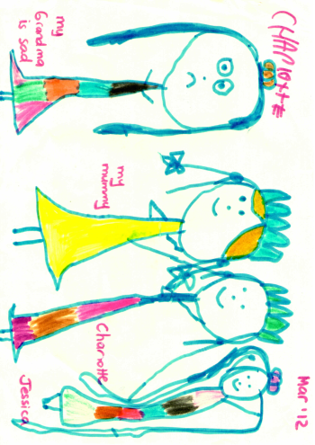
Staff, children and volunteers must adhere to the hand washing procedures.
All children are encouraged to wash their hands:
- on arrival
- before and after eating or touching food
- after toileting
- after blowing their nose and wiping tears
- when leaving the preschool
All scratches and cuts must be covered.
Food
Provision is made for the children to eat during the preschool session. Parents/carers are urged to provide children with healthy snacks and lunch which will enable the staff to assist in the development of lifelong healthy eating habits. All children will need their own drink bottle with water only. Please note: North Ainslie preschool is a nut aware school due to the inclusion of students with life threatening anaphylactic allergic conditions. Please bring non nut foods to preschool.
Food safety tips for homemade lunches & snacks
Healthy lunches and snacks are important for children and help with their concentration and learning. School lunches however are particularly susceptible to food poisoning, especially in the summer heat. Parents and carers are reminded of a few simple food safety rules to prepare safe and healthy lunches and avoid the growth and contamination of food poisoning bacteria.
- Before handling food, wash hands with soap and warm running water and dry thoroughly. Lunch boxes and eating utensils should also be washed thoroughly before reuse.
- Foods that are prepared the night before, such as sandwiches, should be frozen overnight and then taken out for each day’s school lunch. This includes leftover meals such as meats, pasta and rice dishes. Other suitable foods to freeze are: bread, cooked meat, and cheese.
- Food is normally stored in a child’s lunch box for several hours, so please ensure the lunch box is kept cool. This can be done by: choosing an insulated lunch box or one with a freezer pack, or including a wrapped frozen water bottle to keep the lunch box cool.
- Perishable foods such as dairy products, eggs and sliced meats should be kept cool, and eaten within four hours of preparation. Don’t pack these foods if just cooked; first cool in the refrigerator overnight.
- Healthy drinks (water and milk) can be frozen overnight and then stored in your child’s lunchbox, helping to keep it cold. Water is the school’s preferred drink.
- Although we are not able to refrigerate children’s lunch boxes at school, teaching staff ensure children keep their lunches in cool places away from direct sunlight and other heat sources that facilitate the development of food poisoning bacteria.

North Ainslie Essential Agreement- Healthy Eating at Our Preschools
We believe that the early childhood education setting has a key role to play in developing healthy eating and drinking behaviours in young children.
The purpose of this agreement is to promote North Ainslie School’s Healthy Eating Guidelines and the related ACT Education and Training Directorate policy.
Whilst acknowledging and respecting the diversity and beliefs of our community, we agree to:
1. provide opportunities for teachers and parents to increase their knowledge of nutrition and the “traffic light” system(Next Page)
2. encourage the eating of healthy foods at preschool by providing a list of healthy food options for lunch boxes and celebrations,
3. promote healthy eating and drinking at preschool by providing healthy options at community events, for example, Fiesta, fetes, Bunnings and garage sales
4. abide by the Directorate policy by not undertaking fundraisers that only offer unhealthy options, for example, chocolate fundraisers, and
5. incorporate green and amber foods into the educational experiences at preschool, including gardening and cooking.

Birthdays and family celebrations
Our preschools wish to acknowledge children’s birthdays and family rituals. If families wish to bring a cake please include a list of ingredients. This enables us to cater for allergies within the group.

THE TRAFFIC LIGHT SYSTEM
The National Healthy School Canteen Guidelines use a traffic light system to categorise food and drinks according to their nutritional value and levels of energy, saturated fat, fibre, sugar and salt. The Traffic Light System is as follows:
Adapted from the National Healthy School Canteen Guidelines 2013.

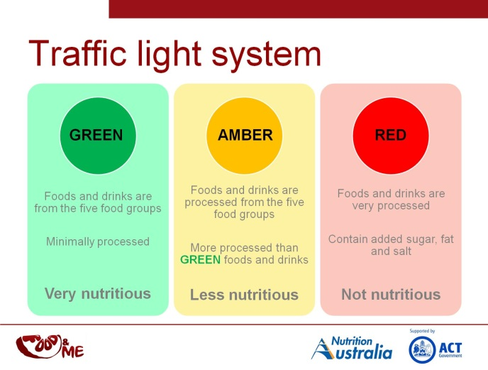

Sun smart practices
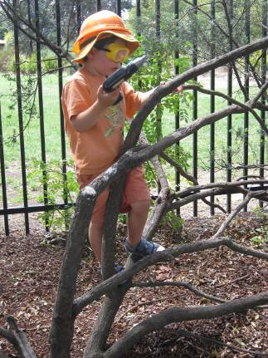
North Ainslie is a sun smart school. Children are required to wear a broad brimmed or legionaries hat outside all year with the exception of June/July which are hat free months within the sun smart guidelines. We recommend you remove any cords from hat for children’s safety. In accordance with our sun smart policy if children are not wearing a hat they are required to play in the shaded areas whilst outside.
Our preschool programs also avoid children being in direct sun areas during peak ‘UV’ periods of the day.
Please apply your child’s sunscreen before starting preschool each day. Sunscreen is available at preschool for your child to re-apply.
Further information on our sun smart policy is displayed on the notice boards at both preschools.
Children’s clothing
Children are offered a range of valuable sensory experiences at preschool, both inside and out. While smocks and precautions such as pulling up sleeves are supported by staff, clothing showing evidence of children’s fun and learning is often unavoidable. Families are advised to send children in ‘play clothes’ that enable them to immerse themselves in these valuable experiences without being concerned about their clothes.
Physical play including running, climbing, balancing, jumping, kicking balls is also an integral part of the program. Ensuring your child’s clothing and footwear supports this activity enables them to safely challenge their physical skills. Footwear such as thongs and ‘croc’ sandals affect children’s stability and grip, therefore compromising their safety. Please send your child to preschool in covered and comfortable walking shoes. Long skirts and dresses can also be dangerous, particularly when participating in physical activities. A warm coat and hat is required in winter.
Please label all of your child’s clothing and belongings and pack a spare set in case of messy play or accidents.
Child protection practices
All employees in schools are mandated to report any case of suspected child abuse. Failure to notify suspected physical and /or sexual abuse of children is a criminal offence.
Staff will deliver lessons to children in protective behaviour and safe behaviours. Staff will also deliver lessons to build on children’s social and emotional skills.
Immunisation
The ACT Department of Health advises that all children attending school in the ACT should be immunised against diphtheria, tetanus, whooping cough, polio, measles, mumps, rubella and HIB (Haemophilus influenzae type b). We would ask that you check your child's present immunisation status to see whether it is complete for his/her age. ACT Public Health regulations require schools to request proof of up to date immunisation when enrolling. Failure to provide this may result in your child being excluded from school should an outbreak of an infectious disease occur. A copy of exclusion periods for students with infectious diseases is provided below. Parents are asked to adhere closely to these requirements unless medical advice to the contrary is provided in writing.

Medical and Accidents
It is important that sick children are kept at home for their own comfort as well as the comfort of other children and staff. If a child becomes ill or is injured at school appropriate First Aid will be given and if necessary parents will be notified and asked to take their child home. If emergency treatment is required parents will be notified immediately and the child will be transferred by ambulance to hospital. In such cases ambulance services and treatment are free. All students who have an ongoing condition (e.g. asthma, diabetes, epilepsy) must have a treatment plan completed by parents and their GP and lodged at preschool (as soon as possible). Plan proformas are available from the Front Office or from a staff member in the preschool.
If a child is to take a prescription medicine while at school, written directions and labelled medicine must be left with staff. Information on a child’s health status e.g. epilepsy, diabetes, should be given on enrolment or on diagnosis. If the health problem is serious please provide an up to date photograph of the child so it can be placed on our Medical Alert board.
Head lice are extremely contagious but easily eradicated. Children with either eggs or live lice will be excluded from school until written evidence of treatment is produced. Please report any cases of head lice to the teacher.

Diseases - Outbreak procedures and exclusion periods
Personal hygiene measures such as hand washing, covering the mouth and nose when coughing or sneezing, covering weeping sores, not sharing food or drinks and not attending school when ill or suffering from diarrhoea are important means of limiting the transmission of a number of common infectious conditions.
The ACT Public Health Regulations 2000 require children with the following conditions, and children who have been in contact with the following conditions, to be excluded from school or preschool for the periods specified.

Condition | Exclusion of person with condition | Exclusion of persons in contact with condition
Amoebiasis (entamoeba histolytica) | Exclude until diarrhoea ceases | Not excluded
*Campylobacteriosis | Exclude until diarrhoea ceases | Not excluded
Chicken pox (varicella and herpes zoster) | Exclude until the last blister has scabbed over.  The child should not continue to be excluded by reason only of some remaining scabs. | Not excluded  Any child with an immune deficiency (eg with leukaemia, or as a result of receiving chemotherapy) should be excluded for their own protection and seek medical advice and varicella-zoster immunoglobulin (ZIG), if necessary.
Conjunctivitis (acute infectious) | Exclude until discharge from eyes ceases. | Not excluded
*Cryptosporidiosis | Exclude until diarrhoea ceases | Not excluded
Diarrhoea | Exclude until diarrhoea ceases | Not excluded
*#Diphtheria | Exclude until—  (a) at least 2 negative throat swabs have been taken (the first not less than 24 hours after cessation of antibiotic treatment and the second not less than 48 hours later), and  (b) a certificate is provided by a medical practitioner recommending that the exclusion should cease. | Exclude family and household contacts until approval to return has been given by the Chief Health Officer.
Giardiasis | Exclude until diarrhoea ceases | Not excluded
*#Haemophilius influenza type b (Hib) | Exclude until a certificate is provided by a medical practitioner recommending that the exclusion should cease. | Not excluded
Hand, Foot and Mouth disease | Exclude if—  (a) child is unwell, or  (b) child is drooling, and not all blisters have dried or an exposed weeping blister is not covered with a dressing. | Not excluded
*Hepatitis A | Exclude for at least 7 days after the onset of jaundice and a certificate is provided by a medical practitioner recommending that the exclusion should cease. | Not excluded
Herpes (cold sores) | Exclude young children unable to comply with good hygiene practices while the lesion is weeping. Lesion to be covered by a dressing in all cases, if possible. | Not excluded
Impetigo (school sores) | Exclude until appropriate treatment has commenced and sores on exposed surfaces are covered with a watertight dressing. | Not excluded
Influenza and influenza-like illnesses | Exclude until well | Not excluded
*Leprosy | Exclude until approval to return has been given by the Chief Health Officer. | Not excluded
*#Measles | Exclude for at least 4 days after the rash appears. | (a) Immunised contacts not excluded.  (b) Exclude non-immunised contacts until 14 days after the first day of appearance of the rash.  (b) Non-immunised contacts immunised with measles vaccine within 72 hours after first contact with the case are not excluded after being immunised.  (d) Non-immunised contacts who are given normal human immunoglobulin (NHIG) within 7 days after their first contact with the index case are not excluded after being given NHIG.
Meningitis (bacterial) | Exclude until well | Not excluded
*Meningococcal infection | Exclude until adequate carrier eradication therapy has commenced. | (a) Not excluded if receiving rifampicin or antibiotic treatment recommended by Health Officer.  (b) Otherwise, excluded until 10 days after last contact with the index case.
*#Mumps | Exclude for 9 days after onset of symptoms, or until parotid swelling goes down (whichever is sooner). | Not excluded
*#Poliomyelitis | Exclude for at least 14 days after onset of symptoms and until a certificate is provided by a medical practitioner recommending that the exclusion should cease. | Not excluded
Ringworm, scabies, pediculosis (lice), trachoma | Exclude until effective treatment has commenced. | Not excluded
Rotavirus | Exclude until diarrhoea ceases | Not excluded
*#Rubella (German measles) | Exclude for 4 days after the appearance of the rash. | Not excluded  Female staff of child-bearing age should ensure that their immune status against rubella is adequate.
*Salmonellosis | Exclude until diarrhoea ceases | Not excluded
*Shigellosis | Exclude until diarrhoea ceases | Not excluded
Streptococcal infection (including scarlet fever) | Exclude until the person has recovered or has received antibiotic treatment for at least 24 hours. | Not excluded
*Tuberculosis | Exclude until approval to return has been given by the Health Officer. | Not excluded
*Typhoid and paratyphoid fever | Exclude until a certificate is provided by a medical practitioner recommending that the exclusion should cease. | (a) Not excluded unless the Chief Health Officer notifies the person in charge of the school.
*#Whooping cough (pertussis) | Exclude for 21 days from start of cough, or for at least 5 days after starting a course of antibiotics recommended by the Chief Health Officer. | Exclude non-immunised household, home based child care and close child care contacts under 7 years old for 14 days after the last exposure to infection, or until 5 days after starting a course of antibiotics recommended by Health Officer.
Worms (intestinal) | Exclude until diarrhoea ceases | Not excluded

To view Education and Training Directorate policies visit www.education.act.gov.au/

Contact Details
Principal: Tania Collis
Deputy Principals: Rikkie Klootwijk and Dan Breen
Early Childhood Executive Teacher: Debbie Lowrey
Phone: 6142 0760 Fax: 6142 0775
Hackett Preschool- Phone: 6205 6599
North Ainslie Preschool- Phone: 6142 0770
North Ainslie Primary School website www.nthainslieps.act.edu.au
P& C Email: napscommunity@gmail.com
Education and Training Directorate Contact Details
13 2281 (62070494 TTY) www.education.act.gov.au/
Feedback
If you have feedback, or a concern about your child’s education please have a conversation with your preschool teacher. You are also welcome to contact the executive teacher- Debbie Lowrey or our Principal, Tania Collis, in the primary school. They can be reached on 6142 0760.
Should the need arise, the ACT Education and Training Directorate has a policy for complaints resolution. This policy can be accessed at https://www.education.act.gov.au/publications_and_policies
Parent Support
Parentlink- www.parentlink.act.gov.au is a website which parents can use to access:
- parents guides, including electronic order forms
- a directory of local parenting services
- upcoming community events and parenting courses

We hope you and your child have a wonderful fun filled year at North Ainslie or Hackett pre-school, where a lifelong love of learning as well as lasting friendships are formed. Every effort will be made by staff to ensure your child has a happy, safe, rewarding and memorable time at pre-school. Please feel free to become involved in all aspects of the pre-school program as this will give you greater insight into your child’s learning and your contribution will be greatly valued. We look forward to working in partnership with you to provide a stimulating educational program for your child.

