***The Gang Gang Gazette***

*Week 7, Term 3 (4th September, 2020)*

Principal: Tania Collis Deputy Principals: Rikkie Klootwijk and Sharon Moloney

School Leaders: Haeley Simms, Kate Bush, Melissa Datson and Jarryd Heywood

Board Parent Representatives: Sue Webeck, Stephen Van Gerwen and Lucy Hopkins

Board Email:  [napsboardreps@gmail.com](mailto:napsboardreps@gmail.com)

P & C President: Maree Wright [napscommunity@gmail.com](mailto:napscommunity@gmail.com)

**Upcoming Events**

|  |  |
| --- | --- |
| Year 6 Combined Band at Anslie Primary School | Monday 7th September |
| 3/4 National Gallery Excursion: Group 1  Group 2 | Thursday 10th September  Friday 11th September |
| Year 5 Combined Band at North Ainslie | Monday 14th September |
| 5/6 Excursion To Parliament | Tuesday 22nd September |

|  |
| --- |
| **Notes Home**   * Kindergarten BASE reports * 5/6 Parliament Excursion note * Chicken Pox email * Head Lice notification (1/2, 3/4 & 5/6) |
|  |
| **Board**  Next Meeting:  Tuesday, 8th September, 6.00 pm  **P & C**  Next Meeting:  Tuesday, 8th September, 6.00 pm |

Dear families and friends,

We continue to have some amazing learning happening across the school and it is a privilege to be able to see how much our teachers, assistants and students achieve together each and every week. With our focus on inquiring, wondering and asking questions, the learning is always varied. It is a pleasure to hear our students talk about the learning that has interested and engaged them across the week.

In year 1/2, the students have been celebrating the arts by making their own musical instruments and creating and performing plays. A highlight for many was learning about the man who makes instruments out of ice! Our IEC students have been learning about fairy tales, with this week’s focus on Little Red Riding Hood. Kindergarten has been busy learning about poetry, and I am delighted to be able to share some of them with you this week. They are reproduced for you later in the newsletter. In years 3/4 student have continued their unit of inquiry within the transdisciplinary theme *Where we are in place and time.* This has included learning about and building gunyas which are traditional homes built from wood and bark. There may have been some mud involved, which is always fun! In our LSUA, they have been learning all about time and writing persuasive texts. They have also had a great time being part of the consultation on the oval upgrades. The year 5’s have been learning about how personal well-being is connected to our physical health and development. Students have spent time learning about personal hygiene, sleep, nutrition and physical fitness. As part of their inquiry students have collaborated in groups to design sports clinics for their peers who are working on a particular type of fitness. The students have been working hard outside and enjoyed the opportunity to teach their peers some new skills.

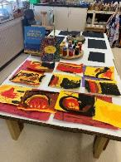The Guginyal preschool group have been continuing with their unit of inquiry *How we express ourselves* with a focus on art. Linking Indigenous Literacy Day earlier this week, Lavy read the story ‘Why I Love Australia’ by Bronwyn Bancroft. The children created artworks inspired by what they saw and heard.

For our year 6 students, the Exhibition is coming closer and they are all busily preparing to share this important milestone with their peers in years 5/6, the rest of the school and families. This year the theme is ‘Connection – In this together’. As part of this, students have been inquiring into a variety of topics including mental health, connections through food, connecting with country, body image, volunteering and racism. The students have been working collaboratively to research their issue, interview experts, conduct surveys and share their learning with others.

This year the students have been required to conduct their own ‘How might…? action questions. The 'How might...?' questions are all about the students applying the learning from the research into their daily lives. For example, I learnt that regular exercise is good for mental health so I am going to exercise every morning for 30 minutes - How might exercising every morning for 30 minutes improve my general mood and well-being? We have had quite the range of questions, which will involve the students:

- regularly complimenting others

- dressing differently

- giving up video games for a week

- not eating their favourite foods for a week

- doing regular meditation

- keeping gratitude journals

- keeping a chocolate bar close by, but not eating it

- recording their calorie intake

The students will complete daily reflections throughout this process and then share their findings. The students are looking forward to sharing their learning with the rest of the school next Friday and are also putting together a presentation to share with their family.

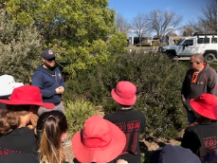**Oval Rejuvenation**

The work around our oval rejuvenation continues and I must once again thank the hardworking members of the P &C to help us learn and take that learning into our design for the oval area. It has been invaluable and the feedback on the work with both Adam ,Uncle Tyronne and Paul Barnett and his group has been outstanding.

*Cultural workshops*

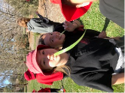This week our student leaders, sports leaders, green team leader and indigenous students participated in another round of cultural workshops with Adam and Uncle Tyronne. This time Adam and Tyronne took the students outside to explore our local environment and the range of native plants we have available at NAPS. The students learnt about plants we can eat, make into rope, use as soap and even plants that help us to catch fish. It was a great experience for the students to immerse themselves in our school environment and learn more about the uses of a range of native plants.

*Paul Barnett – Student leadership workshop*

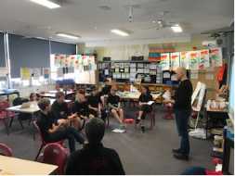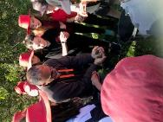Yesterday, Paul Barnett spent some time with our six student leaders as part of the consultation process for our senior oval re-design. Over the last 2 weeks, the student leaders worked with students from Years 3-6 to collate their ideas and opinions on the senior oval re-design. They then represented the student body and shared their findings with Paul. As part of the workshop, Paul took the student leaders through the design process he follows and how we connect our vision, ideas and design to create a new space for all to enjoy.  The leaders have been given some homework by Paul and will then meet with him in 2 weeks to start visualising our plans for the space.

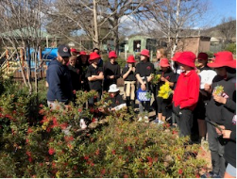

**2020 School Satisfaction & Climate Survey**

The survey has been extended again and is now open until Sunday night. Please take 10 minutes to complete the *2020 School Satisfaction & Climate Survey* and help improve our school. Enter this link [**https://tinyurl.com/y6y8owmj**](https://tinyurl.com/y6y8owmj) into your device to complete the online survey for parents before 6 September. You will need to have your child’s Student ID handy. This link may be re-used if you want to complete the survey for a second child. Please ring the front office if there are any issues with completing the survey.

This week was also the week we had our school photos taken and I am looking forward to seeing them later this year. Today we had our second online assembly, this time for our senior students. Thank you to Jarryd Heywood for all the organisation and the teachers for working so flexibly with technology so we can make them happen. Once again, the Principal’s Awards were awarded for a range of skills and across the IB Learner Profile Attributes which shows what amazing young people we have here at our school. It does remind me that the future is in good hands.

Have a wonderful weekend.

Tania Collis

Principal

Kindergarten students welcomed Spring this week with some present participle ‘ing poems’ and senses poetry as a part of our How we express ourselves UOI.

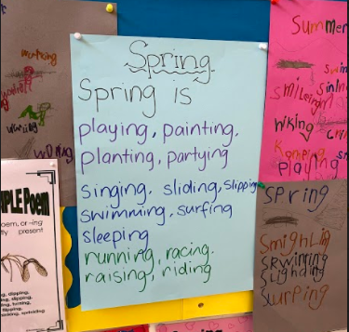

Spring

It smells like very fresh air.

It looks like leaves back on trees.

It tastes like mangoes.

It feels like a nice breeze.

It sounds like lorikeets.

*By James*

Spring

Smells like fresh air.

Looks like flowers blooming.

Tastes like lemonade.

*By Cee Cee*

Spring

It smells like lemonade.

It looks like the sun setting.

It feels like warmth.

*By Charlotte*

**Wanted: Seedling Donations for Hehub Garden**

Spring is here, and the soil is warming up! Green thumbs prepare for planting. We are seeking seedling donations for Springtime. Please drop off the seedlings to the front office or Hehub garden.

|  |  |
| --- | --- |
| * Snow peas * Cucumbers * Beans * Peas * Radish | * Carrots * Beetroot * Strawberries * Tomatoes * Cherry tomatoes (we love!) |

## NAPS P & CP&C News

Hi All,

There’s a new blog post up! Details include how the co-design process will work, and how all the great feedback and suggestions will be brought together to inform the concept sketch in weeks 9 & 10. Go to <https://napspc.com.au/blog/> for all the details.

The cultural workshops with Uncle Tyronne and Adam have been really fantastic. Thanks to all those who took the time to attend and add to the conversation. Some really great ideas came out of the workshops, and I can’t wait to see how we can incorporate them into the design.

A huge thanks also to our student leaders, who have been out gathering input from their peers in years 3-6, and also to the teaching staff for your support and assistance.

**LEAD PAINT**

By now you will be aware of the detection of some lead paint in a few non-teaching areas of the school. If you have questions or concerns on this issue, please contact the school directly or you are also welcome to give me a call or email if you prefer.

**P&C MEETING WEEK 8**

We will be holding our usual meeting next Tuesday 8th at 7:30pm, on Zoom. See you then.

**CANTEEN**

Our canteen is open Wednesday to Friday, go to the Flexischools website / app to order.

We are also welcoming volunteers back to the canteen, with enhanced hygiene and sign-in requirements for COVID.

If you would like to volunteer, please email [naps.canteen@gmail.com](mailto:naps.canteen@gmail.com) to arrange with Karen. She is particularly busy just prior to lunch, so if you can help pack lunch orders just for an hour 12-1pm, that would be great.

Maree

0431 062 423

[napscommunity@gmail.com](mailto:napscommunity@gmail.com)

P & C General Meeting

Tuesday 8 September at 7.30pm

The next P&C meeting is being held on Tuesday 8 September 2020 at 7.30pm.

The meeting will be run online only, using the video conferencing platform "Zoom". You can download the free app on your phone.

**ZOOM MEETING DETAILS**

Topic: P&C Term 3 Week 8 Meeting Time: Sep 8, 2020 07:30 PM

Join Zoom Meeting https://us02web.zoom.us/j/81600272717

Meeting ID: 816 0027 2717

One tap mobile +61861193900,,81600272717# Australia

+61871501149,,81600272717# Australia

Our agenda will include:

* Engagement Grant
* COVID-19 updates
* Oval – redevelopment
* Uniform Store
* Canteen
* Future Events and alternative options
* Lead paint and school maintenance approval

If you would like us to add any other items, please email napscommunity@gmail.com

**Healthy Eating Hub LogoTERM 3 HEHUB CANTEEN MENU (Open Wednesday and Friday)**

**Healthy Eating Canteen Menu:** **Term 3**

**We are open for recess and lunch on Wednesdays, Thursdays and Fridays**

|  |  |
| --- | --- |
| **ALL WEEK RECESS**  **NOTE: not for lunch orders, counter orders only** | |
| Yoghurt | $2.50 |
| Frozen Peas 'n' Corn cup | $1.00 |
| Fruit of the day | $1.00 |
| Frozen fruit cup | $1.00 |
| Cheesey corn fritters | $1.00 |
| Pikelets, popcorn | $0.50 |
| Toasties | $1.00 |
| Muffins | $0.50 |
| **ALL WEEK LUNCH** | |
| Vegie sticks – from the counter | Free |
| Fruit of the day | $1.00 |
| Sausage Roll (homemade) | $4.00 |
| Sandwiches (Ham, chicken, tuna or cheese) | $4.00 |
| -Add salad (lettuce, tomato, carrot and cucumber) | $0.50 |
| -Make it a wrap | $0.50 |
| -Toast it | $0.50 |
| Vegemite sandwich | $3.00 |
| Honey sandwich | $3.00 |
| Salad bowl with either chicken or tuna | $4.00 |
| Yoghurt | $2.00 |
| **DRINKS** |  |
| Milk bottle (200ml) | $2.50 |
| Soy milk | $2.50 |
| Smoothie (collect from canteen) | $3.00 |
| Juice Box | $2.50 |
| **LUNCH PACKS** |  |
| Toasted chicken/cheese + milk + fruit | $7.00 |
| Toasted tuna/cheese + milk + fruit | $7.00 |
| Toasted chicken/cheese + juice + yoghurt | $7.00 |
| Toasted tuna/cheese + juice + yoghurt | $7.00 |

|  |  |  |  |  |
| --- | --- | --- | --- | --- |
| **DAILY LUNCH SPECIALS – ALL $4.00 EACH** | | | | |
| **Monday** | **Tuesday** | **Wednesday** | **Thursday** | **Friday** |
| Closed | Closed | Mini Quiche | Spaghetti Bolognese | Pizza  Margherita or Ham/Cheese |

**How do I make a lunch order?**

Lunch orders are available to all children and are for lunch, lunch pack and drink items only.  
**They need to be received by the canteen by 9.30am.**

**Cash orders:** Should be written on a brown paper bag with your name and class**,** what you'd like to order and the correct money. Lunch or drinks items only please.

**Online orders**: Flexischools App or www.flexischools.com.au. Online orders close 9.30am on the same day as you are ordering for.

*If you have a problem with your order, please call/text the manager, not the school front office.*

Canteen manager: Karen 0406 937 139

naps.canteen@gmail.com

## After School activities

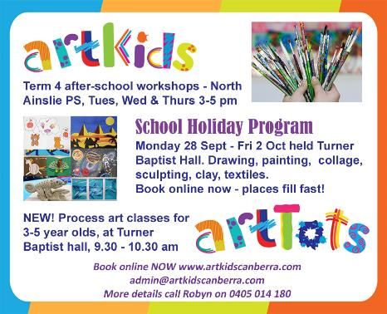

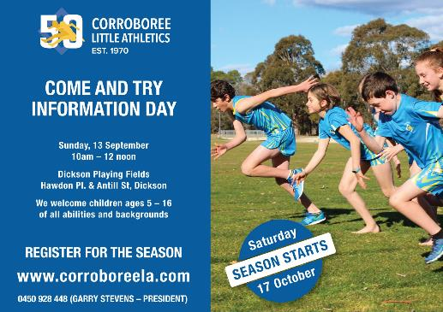



**Pro performance cricket**