***The Gang Gang Gazette***

*Week 5, Term 4 (15th November, 2019)*

Principal: Tania Collis Deputy Principals: Rikkie Klootwijk and Deborah Lowrey (A/g)

School Leaders: Haeley Simms, Alex Patterson (A/g) and Kate Bush (A/g)

Board Parent Representatives: Sue Webeck, Tara Pearce and Stephen Van Gerwen

Board Email:  [napsboardreps@gmail.com](mailto:napsboardreps@gmail.com)

P & C President: Jhay Mann [napscommunity@gmail.com](mailto:napscommunity@gmail.com)

## Upcoming Events

|  |  |
| --- | --- |
| Year 6 Bandstrav Rehearsal | Monday 18th November |
| 1/2 Indigenous Storytelling Incursion | Monday 18th November & Friday 22nd November |
| Year 6 Bandstrav at ANU Lewellyn Hall | Tuesday 19th November |
| Preschool Transition Day No 1 | Tuesday 19th November and Thursday 21st November |
| K-6 School Transition Morning | Tuesday 19th November and Thursday 21st November |
| Senior Assembly, Hosted by Year 5 | Friday 22nd November |
| P & C Movie Night (5.30pm) | Friday 22nd November |
| Kindergarten Firefighter Visit | Monday 25th November |
| Swimming Lessons (3, 4, 5 ,6) | Week 7 and Week 8 |

|  |
| --- |
| **Notes Home**   * 1/2 Larry Brandy Storytelling Workshop * 3/4 Camp Group 1 (email) |
|  |
| **Board**  Next Meeting:  Tuesday, 3rd December, 6.00pm  **P & C**  Next Meeting:  Tuesday, 3rd December, 7.30pm |

**Dear Families and Friends,**

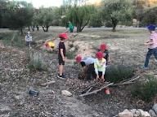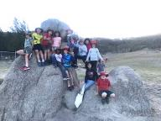Wow, what a week it has been! We started with a bit of a setback with our first 3/4 Camp Group when the high winds on Monday postponed the start of the camp at Birrigai. Thank you to our families who worked with us in the morning and to our staff who banded together with Birrigai to organise recess and lunch for the day. A huge thank you to our 3/4 teachers and students who rallied and were so flexible and resilient when the changes were announced. Just a reminder that we will be organising a day trip later this term for Group 1 to make up the missed day. Both groups have had a fantastic time, working collaboratively and demonstrating their risk-taking on activities such as the Vertical Playground. We have enjoyed seeing the pictures and videos on our School Story posts over the week.

**Year 6 Exhibition**

On Wednesday night we had our Year 6 Exhibition opening for family and friends. Students and teachers shared their journey over the last 10 weeks with a fabulous start in the hall . Our students’ reflections on themselves as inquirers and learners were amazing and demonstrated just how much they have grown and all they have learned on the transdisciplinary theme of *Sharing the Planet.* Under this guiding idea, they explored a range of topics from sustainable housing, through to gender equality, fast fashion, homelessness, disability education, equality in sport and the causes and impacts of Climate Change. When talking to everyone who attended the Exhibition, the one key piece of feedback was how well each and every student could speak about their inquiry. They have shown how they can understand these big ideas, engage in quality research and inquiry and make considered choices about how to take action. In his reflection on the process Mr Heywood shared some of these actions which included a student who interviewed a minister on climate change, the group who ran a junior sports club for girls, those who organised care packages for the homeless and the student who toured a school for students with a disability? Some of this action will continue next week when many of the stalls at our Sideshow Alley at the P and C Movie Night will be fundraising for their chosen charity. Jarryd also shared the impact the students’ action has personally had upon him.

*Never did I think I would participate in a vegan challenge and eat no animal products for a week. Nor did I think, 2 weeks later, I would still be eating scrambled tofu and sipping on soy chai lattes. I also didn’t really get a choice when 2 girls signed me up to a composting service in my local suburb, which I now use religiously. But that’s what happens when you work with an inspiring group of young people who have passionately pursued their learning for the last 10 weeks*

After starting their Exhibition journey watching the film 2040, they enthusiastically showed all of us just what bright futures they have, and how they will be changing the world someday whether they be small, private changes or big public ones for all to see. On behalf of our year 6 students, we would like to ask you what you think you might be able to do to have an impact on our world - What’s your 2040?

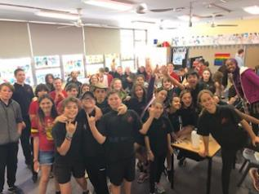

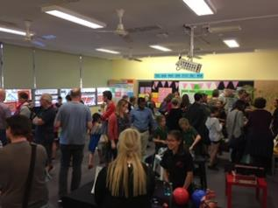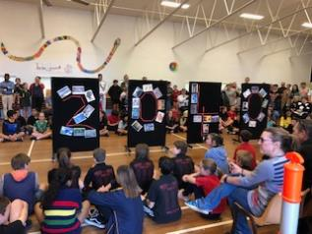

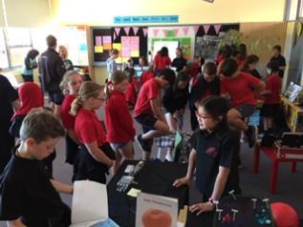

**Donations for Sideshow Alley**

Some of our senior students will be holding stalls at the P & C’s Movie Night next week to raise funds towards school projects and for charities of their choice. If you are able to help them out, we would love donations of:

* Individual or family blocks of chocolate
* Good quality, unwanted toys
* Good quality, unwanted books
* Large bottles of soft drink to make ice-cream spiders

**National Recycling Week**

This week we celebrated National Recycling Week. Yesterday the school held a big weigh-in with all classes weighing their waste for the day. All week, classes have been encouraged to think about how much waste they are creating and used their learning in their inquiries to think about their choices and how to take action. Thanks to our student Green Team and our PACH Teachers, Amy Pepper and Kylie Giltrap, for all their organisation and encouragement of sustainability at our school.

**Year 5 Combined Band**

Tuesday saw our year 5 band combining with our cluster bands to practise and perform as one large band. Once again, they demonstrated just how far they have come in their first year as a band performing with confidence and enthusiasm. Thanks to Kath Bingham for all of her leadership of the band.

**Safe Cycle for Families - New ACT health online resource for families**

ACT Health has launched a new online resource to help families get bike riding! A range of topics are included from teaching children to ride, through to basic bike maintenance skills e.g. changing a tyre. This resource is filled with videos and downloadable posters and is worth having a browse through with your children.   
<https://www.health.act.gov.au/about-our-health-system/healthy-living/ride-or-walk-school/resources-families>

**Leaving NAPS in 2020**

If you are leaving our school at the end of the year, we would appreciate you letting us know so we can continue to plan our classes for next year. The best option is to let both your class teacher and the front office know. The best email to use is: [admin@nthainslieps.act.edu.au](mailto:admin@nthainslieps.act.edu.au)

**Semester 2 Reports**

If you do not want to receive an A to E report with your child’s school report at the end of the term, please let Rikkie Klootwijk know as soon as possible to ensure we can set the new reporting system up correctly.

Have a wonderful weekend.

Tania Collis

(Principal)

**National Recycling Week at NAPS**

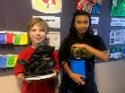National Recycling Week is a great opportunity to be mindful about the waste we create. Did you know that students at NAPS are leading the way in recycling? We have bins for mixed recycling, soft plastics, paper and cardboard, and compost our food scraps. We are also a collection point for the Container Deposit Scheme and the Lids for Kids.

This week our Green Team ran a competition to see which class would wins the title of NAPS Waste Warriors. We were impressed with all the classes efforts to reduce their landfill waste .There are four winners of the waste-free popcorn party. Congratulations to the Waste Warriors:

**5/6JH, 1/2YJ, 1/2SH and 1/2 (Rachel and Kate) – all with zero waste!!! Fantastic recycling.**

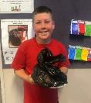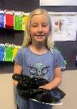

Below is an article about recycling in Canberra:

<https://www.abc.net.au/news/2019-02-17/canberra-recycling-common-mistakes-you-are-making/10793460>

Info about container deposit scheme: <https://actcds.com.au/>

**P &C NEWS**

**Cherries to NAPS…**…

Taste tested and approved! We’re bringing you some delicious cherries from Young.

2kg boxes for $27 - Go halves with a neighbour or munch the entire lot!

Martin Sullivan, a father of four, and small independant cherry farmer will be hand picking and delivering in week 9. So get your online orders in by Friday 5pm 29th November [www.napspc.com.au](http://www.napspc.com.au)

*Thankyou for supporting our local farmers and our school.



**Volunteer opportunities for "Movie Night**

Volunteer opportunities for "Movie Night" on Friday Nov 22nd are now open.

Please click on the following web link (or copy it into your web browser if clicking doesn't work) to go to the signup sheet:

[volunteersignup.org/XJ7CM](https://volunteersignup.org/XJ7CM)

To sign up, just follow the instructions on the page. It only takes a few seconds to do.

Thank you for volunteering!  
**Rachael Harris**  
[napscommunity@gmail.com](mailto:napscommunity@gmail.com)

**North Ainslie Primary Movie Night**

**North Ainslie Primary School Community Raffle**

**Once again we are raising funds for library books, sports equipment and upgrading the senior playground.** We have distributed raffle tickets for you to sell to your family and friends. Make sure that the ticket stubs are filled out & returned so we can notify the winners.

Please place the ticket stubs, money & any unsold tickets in the provided snap lock plastic bag and return to school by Friday November 22nd. Return to the front office or in the silver boxes in the school corridors.

If you would like more tickets to sell, please email [napscommunity@gmail.com](mailto:napscommunity@gmail.com). Thank you so much for raising funds for our school!

**There are 10 fantastic prizes, worth $2500 in total!!**

**1st Prize:** (prizes valued at $742)

* **Restaurant 86** voucher ($300)
* **Team Fitness Dickson** 3mth membership ($375)
* **Street Theatre** double pass ($72)

**2nd Prize:** (prizes valued at $292)

* **Pilot Restaurant** voucher ($200)
* **Canberra Symphony family PROMS** voucher ($92)

**3rd Prize:** (prizes valued at $267)

* **The Old Canberra Inn** voucher ($150)
* **Street Theatre** double pass ($72)
* **The Dinosaur Museum** family pass ($45)

**4th Prize:** (prizes valued at $330)

* **Photography By Kobi-Lee** session ($300)
* **Breizh Cafe** voucher ($30)

**5th Prize:**  (prizes valued at $192)

* **Assembly Restaurant** voucher ($100)
* **Street Theatre** double pass ($72)
* **The Games Capital** voucher (20)

**6th Prize:** (prizes valued at $210)

* **Mojo** guitar lessons ($190)
* **The Games Capital** voucher ($20)

**7th Prize:**  (prizes valued at $160)

* **Tip You’re It** voucher ($70)
* **Shaw Vineyard** wines x2 ($40)
* **Polo Restaurant** voucher ($50)

**8th Prize:**  (prizes valued at $125)

* **Massage Therapy @ North Canberra Osteopathy** voucher ($100)
* **Capital Brewing Tour** ($25)

**9th Prize:**  (prizes valued at $90)

* **Ainslie IGA** voucher ($50)
* **Siam Twist Restaurant** voucher($40)

**10th Prize** (prizes valued at $100)

* **Dickson Tradies** vouchers ($50)
* **Bec Taylor School of Music** voucher ($50)

**Upcoming Events**

## Ricky Stuart House Open day

Ricky Stuart House is a short term accommodation service for children age 5 – 13 with disability. Ricky Stuart house is  a six bedroom spacious house which features a beautiful outdoor area, a sensory room with a home away from home warm environment. We cater to the needs of your child and provide fun activities and outings. We accept bookings with a minimum stay of three hours. We are open 52 weeks of the year. Rates are in line with the NDIS price guide as we are an NDIS registered provider.

We are opening the house for families, carers and service providers interested in using our service on Friday 22 November from 10 – 2 at 70 Maclaurin St Chifley. This event will also feature providers and services for children within the Canberra Community.

Come along and have a cuppa and a chat! Please RSVP to [Michelle.Groeneveld@marymead.org.au](mailto:Michelle.Groeneveld@marymead.org.au).



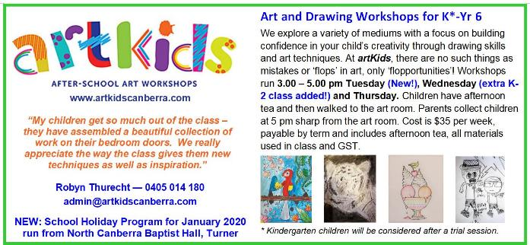

## Bricks 4 Kidz

## Healthy Eating Hub LogoTERM 4 HEHUB CANT EEN MENU (Open Wednesday, Thursday Friday)

**Recess**

A selection from the following:

Frozen Peas ‘n’ corn cup $1.00 Fruit of the day / Apple slinky $0.50 / $1.00

Pikelets, Popcorn (VG) $0.50 Toasties $1.00 Frozen fruit cup $1.00 Vanilla Yogurt (V, GF) $2.00

Banana muffin (v, DF) $1.00 Cheesy Corn Fritters $0.50

**Lunch**

Vegie sticks Free Fruit of the day $0.50

Vegemite sandwich (VG) $2.00 Vanilla Yogurt (V, GF) $2.00

Tex Mex toasted wrap(V) $2.50 Milk bottle (150ml) $1.50

Soy milk (VG) $2.50 Tuna & cheese toasted sandwich $3.50

Smoothies $2.00 (collect from canteen) Baked Potato with Salsa+/- cheese (GF) $ 3.50

**Daily Lunch Special- $3.50**

**Wednesday: Thursday: Friday:**

*Pizza(V) Chicken Burger (DF) Sushi Tuna or Veg (GF, DF*