***The Gang Gang Gazette***

*Week 5, Term 3 (23rd August, 2019)*

Principal: Tania Collis Deputy Principals: Rikkie Klootwijk and Deborah Lowrey (Acting)

School Leaders: Marni Payne, Kate Stear, Alex Patterson and Kate Bush

Board Parent Representatives: Sue Webeck, Tara Pearce and Stephen Van Gerwen

Board Email:  [napsboardreps@gmail.com](mailto:napsboardreps@gmail.com)

P & C President: Jhay Mann [napscommunity@gmail.com](mailto:napscommunity@gmail.com)

## Upcoming Events

|  |  |
| --- | --- |
| Book Week Parade | Monday 26th August |
| Father’s Day Stall | Tuesday 27th August |
| Wear It Purple Day | Friday 30th August |
| District Athletics Carnival | Friday 30th August |
| P &C Trivia Night | Friday 30th August |
| School Photos | Wednesday 4th September & Thursday 5th September |
| Preschool Photos | Tuesday 3rd September & Thursday 5th September |
| Junior assembly hosted by 1/2CL & 1/2KW | Friday 6th September@ 12 pm |

|  |
| --- |
| **Notes Home**   * Year 6 Exhibition Information Session email * Year 1/2 Swimming Clothes email * Canteen Online Order email * Student Email Addresses email |
|  |
| **Board**  Next Meeting:  Tuesday 10th September, 6.00 pm  **P & C**  Next Meeting:  Tuesday, 10th September, 7.30pm |

**Dear Families and Friends,**

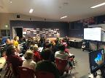As I write this week’s newsletter, we are now half way through the term and heading towards our Student Led Conferences which will be in the week of 9th – 13th September. This week is such an important part of sharing each child’s learning journey with their family and a chance for us to celebrate working together as a community. It was an important week for our families with students in year 6 as they had their information night about the upcoming Exhibition which is the culmination of the IB, Primary Years Programme. Thank you to the 5/6 teachers for hosting the night which received fabulous feedback from all our families. Having the opportunity to start this process with their children, and play an active part in the entire journey is so valuable for them in their child’s last year of primary school.

This week our 1/2 students attended swimming and Aqua Safe lessons. Thank you to Sharon Hickey who coordinated the program, which is a mammoth task. Thanks also to all teachers and students for representing our school in such a principled manner. Swimming also shows us how well you take risks with your learning and is part of being a balanced person.

**ACT Hockey Representation**

Congratulations to Thomas V G who has spent the week representing the ACT at the Australian Hockey Championships in Bendigo. I was able to see part of his game on Monday through a live stream and he has sent me some pictures and a reflection on his week.

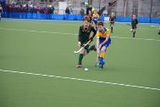*It’s been a very busy week. We have won against Tasmania and Queensland and lost against NSW, SA and WA. We still have games today, but the standard of hockey has been extremely high and very rough and umpires have been giving out lots of cards. We caused the upset of the tournament yesterday with our 2-1 win against an unbeaten QLD. The week hasn’t just been about hockey there has been trips to local Gold Mines, a historical tram museum, parks and gardens, tram rides, the cathedral, dragon museum and Bendigo Pottery and we even saw the original Myer store. As well as pre and post-match game education sessions which usually take an hour before the game and 45min to an hour after the game. We have had team dinners which are very loud and fun and yesterday we celebrated our big win against Qld by going to cold rock for ice cream. At the end of each game we shake hands with the opposition and swap pins from our home state. This is a tradition that has been going since school sport started many years ago.*

*Thank you for giving me permission to trial for school sport hockey and allowing me this great opportunity to represent NAPS and the ACT. I have had so much fun, learnt so much and had a great week. I am the youngest in the team and cannot wait to do it all again next year.*

**Active Streets**

As an Active Streets School, we have the opportunity to have wayfinding stencils installed around our school. These stencils show the preferred and easiest ways to get to school. This link shows the draft map for our school. Any feedback can be emailed to our admin email address.

[North Ainslie Primary School’s draft map](https://drive.google.com/open?id=1aNYQDJcxZujQdpZcpT477_vBpB840tD0)

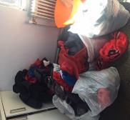**Lost Property WE NEED YOUR HELP**!!  
This is the un-named lost property from just the last few weeks. If items are labelled we can return them in a timely manner so we would appreciate you writing your child’s name on their property and clothing.   
We also have some pictures of some items that you might recognise. We will be taking all of this to the second hand shops if they are not collected by Monday of next week. Please come through to see if any of the clothing belongs to your family. It is in our staff room.   
If you can help us by taking a load home, washing it and then taking it to a second hand shop, we would also be most appreciative.

**Survey on Out of Hours School Care**

You still have an opportunity to provide feedback to the ACT Education Directorate on the out of hours school care service at our school. All responses are anonymous and collated data will be provided back to individual schools.

<https://acteducation.au1.qualtrics.com/jfe/form/SV_38lzuh4MMfdCsnj>

***The School Board is an integral part of this review so feedback can also be provided to any Board Member or through their email address:*** [***napsboardreps@gmail.com***](mailto:napsboardreps@gmail.com)

**2019 School Satisfaction Surveys**

Thank you to everyone who has completed this year’s School Satisfaction Surveys. If you have not yet had the opportunity to do so, we would appreciate you providing us with this important feedback.

Have a great weekend.

Tania Collis (Principal)

**My Special Place**

Taali 5/6LK

Crystal clear water laps gently at the moss-covered rocks, causing tiny ripples to spread beautifully across the clam water. My sharp ears catch the wonderful sound of a waterfall slowly flowing down the smooth rocks. In my special place birds are always happily chirping and flapping their tiny fan like wings creating a lovely peaceful sound. The lush green leaves slowly sway to and fro creating a gentle breeze that blows my hair across my relaxed face. The smell of wet soil and trees hangs around me like a ghost on Halloween as if sitting there drawn in by the beauty of nature. The trees wave in front of me as I sit on the smooth sparkly rocks feeling dreamy and relaxed. The taste of pure water fills my mouth as I dive into the fresh aqua water.

**My Special Place**

Angela 5/6LK

My eyes glisten as I gaze at the neatly shelved books. My ears tingle as I pick up the little tiny books which whisper. I lift my nose up into the air slowly to catch a whiff of the extraordinary floral scent floating around. I feel the leathery texture of the old books as I pick one up. The rich and beautiful vocabulary fills my mind as I wonder to myself … why do books have to be so beautiful? I wipe a tear away from my eye gently.

## Healthy Eating Hub LogoTERM 3 HEHUB CANTEEN MENU (Open Wednesday, Thursday Friday)

**Recess**

A selection from the following:

Frozen Peas ‘n’ corn cup $1.00 Fruit of the day / Apple slinky $0.50 / $1.00

Pikelets, Popcorn (VG) $0.50 Toasties $1.00 Frozen fruit cup $1.00 Vanilla Yogurt (V, GF) $2.00

Banana muffin (v, DF) $1.00 Cheesy Corn Fritters $0.50

**Lunch**

Vegie sticks Free Fruit of the day $0.50

Vegemite sandwich (VG) $2.00 Vanilla Yogurt (V, GF) $2.00

Tex Mex toasted wrap(V) $2.50 Milk bottle (150ml) $1.50

Soy milk (VG) $2.50 Tuna & cheese toasted sandwich $3.50

Smoothies $2.00 (collect from canteen) Baked Potato with Salsa+/- cheese (GF) $ 3.50

**Daily Lunch Special- $3.50**

**Wednesday: Thursday: Friday:**

*Pizza(V) Italian chicken toasted sandwich (DF) Pasta beef bolognaise (DF)*

**P &C NEWS**

## Father’s Day Stall

The P&C Father’s Day Stall is happening Tuesday 27th Aug. 9.15-11am Kids can buy their Dad a gift for $1, $2, $5, $7 or $10.

If you would like to help run the Father’s Day stall please contact Rach on [napscommunity@gmail.com](mailto:napscommunity@gmail.com)

## Trivia Night



Trivia Night is just one week away! There are tons of great prizes up for grabs, including restaurant vouchers, books and games vouchers, movie tickets, gym passes and heaps more. Huge thanks to all our generous sponsors, with special mention to the NAPS parents who have gone above and beyond to give support for our school from the Old Canberra Inn, Quizzic Alley, Jim Murphy's, Capital Brewing Co, Maitland St Roasters and the Polo.

If you haven't already, you can book your table (of up to 10 people) by emailing [napsfundraising@gmail.com](mailto:napsfundraising@gmail.com).

Also, please note Trivia Night is an adult oriented event, and is not suitable for kids.

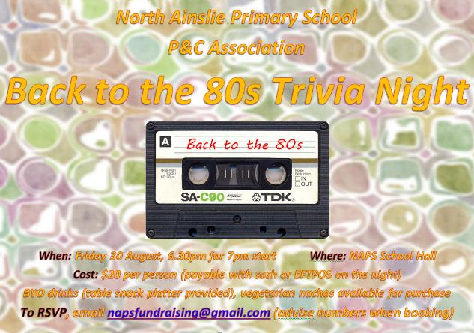

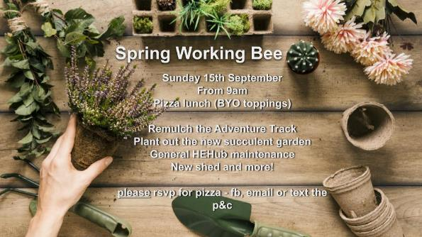

Transition to parent forum