Healthy Eating Canteen Menu: Term 4

We are open for recess and lunch on Wednesdays, Thursdays and Fridays

ALL WEEK RECESS – not for lunch orders, counter orders only
Fruit yoghurt | $2.00 | Pikelets (VG) | $0.50
Frozen Peas 'n' Corn cup | $1.00 | Toasties (V) | $1.00
Fruit of the day/Apple slinky | $0.50/$1 | Banana muffins (V, DF) | $0.50

ALL WEEK LUNCH
Vegie sticks – from the counter | Free | Tuna & cheese toasted sandwich | $3.50
Fruit of the day | $0.50 | Tex Mex toasted wrap (V) | $2.50
Milk bottle (150ml) | $1.50 | Vegemite sandwich (VG) | $2.00
Soy milk (VG) | $2.50 | Baked potato, cheese (or not), salsa (V) | $3.50

DAILY LUNCH SPECIALS – ALL $3.50 EACH
Monday | Tuesday | Wednesday | Thursday | Friday
Closed | Closed | Pizza (V) $3.50  Fruit smoothie $2 | Potato wedges (GF, VG) $3.50  Fruit smoothie $2 | Chicken burger (DF) $3.50  Fruit smoothie $2
V = vegetarian, VG = vegan, DF = dairy free GF = Gluten Free |  |  | Collect smoothie from canteen
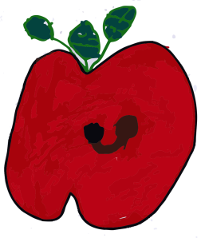
Lunch orders for years K to 6 – lunch items only
Counter sales at Recess and Lunch for years 1 to 6 only

How do I make a lunch order?
Lunch orders are available to all children and are for lunch items only.
They need to be received by the school by 9.30am.
Your cash order should be written on a brown paper bag with your name and class (eg. 1/2KG), what you'd like to order and the correct money. Lunch items only please. Online orders: www.school24.net.au (new users: school ID = 25311963). Online orders close 9am on the same day as you are ordering for.
Canteen manager: Heather 0405 266 153 or naps.canteen@gmail.com
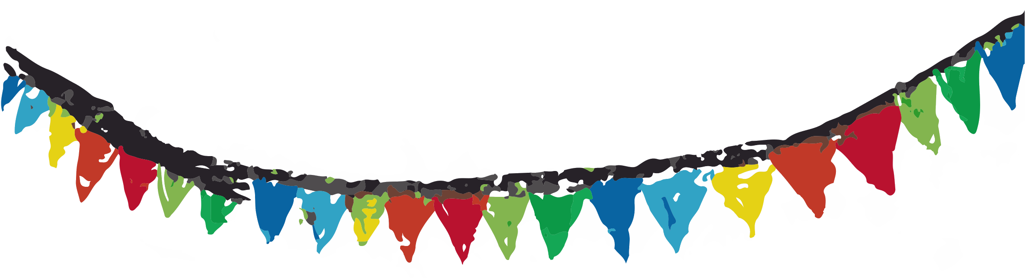
What's in our food?

All our food is made from scratch in our canteen kitchen. All menu items are vegetarian except for Thursday’s pasta and toasted tuna sandwich. Prepared tinned goods, cheese, pasta and breads do not contain preservatives. When selecting what foods we will include on our menu, we follow the national healthy school canteen guidelines and classify them using the traffic light system (Green/Amber/Red).

Menu item | What's in it?
Vegie sticks (Green) VG GF | Uncooked seasonal vegies: usually a choice of carrots, cucumber, celery plus fresh produce straight from our garden when available.
Pikelets (Green) VG | Self-raising wholemeal flour, soda bicarbonate, very small amount of sugar, rice milk. No egg or dairy.
Toasties (Green) V | Multigrain bread, pizza tomato sauce (see Pizza), mozzarella cheese.
Baked Potato (Green) V, GF  Vegan without cheese | An oven-baked potato served with reduced-fat tasty cheese and our own salsa (tomatoes, invisible vegies and mashed kidney beans, Mexican spices). Gluten free. We can leave out the cheese by request – this makes it vegan.
Tex Mex wrap (Green) V | Our own refried beans (red kidney beans, onion, garlic, spices), corn, reduced-fat tasty cheese, wrapped in Lebanese bread and toasted.
Vegemite sandwich (Amber – vegemite is salty) VG | Wholemeal bread, vegemite. No dairy - vegan.
Banana muffins (Amber – sugar and olive oil) V, DF | Self-raising wholemeal flour, wheat germ, bicarbonate of soda, banana, grated raw carrot, cinnamon, egg, rice milk, sugar, olive oil.
Pizza (Green) V | White bread flour, wholemeal bread flour, semolina, yeast, our own tomato sauce base (canned tomatoes and/or pasatta, garlic, herbs), mozzarella cheese.
Potato wedges (Green) GF, VG | Potatoes cut into wedges, brushed with olive oil and mixed with gluten free flour and spices and rosemary.
Chicken burger (Green) DF | A chicken burger made from chicken mince, grated vegies, herbs, breadcrumbs, served on a multigrain bun with lettuce and sliced fresh tomato.
Tuna & cheese toasted sandwich (Green) | Multigrain/wholemeal bread, canned tuna (sustainably-fished skip-jack), reduced-fat tasty cheese.

VG = vegan; GF = gluten free; V = vegetarian; DF = dairy free

