***The Gang Gang Gazette***

*Week 10, Term 3 (25thSeptember, 2020)*

Principal: Tania Collis Deputy Principals: Rikkie Klootwijk and Sharon Moloney

School Leaders: Haeley Simms, Kate Bush, Melissa Datson and Jarryd Heywood

Board Parent Representatives: Sue Webeck, Stephen Van Gerwen and Lucy Hopkins

Board Email:  [napsboardreps@gmail.com](mailto:napsboardreps@gmail.com)

P & C President: Maree Wright [napscommunity@gmail.com](mailto:napscommunity@gmail.com)

**Upcoming Events**

|  |  |
| --- | --- |
| Term 4 Starts | Monday 12th October |
| Book Week | Week 2 |
| Preschool Arboretum Excursion Group 1:  Group 2: | Monday 19th October  Thursday 22nd October |
| Adam Shipps Bush Tucker Workshop | Monday 19th October & Thursday 22nd October |

|  |
| --- |
| **Notes Home**   * National Arboretum Excursion (preschool) * 2021 Preschool Second Round Offer Letters * Parent Feedback, Information and Support for Term 4 (preschool) * 1/2 Bush School Wet Weather Note * Whole School Chicken Pox (email) |
|  |
| **Board**  Next Meeting:  Tuesday, 3rd November, 6.00pm  **P & C**  Next Meeting:  Tuesday, 20th October, 7.30pm |

Dear families and friends,

We come to the end of term 3 and I want to thank everyone for their continued support of all of us here at NAPS. It has been so wonderful to be able to have a whole term of face to face schooling and to see our students learning and coming together in person. Another highlight for us has been the work done as part of our oval revamp. Last week our students led the way, bringing the results of the consultation together after listening to the voices of their peers and other members of our community

Today we had further evidence of action and voice in their protest for action on Climate Change. The theme for this global day is ‘Fund Our Future, Not Gas’ and has been organised by School Strike 4 Climate Australia. This grassroots group is made up of students of all ages from across cities, towns and regional Australia. Their mission is to effect change and to unite everyone in a concern for the future of our planet. To show their support, NAPS students from a range of year levels met outside, under the junior cover, to share speeches, ideas of how we can all change our habits to make a difference, and to ask us all to join them in choosing to change our future. This weekend there will be a post on the School Story in Class Dojo and we would love you to like the post so we can have it be our most popular post ever!

## climate actionclimate action

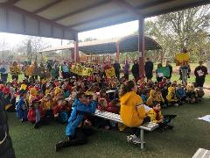climate action

**National Science Week Satellite Selfie Update**

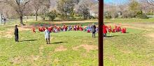Earlier in the term Kindergarten participated in the Satellite Selfie, an event presented by ACT National Science Week and the Where You Are Festival with the support of the ACT Government and The Australian National University. A satellite flew over the ACT and surrounding area and captured an image of as much of Canberra and the people in it as possible to create a time-capsule image of Australia's Capital from above. Kindy wanted to spread some happiness and colour, so decided to create a gigantic human rainbow. We have been given an update that the satellite image is taking longer than expected to process, but we are looking forward to trying to spot our human rainbow soon. Keep an eye out on Class Dojo and in the newsletter.

**Ooshies**

We know that Ooshies have become a popular collector item amongst many of our students over the last few weeks. As we head into the break, we would ask that Ooshies be left at home next term. We are unable to guarantee their safety here at school and, with so many now coming, there have been issues over ownership and challenges with children trading them. We thank you for your assistance in this matter.

**Chickenpox**

We have had two more cases of chickenpox diagnosed in the school. Both students are in year 1/2. All cases in the school so far have been in either year 1/2 or year 3/4. If you or your family has anyone who is immunocompromised or at greater risk to their health if they do develop chickenpox, please let us know at the front office so we can work with you in order to provide advice and assistance.

Have a wonderful break and we look forward to seeing you next term.

Tania Collis

Principal

## P&C News

A massive thank you to the teachers, students and volunteer parents who have contributed to the school oval project this term. The student leaders in particular, and the wider student leadership group, have been complete superstars, and have contributed enormously to the process - thanks so much for making this process richer, sharing your perspectives, and representing your peers so well. Thanks also to Jarryd Heywood and Melissa Datson for accommodating us in a very busy term, and representing *your* peers through the process. I was amazed by the sheer potential and range of options available, and the diversity of needs and wants gathered from all stakeholders. Hopefully the final design will meet all our needs - from teams sports to quiet reflection and everything in between.

We are going to hold off on unveiling the Oval draft Master Plans until week 1 next term, to allow for a better consultation process, rather than rushing to get it done by the end of the term. I can share with you some of the concepts that were created last week as we worked through journey and spatial layout.

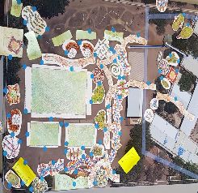 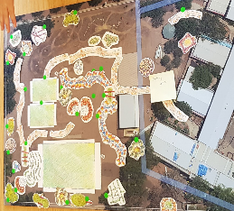

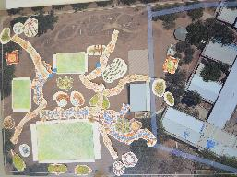 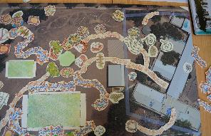

**P&C MEETINGS**

A reminder that we will be trialling P&C meetings in weeks 2 and 8 next term. So in term 4, our first meeting will be in week 2, TUESDAY OCTOBER 20TH.

**CANTEEN**

Our canteen is open Wednesday to Friday, go to the Flexischools website / app to order.

**We are also welcoming volunteers back to the canteen**, with enhanced hygiene and sign-in requirements for COVID.

If you would like to volunteer, please email [naps.canteen@gmail.com](mailto:naps.canteen@gmail.com) to arrange with Karen. She is particularly busy just prior to lunch, so if you can help pack lunch orders just for an hour 12-1pm, that would be great.

Enjoy the holidays,

Maree

[napscommunity@gmail.com](mailto:napscommunity@gmail.com)

**Healthy Eating Hub LogoTERM 4 HEHUB CANTEEN MENU (Open Wednesday and Friday)**

**Healthy Eating Canteen Menu:** **Term 3**

**We are open for recess and lunch on Wednesdays, Thursdays and Fridays**

|  |  |
| --- | --- |
| **ALL WEEK RECESS**  **NOTE: not for lunch orders, counter orders only** | |
| Yoghurt | $2.50 |
| Frozen Peas 'n' Corn cup | $1.00 |
| Fruit of the day | $1.00 |
| Frozen fruit cup | $1.00 |
| Cheesey corn fritters | $1.00 |
| Pikelets, popcorn | $0.50 |
| Toasties | $1.00 |
| Muffins | $0.50 |
| **ALL WEEK LUNCH** | |
| Vegie sticks – from the counter | Free |
| Fruit of the day | $1.00 |
| Sausage Roll (homemade) | $4.00 |
| Sandwiches (Ham, chicken, tuna or cheese) | $4.00 |
| -Add salad (lettuce, tomato, carrot and cucumber) | $0.50 |
| -Make it a wrap | $0.50 |
| -Toast it | $0.50 |
| Vegemite sandwich | $3.00 |
| Honey sandwich | $3.00 |
| Salad bowl with either chicken or tuna | $4.00 |
| Yoghurt | $2.00 |
| **DRINKS** |  |
| Milk bottle (200ml) | $2.50 |
| Soy milk | $2.50 |
| Smoothie (collect from canteen) | $3.00 |
| Juice Box | $2.50 |
| **LUNCH PACKS** |  |
| Toasted chicken/cheese + milk + fruit | $7.00 |
| Toasted tuna/cheese + milk + fruit | $7.00 |
| Toasted chicken/cheese + juice + yoghurt | $7.00 |
| Toasted tuna/cheese + juice + yoghurt | $7.00 |

|  |  |  |  |  |
| --- | --- | --- | --- | --- |
| **DAILY LUNCH SPECIALS – ALL $4.00 EACH** | | | | |
| **Monday** | **Tuesday** | **Wednesday** | **Thursday** | **Friday** |
| Closed | Closed | TBA | TBA | TBA |

**How do I make a lunch order?**

Lunch orders are available to all children and are for lunch, lunch pack and drink items only.  
**They need to be received by the canteen by 9.30am.**

**Cash orders:** Should be written on a brown paper bag with your name and class**,** what you'd like to order and the correct money. Lunch or drinks items only please.

**Online orders**: Flexischools App or www.flexischools.com.au. Online orders close 9.30am on the same day as you are ordering for.

*If you have a problem with your order, please call/text the manager, not the school front office.*

Canteen manager: Karen 0406 937 139

naps.canteen@gmail.com

## After School activities

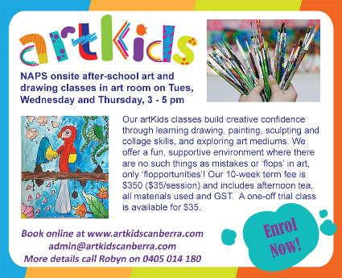

Mojo Guitar