***The Gang Gang Gazette***

*Week 8, Term 3 (11thSeptember, 2020)*

Principal: Tania Collis Deputy Principals: Rikkie Klootwijk and Sharon Moloney

School Leaders: Haeley Simms, Kate Bush, Melissa Datson and Jarryd Heywood

Board Parent Representatives: Sue Webeck, Stephen Van Gerwen and Lucy Hopkins

Board Email:  [napsboardreps@gmail.com](mailto:napsboardreps@gmail.com)

P & C President: Maree Wright [napscommunity@gmail.com](mailto:napscommunity@gmail.com)

**Upcoming Events**

|  |  |
| --- | --- |
| Year 5 Combined Band at North Ainslie | Monday 14th September |
| My Place Viewing and Mt Ainslie Excursion :  Group 1: 1/2 AC, 1/2YJ, 1/2LF and 1/2 KW  Group 2: CTS classes, 1/2SM and 1/2 CL | Thursday 17th & 24th September  Friday 18th & 25th September |
| 5/6 Excursion To Parliament | Tuesday 22nd September |

|  |
| --- |
| **Notes Home**   * 1/2 Mt. Ainslie and My Place (note) * 5/6 Movie (note) * Chicken Pox (email) * Year 5 Combined Band Rehearsal (note) * P & C Reminder (email) * IMP Audition for 2021 (Year 6 Band) * Advice regarding harmful content (email) |
|  |
| **Board**  Next Meeting:  Tuesday, 3rd November, 6.00pm  **P & C**  Next Meeting:  Tuesday, 20th October |

Dear families and friends,

Today was Exhibition - the culmination of many weeks of learning, working collaboratively and using all the attributes of the learner profile for our amazing year 6 students. I had the most wonderful morning talking to the students and hearing about all the new things they have learnt through their student driven inquiries. Their ability to talk about the content was outstanding. It was clear they had engaged in a range of rich research opportunities that have taught them so much about their selected inquiry. We had fantastic discussions which showed me they can speak articulately about the new skills they have acquired, reflect on their choices during the ride, that is Exhibition. They unpacked how they used the attributes for learning to explore their chosen topic. All of this has had an impact on them as learners. They discussed their strengths and what came easily to them, what was hard and how they might work at that as they head off to high school. Many talked about how the hardest part was narrowing down their key lines of inquiry and questions. They explained how they had worked together to determine this before starting their research. Others said that working in groups had been great but had required them to use their social and self-management skills to manage group dynamics. Some students reflected on work habits and staying focused on how they had learnt more about time management to help them finish in time for today. Their enthusiasm was palpable and the engagement they all displayed was amazing. This shows us the power of agency and voice and how ready these young people are for the next phase of their life. Congratulations to the 5/6 teachers for all their hard work for Exhibition.

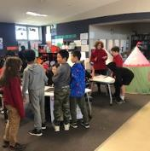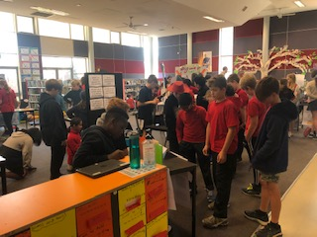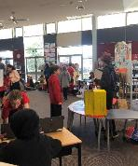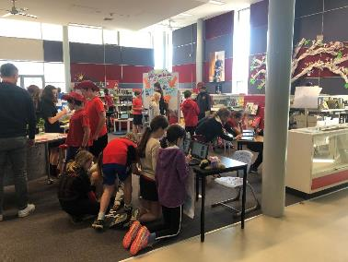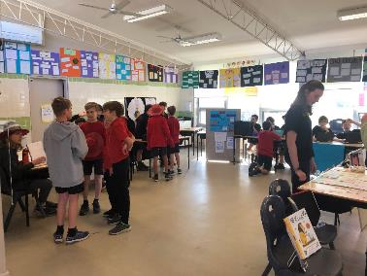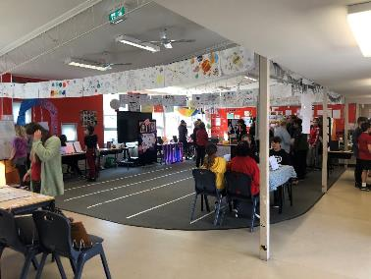

2020

Exhibition

For the first time since lockdown our year 6 students participated in a combined band rehearsal with students from other schools. I know they had a wonderful time sharing their music and playing as a larger band with all the instruments together.

Our year 3/4 students continued their UOI learning with a visit to the National Museum to see the Endeavour Exhibition which tells the stories of Cook and our First Australians. The exhibition looks at both sides of this important part of our history as a nation. The exhibits look at James Cook’s maps, the botanical works of Joseph Banks and importantly bringing in the voices of our Indigenous people.

Our work on the oval revamp continues and this week the teachers in the focus group had a session with Paul Barnett, and the combined ideas of the students were shared with him. Next week we start the very exciting first stage of pulling it all together with teachers, student leaders and Paul and his team. I can’t wait.

***Kindergarten Health Check***

Canberra Health Services is offering **a targeted kindergarten health check concentrating on vision and hearing**.

These health checks are performed  in clinics at the City Health Centre Mondays and Fridays and there will be appointments most days in the school holidays.

**An appointment can be made by phoning the** **Central Intake Line on 51249977.**

***Bike riding protocols***

It is great to see so many students riding to school, especially now that Spring is here. Could everyone please remind their children to:

* When waiting at the traffic lights to cross the road, ride carefully and wait sensibly
* Be aware of other students in the bike rack, especially younger students

Have a wonderful weekend.

Tania Collis

Principal

## P&C News

The term is fast disappearing, and we are finally getting into the gritty reality of Oval co-design. Thanks to all the families who filled in our online survey - a summary of the results is included. The teaching staff and student leaders have also gathered their ideas and needs into a list of spaces to be considered for inclusion, which we will share with you next week.

Next week is when the magic happens - our student leaders will bring all their preparation and consultation into two workshops with a few parents and teachers, where they will explore how the different elements might all go together. Once they have made the important decisions about the sorts of spaces needed, the relationships between those spaces, and how they might go together, our expert design team will refine the sketches into a few draft master plan designs, incorporating components like water harvesting, climate management (shade, wind shelter, etc), safety standards and educational & cultural elements.



These **draft master plans will be available to the whole community in Week 10 for your feedback**. Tendering for construction will begin as soon as possible after the design is finalised. I’m so looking forward to seeing our community reflected in this design and moving into the construction phase.

**P&C MEETINGS**

Our meetings have traditionally been in weeks 4 and 8. This means that there is one month and then two months between meetings. We agreed at the last meeting to trial holding meetings in week 2 and 8 instead, to spread them more evenly.

So, in term 4, our first meeting will be in week 2, TUESDAY OCTOBER 20TH.

**CANTEEN**

Our canteen is open Wednesday to Friday, go to the Flexischools website / app to order.

**We are also welcoming volunteers back to the canteen**, with enhanced hygiene and sign-in requirements for COVID.

If you would like to volunteer, please email [naps.canteen@gmail.com](mailto:naps.canteen@gmail.com) to arrange with Karen. She is particularly busy just prior to lunch, so if you can help pack lunch orders just for an hour 12-1pm, that would be great.

Have a lovely weekend,

Maree

[napscommunity@gmail.com](mailto:napscommunity@gmail.com)

## NAPS Family and Community Survey

What we asked

We asked you to tell us what you enjoyed as a child and what you thought the Senior Oval wanted and needed.

Who responded

Thank you to everyone who took part in survey. Almost a quarter of all families with children at the school responded (i.e. over 100). What a terrific response!

What we did with the data

We read all you wrote and counted the number of times different things were mentioned (e.g. turf, trees and play equipment). We also tried to understand what was behind the numbers. The concepts or ideas (e.g. choice, variety, functionality) behind the particulars. Just for fun, we entered your answers into a ‘word cloud’, which produced an image of your words. The more often a word was used the bigger it appears.

What you told us

A few things stand out from all that you wrote. These things were mentioned more than 40 times. Overwhelmingly you want to see

* open grassy spaces where kids can run and play formalised sports,
* more trees, more plants, more shade, and
* natural elements like rocks, logs and plants incorporated.

Choice was important and you told us that you want the area to have multiple spaces for different uses.

“An area that gives options to kids. A space that encourages kids to explore and also opportunity to play sports.”

Some of you expanded on this by saying there needed to be ‘age appropriate’ options that physically challenge the Year 6 students not just the Year 3. You also want more play equipment for the children to play on, in, around and under (e.g. a flying fox, a cubby or treehouse, a bridge). All of these received between 20 and 26 mentions.

Next up, you talked about creating a more 3D environment for play with hills and ditches, tunnels, and perhaps a maze. Extending the bike or adventure track was also popular, as was having quiet places where students could hang out. Many of you also commented on the poor state of the grass. Some suggested AstroTurf. Others were committed to real grass acknowledging the need for irrigation. The things in this group were mentioned 10-19 times.

Oval revamp

Oval revamp ideas

Next Steps

* This summary and the detail of the survey will be given to the Paul Barnett Design Group, and will be considered alongside the input from 600+ students and 70+ teachers (Week 8)
* A small group of students, teachers and parents will meet with the Design Group (Week 9) to consider the feedback from all three groups and determine how to best accommodate the needs and ideas of our whole community within the space.
* The school will receive two proposed designs for comment (mid Week 10).
* Final comments are due Monday, 28 September (NB First week of school holidays)
* Preparations for construction will begin Term 4, along with creating a propagation and seedling nursery.

If you want to get involved

Visit the P&C website for more information <https://napspc.com.au/home/senior-oval-reimagined/> or email us at [napscommunity@gmail.com](mailto:napscommunity@gmail.com).

**Healthy Eating Hub LogoTERM 3 HEHUB CANTEEN MENU (Open Wednesday and Friday)**

**Healthy Eating Canteen Menu:** **Term 3**

**We are open for recess and lunch on Wednesdays, Thursdays and Fridays**

|  |  |
| --- | --- |
| **ALL WEEK RECESS**  **NOTE: not for lunch orders, counter orders only** | |
| Yoghurt | $2.50 |
| Frozen Peas 'n' Corn cup | $1.00 |
| Fruit of the day | $1.00 |
| Frozen fruit cup | $1.00 |
| Cheesey corn fritters | $1.00 |
| Pikelets, popcorn | $0.50 |
| Toasties | $1.00 |
| Muffins | $0.50 |
| **ALL WEEK LUNCH** | |
| Vegie sticks – from the counter | Free |
| Fruit of the day | $1.00 |
| Sausage Roll (homemade) | $4.00 |
| Sandwiches (Ham, chicken, tuna or cheese) | $4.00 |
| -Add salad (lettuce, tomato, carrot and cucumber) | $0.50 |
| -Make it a wrap | $0.50 |
| -Toast it | $0.50 |
| Vegemite sandwich | $3.00 |
| Honey sandwich | $3.00 |
| Salad bowl with either chicken or tuna | $4.00 |
| Yoghurt | $2.00 |
| **DRINKS** |  |
| Milk bottle (200ml) | $2.50 |
| Soy milk | $2.50 |
| Smoothie (collect from canteen) | $3.00 |
| Juice Box | $2.50 |
| **LUNCH PACKS** |  |
| Toasted chicken/cheese + milk + fruit | $7.00 |
| Toasted tuna/cheese + milk + fruit | $7.00 |
| Toasted chicken/cheese + juice + yoghurt | $7.00 |
| Toasted tuna/cheese + juice + yoghurt | $7.00 |

|  |  |  |  |  |
| --- | --- | --- | --- | --- |
| **DAILY LUNCH SPECIALS – ALL $4.00 EACH** | | | | |
| **Monday** | **Tuesday** | **Wednesday** | **Thursday** | **Friday** |
| Closed | Closed | Mini Quiche | Spaghetti Bolognese | Pizza  Margherita or Ham/Cheese |

**How do I make a lunch order?**

Lunch orders are available to all children and are for lunch, lunch pack and drink items only.  
**They need to be received by the canteen by 9.30am.**

**Cash orders:** Should be written on a brown paper bag with your name and class**,** what you'd like to order and the correct money. Lunch or drinks items only please.

**Online orders**: Flexischools App or www.flexischools.com.au. Online orders close 9.30am on the same day as you are ordering for.

*If you have a problem with your order, please call/text the manager, not the school front office.*

Canteen manager: Karen 0406 937 139

naps.canteen@gmail.com

## After School activities

