The Gang Gang Gazette
Week 9, Term 1 (3rd April, 2020)
Principal: Tania Collis Deputy Principals: Rikkie Klootwijk and Sharon Moloney
School Leaders: Haeley Simms, Kate Bush (Acting), Melissa Datson (Acting) and Jarryd Heywood (Acting)
Board Parent Representatives: Sue Webeck, Stephen Van Gerwen and Lucy Hopkins
Board Email: napsboardreps@gmail.com
P & C President: Maree Wright napscommunity@gmail.com

Dear families and friends,

It is nice to be writing to you again through the newsletter now that we have settled into the new way of school for the rest of this term. I would like to take this opportunity to thank all of you for the support you have shown us over the last two weeks and the messages of thanks and encouragement we have received. It has really helped us to focus on getting ready for online learning in term 2 and to keep us feeling connected to our amazing community.

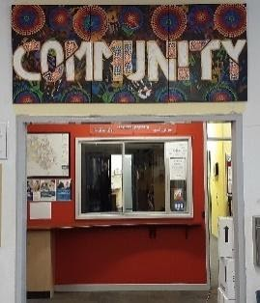
The board would like to thank Tara Pearce for her role over the last few years. We really appreciate your insight and the way you have worked with all of us on the board to make our school an even better place. We will definitely have a dinner when all of this is over and share that thanks with you in person. We would also like to congratulate Lucy Hopkins on joining the board and look forward to working with you.

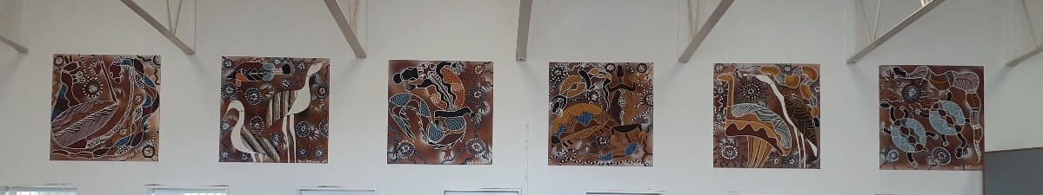
Our community would like to thank you to our amazing P&C who last week provided all our staff members with a beautiful lunch to end the week. It was very much appreciated. Thank you to the P&C for helping the school to hang some gorgeous artworks by Dale Huddleston and Jakki Kennedy, one of our parents. We can’t wait for you to all return and see them.
You might be wondering what we have all been doing these past nine days without our students and families at school. It’s been quiet and we miss you all, but we have been very busy. We have spent a lot of our days learning how to deliver online education. The teachers have worked hard to ensure the learning links to the Australian Curriculum and the IB Transdisciplinary Themes. Teachers have developed different online learning platforms for preschool to year 6. Each day, our staff participated in webinars and online learning to develop their skills and practise learning within a virtual classroom.

Playgrounds closed
We just want to remind you that with the new procedures implemented by the Government, the playgrounds, ovals and Adventure Track are closed to the public. The teachers are able to use these spaces for the children of essential workers during school hours. The YMCA can use them for anyone attending their program before or after school. These spaces have been signposted as closed after we received notification from the ACT Education Directorate that school playgrounds are included in this initiative. We appreciate your cooperation in this matter.

What will learning look like next term?
We are very proud of what we have put together and can’t wait to share it with you.

Preschool to year 2, IEC and LSUA students have had some physical resource packs collated for them that they can use as part of their learning for term 2. If you have not yet picked your pack up, please come to school to get it between 8.30am and 3.30pm next week. For the online component of their learning, preschool, kindergarten and the IEC will be using Class Dojo. Learning provocations, explicit teaching and links to resources will be posted on the Class Story and students will be able to share their learning with their teachers through the portfolio section of the application.

Students in year 1/2 will be using Google Classroom and had login details sent home last week to assist them with accessing the online classroom. For these students, learning will be uploaded each morning and will consist of provocations, explicit teaching and links to resources. Their learning can be submitted through the Google Classroom. The Google Classroom platform for year 1/2 can be accessed with a phone, tablet, Chromebook or laptop.

Years 3-6 will also be using Google Classroom. Using data supplied through the survey, we have ensured each student has a laptop, desktop or Chromebook to access their learning. For students in years 3-6, the learning will be uploaded at the beginning of each week for students to complete over the week. There will be a range of explanation, teaching and learning slides as well as links to resources.

Each week, students will have access to PE, Social and Emotional Learning (focusing on the IB Approaches to Learning and Learner Profile Attributes) and lessons from our fabulous specialist teachers in music, French, visual art and PACH.

Students will be able to catch up with their teachers through the messaging aspects of Class Dojo and Google Classroom as well as through online conferences in Google Meets. This is an online app, similar to Zoom, which is part of our Google Suite and can be accessed from any device. Conferences will be set up regularly over the course of the week. Written feedback will also be provided, and students will be able to ask questions and ask for help with their learning. Specific information for each team will be coming home via email today to support you when using these tools.

The whole school will be promoting the idea of the equivalent of one day free of learning on a device and will be sharing ideas for families to use at home. For many year levels they will be calling this Screen Free Friday, but our teaching teams and families can make it work best for them and may decide another day works better. Perhaps you may even decide to have a dedicated screen free time each day. Your child’s teachers will be sending out more information as we move ahead on things such as screen free time, timetables for conferences or workshops etc.

The IB has also been sharing best practice with us and talked about all of us managing screen time together. For ages two to five: one hour, broken into sessions of a maximum of 30 minutes per day is a good guide. From age six and above, there are no specific screen time limits, but screen time should not affect physical activity and face-to-face interactions. We will be aiming to meet these guides working collaboratively with you.

Next week we will be trialling lessons each day for all students and will be sending out surveys towards the end of the week so we can see how the online learning worked for all our families.
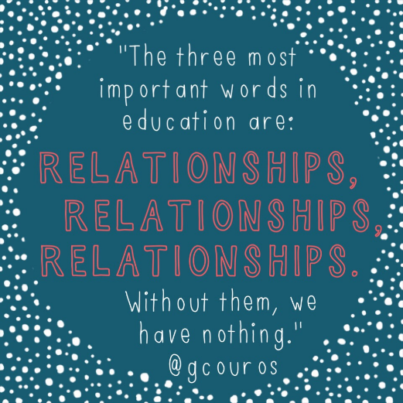
Before we get started, we wanted to share some thoughts and tips for all our families as we work together to bring this new way of learning to fruition. We are on this journey together as partners so want to work collaboratively in order to stay connected as we work for the best outcomes for all our students. We have already noticed how much we miss the community at NAPS and the chance to catch up with our families so we will place a great deal of emphasis on maintaining the connections and relationships. We especially know that children are missing their teachers. Our community connection and well-being will be the most important thing for all of us as we move ahead next term. Communication with parents and carers will still take place through the newsletter and on Class Dojo, so keep watching your emails and class/school stories.

Some ideas from experts in remote learning and other countries include:
- Set up some routines for each day to maintain a sense of structure and calm. Make them work for your family and everything else you have going on for you at this time.
- Work with the school’s expectations and what we know about online safety and protocols to ensure the online learning is safe as well as fun and educational for everyone. There is more information on this in the letters coming home from teaching teams today via email. This includes not having students online in their bedrooms.
- Have some formal learning during the day but don’t stress about keeping to a normal school schedule.
- You are not home-schooling, we are still the teachers. We are providing the explicit teaching, content and resources to support your child.
- Enjoy the day! Give your children time to explore, play and investigate their environment as this is still really valuable learning.

As we embark on this journey together, please do not hesitate to contact us. In the first instance, contact your child’s teacher or you can email us at admin@nthainslieps.act.edu.au or call the front office on 61420760. The leadership team is always available to support you and can be contacted through the same avenues. We will be working hard to stay connected with you by joining in Class Meets and sharing what we have been up to in the newsletter and on Class Dojo.

On a separate note I would like to introduce you to Winston. Earlier this week I was very lucky to welcome this cute little ball of fluff to my family. He has already brought us much joy. He had a quick visit to school on Tuesday and a few of the students were able to meet him so it was suggested I share a picture with all of you so you will be able to see who will be keeping me company in these challenging times.

We miss you all and look forward to seeing you online soon.

Have a great weekend.

Tania Collis
Principal

