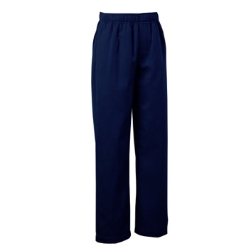
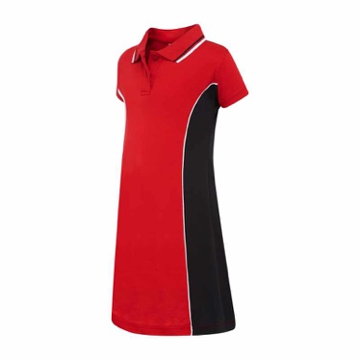

ORDER ONLINE
HAVE YOUR UNIFORM PACKED AND SENT HOME!

The uniform shop is now some new exciting items.

Sport dress
This dress is made from a cotton / polyester blend with side pocket.
Currently available in sizes 8 to 14 and will be available for online pre order
next week in junior sizes.

Sports / Excursion / Swimming pack
Great for all the excursions!
Available in store now and online next week.

Straight leg pants
Our pants now come in the straight leg version and
no longer have the elasticated cuff.

Online store discount
From next week there will be an online
discount for orders placed before the end of term!

Welcome pack bundle
From next week there will be a selection of
combined items to make up a new starter pack
saving you more time!

Regular shop hours
The Uniform Shop is operated by volunteers
and is open Tuesdays and Thursdays,
at 8:45-9:15am and 2:45-3:15pm.

We are located near the Kindergarten
and 1/2 classrooms.
2020 week 1 hours
The uniform shop opens additional days during the
first week of the 2020 term.

Friday 31 January 11am-12pm
Monday 3 February 8.30-9.30am and 2.45-3.15pm
Tuesday 4 February 8.30-9.30am and 2.45-3.15pm
UNIFORM SHOP NEWS
https://www.napspc.com.au

VOLUNTEERS 2020 NEEDED

The uniform shop is seeking new volunteers for 2020! If you would like to help your school by volunteering in the uniform shop, you are very welcome! The first few weeks are also very busy in the uniform shop and additional volunteers are needed for this busy period.

Speak to the volunteer during opening hours, or email us at napscommunity@gmail.com

