***The Gang Gang Gazette***

*Week 6, Term 2 (7th June, 2019)*

**Principal: Tania Collis Deputy Principals: Rikkie Klootwijk and Deborah Lowrey (Acting)**

**School Leaders: Marni Payne, Kate Stear,** **Alex Patterson and Kate Bush**

**P & C President: Jhay Mann** [napscommunity@gmail.com](mailto:napscommunity@gmail.com)

**Board Parent Representatives: Sue Webeck, Tara Pearce and Stephen Van Gerwen**

**Board Email**:  [napsboardreps@gmail.com](mailto:napsboardreps@gmail.com)

## Upcoming Events

|  |  |
| --- | --- |
| Queen’s Birthday Long Weekend | Monday 10th June |
| ACT Cross Country | Wednesday 12th June |
| Kindergarten Grandparents Morning Tea | Wednesday 12th June |
| Peer support | Friday 14th June |
| Senior assembly hosted by 3/4AC, 3/4JM & 3/4LF | Friday 14th June |
| Musica Viva | Wednesday 19th June |
| Peer Support | Friday 21st June |
| NAPS Preschool Program 1 Art Gallery | Monday 24th June (8:30am – 9:30am) |
| CEIS | Tuesday 25th June |

|  |
| --- |
| **Notes Home**   * Head lice notification (Kindergarten and Year 1/2) * Scholastic Book Order (Due Friday 21st June) |
|  |
| **Board**  Next Meeting:  Tuesday 18th June 2019, 6.00pm  **P & C**  Next Meeting:  Wednesday 19th June, 6:00pm |

**Dear Families and Friends,**

This week we had a wonderful Thursday with our Athletics Carnivals for both our junior and senior students running on a glorious, sunny day. Although it gets cold in Canberra over winter, we are very lucky to still have so many days with blue skies and the sun shining through. All our students exemplified our Learner Profile through their risk taking when trying new activities or races and being principled and caring whether they were a place getter or representing their house as a participant.

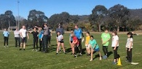Many thanks should go to our staff who ran the day with special thanks to Sharon Hickey and Jarryd Heywood for their outstanding organisation. We could also not run these days without the assistance of our families who attended both events, helping teachers, time-keeping and cheering on our students. We also had assistance from students from Campbell High School and the University of Canberra who ran events at our senior carnival. This community spirit continues to be one of the aspects of our school of which I am most proud. Keep your eyes on Dojo for some more photos and video from the day.

**School Improvement**

Last year our school was reviewed with the Directorate and we had an evaluation from the International Baccalaureate. Both organisations provided us with feedback on areas of strength and those we could improve. We have also been working with them to design our next five-year Strategic Plan and our PYP Action Plan. Our new Strategic Plan has a focus on continuing to improve the teaching and learning of writing and our newer initiative around maths. We have participated in professional learning on both areas and have developed our essential beliefs about why they are so important for our students. These beliefs underpin everything we do and are below.

***At North Ainslie Primary School, we teach writing because it is an essential life skill which enables us to communicate effectively, express ourselves and successfully contribute to society in a meaningful way.***

***At North Ainslie, we teach maths to empower our students to understand concepts, think critically and problem solve in order to confidently participate in life.***

You can see that they also reflect our belief in life-long learning and the importance of literacy and numeracy skills for our students as they become global citizens.

As part of the process of developing this new plan we are looking for input from you to help shape our Vision, Mission and Values. They will be included in our plan and shape our way forward as a school using Positive Behaviours for Learning. Please look out for information in the coming weeks from our School Board who will be working with us to run surveys and small group workshops to assist us to finalise these areas of the plan.

**Walk-in Centres**

The ACT Health Directorate has asked us to let you know about one of their services as we head into winter.

*With winter upon us, it’s important to remember that Canberra has lots of health options that don’t involve a trip to a hospital emergency department. Many of these are free and available after hours. Walk-in Centres provide free, one-off treatment of minor injury and illness, including colds and flu. They’re a great choice for children over 2 years of age – children under 2 should see their GP.*

*****Walk-in Centres are open from 7.30am to 10pm, every day of the year. They are staffed by highly skilled nurses who can provide you with a sick certificate and in some cases, medication, saving you time and money. The service is free and no appointments are necessary. Walk-in Centres are located in Tuggeranong, Belconnen and Gungahlin.*

*To find out more about getting the right health care for your symptoms, visit* [*www.act.gov.au/yourhealthoptions*](http://www.act.gov.au/yourhealthoptions)

**P and C**

You will notice below (in P and C News) that the P and C is having a special event in the coming weeks. They are hoping to have more of you come along and to find out about what they are doing with us to continue to build our school. It would be lovely to see you there.

**Skoolbag app**

The school has been advised that there will be a significant cost increase for the usage of the Skoolbag app.  We have found that statistically more families are accessing Dojo than Skoolbag. As a result, the school is planning to discontinue using Skoolbag and utilise Dojo for school content such as the weekly newsletter. If you have any concerns regarding this, please contact the school before 9am, Friday 14th June.

We hope you enjoy the long weekend and stay safe, particularly if you are travelling. We will see you all next Tuesday.

Tania Collis (Principal)

## PACH News

Students in Personal and Community Health (PACH) are learning about healthy food choices. Students are learning about the importance of eating a variety of foods from the five food groups to help their bodies go, grow and glow. Over the last couple of weeks, students have enjoyed making rice paper rolls. Encourage your little chef to teach you how to make them at home as a healthy snack or meal. For more inspiration look at the recipes on the Nutrition Australia website: <http://www.nutritionaustralia.org/national/recipes>

More information can be found on healthy eating and dietary guidelines can be found on the following websites:

[https://www.eatforhealth.gov.au/sites/default/files/content/The%20Guidelines/n55f_children_brochure.pdf](https://www.eatforhealth.gov.au/sites#/default/files/content/The%20Guidelines/n55f_children_brochure.pdf)

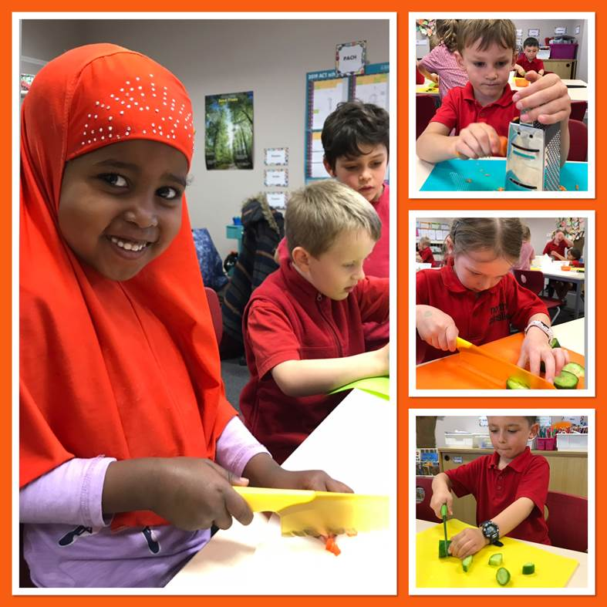

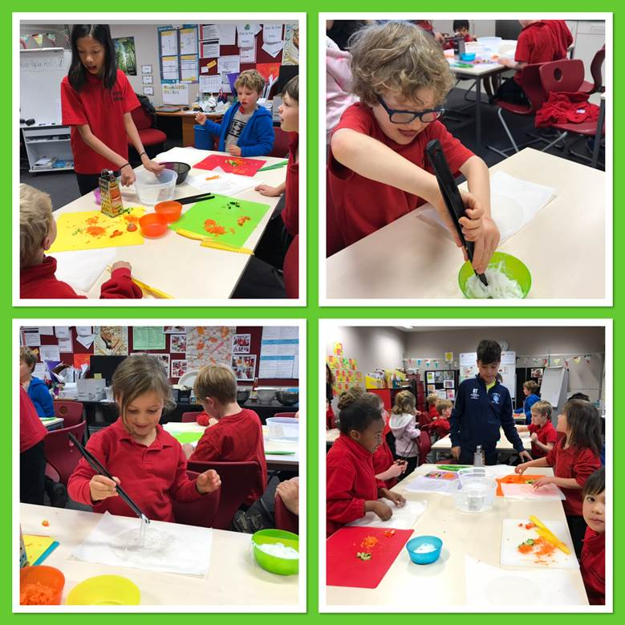<https://www.eatforhealth.gov.au/sites/default/files/content/The%20Guidelines/n55i_australian_guide_to_healthy_eating.pdf>

Australian Guide to Healthy Eating

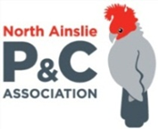**P &C NEWS**

NAPS P & C Forum

**Canteen News**



**Healthy Eating Hub LogoTERM 2 HEHUB CANTEEN MENU (Open Wednesday, Thursday Friday)**

**Recess**

A selection from the following:

Frozen Peas ‘n’ corn cup $1.00 Fruit of the day / Apple slinky $0.50 / $1.00

Pikelets, Popcorn (VG) $0.50 Toasties $1.00 Frozen fruit cup $1.00 Vanilla Yogurt (V, GF) $2.00

Banana muffin (v, DF) $1.00 Cheesy Corn Fritters $0.50

**Lunch**

Vegie sticks Free Fruit of the day $0.50

Vegemite sandwich (VG) $2.00 Vanilla Yogurt (V, GF) $2.00

Tex Mex toasted wrap(V) $2.50 Milk bottle (150ml) $1.50

Soy milk (VG) $2.50 Tuna & cheese toasted sandwich $3.50

Smoothies $2.00 (collect from canteen) Baked Potato with Salsa+/- cheese (GF) $ 3.50

**Daily Lunch Special- $3.50**

**Wednesday: Thursday: Friday:**

*Pizza(V) Italian chicken toasted sandwich (DF) Pasta beef bolognaise (DF)*

## Community Notices



***Being a parent is the hardest job we’ll ever have. All parents at some time experience difficulties and stress.***

**Parentline ACT**

is a confidential and free telephone and face-to-face counselling and information service.

Phone Parentline if you would you like:

* To talk with someone about those parenting issues.
* Help with some ideas on raising children.
* Support in the important job you are doing.
* To know what is available for parents, teenagers and children.
* To build better relationships in your family.
* Help to understand your child or teenager’s behaviour.
* Make an appointment for a counselling session.

**Parentline ACT.**

**Monday to Friday (except on public holidays), 9am to 5pm.**

**Phone: 6287 3833**