Student Management at NAPS
Non-coercive behaviour management: Classroom and Playground
Our experiences have demonstrated to us that punishment and exclusion are ineffective strategies for addressing harm in schools. The implementation of restorative practices has provided us with a framework, which improves the effectiveness of conflict resolution strategies being used by students and teachers, and empowers victims and offenders to restore relationships and establish new, supportive alliances with others.
At North Ainslie we operate in the "firm but fair" mode, encouraging all members of our community to denounce unacceptable behaviour, to clarify values, and to seek just resolution of conflict which will meet the needs of the victim, offender and others involved in the conflict.
The Restorative Justice framework provides a simple set of carefully delivered questions for use in informal and formal conference situations where harm has occurred, which will meet the needs of all concerned. These key restorative questions focus on who has been harmed, and what needs have been created by this harm. These questions are used by staff and students in cases of conflict, both in the classroom and on the playground. Where a more formal approach is required, staff members have been trained to facilitate the restorative process. During the restorative conference, the stakeholders propose solutions, and agreements are made by the offender, which will, as much as possible, repair the harm done to the victim. Restoration is made “in kind" wherever possible and is relevant to the offence. (When necessary, to protect the rights of staff and students, students will be removed from the classroom and playground according to the behaviour management stages. In these cases, restorative meetings will be held as soon after the offence has occurred as possible.)
At North Ainslie, staff and students also participate in problem solving circles to resolve issues e.g. bullying (Bullying Policy). These circles promote cooperation, listening skills and emotional literacy development.
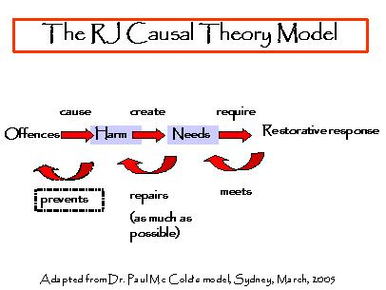
Restorative Justice Framework Diagram

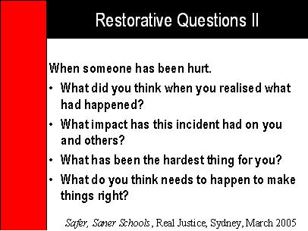
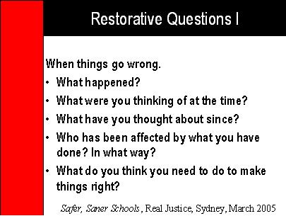

Guidance and Counselling - Guidance and counselling services are available at the school. The school psychologist is available on Tuesdays and Wednesdays. We also have a student welfare officer who is available on Thursdays and Fridays. Parents wishing to discuss any matters relating to the progress or performance of their children should contact the class teacher or school principal. Appointments with the principal or the school psychologist can be made through the front office staff directly, or by phoning 6205 6533. (September 2013)

