***The Gang Gang Gazette***

*Week 3, Term 3 (7th August, 2020)*

Principal: Tania Collis Deputy Principals: Rikkie Klootwijk and Sharon Moloney

School Leaders: Haeley Simms, Kate Bush (Acting), Melissa Datson (Acting) and Jarryd Heywood (Acting)

Board Parent Representatives: Sue Webeck, Stephen Van Gerwen and Lucy Hopkins

Board Email:  [napsboardreps@gmail.com](mailto:napsboardreps@gmail.com)

P & C President: Maree Wright [napscommunity@gmail.com](mailto:napscommunity@gmail.com)

**Upcoming Events**

|  |  |
| --- | --- |
| Year 3/4 Day Trip to Birragi: Group 1  Group 2 | Tuesday 25th August  Thursday 27th August |

|  |
| --- |
| **Notes Home**   * Picture plate note (NAPS preschool) * Consultation with Parents (P & C email) |
|  |
| **Board**  Next Meeting:  Tuesday, 11th August, 6 pm  **P & C**  Next Meeting:  Tuesday, 11th August, 6.30pm (in the school hall) |

Dear families and friends,

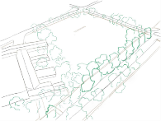Today we had Paul Barnett from the Paul Barnett Design Group begin his consultation on our oval project with our students by presenting to a group of year 5/6s. Before the presentation our Student Leaders, Sports Leaders, Indigenous Leaders and Green Team Leaders worked with Jarryd Heywood and Melissa Datson on some questions Paul had sent through to start them thinking and researching into what the possibilities might be for the oval and how we would like to care for the land and make the most of it as we re-develop the area. Paul will now continue this process over the next few weeks and our student leaders will help us to take the consultation from today across our students of all year levels. Paul will begin working with our parents, carers and teachers over the next few weeks to find out as much as he can from all our stakeholders on how we use our oval and how we can make the most of the space for everyone. I am looking forward to hearing from all the groups and seeing what exciting ideas they share with us.

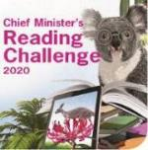**Chief Minister’s Reading Challenge**

In our last week of the Chief Minister’s Reading Challenge, we have another group of students to acknowledge for their great reading over the last few months. Congratulations to Benjamin T, Erik V, Amelia E, Sophia T P, Gus L, Jason D, Georgina F, Benjamin T and Gitanjali S who all met the challenge. Well done!

**Hats back on from August 1st**

Please remember that hats are now back on and ensure that your child has their hat for both PE and play times in order for them to be protected from the UV levels which are starting to climb back to 3 and above.

**Wear It Purple Day**

Wear It Purple Day is coming up on the 28 August and is our school’s opportunity to show our LGBTIQ+ children and families that we support them and they are valued members of our school community. To show your support, you can either wear purple or rainbow colours to school on Friday 28 August and we will share photos of the day with you through our Gang Gang Gazette.

**What’s Going On In Your Child’s Brain When You Read Them A Story?**

As with all schools, we encourage and promote regular reading for all our students. As a parent and a teacher, I have always loved beautiful picture books and one of the joys of both roles has been reading to my own children and to children at school. There is nothing quite like going on a journey through a wonderful picture book with students of all ages. I recently came across an article about what happens to children’s brains when we read to them. Interestingly the experiment looked at what happens to children’s brains when they engage with three different types of texts or stories. You won’t be surprised to hear that I was particularly delighted with the findings. I will be interested to hear what others think about the research.

*These days parents, caregivers and teachers have lots of options when it comes to fulfilling that request. You can read a picture book, put on a cartoon, play an audiobook, or even ask Alexa. A newly published study gives some insight into what may be happening inside young children's brains in each of those situations. And, says lead author Dr. John Hutton, there is an apparent "Goldilocks effect" — some kinds of storytelling may be "too cold" for children, while others are "too hot." And, of course, some are "just right."*

*Hutton is a researcher and paediatrician at Cincinnati Children's Hospital with a special interest in "emergent literacy" — the process of learning to read. For the study, 27 children around age 4 went into an FMRI machine. They were presented with stories in three conditions: audio only; the illustrated pages of a storybook with an audio voiceover; and an animated cartoon. All three versions came from the Web site of Canadian author Robert Munsch. While the children paid attention to the stories, the MRI, the machine scanned for activation within certain brain networks, and connectivity between the networks.*

*"We went into it with an idea in mind of what brain networks were likely to be influenced by the story," Hutton explains. One was language. One was visual perception. The third is called visual imagery. The fourth was the default mode network, which Hutton calls, "the seat of the soul, internal reflection — how something matters to you."*

*The default mode network includes regions of the brain that appear more active when someone is*not*actively concentrating on a designated mental task involving the outside world. In terms of Hutton's "Goldilocks effect," here's what the researchers found:*

*In the audio-only condition (too cold): language networks were activated, but there was less connectivity overall. "There was more evidence the children were straining to understand."*

*In the animation condition (too hot): there was a lot of activity in the audio and visual perception networks, but not a lot of connectivity among the various brain networks. "The language network was working to keep up with the story," says Hutton. "Our interpretation was that the animation was doing all the work for the child. They were expending the most energy just figuring out what it means." The children's comprehension of the story was the worst in this condition.*

*The illustration condition was what Hutton called "just right". When children could see illustrations, language-network activity dropped a bit compared to the audio condition. Instead of only paying attention to the words, Hutton says, the children's understanding of the story was "scaffolded" by having the images as clues. "Give them a picture and they have a cookie to work with," he explains. "With animation it's all dumped on them all at once and they don't have to do any of the work." Most importantly, in the illustrated book condition, researchers saw increased connectivity between — and among — all the networks they were looking at: visual perception, imagery, default mode and language.*

*"For 3- to 5-year-olds, the imagery and default mode networks mature late, and take practice to integrate with the rest of the brain," Hutton explains. "With animation you may be missing an opportunity to develop them." When we read to our children, they are doing more work than meets the eye. "It's that muscle they're developing bringing the images to life in their minds."*

*Hutton's concern is that in the longer term, "kids who are exposed to too much animation are going to be at risk for developing not enough integration." Overwhelmed by the demands of processing language, without enough practice, they may also be less skilled at forming mental pictures based on what they read, much less reflecting on the content of a story. This is the stereotype of a "reluctant reader" whose brain is not well-versed in getting the most out of a book.*

*One interesting note is that, because of the constraints of an MRI machine, which encloses and immobilizes your body, the story-with-illustrations condition wasn't actually as good as reading on Mom or Dad's lap. The emotional bonding and physical closeness, Hutton says, were missing. So were the exchanges known as "dialogic reading," where caregivers point out specific words or prompt children to "show me the cat?" in a picture. "That's a whole other layer," of building reading Hutton says. In an ideal world, you would always be there to read to your child. The results of this small, preliminary study also suggest that, when parents do turn to electronic devices for young children, they should gravitate toward the most stripped-down version of a narrated, illustrated ebook, as opposed to either audio-only or animation. (Copyright, Anya Kamanetz, 2018 NPR.)*

**Year 1/2 Learning**

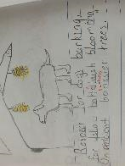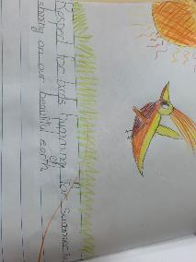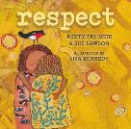In keeping with the theme of literacy, our year 1/2 students have been doing some amazing learning. Using the book ‘Respect’ by Aunty Fay Muir and Sue Lawson, with illustrations by Lisa Kennedy, they have been exploring ideas about the importance of respecting the land, all living things and our families. They have engaged in fantastic discussions about the things they respect, and what they mean to them and the people around them. They have then used the discussions as provocations for the dioramas, paintings and the books they have all authored and illustrated themselves. I have been very lucky to have many of them share these books with me and have been impressed with both the quality of their writing, but also the way in which they could talk about their learning!

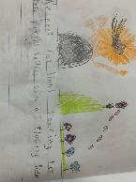

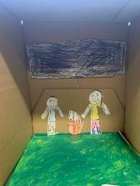

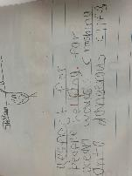

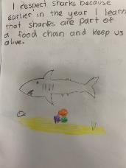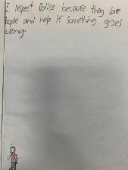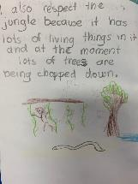

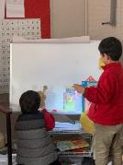

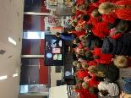This term for UOI the year 1/2 students are inquiring into how the world works. They have also been investigating light and sound and how it works. In some of the classes they have been making shadow puppets and presenting their plays to the class. The students were also lucky enough to have a special guest presenter today Dr Karen Arthur who is also a parent at our school. She spoke to the students about light pollution and the students were captivated by her presentation.

It looks we are going to have a rainy weekend so stay warm and have a lovely two days.

Tania Collis (Principal)

## 2020 School Satisfaction & Climate Survey

Each year, the Directorate surveys all parents, school staff and students in Years 4 to 12 about their satisfaction with public education. The *2020 School Satisfaction & Climate Survey* will be available online from 10 to 31 August.

The survey results will help us to continue to make quality informed decisions about how to improve our school. No personal identifying information will be provided to any school or college.

An email about the staff survey, including a unique link to access the survey, will be sent to all school staff via the email address they have nominated for their payslips; staff who do not receive the email may contact EDUSurveys@act.gov.au to request a survey invitation.

An email about the parent survey, including a unique link to access the survey; parents who do not receive the email may contact EDUSurveys@act.gov.au to request a survey invitation.

A shortened paper-version of the parent survey is also available in the following 12 languages: Arabic, Burmese, Chinese, Dari, Dinka, Farsi, Hindi, Karen, Korean, Mon, Urdu and Vietnamese; email EDUSurveys@act.gov.au to request a copy.

For the results to reflect the opinions of our whole school community, we need as many parents, staff and students as possible to complete the survey. Your feedback is important, and we hope you will take part.

For more information, visit: <https://www.education.act.gov.au/public-school-life/school-satisfaction-and-climate-survey>

## After School activities



**Healthy Eating Hub LogoTERM 3 HEHUB CANTEEN MENU (Open Wednesday and Friday)**

**Healthy Eating Canteen Menu:** **Term 3**

**We are open for recess and lunch on Wednesdays, Thursdays and Fridays**

|  |  |
| --- | --- |
| **ALL WEEK RECESS**  **NOTE: not for lunch orders, counter orders only** | |
| Yoghurt | $2.50 |
| Frozen Peas 'n' Corn cup | $1.00 |
| Fruit of the day | $1.00 |
| Frozen fruit cup | $1.00 |
| Cheesey corn fritters | $1.00 |
| Pikelets, popcorn | $0.50 |
| Toasties | $1.00 |
| Muffins | $0.50 |
| **ALL WEEK LUNCH** | |
| Vegie sticks – from the counter | Free |
| Fruit of the day | $1.00 |
| Sausage Roll (homemade) | $4.00 |
| Sandwiches (Ham, chicken, tuna or cheese) | $4.00 |
| -Add salad (lettuce, tomato, carrot and cucumber) | $0.50 |
| -Make it a wrap | $0.50 |
| -Toast it | $0.50 |
| Vegemite sandwich | $3.00 |
| Honey sandwich | $3.00 |
| Salad bowl with either chicken or tuna | $4.00 |
| Yoghurt | $2.00 |
| **DRINKS** |  |
| Milk bottle (150ml) | $1.50 |
| Soy milk | $2.50 |
| Smoothie (collect from canteen) | $3.00 |
| Juice Box | $2.50 |
| **LUNCH PACKS** |  |
| Toasted chicken/cheese + milk + fruit | $7.00 |
| Toasted tuna/cheese + milk + fruit | $7.00 |
| Toasted chicken/cheese + juice + yoghurt | $7.00 |
| Toasted tuna/cheese + juice + yoghurt | $7.00 |

|  |  |  |  |  |
| --- | --- | --- | --- | --- |
| **DAILY LUNCH SPECIALS – ALL $4.00 EACH** | | | | |
| **Monday** | **Tuesday** | **Wednesday** | **Thursday** | **Friday** |
| Closed | Closed | Mini Quiche | Spaghetti Bolognese | Pizza  Margherita or Ham/Cheese |

**How do I make a lunch order?**

Lunch orders are available to all children and are for lunch, lunch pack and drink items only.

**They need to be received by the canteen by 9.30am.**

**Cash orders:** Should be written on a brown paper bag with your name and class**,** what you'd like to order and the correct money. Lunch or drinks items only please.

**Online orders**: Flexischools App or www.flexischools.com.au. Online orders close 9.30am on the same day as you are ordering for.

*If you have a problem with your order, please call/text the manager, not the school front office.*

Canteen manager: Karen 0406 937 139

naps.canteen@gmail.com

## NAPS P & CP&C News

**Senior Oval Workshop 1**

We need to hear from YOU.

The Senior Oval is getting a whole new look - and we need your input to make it great. Come along and meet our design team, explore some innovative ways to approach this project, and let us know what's important to you and your family.

### Tuesday 11th August 6pm for a 6:30 start

### NAPS Hall - in-person places strictly limited

### This event will also be live-streamed RSVP by Monday 10th August

[napscommunity@gmail.com](mailto:napscommunity@gmail.com)

Go to the new P&C website to read about the timelines, the project outline,

and get inspired!

[www.napspc.com.au](http://www.napspc.com.au)

**Dear NAPS Community,**

The P&C has a permanent location for the 'WE WANT YOUR SCHOOL UNIFORMS' initiative.

Located inside the front entrance on Majura Avenue, place your freshly laundered preloved school uniforms in the tub provided and we'll collect them.

All pre loved items will be on sale at the P&C website [www.napspc.com.au](http://www.napspc.com.au).

Every donation and purchase helps the P&C support and grow our NAPS community.

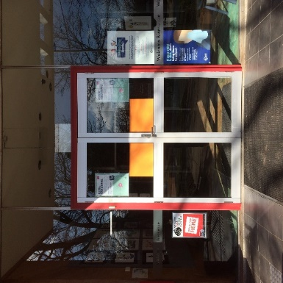 Harry Sideris

NAPS P&C Treasurer

 