***The Gang Gang Gazette***

*Week 7, Term 4 (29th  November, 2019)*

Principal: Tania Collis Deputy Principals: Rikkie Klootwijk and Deborah Lowrey (A/g)

School Leaders: Haeley Simms, Alex Patterson (A/g), Kate Bush (A/g) and Jarryd Heywood (A/g)

Board Parent Representatives: Sue Webeck, Tara Pearce and Stephen Van Gerwen

Board Email:  [napsboardreps@gmail.com](mailto:napsboardreps@gmail.com)

P & C President: Jhay Mann [napscommunity@gmail.com](mailto:napscommunity@gmail.com)

## Upcoming Events

|  |  |
| --- | --- |
| Swimming Lessons (Years 3-6) | Week 8 |
| Preschool Transition Day No 2 | Tuesday 3rd December & Thursday 5th December |
| 2020 Kindergarten Information Session | Thursday 5th December @ 3:30pm |
| 2020 Prospective Pre-schoolers Visit | Tuesday 5th December @ 3:30pm |
| Year 6 Graduation Assembly | Thursday 12th December @ 11:30am |
| Year 6 Graduation Dinner | Thursday 12th December @ 6.00pm |
| Year 5/6 Disco | Thursday 12th December @ 7:00pm |
| IEC Class Graduation | Thursday 12th December @ 2.00pm |

|  |
| --- |
| **Notes Home**   * 2020 5/6 Camp Note * Year 6 Graduation Assembly (email) * Movie note (5/6LK & 5/6JH) |
|  |
| **Board**  Next Meeting:  Tuesday, 3rd December, 6.00pm  **P & C**  Next Meeting:  Tuesday, 3rd December, 7.30pm |

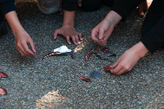**Dear Families and Friends,**

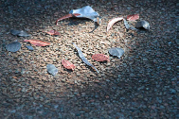Thank you to our P and C for last week’s wonderful movie night on our junior playground. The atmosphere was fantastic, and it was lovely to have our community come together on a beautiful night to share dinner and the movie ‘Trolls’. There were large array of stalls providing lots of tasty food and our senior students ran a very successful Sideshow Alley. Thanks to everyone who contributed to the night.

Earlier this year, we had students attend the National Art Gallery where they made artworks with Luritja Artist Kannie Denigan. The photos below were taken and printed at the Gallery and, along with the students’ collaborative statement were our successful entry for the Schools Reconciliation Challenge exhibit on display at the Tuggeranong Arts Centre next week. Sarah Buckley and some of our students will be attending the opening next week to represent us at this important event.

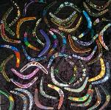**Indigenous Art Project**

Last week we shared an art project Sarah was working on with our Indigenous families and Jakki Kennedy. The boomerangs they produced were beautiful and it allowed us to connect with our families and Aunty Jenny and Kuzi from Dickson College who we hope to continue to work with next year. If you would like to see more photos from the day, we will be showing them on the display board in the front entrance.

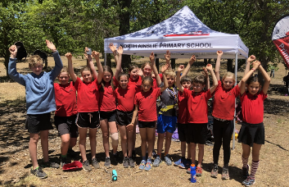

**ACT Primary School Orienteering Championships**

This week Oscar W, George B, Lulu S, Isla O-D, Tilly V, Megan F, Eloise H, Rahda, Archie L-S, Zebulon V, Julian W, Isla F and Evie N represented NAPS at the ACT Primary School Orienteering Championships. Well done to all of these students who came 7th overall in the ACT which is a wonderful achievement. Congratulations to Archie who took out gold in the 10-year boys. Thanks also to the families who supported the students by taking them to the various events over the term.

**ACT Primary Concert Choir**

Yesterday, the ACT Primary Concert Choir performed at Australian Parliament House at their annual Christmas at the House event. To be a member of the choir, students audition at the beginning of the year and practice through the Instrumental Music Program. Well done to Julian W, Elsa L and Georgia W who are part of the choir, sang at the event and have been representing NAPS all year.

**Test Email for School Reports**

On Monday, we sent home our test email for reports for this semester. If you did not receive this test email, or you would like the report sent to a different email address, please contact the school by COB today at [admin@nthainslieps.act.edu.au](mailto:admin@nthainslieps.act.edu.au) The email should come from the address you would prefer the report to be emailed to. In the subject line, please write ‘Address for Reports’. In the body of the email, please include your child’s name and current class.

**Library Book**

Today was the final day for borrowing. We ask all students to begin returning their books next week. The final date for returns is Monday, 9th December, 2019. Any books not returned by this date will be considered overdue and an overdue notice will be sent home.

If your child has lost a book please contact Rebecca Cameron to discuss the matter.

Have a great weekend.

*Tania Collis*

Principal

Thank you Morning Tea

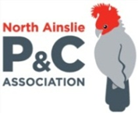**P &C NEWS**

## Master Plan meeting - this Sunday 1st December

Come along to Edgar's Inn at 2pm for a chat about the P&C's plans to develop a new school Master Plan next year. All welcome. Please let us know you're coming so we can book enough space.

## Last general meeting for the year - next Tuesday 3rd December

Our last P&C meeting this year is at 7:30pm in the staff room. We will be talking about plans for next year - we'd love to see you then!

## P&C website

Our new website is already making life easier, from ordering your mangos and cherries to buying new school uniforms. We will be working hard to add new content including info on after school activities and an event calendar for next year, and your input and feedback is essential. Please get in touch if you have any suggestions, comments or ideas.

## Fiesta 2020

Fiesta is coming back in 2020 - planning is well underway, and we need YOU! There will be great food, fun rides, and the best sideshow alley ever! If you can help out in any way, please let us know. Many hands make light work and it's going to be fun.

We will be asking each class to nominate an organiser, so if you think you could help, drop us a line. You can even team up with a friend!

## Crazy Camel Fundraiser

Crazy Camel Art Fundraiser orders went home this week. Artworks will be returned in the student art folders at the end of term. Thanks to all who ordered and helped, the P&C raised over $3k which will go towards both the school art program and future P&C projects. If you think any items were missing from your order email [napscommunity@gmail.com](mailto:napscommunity@gmail.com) with your child’s name and class and we’ll follow up for you.

**Today is the LAST DAY to order your Cherries…..**

[**www.napspc.com.au**](http://www.napspc.com.au)

**\*Thankyou for supporting our local farmers and our preschool.**

**Upcoming Events**

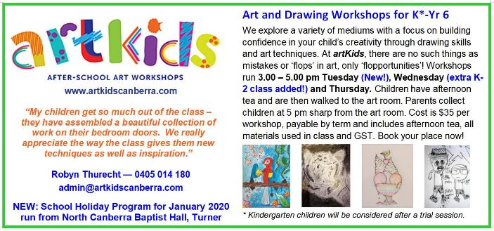

## 

## Healthy Eating Hub LogoTERM 4 HEHUB CANT EEN MENU (Open Wednesday, Thursday Friday)

**Recess**

A selection from the following:

Frozen Peas ‘n’ corn cup $1.00 Fruit of the day / Apple slinky $0.50 / $1.00

Pikelets, Popcorn (VG) $0.50 Toasties $1.00 Frozen fruit cup $1.00 Vanilla Yogurt (V, GF) $2.00

Banana muffin (v, DF) $1.00 Cheesy Corn Fritters $0.50

**Lunch**

Vegie sticks Free Fruit of the day $0.50

Vegemite sandwich (VG) $2.00 Vanilla Yogurt (V, GF) $2.00

Tex Mex toasted wrap(V) $2.50 Milk bottle (150ml) $1.50

Soy milk (VG) $2.50 Tuna & cheese toasted sandwich $3.50

Smoothies $2.00 (collect from canteen) Baked Potato with Salsa+/- cheese (GF) $ 3.50

**Daily Lunch Special- $3.50**

**Wednesday: Thursday: Friday:**

*Pizza(V) Chicken Burger (DF) Sushi Tuna or Veg (GF, DF*