***The Gang Gang Gazette***

*Week 9, Term 3 (20th September, 2019)*

Principal: Tania Collis Deputy Principals: Rikkie Klootwijk and Deborah Lowrey (A/g)

School Leaders: Marni Payne, Kate Stear, Alex Patterson (A/g) and Kate Bush (A/g)

Board Parent Representatives: Sue Webeck, Tara Pearce and Stephen Van Gerwen

Board Email:  [napsboardreps@gmail.com](mailto:napsboardreps@gmail.com)

P & C President: Jhay Mann [napscommunity@gmail.com](mailto:napscommunity@gmail.com)

## Upcoming Events

|  |  |
| --- | --- |
| IEC Graduation | Friday 27 September |
| Term 3 Ends | Friday 27 September |
| Term 4 Start | Monday 14th October |
| Senior assembly hosted by 3/4AC, 3/4JM and 3/4LF | Friday 18th October |
| Kindergarten Tidbinbilla Excursion | Wednesday 23 October |
| ISABELLE ET LA BÊTE- French Puppet Theatre | Friday 25th October |
| Junior assembly hosted by 1/2KB, 1/2YJ and 1/2TS | Friday 25th October |

|  |
| --- |
| **Notes Home**   * Head lice notification (Yr 1/2) |
|  |
| **Board**  Next Meeting:  Tuesday, 5th November, 6.00pm  **P & C**  Next Meeting:  Tuesday, 5th November, 7.30pm |

**Dear Families and Friends,**

**What a fantastic week we have just had with our Student Led Conferences showcasing the amazing learning happening here at North Ainslie. It was enjoyable to see the interactions as our students showed their families what they have been learning and doing and being the teachers as they taught their grownups games, activities and had them participate in a range of opportunities to inquire and create. Thank you to everyone who came and made the conferences so successful and enjoyable. Thank you to our staff who set their classrooms up to be interactive making them engaging way for families to share in their child’s learning journey. Thanks also to our specialist teachers who set up activities for the families to share in.**







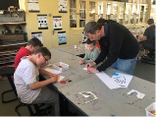

**P & C**

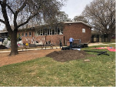On Sunday we had a working Bee in which we had the most amazing turnout of community members at our Working Bee. The school really was a hive of activity with work taking place in garden beds out the front of the school, in the CTS, the courtyard and the HEHub. We had the lines repainted on our courtyard and lots of building happening in the HEHub to help us with our composting and work with bettering our environment. Some things to look forward to will be the new fruit trees and hardenbergia flowers on the new trellises. The Adventure Track was tidied and mulched and is looking fabulous. Thanks to the organisers from the P & C and to everyone who came on the day to lend a hand. It was then lovely to share a pizza and chat at lunchtime and celebrate the progress we had all made together. Thanks also to our fabulous canteen volunteers for supplying the pizza dough, bacon and eggs and to our chef who spend quite some time cooking our pizzas. This day truly celebrates what makes NAPS such a special place to work and learn together.

**Governor General’s Rocket Design Challenge**

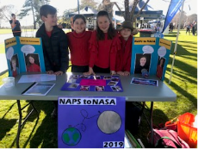Earlier this term, in Science Week, we had a team of our students take part in the first ever Governor General’s Rocket Design Challenge. With over 100 students from 28 different schools at the event we were proud to have Isla O, Isla F, Oscar W and Grace N representing NAPS that saw them designing, building and launching their own rockets. Other sectors who helped students to learn more about rockets and maximising flight distance on the day included the University of New South Wales, Mount Stromlo Observatory, NASA Deep Space Complex, ANU Research School of Physics, the Civil Aviation Safety Authority and Geospatial Intelligence. On the day, they tested their rocket in various stations and votes were cast by all participants using ‘space nuts’. Final judgement was based on the number of ‘space nuts’ awarded to each rocket. The four students had a fabulous time and are keen to represent us again next year. Thank you to Jayde Condon who facilitated the event and worked with the students at lunchtimes to prepare them for the challenge.

**Climate Change**

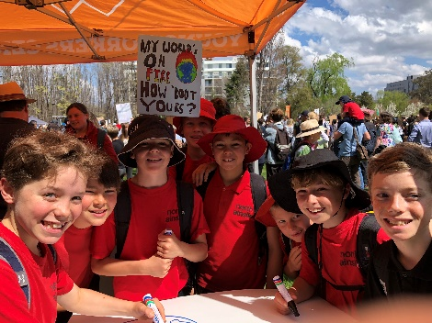This week we have all been thinking about how we can help our environment.  Today we had many of our students demonstrating the attributes of the learner profile and taking action by attending the Climate Change Strike. Yesterday, the students from 1/2 shared how we can all take action to help with climate change at morning lines so perhaps you can talk about these as a family this weekend and together we can all make a difference.

* Make an effort to pick up any rubbish that you see.
* Pack a waste free lunch, and be plastic free.
* Turn lights out.
* Don’t use heaters if you don’t have to.
* Ride or walk to school.
* Be water wise. Turn off dripping taps.

**Staffing news**

Congratulations to Marni Payne and Kate Stear who have won transfers in the school leader transfer round. Both will be starting at their new schools next term, Marni at Charnwood Dunlop and Kate at Campbell Primary School. We will miss them both but wish them well on their adventures. Haeley Simms will be joining us from next term after many years as a leader at Palmerston District Primary School.

Have a wonderful weekend.

Tania Collis (Principal)

**P &C NEWS**

## Uniform

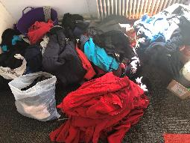Spring is in the air and summer is just around the corner....do you need summer uniform items? As well as new items, the uniform shop has plenty of 2nd hand uniforms, in particular t-shirts, shorts and dresses in smaller sizes. Please pop in to look through our 2nd hand rack and purchase any items needed for the warmer seasons.  The NAPS uniform shop is open Tuesday & Thursday mornings 8:45-9:15am and afternoons 2:45-3:15pm and you can pay by cash or card. If you cannot make it into the shop during these hours, order forms can be placed into the silver boxes.

* A reminder to please write your child's name on all uniform items. There is a huge amount of unlabelled lost uniforms that continues to grow in the cupboards near the school hall.

**VOLUNTEERS NEEDED FOR LOST PROPERTY:** If you are able to take home one grocery bag of lost property to be washed and are then happy to drop it in a charity bin, we would love you to come to the front office. We would like to clear this pile of clothes by the end of this term.

## P & C Fundraiser

Date for the for the P&C Fundraiser has been extended till the end of next week. Please use P&C bank details for payment.

## Healthy Eating Hub LogoTERM 3 HEHUB CANTEEN MENU (Open Wednesday, Thursday Friday)

**Recess**

A selection from the following:

Frozen Peas ‘n’ corn cup $1.00 Fruit of the day / Apple slinky $0.50 / $1.00

Pikelets, Popcorn (VG) $0.50 Toasties $1.00 Frozen fruit cup $1.00 Vanilla Yogurt (V, GF) $2.00

Banana muffin (v, DF) $1.00 Cheesy Corn Fritters $0.50

**Lunch**

Vegie sticks Free Fruit of the day $0.50

Vegemite sandwich (VG) $2.00 Vanilla Yogurt (V, GF) $2.00

Tex Mex toasted wrap(V) $2.50 Milk bottle (150ml) $1.50

Soy milk (VG) $2.50 Tuna & cheese toasted sandwich $3.50

Smoothies $2.00 (collect from canteen) Baked Potato with Salsa+/- cheese (GF) $ 3.50

**Daily Lunch Special- $3.50**

**Wednesday: Thursday: Friday:**

*Pizza(V) Italian chicken toasted sandwich (DF) Pasta beef bolognaise (DF)*

## Upcoming Events



**HOLIDAY STITCHING CLASSES**

October School Holidays

Run by The Embroiderers’ Guild ACT Inc

For students 7 years and up

will be held on:

THURSDAY 10th and

FRIDAY 11th October

Morning 9-12.30

Afternoon 1.30-5

If attending for a full day please BYO lunch

Cost

$30 per half day (includes all materials)

Where

In the Guild Rooms at Maitland House

100 Maitland St Hackett

Enquiries

(Preferably by email)

email lxwhitbread@gmail.com or embroideryact@gmail.com

or

Phone Lel Whitbread ah 6251 5957 or 0402 411 398

**Exclusive to North Ainslie Primary School – WALK-TO-TENNIS: AFTER SCHOOL PROGRAM**

After***Monday & Thursday @ Majura Tennis Club, Dickson***

·     North Ainslie School Coach Pick Up (3pm)

·     Supervised walk to Majura Tennis Club, Dickson

·     Healthy Snack at the Tennis Club

·     Tennis Lesson with Tennis Canberra Coaches (4-5pm)

·     Parent pick up at the Majura Tennis Club, Dickson

**More information**[**www.tenniscanberra.com.au/walk-to-tennis**](http://www.tenniscanberra.com.au/walk-to-tennis)

**Free Trial - Give Tennis A Go!**

We invite new players to **a free trial**.  This is a great opportunity for all students to see if tennis is the sport for them.  Please e-mail [**play@tenniscanberra.com.au**](mailto:play@tenniscanberra.com.au) to request a free trial and our team will get back to you with the best options.

**After-School & Weekend Coaching - Term 4**

*Run by Tennis Australia professional at a North Canberra Tennis Club.*

-       Monday, Thursday & Saturday @ *Majura Tennis Club, Dickson*

-       Tuesday @ *Turner Tennis Club*

-       Wednesday @ *Reid Tennis Club*

**Sign up:** [www.tenniscanberra.com.au/junior-tennis](http://www.tenniscanberra.com.au/junior-tennis)

**Email:**[play@tenniscanberra.com.au](mailto:play@tenniscanberra.com.au)

**Phone:** 0416 186 121

