***The Gang Gang Gazette***

*Week 3, Term 2 (17th May, 2019)*

**Principal: Tania Collis Deputy Principals: Rikkie Klootwijk and Deborah Lowrey (Acting)**

**School Leaders: Marni Payne, Kate Stear,** **Alex Patterson, and Kate Bush**

**P & C President: Jhay Mann** [napscommunity@gmail.com](mailto:napscommunity@gmail.com)

**Board Parent Representatives: Sue Webeck and Stephen Van Gerwen**

**Board Email**:  [napsboardreps@gmail.com](mailto:napsboardreps@gmail.com)

## Upcoming Events

|  |  |
| --- | --- |
| Democracy Fair | Saturday 18th May (9.00am – 2.00pm) |
| Preschool National Gallery Excursion | Tuesday 21st May & Friday 24th May |
| National Simultaneous Storytime | Wednesday 22nd May |
| Brainstorm Production -The Protectors | Friday 24th May |
| Senior School Rostrum Final | Friday 24th May |
| Peer Support | Friday 24th May |
| Kindergarten Health Checks | Tuesday 28th May, Thursday 30th May & Friday 31st May |

|  |
| --- |
| **Notes Home**   * Kindergarten Term 2 Overview * Kindergarten Grandparents Morning * North Gungahlin Cross Country (selected students) * Year 6 Combined Band Performance (email) * Headlice Notification, Year 5/6) |
|  |
| **Board**  Next Meeting:  Tuesday 21st May 2019, 6.00pm  **P & C**  Next Meeting: Special AGM  Tuesday 21st May 7:30pm |

**Dear Families and Friends,**

This morning we had our Walk Safely to School Day which is part of our commitment to being in the Ride and Walk to School Program. It was great to see so many of our students celebrating actively walking to school and tracing around their feet in the senior courtyard. Thanks to Rachel Levinson for her organisation of these events and to our fantastic Sports Leaders who helped run the morning.

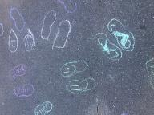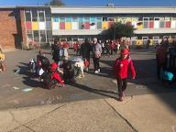

On Wednesday we held an Information Session for families interested in enrolling in our school for 2020. We had wonderful feedback from families on the presentation and our school. We were especially proud of the positive feedback on our Student Leaders who were MCs for the session and then toured families around the school. Families in our Priority Enrolment Area who would like to apply to North Ainslie should do so at <https://www.education.act.gov.au/> For applications received by 7 June, offers will begin from 29 July.

This week our 1/2 students had their walking excursion to Dickson to explore the local area as part of their unit of inquiry. They were able to see and discuss the changes to their local area due to the building of the light rail and were very excited when they returned, telling me all about what they had learnt. They also practised walking safely demonstrating how to cross the road and be aware of their surroundings. Members of our community commented on how mature and principled they were, so we are all very proud of them.

**Reporting Student Achievement in ACT Public Schools**

Each year, North Ainslie Primary School provides written reports of student achievement at the end of semester 1 and semester 2 for students in Preschool to Year 6. In preschool this reporting incorporates the Early Years Learning Framework and for students in kindergarten to year 6 it is to the Achievement Standards from the Australian Curriculum. In the past, schools, including North Ainslie, have used school-based formats for this process.

In 2019 the Education Directorate is introducing a common report format, for students in Kindergarten to Year 10, through the new Student Administration System (SAS). This change will occur via a staged implementation process, with some schools piloting the new report format in Semester 1 and others in Semester 2. North Ainslie is one of the schools implementing the new report in Semester 1 so you will see a different style of report for students in kindergarten to year 6 when it is sent home later this term.

**What is the same?**

All students reports from Kindergarten to Year 10 have always included and will continue to include academic achievement in relation to the prescribed Australian Curriculum and associated achievement standards for each subject studied. For students in Kindergarten, a five-point scale is used. For students in Years 1 to 10, a five-point A-E scale is used to indicate academic achievement. Reports also include information on personal and social capabilities.

**What is different?**

Previously school-based reports have allowed schools to make decisions regarding the detail included against a learning area. For example, some schools reported against English using the different strands e.g. writing, reading, viewing, listening and speaking, whilst some other schools reported against English using school generated outcome statements. The new system report format uses information directly from the subject area Achievement Standards outlined in the Australian Curriculum. Achievement Standards set the goal for what all students should learn as they progress through their school life. From the first year of schooling to Year 10, students develop knowledge and skills in eight learning areas:

* English
* Mathematics
* Science
* Health and Physical Education (HPE)
* The Arts
* Technologies
* Languages
* Humanities and Social Sciences (HASS)

Each learning area contains content descriptions accompanied by **Achievement Standards** that describe what students will know and will be able to do as a result of teaching and learning in the classroom. Schools will select when they report against different sentences in the **Achievement Standards.** The new SAS generated report format will help ACT public schools to provide greater consistency when reporting student achievement to families. In the ACT, student work at standard is considered a ‘C’ grade which indicates the student is on track and demonstrating achievement at the standard. A ‘C’ grade is to be celebrated. Our teachers have been learning about how to write reports using SAS since last term with coaching from the Directorate and our own school-based coaches. The Directorate will be seeking feedback on the report in term 3.

Active Streets

Many of you have assisted the Active Streets Program and Transport Canberra and City Services (TCCS) by completing their survey on how your children currently travel to and from school and where you think improvements can be made around the suburb and the school. North Ainslie has had one of the highest participation rates in the survey. They are still open for further participation if you have not yet participated. All the information collected will be de-identified and confidential. The final survey question asks about the type of infrastructure improvements our community would like considered through the program.

To complete this question you can either:

* Provide an explanation in the text field in the survey, or
* Drop a pin on our [Ride or Walk to School map](https://www.google.com/maps/d/edit?mid=1RP_zciskvt-cYdbd_ZwyoxHRVOPMcNHZ&ll=-35.25342634400636%2C149.14229910208428&z=16) and provide a comment

To drop a pin on the map, you will need to be signed in to a Google account, which is as simple as signing up if you don’t already have one. More information about setting up an account and dropping a pin on the map is available in [these instructions](https://drive.google.com/file/d/1VZixMKbeDkaqxn0lCNymgCjceRNxiweW/view?usp=sharing). TCCS will also welcome feedback about their Ride or Walk to School map, so please use the drop pin feature to comment on the highlighted routes. Alternatively you can print our map, write on the map and return it to [TCCS](mailto:TCCS.Activetravel@act.gov.au?subject=Active%20Streets).

[Complete Survey](http://bit.ly/AS-survey)

<http://bit.ly/AS-survey>

**Updating Contact Information**

We know that people move, phone numbers change and so do email addresses. To assist us with communicating with you in a timely manner, could you please let the Front Office know if any of these details have changed. You can either ring or email on [admin@nthainslieps.act.edu](mailto:admin@nthainslieps.act.edu)

Have a great weekend and see you tomorrow for the Democracy Fair.

Tania Collis (Principal)

**P &C NEWS**

## P & C Meeting

P&C meeting at the school next Tuesday 21st May, starting at 7.30pm. Sweet treats and tea/coffee provided.

We will be discussing community engagement ideas and assessing the success of the Democracy Fair.

Come and meet the new committee.

**Healthy Eating Hub LogoTERM 2 HEHUB CANTEEN MENU (Open Wednesday, Thursday Friday)**

**Recess**

A selection from the following:

Frozen Peas ‘n’ corn cup $1.00 Fruit of the day / Apple slinky $0.50 / $1.00

Pikelets, Popcorn (VG) $0.50 Toasties $1.00 Frozen fruit cup $1.00 Vanilla Yogurt (V, GF) $2.00

Banana muffin (v, DF) $1.00 Cheesy Corn Fritters $0.50

**Lunch**

Vegie sticks Free Fruit of the day $0.50

Vegemite sandwich (VG) $2.00 Vanilla Yogurt (V, GF) $2.00

Tex Mex toasted wrap(V) $2.50 Milk bottle (150ml) $1.50

Soy milk (VG) $2.50 Tuna & cheese toasted sandwich $3.50

Smoothies $2.00 (collect from canteen) Baked Potato with Salsa+/- cheese (GF) $ 3.50

**Daily Lunch Special- $3.50**

**Wednesday: Thursday: Friday:**

*Pizza(V) Italian chicken toasted sandwich (DF) Pasta beef bolognaise (DF)*

## After School Programs

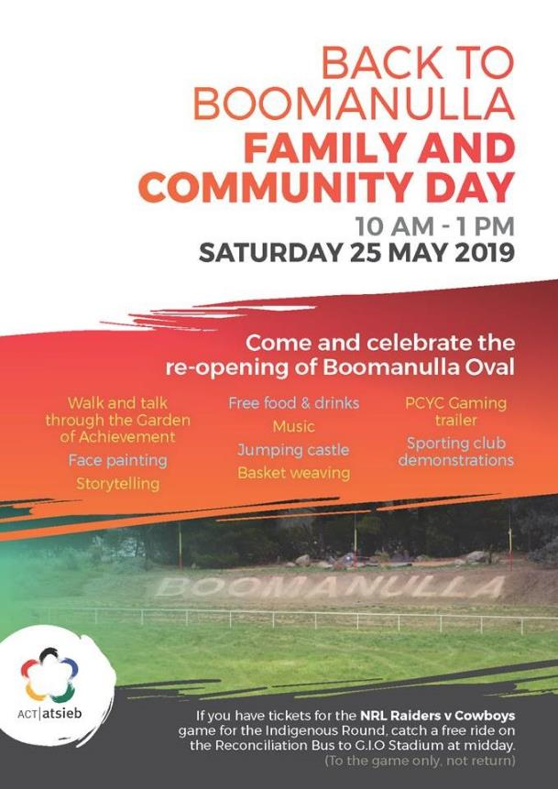

Canberra Toy and Hobby Fair