***The Gang Gang Gazette***

*Week 8, Term 2 (21st June, 2019)*

**Principal: Tania Collis Deputy Principals: Rikkie Klootwijk and Deborah Lowrey (Acting)**

**School Leaders: Marni Payne, Kate Stear,** **Alex Patterson and Kate Bush**

**P & C President: Jhay Mann** [napscommunity@gmail.com](mailto:napscommunity@gmail.com)

**Board Parent Representatives: Sue Webeck, Tara Pearce and Stephen Van Gerwen**

**Board Email**:  [napsboardreps@gmail.com](mailto:napsboardreps@gmail.com)

## Upcoming Events

|  |  |
| --- | --- |
| NAPS Preschool Program 1 Art Gallery | Monday 24th June (8:30am – 9:30am) |
| CEIS | Tuesday 25th June |
| Senior assembly hosted by 5/6LK & 5/6JC | Friday 28th June |
| Peer Support | Friday 28th June |
| Parent Interviews | Week 10 |
| Term 2 Ends | Friday 5th July |

|  |
| --- |
| **Notes Home**   * Academic Report Test Email * P & C Forum Email |
|  |
| **Board**  Next Meeting:  Tuesday 13th August 2019, 6.00 pm  **P & C**  Next Meeting:  Wednesday 13th August 2019, 7.30 pm |

**Dear Families and Friends,**

As I write this week’s newsletter, we have only two weeks of this term left. Next week our semester 1 reports will be emailed home for kindergarten to year 6. They will be sent to one email address for each family. There will be a test email sent early next week to ensure the email addresses we have on file are correct. If you have changed your email address, could you please let the school know by Tuesday 25th June. Please contact the school if your family hasn’t received any report by the beginning of week 10 as parent teacher interviews are scheduled in week 10. Preschool reports will be printed for families and sent home via the student. Please ensure you have booked an interview through the notes that have been sent home.

Today our Student Leaders held their second SEL (Social and Emotional Learning) Summit with a focus on being a communicator and reflective. We all played a game to show the importance of listening to others and the possible problems that occur when we don’t. They also shared a new suggestion box they have started to enable students to reflect and share with us their ideas for our school. We also enjoyed a fun song from one of our favourites, Sesame Street, on the Power of Yet, which reminds us that reflection is all about knowing what our strengths are and what we are working on as we can’t do it just ‘yet’.

The Student Leaders also told us about their term 2 fundraiser which is raising money for the Asthma Foundation through a PJ Day to be held on the last day of school, Friday, July 5. Students can wear their pyjamas and bring in a gold donation which will go towards asthma education and research.

**P and C Forum**

Wednesday night saw our P and C’s forum run by our new P and C Executive Team. There was a fabulous turnout with approximately 30 people coming along to brainstorm and work together to plan for our P and C for the rest of the year, through to 2020. The ideas shared by parents and carers were very exciting and I know the P and C were very appreciative of the support for the forum. They will have some exciting community events coming up and look forward to having lots of you join them throughout the rest of 2019.

**Musica Viva**

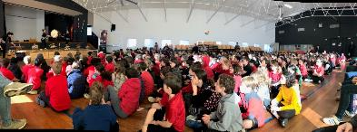On Wednesday, our students enjoyed our annual Musica Viva performance and this year they brought us Taikoz. Taikoz are a three piece band who showed us how traditional Japanese taiko drumming can be used today. They had our students engrossed throughout the whole performance and then up on their feet as they became a part of the music. Musica Viva is always a highlight of the year due to the quality of the performers and Taikoz were a favourite with all of our students. Thanks to our music teacher, Kath Bingham, who organised the event for us.

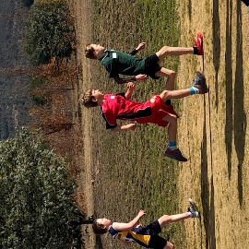

**ACT Cross Country Championship**

Congratulations to Pepi W who competed in the ACT Cross Country Championships last week and came 7th in his age group which was amazing.

**IMP Performance**

Last week Georgia W, Julian, Elsa, L, Jade H, Alice M, Zac O, Noah D, Katherine M, Riley W and Idan G were part of the IMP Performance in the primary choir and concert band.  They represented both NAPS and the ACT for music and did us all proud with their skills and the attributes they displayed on the night.

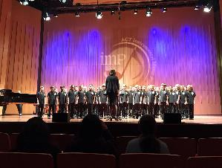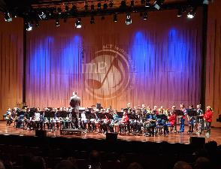

Have a great weekend.

Tania Collis

(Principal)



**P &C NEWS**

Dear parents and carers

Seeing our NAPS community come together and brain storm ideas that will shape the next 12 months builds confidence with the P&C that we’re on track to deliver what our community deserves.

A huge thank you to all that attended and contributed at the Forum this week. It was a fantastic turn out. I think the kids had a great time as well.

We will continue the conversation at our next meeting which will be held at the school and we encourage you to bring your kids along.

I hope to see you there.

Regards

Jhay ( President NAPS P&C)

**Healthy Eating Hub LogoCanteen News**

**TERM 2 HEHUB CANTEEN MENU (Open Wednesday, Thursday Friday)**

**Recess**

A selection from the following:

Frozen Peas ‘n’ corn cup $1.00 Fruit of the day / Apple slinky $0.50 / $1.00

Pikelets, Popcorn (VG) $0.50 Toasties $1.00 Frozen fruit cup $1.00 Vanilla Yogurt (V, GF) $2.00

Banana muffin (v, DF) $1.00 Cheesy Corn Fritters $0.50

**Lunch**

Vegie sticks Free Fruit of the day $0.50

Vegemite sandwich (VG) $2.00 Vanilla Yogurt (V, GF) $2.00

Tex Mex toasted wrap(V) $2.50 Milk bottle (150ml) $1.50

Soy milk (VG) $2.50 Tuna & cheese toasted sandwich $3.50

Smoothies $2.00 (collect from canteen) Baked Potato with Salsa+/- cheese (GF) $ 3.50

**Daily Lunch Special- $3.50**

**Wednesday: Thursday: Friday:**

*Pizza(V) Italian chicken toasted sandwich (DF) Pasta beef bolognaise (DF)*

## Community Notices



