***The Gang Gang Gazette***

*Week 4, Term 3 (14th August, 2020)*

Principal: Tania Collis Deputy Principals: Rikkie Klootwijk and Sharon Moloney

School Leaders: Haeley Simms, Kate Bush (Acting), Melissa Datson (Acting) and Jarryd Heywood (Acting)

Board Parent Representatives: Sue Webeck, Stephen Van Gerwen and Lucy Hopkins

Board Email:  [napsboardreps@gmail.com](mailto:napsboardreps@gmail.com)

P & C President: Maree Wright [napscommunity@gmail.com](mailto:napscommunity@gmail.com)

**Upcoming Events**

|  |  |
| --- | --- |
| Year 3/4 Day Trip to Birragi: Group 1  Group 2 | Tuesday 25th August  Thursday 27th August |

|  |
| --- |
| **Board**  Next Meeting:  Tuesday, 8th September, 6.00 pm  **P & C**  Next Meeting:  Tuesday, 8th September, 6.00 pm |

Dear families and friends,

After a wet and windy start to the week, we have had a couple of beautiful days and it has been lovely to see everyone enjoying the sunshine whilst they play and have their regular PE lessons. Our P & C have continued their consultation on the rejuvenation of our oval with both these activities in mind. Paul Barnett, who is leading this process, worked with our parents and carers on Tuesday night to find out what they believe is important for the oval so their children can engage meaningfully in the space. It was fabulous to see so many families join in the session, both in person and remotely, and share what is valuable to their children. The consultation with Paul will continue nextweek with staff and we are looking forward to engaging in the process with the P & C. The next phase will have Adam Shipp and Uncle Tyronne present sessions on the use of plants for foods, medicines and fibres, Aboriginal stories, artefacts and kinship and an introduction to Ngunnawal history and language. These sessions will also be for all three community groups - students, staff and parents and carers and you should look out for the times when advertised by the P & C.

This week we have had the ACT Education Directorate visit us to find out more about the wonderful Respect books made by our year 1/2 students. They were excited to share their learning with our visitors and we cannot wait to see the story they put together about our students. Thank you to our amazing year 1/2 teachers who led this fantastic learning and to our students who engaged so meaningfully in the book and becoming authors in their own rights.

**TED Talks on the Growth Mindset**

**One of the most important things in maintaining a commitment to lifelong learning is having a Growth Mindset and there are a number of TED talks you can watch with your child on the subject. If you are interested in exploring some of these talks, you can follow the link below to see ten great presentations. The talks include children sharing their experiences and knowledge and some of the titles are S**cience is for Everyone, Kids Included, **Grit: The Power of Passion and Perseverance, What Adults Can Learn from Kids, The Power of Introverts and Kids Can Too. In this last podcast, 9 year old Noah Diguangco gives a TEDTalk all about how he started his own business when he was 7. If you have a budding entrepreneur or someone who wants to make a change in the world, this is an inspiring talk.**

<https://childhood101.com/growth-mindset-videos/?fbclid=IwAR0G_5XezvQ89_7OyoL1Sqx5oh29OcNW7HwUzSmXXPTEl1vCPzmocsnjMN8>

**Changes to Internet Filtering in Schools**

In light of the greater use of Chromebooks by many students across ACT schools, there are some changes being made to internet filtering to further enhance the safety of students who are learning online. Please see below for communication from the Directorate about the changes.

*Currently the Education Directorate filters the internet when a student is using their Chromebooks at school using the internet connection. We are extending this coverage to include all non-school based internet connections. This will enhance student safety when online studying at home. The extension will apply to Education Directorate supplied Chromebooks and personally owned Chromebooks when they are logged in using Education login credentials.*

***Why are we doing this now?***

*To promote student eSafety and provide a safer learning environment for students irrespective of the location that they are learning from.*

*As a result of the exponential increase in students moving to home-based internet connections during the COVID-19 pandemic the Education Directorate is enhancing the safety of the learning environment of students when using their Chromebooks and Education login credentials outside of the school.*

***When is this happening:***

*Starting from week 5 Term 3 (Monday 17 August 2020).*

***How will this update happen:*** *The update will occur via a student’s Education login credentials whether on their Directorate supplied Chromebook or when logged-in to their personally owned Chromebook. Should there be a requirement to use an unfiltered internet connection on a personally owned Chromebook then the user will need to sign out of their child’s Education login credentials and sign-in with a personal login (e.g. a Gmail account).*

***Do I need to do anything?***

*No action is required by parents/guardians around the extension update. However as always, we encourage parents/guardians to remain vigilant around their children’s online activity.*

Below my signature there is information on the 2020 Satisfaction and Climate Surveys and how you can participate. We would love you to participate and help us to continue improving and growing.

Have a wonderful weekend.

Tania Collis (Principal)

## 2020 School Satisfaction & Climate Survey

Each year, the Directorate surveys all parents, school staff and students in Years 4 to 12 about their satisfaction with public education. The *2020 School Satisfaction & Climate Survey* will be available online from 10 to 31 August.

The survey results will help us to continue to make quality informed decisions about how to improve our school. No personal identifying information will be provided to any school or college.

An email about the parent survey, including a unique link to access the survey has been sent to all school; parents who do not receive the email may contact EDUSurveys@act.gov.au to request a survey invitation.

A shortened paper-version of the parent survey is also available in the following 12 languages: Arabic, Burmese, Chinese, Dari, Dinka, Farsi, Hindi, Karen, Korean, Mon, Urdu and Vietnamese; email EDUSurveys@act.gov.au to request a copy.

For the results to reflect the opinions of our whole school community, we need as many parents, staff and students as possible to complete the survey. Your feedback is important, and we hope you will take part.

For more information, visit: <https://www.education.act.gov.au/public-school-life/school-satisfaction-and-climate-survey>

## NAPS P & CP&C News

The P&C have had a busy few weeks getting the consultation sessions arranged for the Senior Oval. We have hosted our first workshop with some of the senior students, and the first parent workshop. Next week the staff will have their first workshop with our Landscape Architect, and the students will have their first Ngunnawal Culture workshops with Uncle Tyronne and Adam.

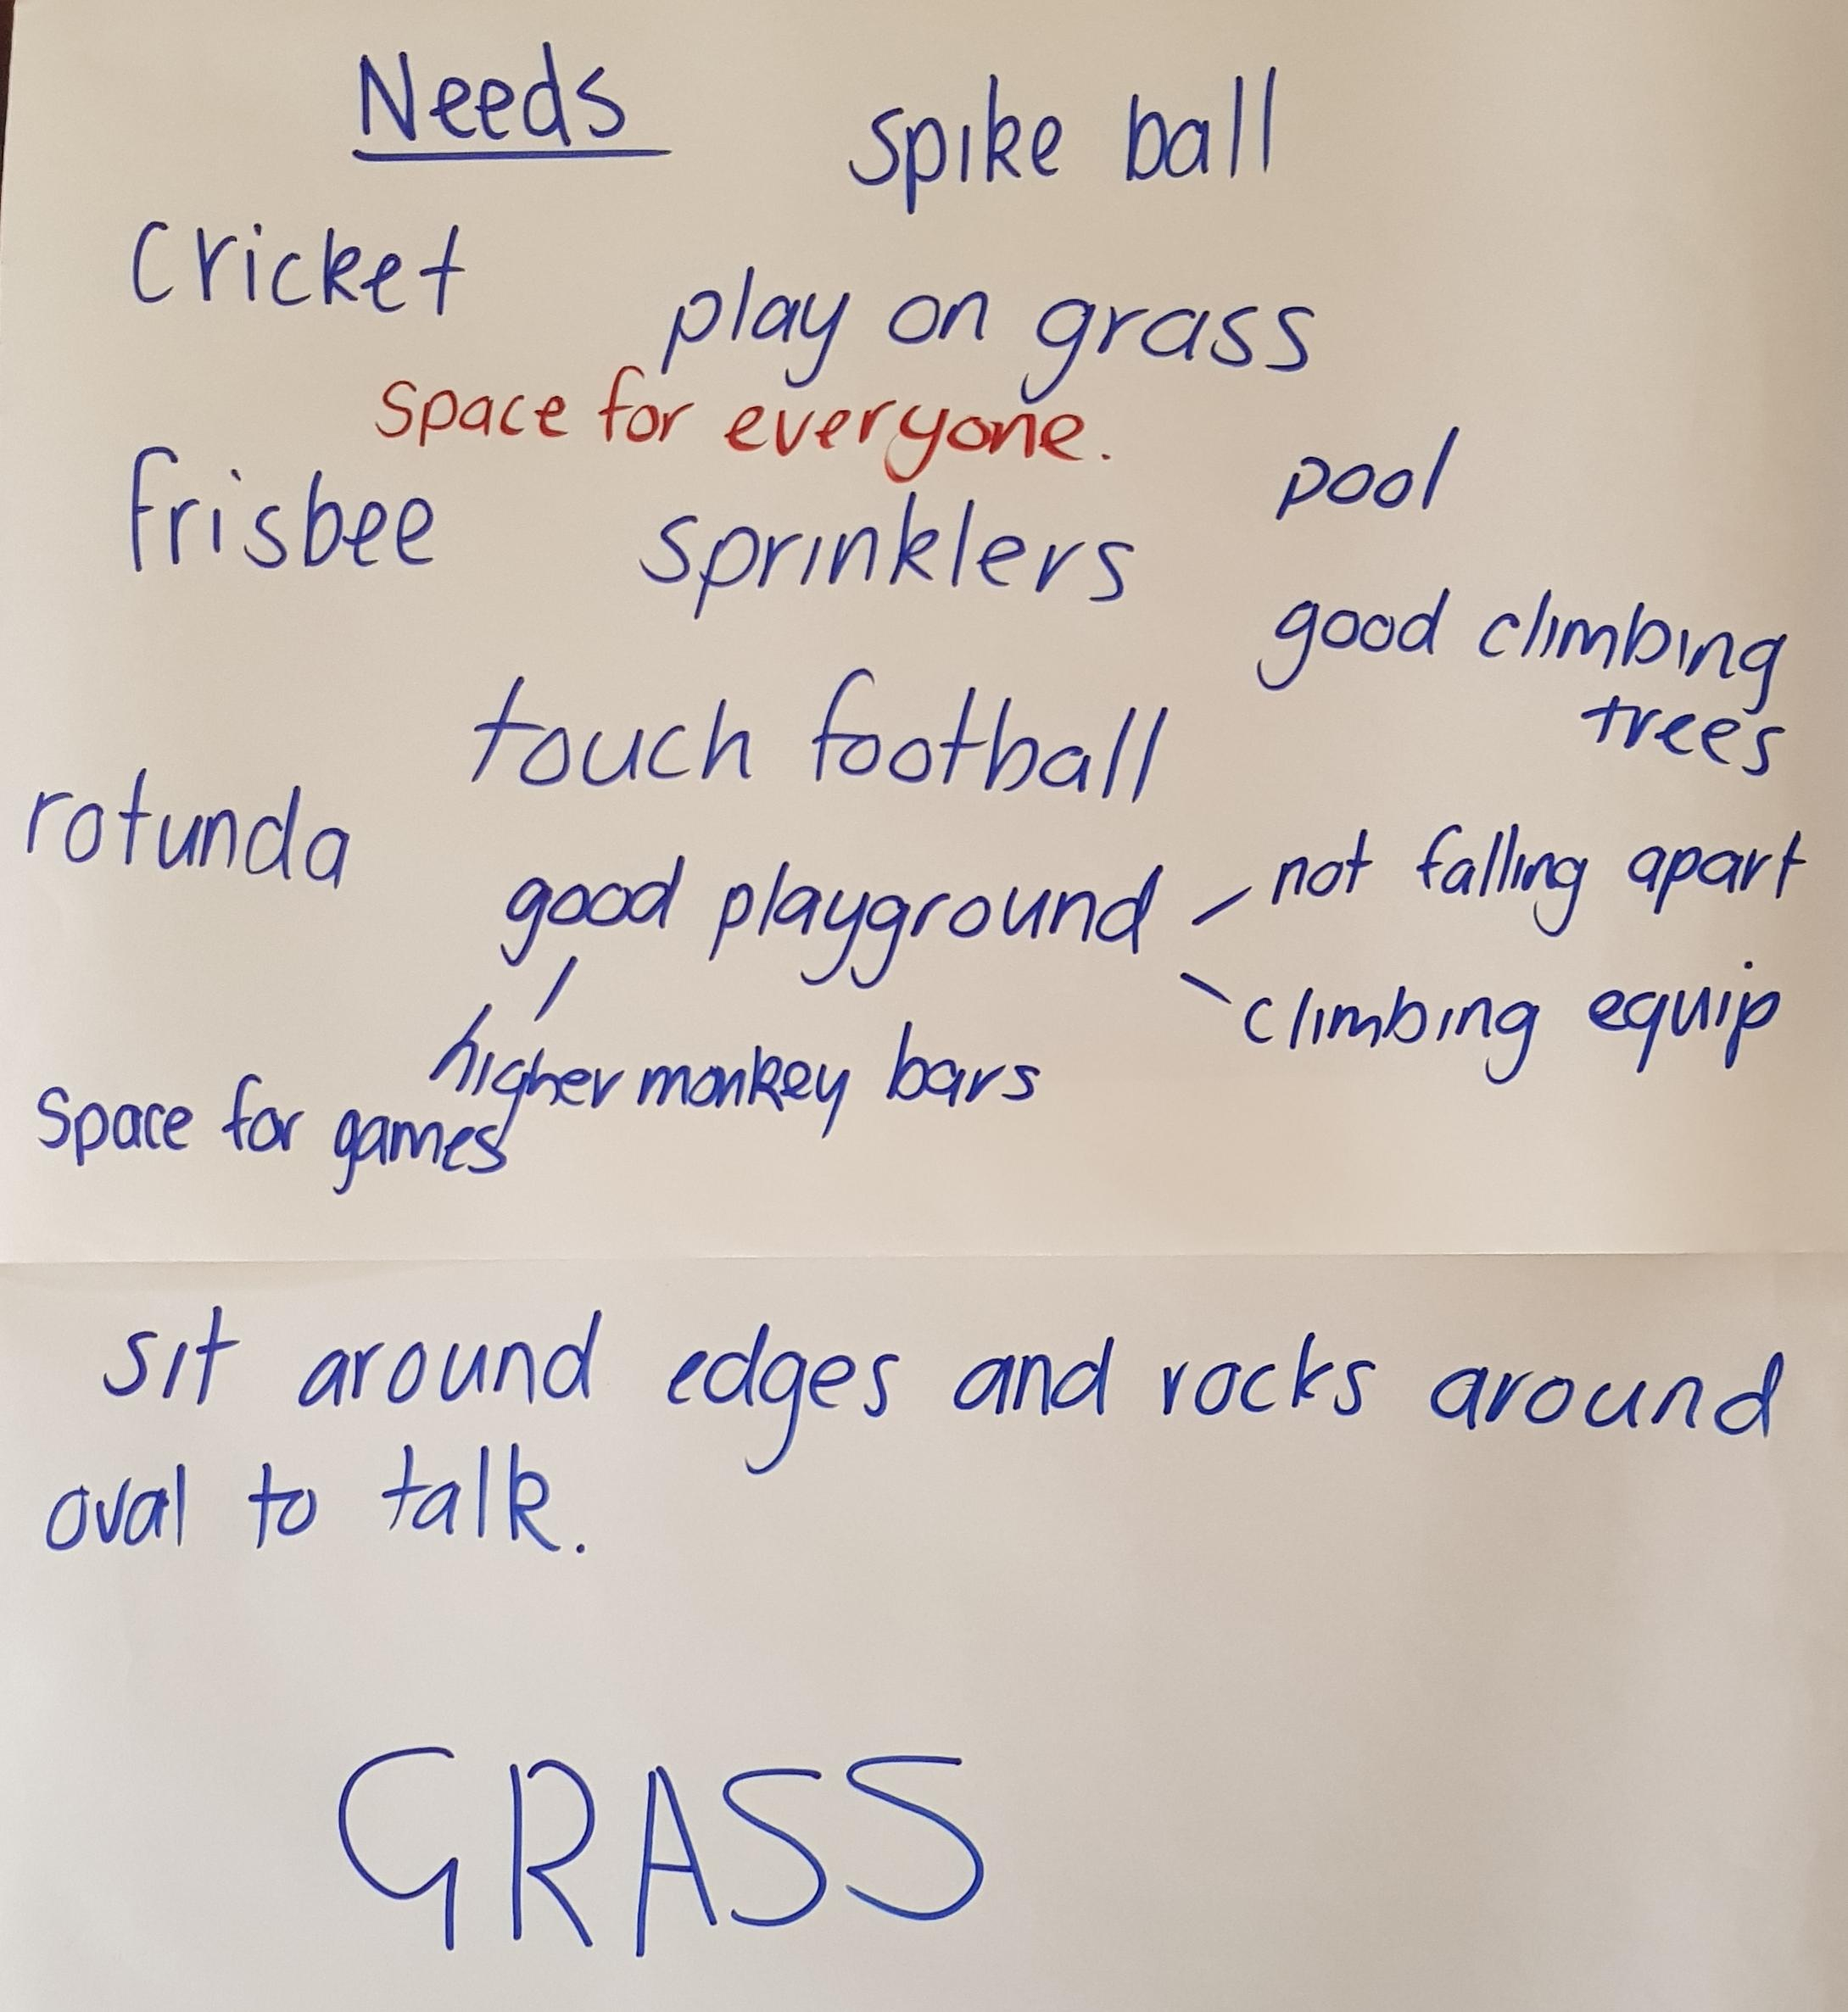The students had some enthusiastic conversations around their needs and wants during their workshop, including the importance of building healthy soil and encouraging biodiversity. The students declared that the space at the moment is ‘dead’, and they would like to see it brought back to life, with spaces for a multitude of activities.

We also had some great input at our Parents’ workshop, with some reminiscing about how we played when we were kids, followed by conversations about process and priorities. In particular, there was strong support for increasing habitat and supporting biodiversity, nature play, water harvesting and storage within the landscape, and spaces for different types of play, including performance spaces, quiet play, small cozy spaces like cubbies, and taking classroom learning outdoors.

*“Keep that 'caring for country' central to whatever you do. With climate change, habitat loss, biodiversity pressures and the need to live locally important considerations for now and in the future this facet is essential to how we live. Setting ourselves up for success through our built environment is key to living well on a sustainable planet.”*

*“Love the dry creek bed. We might get frogs like at Mt Ainslie. What do we plant for gang gangs?”*

*“”A quiet/contemplative space in which to sit and observe, draw/sketch, talk, etc. Perhaps an area dedicated to endemic plants - bush tucker. Thank you for this exciting collaborative project!!”*

Over the next few weeks there will be a number of ways for students, staff and parents to get involved and provide your ideas, thoughts, and concerns. Our Student Leaders will be working with the year 3/4 students to gather their needs and ideas for the space, and the 5/6 students will do this work in class as well. Our Student Leaders will then analyse the responses (with support) and bring them to the next design workshop, to represent the student body in this co-design project.

Parents (and other family and community members) are also invited to attend a set of two cultural workshops, similar to those the students and staff will be attending. These will cover topics like Introduction to Aboriginal plant use, How we use plants for foods, medicines and fibres, Introduction to Ngunawal history, Introduction to Ngunawal language, and Aboriginal stories, artefacts and kinship. This is a fantastic opportunity to learn more about the Country on which we live, learn and play, and I encourage you to register your interest in attending.

The workshops will be held over two weeks. Please email us at [napscommunity@gmail.com](mailto:napscommunity@gmail.com) if you would like to attend.

|  |  |  |
| --- | --- | --- |
| Week 6 (choose one time) | Tues 25th (3:30-5pm) | Tues 25th 5:30-7pm |
| Week 7 (choose one time) | Mon 31st (3:30-5pm) | Tues 1st Sept (5:30-7pm) |

Finally, we will be holding our P&C meeting next week, on Tuesday 18th August at 7:30pm. This will be an online session only.

Join Zoom Meeting: <https://us02web.zoom.us/j/87344998673>

Meeting ID: 873 4499 8673 (no password)

Dial by your location: +61 731 853 730 Australia

Thanks everyone, have a lovely weekend, **Maree** ([napscommunity@gmail.com](mailto:napscommunity@gmail.com)

**Healthy Eating Hub LogoTERM 3 HEHUB CANTEEN MENU (Open Wednesday and Friday)**

**Healthy Eating Canteen Menu:** **Term 3**

**We are open for recess and lunch on Wednesdays, Thursdays and Fridays**

|  |  |
| --- | --- |
| **ALL WEEK RECESS**  **NOTE: not for lunch orders, counter orders only** | |
| Yoghurt | $2.50 |
| Frozen Peas 'n' Corn cup | $1.00 |
| Fruit of the day | $1.00 |
| Frozen fruit cup | $1.00 |
| Cheesey corn fritters | $1.00 |
| Pikelets, popcorn | $0.50 |
| Toasties | $1.00 |
| Muffins | $0.50 |
| **ALL WEEK LUNCH** | |
| Vegie sticks – from the counter | Free |
| Fruit of the day | $1.00 |
| Sausage Roll (homemade) | $4.00 |
| Sandwiches (Ham, chicken, tuna or cheese) | $4.00 |
| -Add salad (lettuce, tomato, carrot and cucumber) | $0.50 |
| -Make it a wrap | $0.50 |
| -Toast it | $0.50 |
| Vegemite sandwich | $3.00 |
| Honey sandwich | $3.00 |
| Salad bowl with either chicken or tuna | $4.00 |
| Yoghurt | $2.00 |
| **DRINKS** |  |
| Milk bottle (200ml) | $2.50 |
| Soy milk | $2.50 |
| Smoothie (collect from canteen) | $3.00 |
| Juice Box | $2.50 |
| **LUNCH PACKS** |  |
| Toasted chicken/cheese + milk + fruit | $7.00 |
| Toasted tuna/cheese + milk + fruit | $7.00 |
| Toasted chicken/cheese + juice + yoghurt | $7.00 |
| Toasted tuna/cheese + juice + yoghurt | $7.00 |

|  |  |  |  |  |
| --- | --- | --- | --- | --- |
| **DAILY LUNCH SPECIALS – ALL $4.00 EACH** | | | | |
| **Monday** | **Tuesday** | **Wednesday** | **Thursday** | **Friday** |
| Closed | Closed | Mini Quiche | Spaghetti Bolognese | Pizza  Margherita or Ham/Cheese |

**How do I make a lunch order?**

Lunch orders are available to all children and are for lunch, lunch pack and drink items only.

**They need to be received by the canteen by 9.30am.**

**Cash orders:** Should be written on a brown paper bag with your name and class**,** what you'd like to order and the correct money. Lunch or drinks items only please.

**Online orders**: Flexischools App or www.flexischools.com.au. Online orders close 9.30am on the same day as you are ordering for.

*If you have a problem with your order, please call/text the manager, not the school front office.*

Canteen manager: Karen 0406 937 139

naps.canteen@gmail.com

## After School activities



