***The Gang Gang Gazette***

*Week 2, Term 2 (10th May, 2019)*

**Principal: Tania Collis Deputy Principals: Rikkie Klootwijk and Deborah Lowrey (Acting)**

**School Leaders: Marni Payne, Kate Stear,** **Alex Patterson, and Kate Bush**

**P & C President: Jhay Mann** [napscommunity@gmail.com](mailto:napscommunity@gmail.com)

**Board Parent Representatives: Sue Webeck and Stephen Van Gerwen**

**Board Email**:  [napsboardreps@gmail.com](mailto:napsboardreps@gmail.com)

## Upcoming Events

|  |  |
| --- | --- |
| NAPLAN Online | Tuesday 14th May – Friday 24th May |
| Year 1/2 Dickson Buildings, Structure and System Walk | Thursday 16th May |
| Walk Safely to School Day | Friday 17th May (before school at 8.30am) |
| Peer Support | Friday 17th May |
| Junior assembly hosted by 1/2KB, 1/2YJ & 1/2TS | Friday 17th May @ 12 Noon |
| Democracy Fair | Saturday 18th May |
| Brainstorm Production -The Protectors | Friday 24th May |
| Kindergarten Health Checks | Wednesday 28th May, Thursday 30th May & Friday 31st May |

|  |
| --- |
| Notes Home   * Year 1/2 Dickson Walk Postponement * Kindergarten enrolment email * Cross country email * Year 5 Band debut performance email * Headlice Notification (Kindergarten &Year 1/2) |
|  |
| **Board**  Next Meeting:  Tuesday 21st May 2019, 6.00pm  **P & C**  Next Meeting: Special AGM  Tuesday 21st May 7:30pm |

**Dear Families and Friends,**

It has been a very busy week here at North Ainslie with lots of great learning and events happening across our school. Our pre-schoolers from Hackett joined us here at the NAPS site to participate in an incursion with the Nutrition Magician. Our littlest students showed amazing perseverance and their grown-up attitude to learning by walking here from Hackett to spend a fun time with the other preschool students and teachers. Our school representatives from year 2 to year 6 also did us proud by attending the ACT Swimming Carnival on Monday. Year 3/4 students have spent the week building upon their learning for their current Unit of Inquiry, *How we express ourselves*, with visits to the National Gallery of Australia. On Wednesday, the P &C did a wonderful job of holding their annual Mother’s Day Stall and there were many excited children showing us the surprise they had bought for the important ladies in their lives.

Yesterday was a wonderful, sunny day to hold our Cross Country for 2019. One of the joys of being in a school is seeing when our students have new experiences and this was so true yesterday when our kinders came out, ready to do their best and have a go at their first cross country. Well done to our staff for running such a great event and thank you to all of the helpers from our school community. Congratulations to every student for doing their best to represent their house and to the Parrots who were the winners on the day. This is a big week for our year 6 students as yesterday they had their first transition visit from Campbell High School in preparation for their exciting new adventure next year. They then attended a Future Career Expo with other year 6 students from across the ACT. Some of the stalls on offer included CIT and representatives from their floristry, plumbing, automotive, hair and beauty and electrical trades sections. ACT Emergency Services were also there as well as the Defence Forces and all our year 11/12 colleges. Other stalls included Geodrones, the University of Canberra, McDonalds, Perform Australia, Geoscience Australia, the Centre for Innovation and Learning and Jerrabomberra Wetlands. Today they will start their roles as Peer Support Leaders teaching students from across kinder to year 6 all about building relationships. We look forward to seeing them put into action the training they had last week.

**Enrolling for 2020 and North Ainslie Information Session**

Applications for enrolment at Canberra Public Schools opened on Monday 29 April. For applications received by 7 June, offers will begin from 29 July. Further details on enrolling can be found on the Directorate’s website at <https://www.education.act.gov.au/>

For families who live in our Priority Enrolment Area (PEA) we will be holding an Information Session on Wednesday, 15 May starting at 9.15am. We will meet in the hall to talk about the PYP and what makes NAPS special.  Families will then be able to tour the school and see learning in action.  If you know someone who would like to attend our information session, please pass this information on to them and direct them to our Front Office for further details.

Our regular lunchtime clubs are now up and running for the year. You might like to talk about these clubs with your child and encourage them to try any that interest them. Thank you to our teachers for running these clubs for our students to provide a greater range of activities at lunchtimes.

**A to E Reports**

If you have a student in years 1 through 6, and you do not want to receive an A to E Report for them, please contact the school on [admin@nthainslieps.act.edu.au](mailto:admin@nthainslieps.act.edu.au) or call Rikkie Klootwijk.

**P & C**

Later in the newsletter there is our P & C section which this week includes a thank you from the outgoing president, Trudy Green. I would personally like to thank Trudy for her wonderful contributions over the past two years and add my thanks to Brett Ford, Caroline Hughes and David Bouchard-Atkinson who all held committee positions over the last two years. Thank you also to everyone Trudy has mentioned as your support is invaluable in our school community.

[](http://www.google.com.au/url?sa=i&rct=j&q=&esrc=s&source=imgres&cd=&cad=rja&uact=8&ved=0ahUKEwis4KWSneTTAhVLI5QKHWi1CGgQjRwIBw&url=http://paf.org.au/programs/walk-safely-to-school-day-19-may-2017/&psig=AFQjCNH5o1b1fjcu1vOwK5xxOG_chdf-kA&ust=1494467963566987)**Walk Safely to School Day - Friday 17 May** **2017**

**Walk Safely to School Day** (WSTSD) is an annual, national event when all Primary School children are encouraged to **walk** and commute **safely to school**. It is a community event seeking to promote road safety, health, public transport and the environment.

WSTSD promotes the important message of Active Kids are Healthy Kids. The event encourages parents, carers and their children to build regular walking to and from school into their daily routine as children need a minimum of 60 minutes exercise per day. It also encourages parents to drive less and walk more, aiming to decrease dangerous vehicle congestion around schools and reduce carbon emissions from idling cars.

Next Friday, we will be handing out stickers to those students who walk to school. Upon arrival students will use a piece of chalk to trace around their foot on the blacktop. We can’t wait to see the footprints of all of our walkers.

**Earn and Learn**

North Ainslie is participating in Woolworths Earn and Learn competition. Stickers can be collected between 1 May and 25th June 2019.

Have a great weekend and see you next Saturday for the Democracy Fair.

Tania Collis (Principal)

**The New Classrooms - 3/4 Mod**

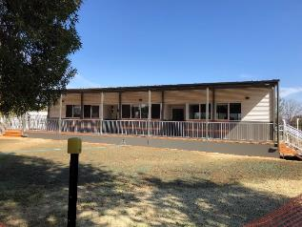

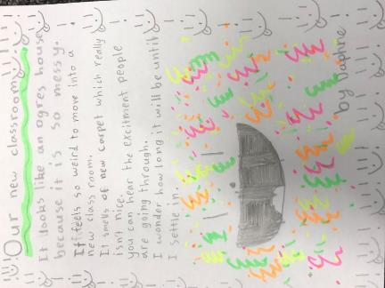

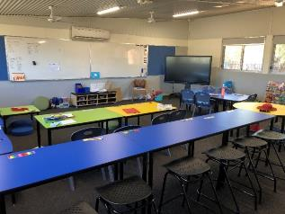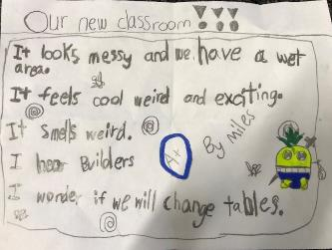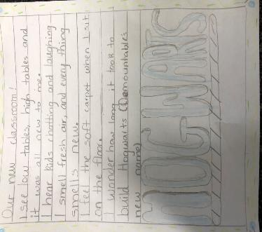

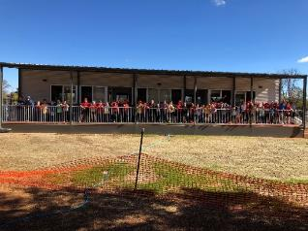

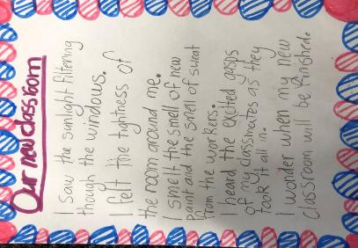

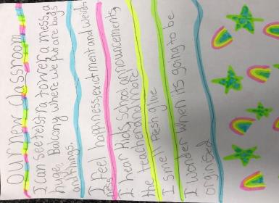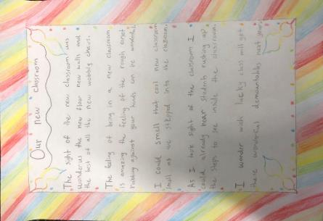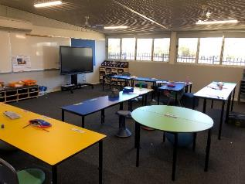

## ACTSmart’s Eco Challenge – Easter Egg Foil Competition

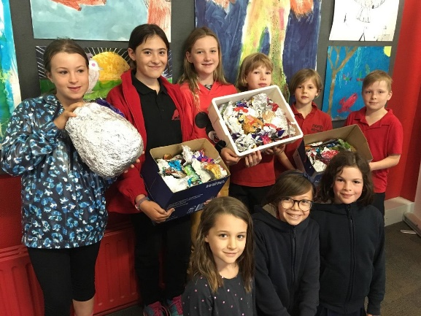Thank you to the families who participated in ACTSmart’s Eco challenge by collecting foil Easter egg wrappers. By participating in the competition, North Ainslie saved 2.2kg of aluminium foil from going to landfill! In total, 21 Primary Schools registered for ACTSmart competition and over 10 thousand students participated. As a result 44.55kg of Easter egg foil will be directed to recycling centres rather than to landfill. Congratulations to Margaret Hendry School for winning the prize.

You can continue to recycle your foil at home by placing it in the mixed recycling bin. Just remember, it needs to be about the size of a credit card or larger.

For more information about recycling in Canberra check out the ACT Government’s Recyclopedia at <https://www.act.gov.au/recycling/a-z_waste_and_recycling_guide>

**P &C NEWS**

**Democracy Fair**

With just over one week to go…we are looking forward to our inaugural Democracy Fair.

*We need your pre-loved books*, so if you can spend some time over the weekend clearing out the bookshelves we welcome your donations. Please leave pre-loved books at the front office

*We need your help*….Please find the Volunteer signup link. If you can spare some time to help make the event fantastic it would be appreciated. Please click on the following web link (or copy it into your web browser if clicking doesn't work) to go to the signup sheet:

[volunteersignup.org/3ACME](https://volunteersignup.org/3ACME)

|  |  |
| --- | --- |
| [https://volunteersignup.org/images/square_logo.png](https://volunteersignup.org/3ACME) | [2019 Election Day Fair](https://volunteersignup.org/3ACME)  Volunteer signup sheet  volunteersignup.org |

To sign up, just follow the instructions on the page. It only takes a few seconds to do. Thank you for volunteering!

## Uniform Shop News

Red Beanies are now available in the uniform shop for $10 and more winter tunics should be here by next week

## P & C Meeting Update

Thank you to those that attended the P&C’s Special Meeting last Monday night. It was great to see some new faces and even more pleasing to be able to announce that we were able to form a Committee for 2019, consisting of:

President – Jhay Mann

Vice President – Tiina Mann

Secretary – Rachael Harris

Assistant Secretary - Jo Lynch

Treasurer – Maree Wright

Assistant Treasurer – Ciaran MacCana

A very big thank you for offering to spend some of your valuable time supporting the school via the P&C. Before I depart to enjoy my time on the backbench, I would like to recognise the many people that supported me in the role of P&C President and more broadly the work of the P&C.

I’d like to start with our fabulous school staff. It never ceases to amaze me how prepared they are to go the extra mile to support the students and the school community. An extra big shout-out to Tania, Nadia and Meenakshi, you have all provided me with a huge amount of support – THANK YOU!

Next, I must mention those that sat on the P&C Committee for the last two years, it can be quite a job but it was always great to come to a meeting and spend some time with you all. Thanks to Brett Ford, Rachael Harris, Caroline Hughes, Heather Sedgeman and David Bouchard-Atkinson.

Now it gets harder, there are so many quiet achievers doing great things behind the scenes. Not to mention all those that lend a hand at our events. But, I would like to make a few special mentions. No doubt I will miss someone – sorry! To the organisers of the Sustainability Fair: Jen Tonna, Nicola Gibson, Dan Watters, Sarah Tynan and last years PACH teachers, Amy Pepper and Rebecca Levinson. To our fabulous Trivia Night team and raffle prize collectors: Sarah Tynan, Cath Zasiadczyk, Jen Tonna and Rachael Harris (and to the Trivia night chefs and markers). To Sarah Lendon and Jo Fisher for working so hard to make our school grounds more beautiful (and all those that moved mulch, dug holes, planted trees etc. at our working bees)

Rachael Harris is a superstar, an all-round helper but an extra mention for organising the Mother’s and Father’s Day stalls. Heather Sedgeman aided by her team of volunteers run an awesome canteen, great food at low prices. We welcome Karen Rumble to the team, taking over on Wednesday and Thursday.

Thank you to Frances Verrier and Karen Rumble, and their team of volunteers for running the uniform stall.

Our students love Book Club (and our librarians the extra resources). Thank you to Karen Power for making that happen. We also love our calendars, greeting cards and other goodies in our art fundraiser. All wouldn’t be possible without the hard work of Cath Zasiadczyk and our art teacher, Sarah Buckley. What is the end of the year without a tray of mangos, thank you to Fiona Matz (ably assisted by me!) for organising our mango fundraiser. To those that organised Flix ‘n the Grass; Jhay Mann, Ellie Archer, Brett Ford and Kerryn Saggers. What a great new event!

Last but not least, to my family, it was a team effort. Thank you.

Helping with the P&C does take time, but it is very rewarding. It’s fantastic to have new faces on the Committee. However, many of those that have been fundamental to the P&C’s events and activities are nearing the end of their time at NAPS. Now is a great time to get involved, plenty of help to learn the ropes. We also have a few small jobs on the wishlist that need an owner, for example updating our constitution and investigating a Legacy Fund for donations. If you would like to know more, get in touch via [napscommunity@gmail.com](mailto:napscommunity@gmail.com) or come meet the new Committee at their first meeting, **Tuesday 21 May, 7:30pm in the staffroom.**

Regards, Trudy Green

## After School Programs



**Have you ever wanted to give hockey a try?**

North Canberra Eagles Hockey Club are running junior programs throughout Terms 2 and 3 for boys and girls.

Hookin2Hockey is a program for Under 9’s and Under 7’s boys and girls to learn the basics of hockey in a fun environment. Sessions are Saturday mornings from 9-10am. $110 for two terms which includes a stick, bag, ball and shin pads.

Our Girls Under 11 team is looking for more players. Games are on Saturday mornings and training Tuesdays from 6-7pm. Beginners are most welcome.

For more information please contact Susan – sford1@tpg.com.au

## Young Music Society events

*Young Music Society events Young Music Society events*

*Young Music Society events*

**Healthy Eating Hub LogoTERM 2 HEHUB CANTEEN MENU (Open Wednesday, Thursday Friday)**

**Recess**

A selection from the following:

Frozen Peas ‘n’ corn cup $1.00 Fruit of the day / Apple slinky $0.50 / $1.00

Pikelets, Popcorn (VG) $0.50 Toasties $1.00 Frozen fruit cup $1.00 Vanilla Yogurt (V, GF) $2.00

Banana muffin (v, DF) $1.00 Cheesy Corn Fritters $0.50

**Lunch**

Vegie sticks Free Fruit of the day $0.50

Vegemite sandwich (VG) $2.00 Vanilla Yogurt (V, GF) $2.00

Tex Mex toasted wrap(V) $2.50 Milk bottle (150ml) $1.50

Soy milk (VG) $2.50 Tuna & cheese toasted sandwich $3.50

Smoothies $2.00 (collect from canteen) Baked Potato with Salsa+/- cheese (GF) $ 3.50

**Daily Lunch Special- $3.50**

**Wednesday: Thursday: Friday:**

*Pizza(V) Italian chicken toasted sandwich (DF) Pasta beef bolognaise (DF)*