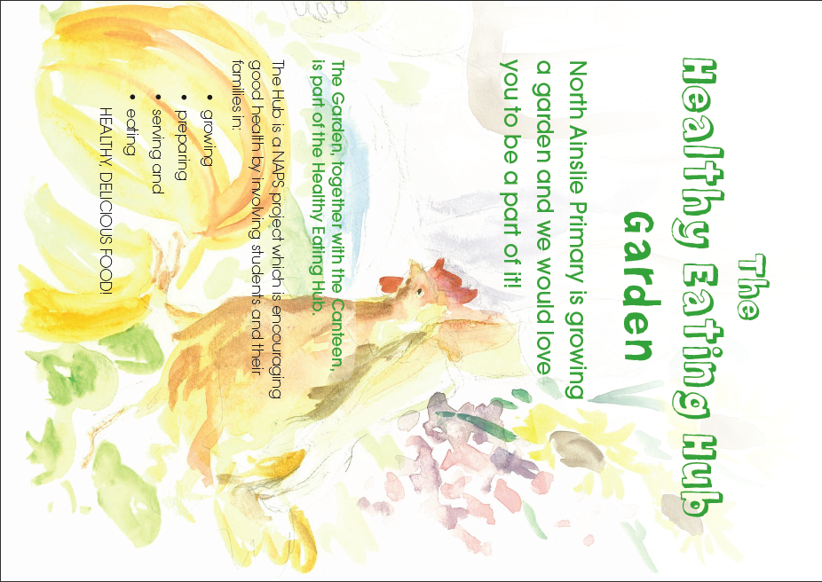

**Becoming Involved**

The garden is run by our environmental science teachers and volunteers who work together with students to maintain the garden. There are lots of ways you can become involved. It can be once a week, once a month or even once a year.

**Seasonal Weekend Working Bees**

Every now and then we hold a weekend or seasonal working bee for bigger jobs in the garden. If you would like to be involved or lead a working bee, please contact us through the Front Office.

**Which students work in the HeHub**

All classes will have the opportunity to work and visit the HeHub. Enrichment is provided through lunchtime clubs and the Green Team. Activities include planting seedlings, harvesting vegetables, preparing food or making art in the garden. We welcome parents who would like to come and assist the kids during the school day for a garden or craft activity in the garden.

**Wood Fired Pizza Oven**

Would you like to learn how to make delicious pizzas using a wood fired pizza oven? Our school garden has a beautiful pizza oven, which is fired up for social events and as a fundraiser. Please let us know if you would like to be involved, it is loads of fun and many hands make light work!



**HEHub Garden Produce Stall**

At regular school events we hold a garden stall to sell produce from the garden and home garden donated produce and goodies. If you have excess produce please bring it to the school on the day. Let us know if you would like to be involved in the produce stalls.

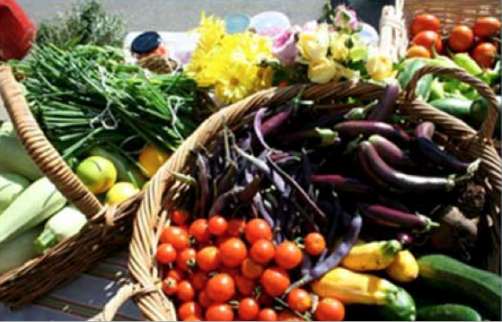

**Garden Arts and Crafts**

Do you have any ideas for our garden? Would you like to run a garden craft activity with a multi-age enrichment group or during a lunch hour? We would love to hear from you.

**If you would like to be involved, have some time to spare or some ideas to share, please contact us.**

[admin@nthainslieps.act.edu.au](mailto:admin@nthainslieps.act.edu.au)

